问题：Expected one result (or null) to be returned by selectOne(), but found: 2

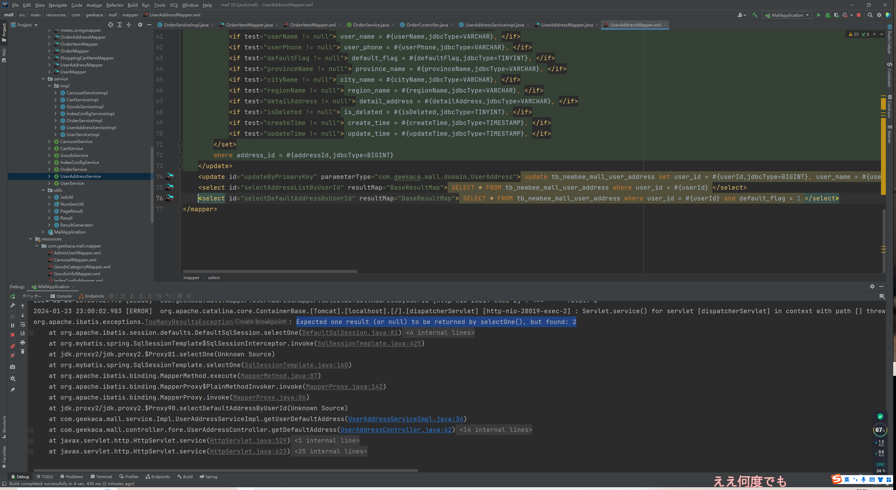

解决：因为返回结果不止一个，删除数据库中多余数据或者加个限制