问题：尝试运行订单流程报错

Error parsing Mapper XML. The XML location is 'com/geekaca/mall/mapper/OrderMapper.xml'. Cause: org.apache.ibatis.builder.BuilderException: Error resolving JdbcType. Cause: java.lang.IllegalArgumentException: No enum constant org.apache.ibatis.type.JdbcType.Integer

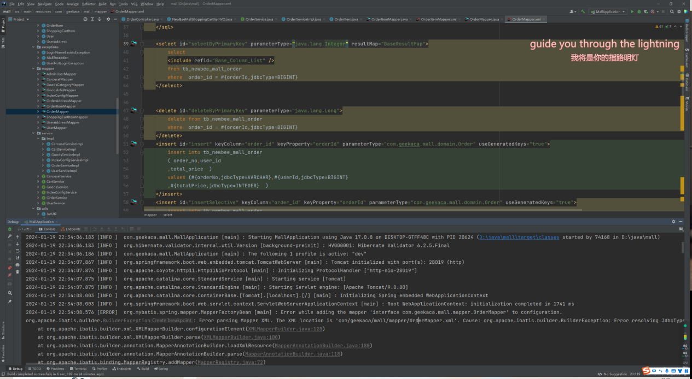

解决：应该是mapper当中的type值错误，从long变成integer

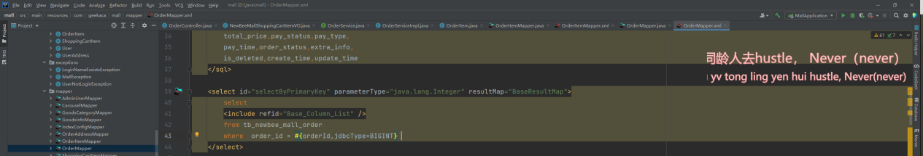

问题：提示找不到对应接口

Error creating bean with name 'orderController': Unsatisfied dependency expressed through field 'orderService';

Error creating bean with name 'orderServiceImpl': Unsatisfied dependency expressed through field 'orderMapper';

Error creating bean with name 'orderMapper' defined in file [D:\java\mall\target\classes\com\geekaca\mall\mapper\OrderMapper.class]

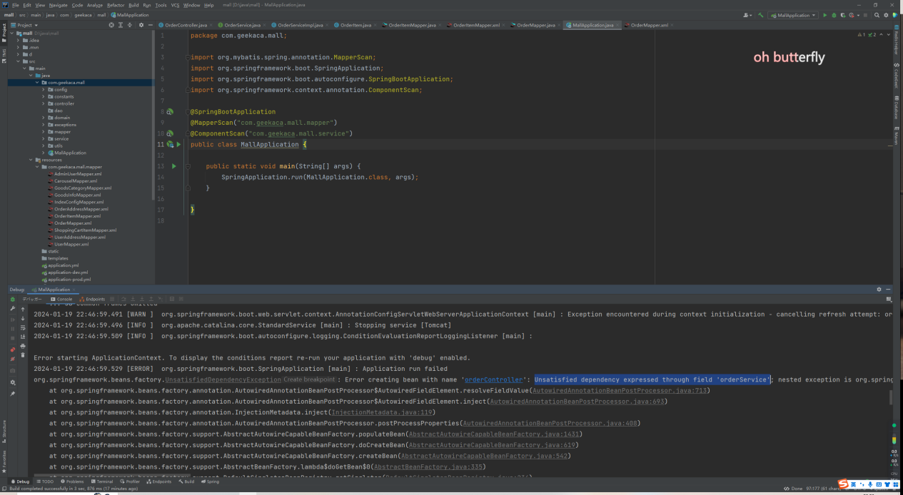

仔细查了下接口都写了，就是查不到，尝试添加全盘扫描也不好用

最后发现还是xml文件里的jdbcType有问题导致的，已解决

报错：Parameter 'ids' not found. Available parameters are [array, id]

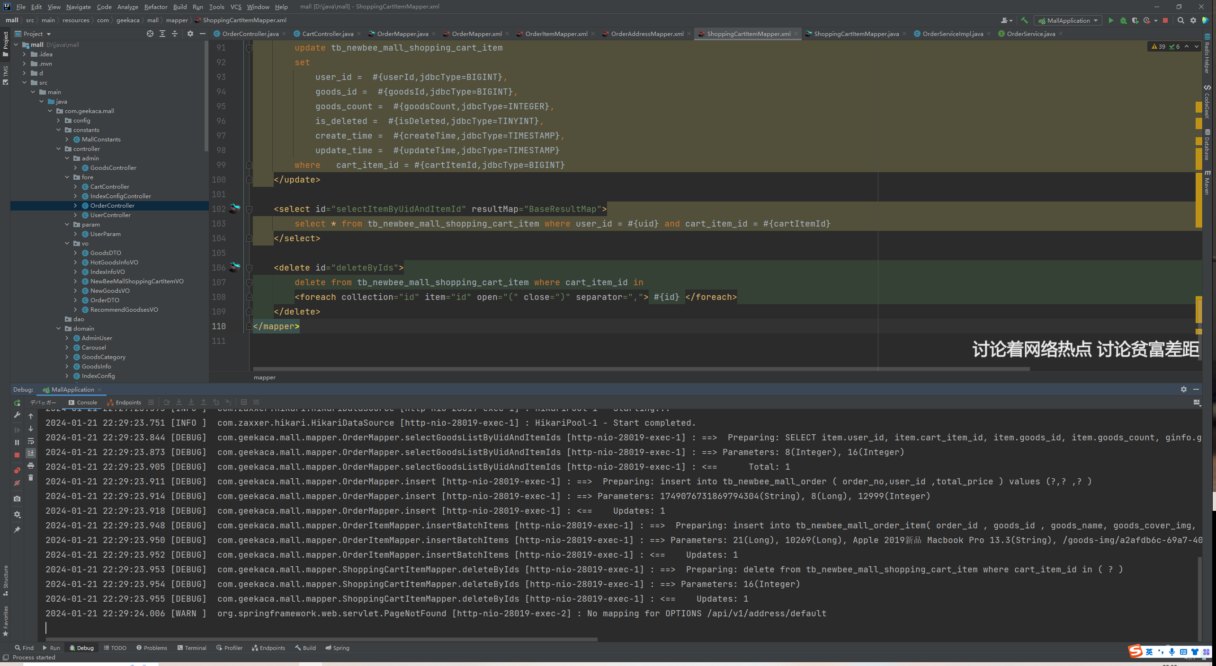

解决：sql语句错误，

将<foreach collection="ids" item="id" open="(" close=")" separator=","> #{id} </foreach>

改成<foreach collection="id" item="id" open="(" close=")" separator=","> #{id} </foreach>