
COMPUTER
APPLICATION
NAME : xclrh xhfj flug| GABHASTI GIRI SINHA
CLASS: IX C
ROLL NO: 11
ADMISSION NO: 16793

ANSWER THE FOLLOWING
Explain Analog and Hybrid Computers ?

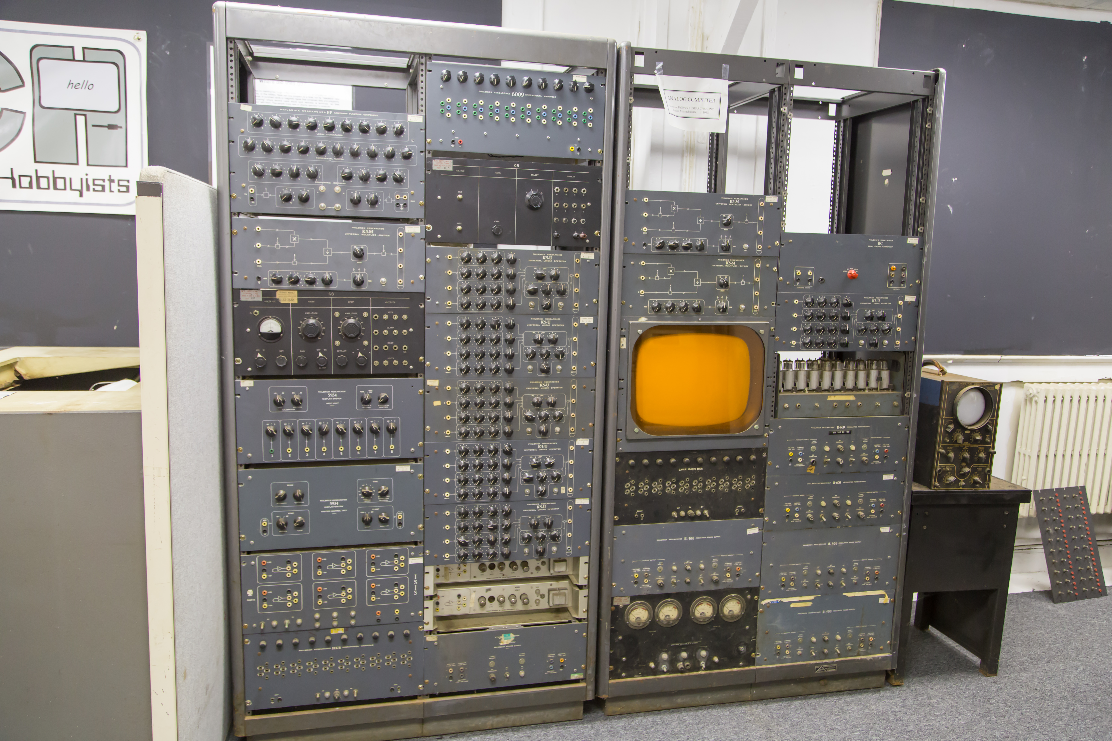
Analog Computers are computing devices that process data represented in continuous physical quantities, such as electrical voltage, fluid pressure, or mechanical motion. These computers are designed to simulate real-world processes and solve complex mathematical problems by manipulating analog signals.

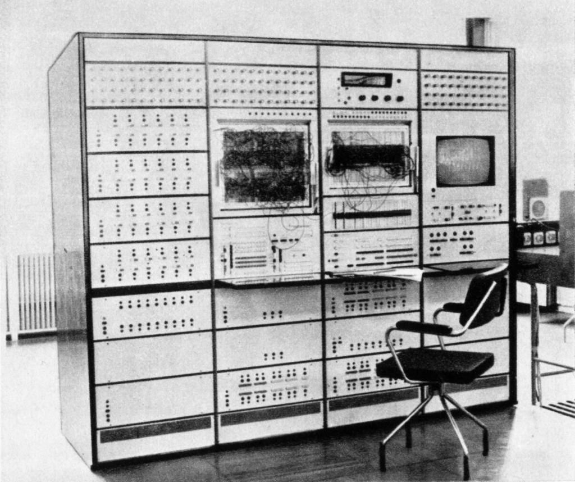
Hybrid Computers combine the features of both analog and digital computers, leveraging the strengths of each to perform complex computations. These systems incorporate both analog processing for continuous data and digital processing for discrete data, making them highly versatile. Key features and applications include:

DIFFERENCE BETWEEN ANALOG AND HYBRID
Operate with continuous data. | Combine continuous analog and discrete digital processing.
Ideal for real-time simulations and solving differential equations. | Suitable for complex, high-precision tasks that require both types of data handling.
Use physical quantities to represent information. | Integrate the best features of analog and digital computers for enhanced performance and versatility.

Make a model of CPU ?

CPU Model Components
Arithmetic Logic Unit (ALU):
    - Function: Performs arithmetic and logical operations.
  - Operations: Addition, subtraction, multiplication, division, AND, OR, NOT, XOR.
- Control Unit (CU):
  - Function: Directs the operation of the processor.
  - Responsibilities: Fetching instructions from memory, decoding them, and executing them by directing the ALU and other components.
- Registers:
  - Function: Small, fast storage locations within the CPU used to hold data temporarily.
  - Types:
    - General-purpose registers: Used for a variety of operations.
    - Special-purpose registers: Include the Program Counter (PC), Instruction Register (IR), Accumulator (ACC), Stack Pointer (SP), and others.
- Cache Memory:
  - Function: Provides faster data access to frequently used instructions and data.
  - Levels: Typically includes L1, L2, and sometimes L3 caches, each progressively larger and slower.
- Bus Interface:
  - Function: Facilitates communication between the CPU and other components (memory, I/O devices).
  - Types:
    - Data Bus: Transfers actual data.
    - Address Bus: Carries the memory addresses of the data.
    - Control Bus: Carries control signals.

- Clock:
  - Function: Synchronizes the operations of the CPU by generating a consistent timing signal.
- Instruction Decoder:
  - Function: Decodes the fetched instructions into signals that can control other parts of the CPU.
- Execution Unit:
  - Function: Executes the instructions after they have been decoded. It often includes the ALU and other components.
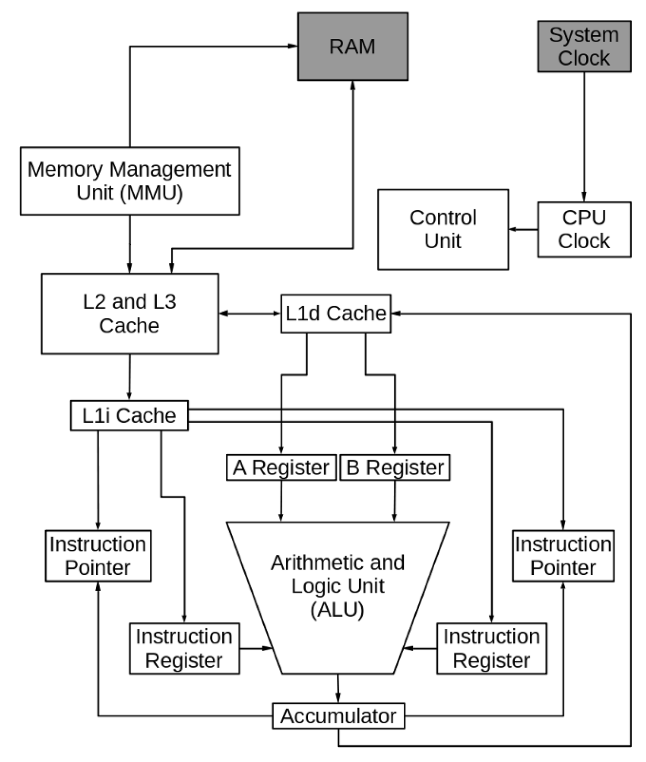
Mention All the home devices which can be controlled through voice. Are these devices using computer? If yes what is the category of such Computer? Mention the model name of the 4-wheeler which can be controlled through Voice.

Voice-controlled home devices fall into various categories and include a wide range of products that can be controlled using voice commands through virtual assistants like Amazon Alexa, Google Assistant, and Apple Siri. These devices are part of the broader category known as smart home devices. Here are some examples:
Smart Speakers:
  - Amazon Echo
  - Google Nest Audio
  - Apple HomePod
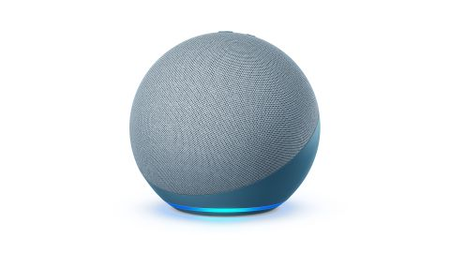

Smart Displays:

  - Google Nest Hub
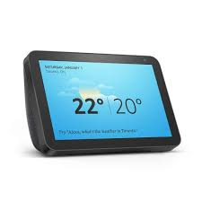
Smart Thermostats:
  - Nest Learning Thermostat
  - Ecobee SmartThermostat
Smart Lighting:
  - Philips Hue
  - LIFX Smart Bulbs
Smart Locks:

  - Schlage Encode
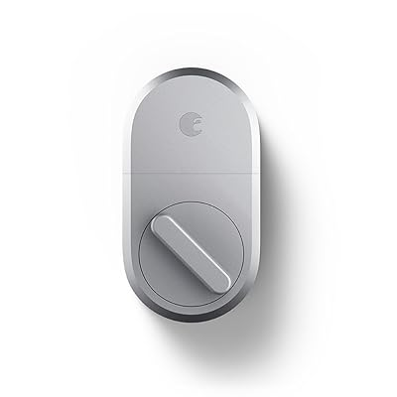
Smart Plugs:
  - TP-Link Kasa Smart Plug
  - Wemo Mini Smart Plug
Smart Security Cameras:
  - Ring Video Doorbell
  - Arlo Pro 3
Smart TVs:
  - Samsung Smart TVs with Bixby
  - LG Smart TVs with ThinQ AI
Smart Appliances:
  - LG Smart Refrigerators
  - Samsung Smart Washing Machines

Are These Devices Using Computers?
Yes, these devices use computers. The computers embedded within these devices can be categorized as embedded systems. These are specialized computing systems that perform dedicated functions within larger mechanical or electrical systems.
Characteristics of Embedded Systems in Smart Home Devices:
- Dedicated Functionality: Designed to perform specific tasks, such as voice recognition and executing voice commands.
- Real-Time Processing: Capable of processing inputs (voice commands) and providing outputs (executing actions) in real time.
- Connectivity: Often include connectivity features like Wi-Fi or Bluetooth to communicate with other devices and the internet.
- Low Power Consumption: Optimized for energy efficiency since many of these devices are always on and ready to respond.
4-Wheeler Models Controlled Through Voice
- Several modern cars come equipped with voice control capabilities, allowing drivers to control various functions such as navigation, climate control, and media playback. Here are some examples:
- Tesla Model 3
- Ford Mustang Mach-E
- BMW 3 Series
- Mercedes-Benz A-Class

Are mini and mainframe computers being used these days. Mention some popular model names. How big are they? Compare them with today’s typical Laptop.

Use of Mini and Mainframe Computers Today
Mainframe Computers:
- Purpose: Used by large companies for important tasks like processing large amounts of data and handling transactions.
- Popular Models: IBM z15, IBM z14, Fujitsu GS21.
- Size: As big as a room; weighs several tons.
Mini Computers:
- Purpose: Used for medium-sized tasks needing more power than a personal computer but less than a mainframe.
- Popular Models: HPE Integrity Superdome X, IBM Power Systems, Dell EMC VxRail.
- Size: About the size of a few large desktop computers; fits in standard data center racks.
Laptops:
- Purpose: Personal use, office work, browsing, and light programming.
- Popular Models: MacBook Pro, Dell XPS, Lenovo ThinkPad.
- Size: Small and portable, with screen sizes from 13 to 17 inches; weighs 1 to 3 kg.
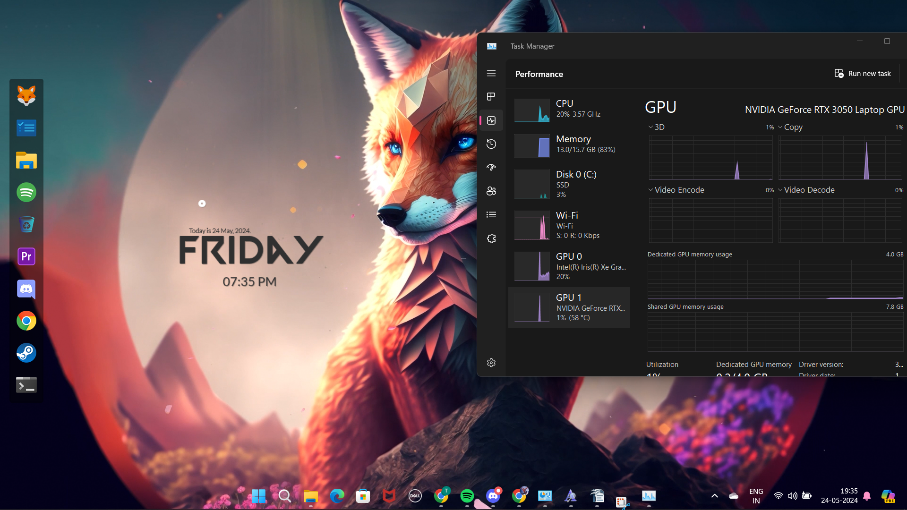

THE END

