**](http://www.akademik.adu.edu.tr/fakulte/muhendislik/default.asp)**

**T.C. AYDIN ADNAN MENDERES UNIVERSITY**

**FACULTY OF ENGINEERING**

**DEPARTMENT OF COMPUTER ENGINEERING**

**CSE435 - Biomedical Signal Analysis and Machine Learning, Autumn 2023**

**Supervisor: Doç. Dr. Ahmet Çağdaş SEÇKİN**

**2022_Final_03_Uniqe_Dataset**

**Final Report**

**By:**

**Bünyamin ÖZEL, Student ID: 181805061**

**Umut ŞENTÜRK, Student ID: 181805049**

**Random Forest model, Decision Tree model and Gaussian Naive Bayes model ML Classification**

First of all, we used our EMG Signal for gesture recognition dataset to make ML classification. A MYO Thalmic bracelet worn on the user's forearm and a PC with a Bluetooth receiver were used to record the patterns in the dataset we used. The bracelet is equipped with eight sensors evenly spaced around the forearm that simultaneously receive myographic signals. Signals are sent to a PC via a Bluetooth interface.

It presents raw EMG data from 36 subjects performing a series of static hand movements. Subject performed two sets of six (seven) basic movements each. Each move was performed for 3 seconds with a 3 second pause between moves.

**Selecting Best Model**

We tried some models to find the best one. These models were Random Forest Classifier,

Decision Tree Classifier and Gaussian Naive Bayes MLP Classifier. As a result of our experiments, we saw that the best model was Random Forest Classifier.

**Accuracy and classification report with** **Random Forest model**

The Random Forest model, which gave the best results among the models we used, gave us the accuracy result as 0.7261680037753657. Accuracy and classification report is shown in the pictures below.

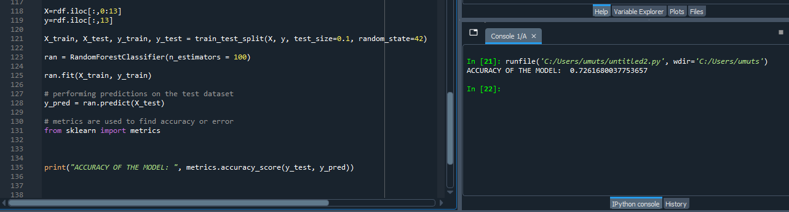

**Accuracy with Decision Tree model**

We used our Decision Tree model to calculate the accuracy of our data, but we did not need to create a confusion matrix as it was too low compared to our Random Forrest model.

The accuracy value of our Decision Tree model is shown in the picture below. (0.38870536416548684)

**Accuracy with Gaussian Naive Bayes**

Finally, our Gaussian Naive Bayes model, which we tried, gave much lower accuracy than our previous two models, so we prepared our confusion matrix for our Random Forest model. (0.08577159037281737).

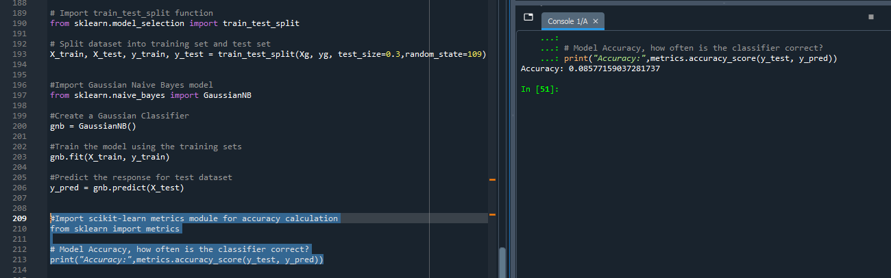

**Show confusion matrix of best model**

The confusion matrix we prepared for our Random Forest model is shown in the pictures below.

**Save model as pckl**

We saved the model we used for our dataset as pickle.

