Team Name:

* Omedi

Project Name:

* Assistant Developed Using Natural Language Processing Techniques

Team Members:

* Dilan Kaya
* Osman Melih Tolunay
* Umut Şentürk
* Mustafa Körükmez

Main Contact for the Instructor:

* Mustafa Körükmez

Instructor:

* Ahmet Çağdaş Seçkin
* 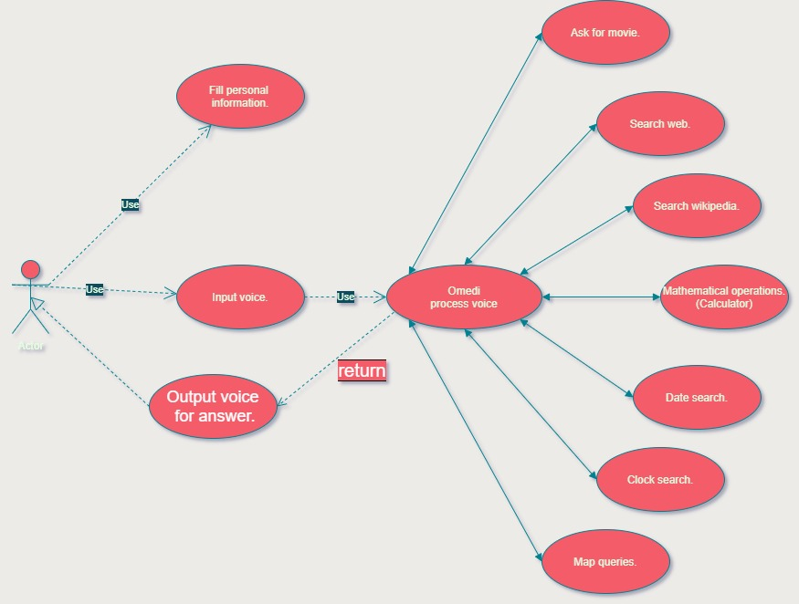UML USE CASE DIAGRAM:

Users will be able to easily access any information they want by voice command. It will be easier to browse the internet while doing research. All that needs to be done is to speak the way users want to find what they want.

* USER STORIES:

1. Wang is 16 years old and she wants to be a chef in a big restaurant so she likes cooking. She is spending her time in her school mostly and she is a history student. Also, she likes reading some books and searching about her department because she likes history. One day she noticed something, if she can cook while listening history or she can read or listen some documents while she is cooking because cooking is an activity which needs too much practice. Firstly, she went her mother and asked if Wiwi can read books for her and her mom read one time and after that Wang went to her dad. After that they could not help her because they are also busy. Wang wanted a sibling but it is not useful for now, she thought about her friends and she said no again because all people has their own jobs. So, she must find something for herself. She searched that on the internet and she saw few different technologies and she said yes! A virtual friend can help her about reading and teaching something because internet knows everything. At that day she downloaded a program from internet and that program helped her about true recipes of foods, history stories, her lessons, documentaries and events and places. She found her virtual friend and she became a good chef.
2. Jacob is 43 years old and he is an amateur businessman, he is earning money from selling cars and one day he is going to open a fast-food restaurant. When he is going rent a place, taking licence, publishing job advertisement for that restaurant. He needs two chefs, one cashier and one person to take orders. He is reading some reports about worker taxing and then he is seeing that if he takes too many worker Jacob will pay too much tax. Jacob needs to give up from one worker in his restaurant. If he sends a chef, one of them can't keep up with all the orders. If he sends cashier, who will take money? A chef cannot do it because this is not hygienic so that Jacob decided to send order man. But who will take it if he sends? That thing must be free or too cheap, it must be useful, people should be able to use it. Jacob was thinking. He should have bought one thing and thus solved his problem. He read something about voice assistant and then he got it. Amateur businessman decided to buy a computer and download a voice assistant for order, first weeks he tried to take orders

with voice assistant. It worked successfully also it was free.

1. Michael is 70 years old and retired. Michael's eyes can hardly see near. That's why he has difficulty reading newspapers and books. When reading something you have to use a magnifying glass. One day, when he comes to visit his grandson Michael, he realizes that his grandfather is struggling to keep up with the agenda. He tells his grandfather about the voice assistant he just discovered. Michael is happy when he tells him that thanks to the voice assistant, he can easily deal with the news and that the assistant will read the news to him. It's easy for Michael to follow the news from now on.
2. Lily is 5 years old and wants to write a storybook, but she is illiterate. She has the many ideas to write stories on her mind, but she can't find anyone to write stories for her. They can't help Lily because her family is constantly working. While researching the internet to help Lily, her father comes across a voice assistant. She thinks this will be useful for Lily because it will be enough for Lily to pronounce the story she wants to write aloud. She will transcribe the story for assistant Lily. Lily finally found someone to print her stories, and she's written 3 stories so far.