NS Lab 4 Answer Sheet
NS3 simulator - TCP Performance Monitoring
Student Name: Abe
Student Surname: Wiersma
Student Number: 10433120

Chariklis Pittaras (c.pittaras@uva.nl)
Karel van der Veldt (karel.vd.veldt@uva.nl)
Koen Koning (koen.koning@gmail.com)
Lab date: Sep 19 & 23 2013
Hand-in time (submit to blackboard) by Sep 30, 2013 13:00CEST
Total points: 20 pts
Please provide your answer in the appropriate space for each question

Task 1 – Throughput of TCP client-server connection

Latency | Measured Throughput | Calculated Throughput | Calculation
64ms | 0.514655 Mbps | 1.024 Mbps | (16384 / 0.128) * 8
96ms | 0.337934 Mbps | 0.683Mbps | (16384 / 0.192) * 8
128ms | 0.249932 Mbps | 0.512 Mbps | (16384 / 0.256) * 8

- Yes, higher latency means less Mbps.

- Optimal RWIN value: 51200
Calculation: (3200000 / 8) * 0.128
- 1.59585 Mbps

Task 2 – Monitoring TCP congestion window
1.

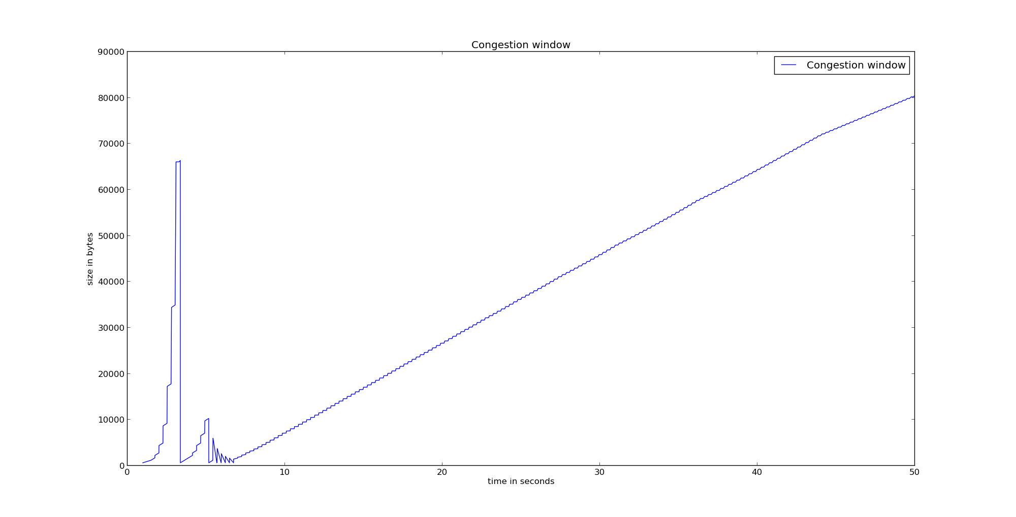
Figure 1: Tahoe – droptail queue = 100

2.a.

Figure 2: Tahoe, droptail queue = 40

2.b
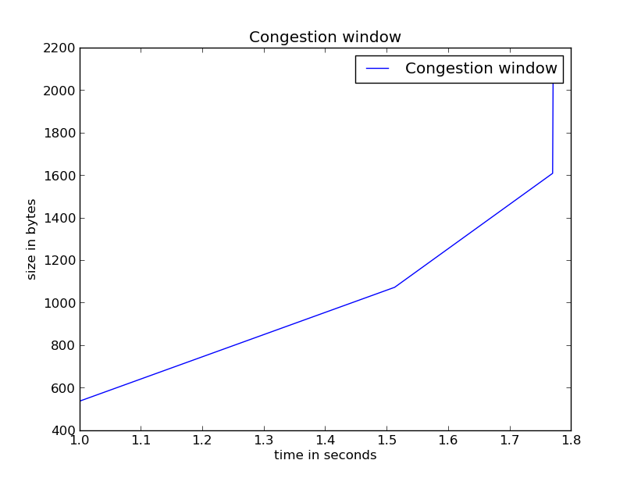
Figure 3: Tahoe, droptail queue = 40 (from 1 until 1.85 secs)

State changes, Tahoe – from 1 until 1.85 secs
Time (sec, accuracy 3 decimal) | cwnd (bytes) | New state
1.000 | 526 | (initial state)
1.5 | 1070
1.77 | 1603

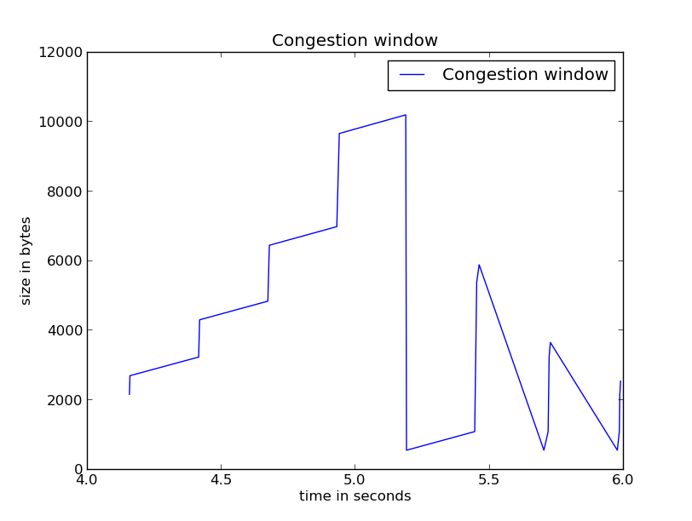
Figure 4: Tahoe, droptail queue = 40 (from 4 until 6 secs)

State changes, Tahoe – from 4 until 6 secs
Time (sec, accuracy 3 decimal) | cwnd (bytes) | New state
4.000 | 2000 | Building cwnd window
5.194 | 10000 | Triple Ack
5.441 | 1040 | Build cwnd window

3.a
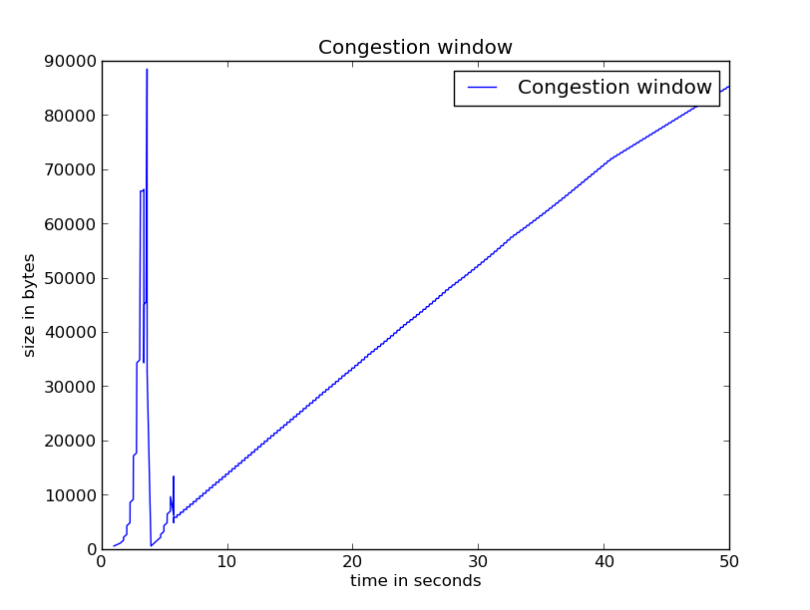
Figure 5: Reno, droptail queue = 40

3.b
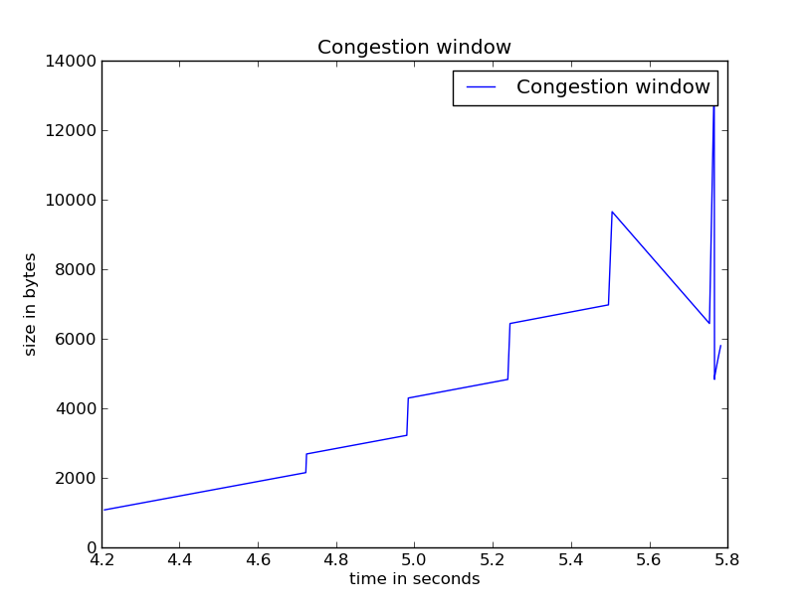

Figure 6: Reno, droptail queue = 40 (from 4 until 6 secs)

State changes, Reno – from 4 until 6 secs
Time (sec, accuracy 3 decimal) | Current cwnd (bytes) | New cwnd (bytes) | New state | Event
4.200 | 1000 |  | (initial state) | Building cwnd
5.500 | 10000 | 6800 | ... | Triple Acks
5.780 | 12400 | 5800 |  | Triple Acks

Submission
You have to submit:
- Your answers to all the questions. Use this provided answer sheet for you answers and graphs. Provide your answers in the appropriate answer field for each question
- The source codes of the two tasks.
- The graphs and the produced data.
Attention: You have to submit one PDF file that contains all the answers and graphs; the name of the file should be lab4-<lastname_firstletter>.pdf (example: lab1-vanderveldt_k.pdf, or lab1-pittaras_c.pdf). Additionally you have to submit one zip (or rar) file containing the source codes, the graphs and the data. The name of the file should be: lab4-source-<lastname_firstletter>.zip
Any other kind of submission will not be taken into account. You must also put your full name and your student number at the top of the answer sheet.

