**Alert(‘text’);**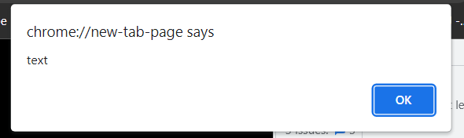

**stringVar = prompt("message")**

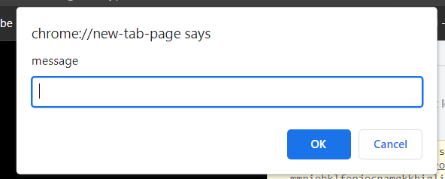

// - comment

<script src=”index.js”></script>; -reference a js file

console.log( ) - print

variables

let name; - Declare a variable (variables cannot start with number like 1name or have spaces)

let name = ‘str_text’;

let number = 1.5;

const number = 15; - const var cannot be changed

let approval = true/false;

let options = null;

let name = undefined;

typeof – check variable type 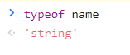

javascript is a dynamic typed language

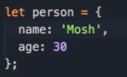 - object

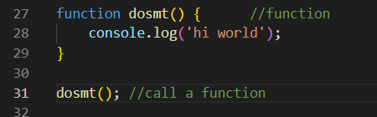-function

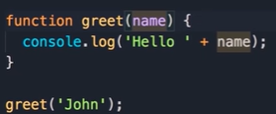

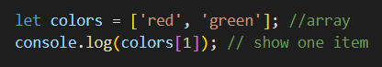- array