OLD-FASHIONED EXERCISE (by Hand!!!)

Dukovany NPP (49.0845 N, 16.1469 E) accident during nighttime T0 (20180905 000000 UTC). --- Is the situation dangerous for the highly populated area of Vienna?

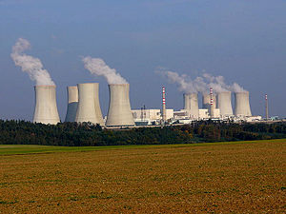

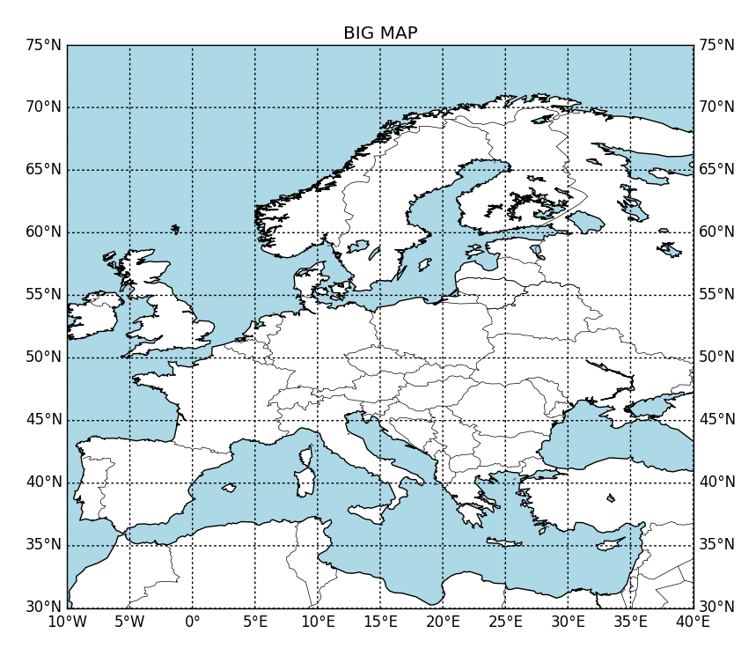
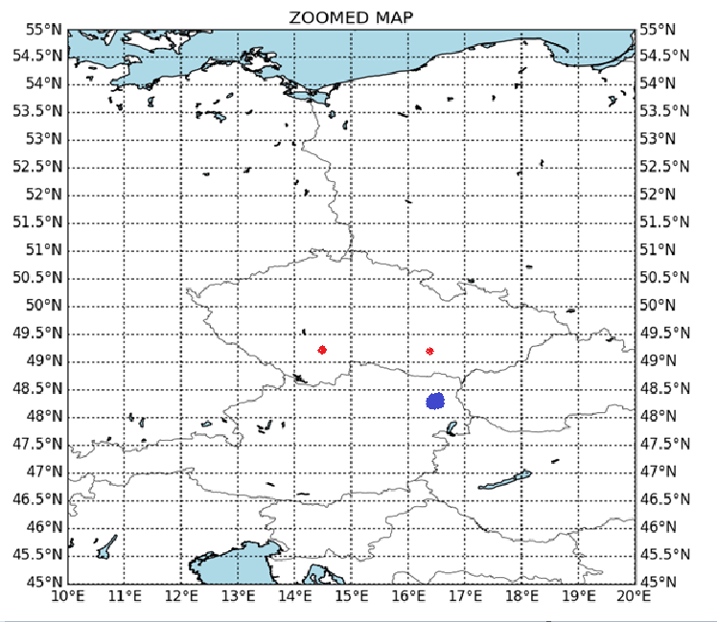

Approximate distance:
- Dukovany – Vienna 100 km
- Temelin – Vienna 200 km

By groups of two/three discuss basic characteristics of the simulation:

- Forward or backward mode?
- What domain?
- What output timestep?
- What emissions? Radionuclides? Tracer? Give argumentation
- How is the overall set-up? Modify the Options files by hand (yes, by hand), number of particles?

Use the chance to read carefully the files and ask questions. Understand “what am I doing?”

After set-up:
- What information am I able to extract?
- What decisions can I take?
- What do I do next?
- Did I use the right set-up? What could have been improved?
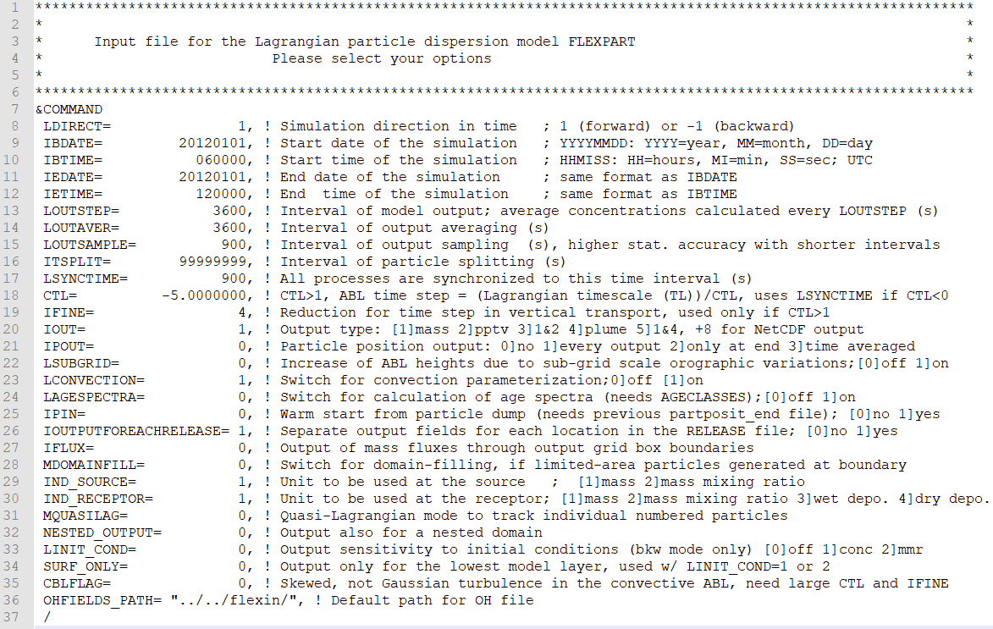
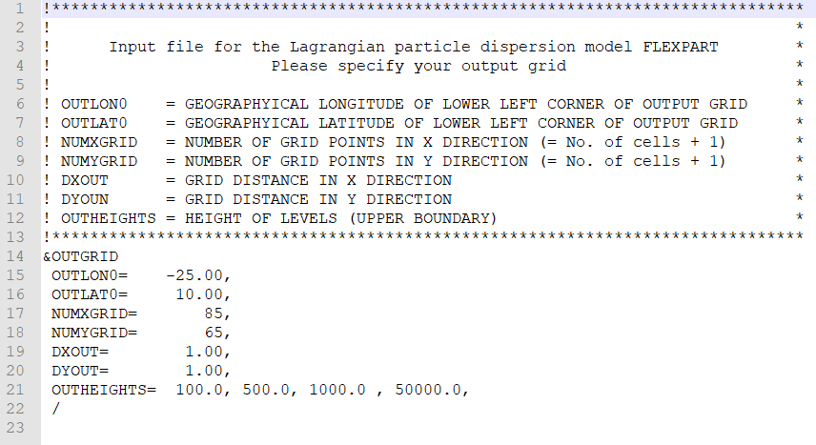

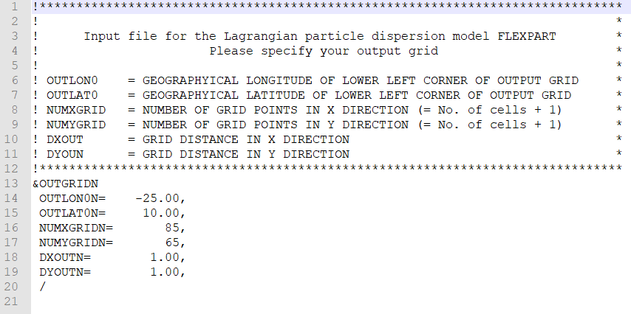

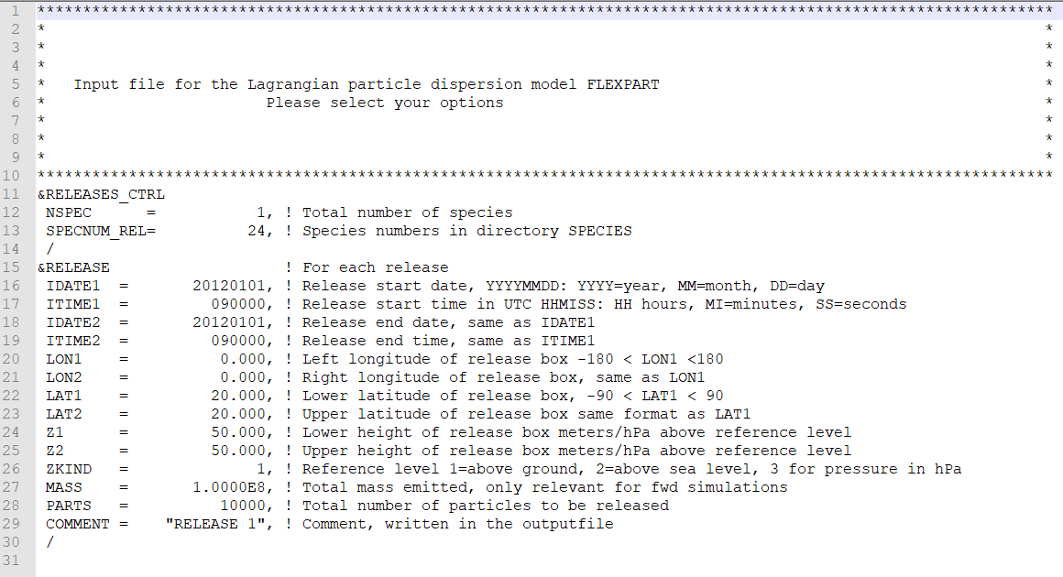

SUPPLEMENTS

SPECIES.README
Specifies all physico-chemical properties for the species.

To generate an overview table compile the specoverview.f90 program

gfortran specoverview.f90 -o specoverview
./specoverview

UPDATE FOR FLEXPART VERSION 10.0 DEV:
---------------------------------------------------------------------------------------------------------------------------
Please note that the format of the SPECIES files has changed from the previous version (9.2) of FLEXPART and it is important
to update all SPECIES files accordingly. The use of SPECIES files from older FLEXPART versions may lead to run-time
errors or erroneous results.
---------------------------------------------------------------------------------------------------------------------------
Half life due to radioactive or chemical decay and can be switched off by specifying a negative value.
Molecular weight (molweight of the species, needed for mixing ratio output)
---------------------------------------------------------------------------------------------------------------------------
WET DEPOSITION

Below-cloud scavenging
- Gases:
A and B are the parameters for below-cloud scavenging defined by Eq. scavenging coefficient = A x precipitation-rate^B
If you migrate from FLEXPART version 9.2 and below this is equal to A and B as it was.
- Particles:
A "rain collection efficiency"
B "snow collection efficiency" are both defined by Equations 46-47.
Suggested values for particle scavenging are A=1.0,B=1.0.
Using values A=0.2 and B=0.2 will give results close to the old scavenging scheme of FLEXPART version 9.2 and below.

In-cloud scavenging
- Gases:
Is switched on if Ai or Bi are given greater than 0
If you migrate from FLEXPART version 9.2 and below this is equal to Ai and Bi should be set to 1
- Particles:
Ai ("Cloud Condensation Nuclei (CCN) efficiency")
Bi ("Ice Nuclei (IN) efficiency") are both from Eq. 51.
Suggested values for particle scavenging are Ai=0.9 and Bi=0.1.
Using values Ai=0.9 and Bi=0.9 should give results cto the old scavenging scheme of FLEXPART version 9.2 and below.
---------------------------------------------------------------------------------------------------------------------------
DRY DEPOSITION
- Gases:
D is the diffusivity of water vapor and
D_i is the diffusivity of the species,
H is the effective Henry’s constant,
f0 varies between 0 and 1 and gives the reactivity of a species relative to that of ozone. For non-reactive species f0 is 0, for slightly reactive it is 0.1 and for highly reactive it is 1.
Dry deposition of gases is switched off by negative D.
- Particles:
rho specifies the density of the substance,
dquer its mean diameter
dsig the measure of variation.
If no detailed information for deposition velocity calculation is available, a constant deposition velocity vd [cm s-1] can be used.
Dry deposition of particles is switched off by negative rho.
---------------------------------------------------------------------------------------------------------------------------
OH REACTION:
can be turned on by giving parameter C [cm^3/molecule/sec]], D [K] and N [no unit] positive values, defined by Eq. 39.
OH reaction is switched off by negative C.
---------------------------------------------------------------------------------------------------------------------------
Optionally emission variation information can be added at the end of the file, defined as following: Since FLEXPART version 6.0, emission factors can be defined that change the temporal variation of particle releases. This is useful, for instance, to simulate the typical daily and weekly cycle of anthropogenic emissions. The emission factors are given in the file of the corresponding species SPECIES_nnn, where nnn is the species number defined in file RELEASES. If no emission variation information is given, emission rates for species nnn are taken as constant. Release rates can vary with the hour of the day and with the day of the week, according to the local time at the release location. Emission factors must be 1 on average. 24
hourly as well as 7 daily values must be specified. Furthermore, different disaggregation factors must be given for area sources and for point sources. FLEXPART distinguishes between the two using the lower altitude of the release box: area sources are assumed to start below 0.5 m above the ground, whereas point sources are assumed to be higher. Please note that when this option is used, it is not so easy to determine the maximum number of particles present at a particular time of the model run. It might then be necessary to increase the parameter maxpart to a higher value than what would otherwise be needed.

