Build bcos on docker

Based on ubuntu18.10 OS



**Let’s start!**

**Install Depends before play**

sudo apt-get install git

sudoapt-get install -y nodejs

sudo npm install -g cnpm --registry=https://registry.npm.taobao.org

sudo cnpm install -g babel-cli babel-preset-es2017

echo '{ "presets": ["es2017"] }' > ~/.babelrc sudo npm install babel-cli

sudo apt-get install cmake

wget https://github.com/ethereum/solidity/releases/download/v0.4.13/solc-static-linux

sudo cp solc-static-linux /usr/bin/solc

sudo chmod +x /usr/bin/solc

sudo apt-get install -y git

sudo cnpm install -g ethereum-console

**#Install Docker#**

You can reference https://docs.docker.com/install/linux/docker-ce/ubuntu/

#use packages repository#

$sudo apt-get install \

apt-transport-https \

ca-certificates \

curl \

gnupg-agent \

software-properties-common

#Add Docker’s official GPG key#

$curl -fsSL https://download.docker.com/linux/ubuntu/gpg | sudo apt-key add –

#by searching for the last 8 characters of the fingerprint.#

$sudo apt-key fingerprint 0EBFCD88

#softwware update#

$sudo apt-get update

$apt list –upgradable

#set up the stable repository#

$sudo add-apt-repository \

"deb [arch=amd64] https://download.docker.com/linux/ubuntu \

(lsb_release -cs) \

stable"

#INSTALL NOW#

$sudo apt-get install docker-ce docker-ce-cli containerd.io

#Add your user to the docker group#

$ sudo groupadd docker

$ sudo usermod -aG docker $USER

#PowerBoot#

$sudo systemctl enable docker

Check docker status, like this:

(if you see anything like “Permission denied”, maybe you need **log back in**)

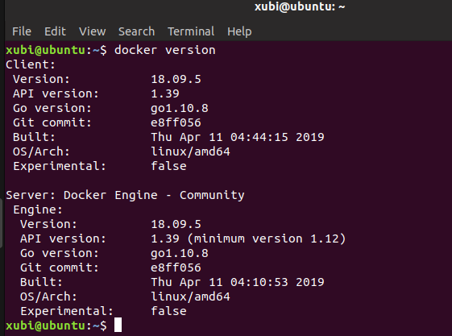

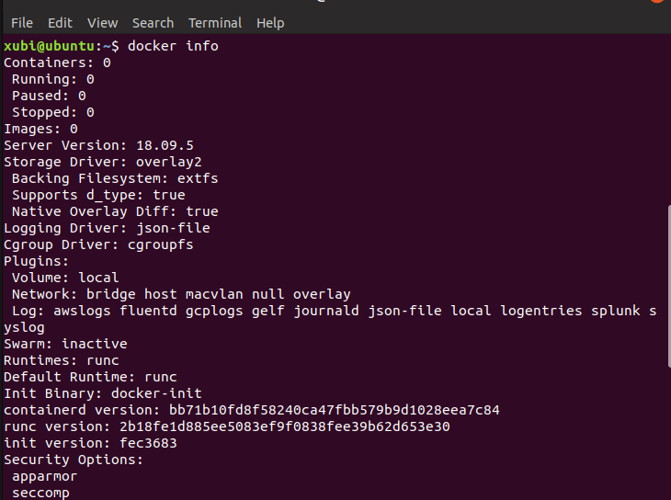

Please refer to the official website for more information.

#Configuring Bcos#

#Cloning file#

git clone https://github.com/bcosorg/bcos

cd bcos/docker

#Set Creation block config file into node-0#

./scripts/genConfig.sh



#launch docker container

$ ./scripts/start_bcos_docker.sh $PWD/node-0

Correct state:

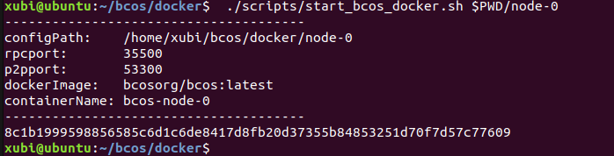

$ cd bcos/systemcontractv2

$ cnpm install

#You can input again to check

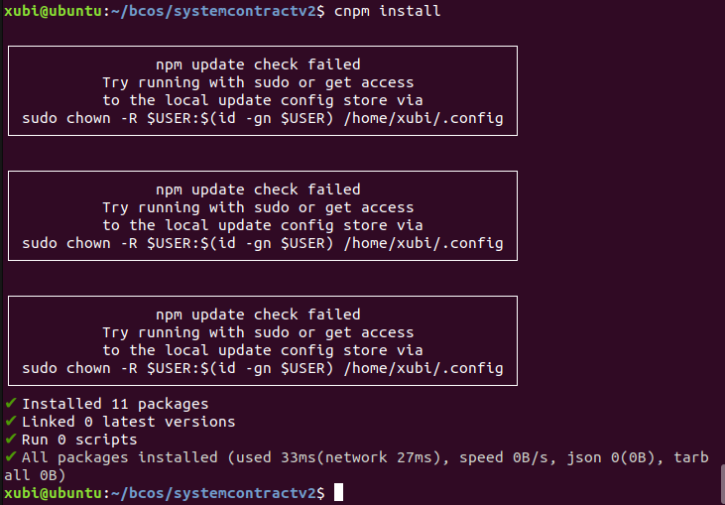

# modification bcos/docker/node-0/config.js "Port": 35500”

#Of course, you can open the file to modify

$ sed -i 's/127.0.0.1:8545/127.0.0.1:35500/' config.js

$ babel-node deploy.js

# 将输出中，SystemProxy合约地址记下来，例如 SystemProxy合约地址 0xff27dc5cc5144c626b9fdc26b2f292d9df062470

# 修改docker/node-0/config.json中systemproxyaddress为上一步骤记录的SystemProxy合约地址

$ sed -i 's/"systemproxyaddress":"0x0"/"systemproxyaddress":"0xff27dc5cc5144c626b9fdc26b2f292d9df062470"/' ../docker/node-0/config.json

# 检查node-0/config.json中系统合约字段是否正确

$ cat ../docker/node-0/config.json | grep systemproxyaddress

# 重启node-0

$ docker restart $(docker ps -a | grep bcos-node-0 | awk 'NR==1{print$1}')

# 创世节点信息写入合约

$ babel-node tool.js NodeAction registerNode ../docker/node-0/node.json