Ilya Laptev 4701BD

System programming

1. Executing SLAVE from cmd without parameters:

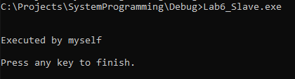

1. Executing MASTER from cmd without parameters:

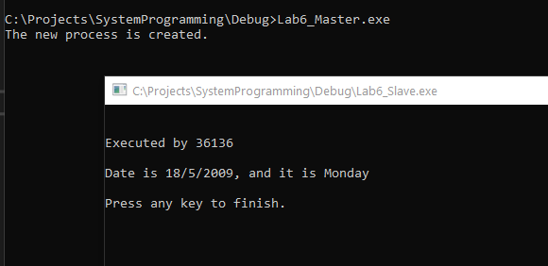

1. Executing SLAVE from cmd with parameters:

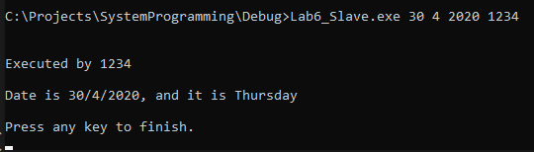

1. Executing MASTER from cmd with parameters:

