**Exercise 1: Implementing the Singleton Pattern**

Code –

***SingletonPatternExample/src/com/SingletonPattern/Logger.java***

package com.SingletonPattern;

public class Logger {

private static Logger logger;

private Logger() {

System.out.println("This is the private Constructor of Logger class");

}

public static Logger getInstance() {

if(logger == null) {

logger = new Logger();

}

return logger;

}

}

***SingletonPatternExample/src/com/SingletonPattern/Test.java***

package com.SingletonPattern;

public class Test {

public static void main(String[] args) {

// TODO Auto-generated method stub

Logger logger1 = Logger.getInstance();

Logger logger2 = Logger.getInstance();

if(logger1==logger2) {

System.out.println("Both logger1 and logger2 are the same instance.");

}

else {

System.out.println("Both logger1 and logger2 are different instances.");

}

}

}

Output –

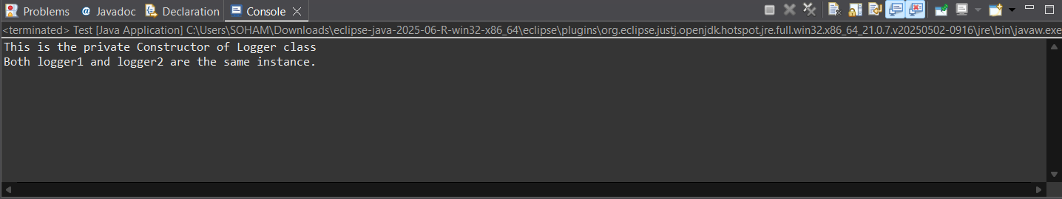

**Exercise 2: Implementing the Factory Method Pattern**

Code –

***FactoryMethodPatternExample/src/com/FactoryMethodPattern/WordDocument.java***

package com.FactoryMethodPattern;

public interface WordDocument {

public void wordOpen();

}

***FactoryMethodPatternExample/src/com/FactoryMethodPattern/PdfDocument.java***

package com.FactoryMethodPattern;

public interface PdfDocument {

public void pdfOpen();

}

***FactoryMethodPatternExample/src/com/FactoryMethodPattern/ExcelDocument.java***

package com.FactoryMethodPattern;

public interface ExcelDocument {

public void excelOpen();

}

***FactoryMethodPatternExample/src/com/FactoryMethodPattern/ConcreteWordDocument.java***

package com.FactoryMethodPattern;

public class ConcreteWordDocument implements WordDocument {

@Override

public void wordOpen() {

// TODO Auto-generated method stub

System.out.println("Opening Word Document");

}

}

***FactoryMethodPatternExample/src/com/FactoryMethodPattern/ConcretePdfDocument.java***

package com.FactoryMethodPattern;

public class ConcretePdfDocument implements PdfDocument {

@Override

public void pdfOpen() {

// TODO Auto-generated method stub

System.out.println("Opening Pdf Document");

}

}

***FactoryMethodPatternExample/src/com/FactoryMethodPattern/ConcreteExcelDocument.java***

package com.FactoryMethodPattern;

public class ConcreteExcelDocument implements ExcelDocument {

@Override

public void excelOpen() {

// TODO Auto-generated method stub

System.out.println("Opening Excel Document");

}

}

***FactoryMethodPatternExample/src/com/FactoryMethodPattern/DocumentFactory.java***

package com.FactoryMethodPattern;

public abstract class DocumentFactory<T> {

public abstract T createDocument();

}

***FactoryMethodPatternExample/src/com/FactoryMethodPattern/WordDocumentFactory.java***

package com.FactoryMethodPattern;

public class WordDocumentFactory extends DocumentFactory<WordDocument>{

public WordDocument createDocument() {

return new ConcreteWordDocument();

}

}

***FactoryMethodPatternExample/src/com/FactoryMethodPattern/PdfDocumentFactory.java***

package com.FactoryMethodPattern;

public class PdfDocumentFactory extends DocumentFactory<PdfDocument>{

public PdfDocument createDocument() {

return new ConcretePdfDocument();

}

}

***FactoryMethodPatternExample/src/com/FactoryMethodPattern/ExcelDocumentFactory.java***

package com.FactoryMethodPattern;

public class ExcelDocumentFactory extends DocumentFactory<ExcelDocument>{

public ExcelDocument createDocument() {

return new ConcreteExcelDocument();

}

}

***FactoryMethodPatternExample/src/com/FactoryMethodPattern/Test.java***

package com.FactoryMethodPattern;

public class Test {

public static void main(String[] args) {

// TODO Auto-generated method stub

DocumentFactory<WordDocument> wordFactory = new WordDocumentFactory();

DocumentFactory<PdfDocument> pdfFactory = new PdfDocumentFactory();

DocumentFactory<ExcelDocument> excelFactory = new ExcelDocumentFactory();

ExcelDocument excel = (ExcelDocument)excelFactory.createDocument();

PdfDocument pdf = (Pdfocument)pdfFactory.createDocument();

WordDocument word = (WordDocument)wordFactory.createDocument();

excel.excelOpen();

word.wordOpen();

pdf.pdfOpen();

}

}

Output –

