**Junit Testing Exercises**

**Exercise 1: Setting Up Junit**

**Pom.xml:**

<?xml version="1.0" encoding="UTF-8"?>

<project xmlns="http://maven.apache.org/POM/4.0.0" xmlns:xsi="http://www.w3.org/2001/XMLSchema-instance"

xsi:schemaLocation="http://maven.apache.org/POM/4.0.0 http://maven.apache.org/xsd/maven-4.0.0.xsd">

<modelVersion>4.0.0</modelVersion>

<groupId>com.junit</groupId>

<artifactId>JUnit</artifactId>

<version>0.0.1-SNAPSHOT</version>

<name>JUnit</name>

<description>A simple JUnit.</description>

<!-- FIXME change it to the project's website -->

<url>http://www.example.com</url>

<properties>

<project.build.sourceEncoding>UTF-8</project.build.sourceEncoding>

<maven.compiler.source>8</maven.compiler.source>

<maven.compiler.target>8</maven.compiler.target>

</properties>

<dependencies>

<dependency>

<groupId>junit</groupId>

<artifactId>junit</artifactId>

<version>4.13.2</version>

</dependency>

</dependencies>

<build>

<pluginManagement><!-- lock down plugins versions to avoid using Maven defaults (may be moved to parent pom) -->

<plugins>

<plugin>

<artifactId>maven-clean-plugin</artifactId>

<version>3.4.0</version>

</plugin>

<plugin>

<artifactId>maven-site-plugin</artifactId>

<version>3.12.1</version>

</plugin>

<plugin>

<artifactId>maven-project-info-reports-plugin</artifactId>

<version>3.6.1</version>

</plugin>

<!-- see http://maven.apache.org/ref/current/maven-core/default-bindings.html#Plugin_bindings_for_jar_packaging -->

<plugin>

<artifactId>maven-resources-plugin</artifactId>

<version>3.3.1</version>

</plugin>

<plugin>

<artifactId>maven-compiler-plugin</artifactId>

<version>3.13.0</version>

</plugin>

<plugin>

<artifactId>maven-surefire-plugin</artifactId>

<version>3.3.0</version>

</plugin>

<plugin>

<artifactId>maven-jar-plugin</artifactId>

<version>3.4.2</version>

</plugin>

<plugin>

<artifactId>maven-install-plugin</artifactId>

<version>3.1.2</version>

</plugin>

<plugin>

<artifactId>maven-deploy-plugin</artifactId>

<version>3.1.2</version>

</plugin>

</plugins>

</pluginManagement>

</build>

<reporting>

<plugins>

<plugin>

<artifactId>maven-project-info-reports-plugin</artifactId>

</plugin>

</plugins>

</reporting>

</project>

**AppTest.java**:  
  
package com.junit.JUnit;

import static org.junit.Assert.*assertTrue*;

import org.junit.Test;

/**

* Unit test for simple App.

*/

public class AppTest

{

*@Test*

public void testApp()

{

*assertTrue*( true );

}

}

**OUTPUT:**

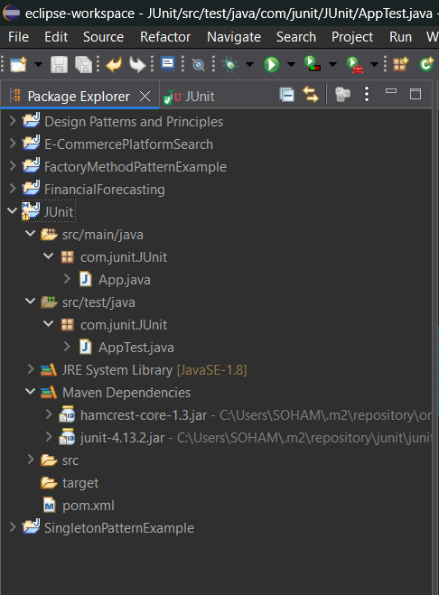

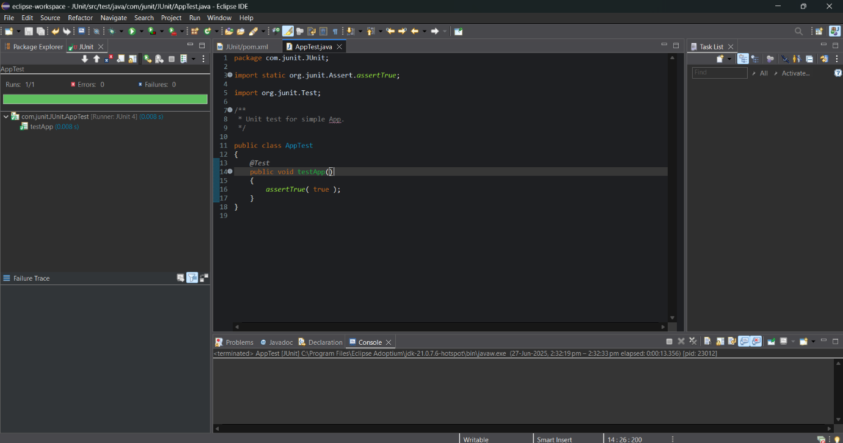

**Exercise 3: Assertions in Junit**

**Pom.xml:**

<?xml version="1.0" encoding="UTF-8"?>

<project xmlns="http://maven.apache.org/POM/4.0.0" xmlns:xsi="http://www.w3.org/2001/XMLSchema-instance"

xsi:schemaLocation="http://maven.apache.org/POM/4.0.0 http://maven.apache.org/xsd/maven-4.0.0.xsd">

<modelVersion>4.0.0</modelVersion>

<groupId>com.junit</groupId>

<artifactId>JUnit2</artifactId>

<version>0.0.1-SNAPSHOT</version>

<name>JUnit2</name>

<description>A simple JUnit2.</description>

<!-- FIXME change it to the project's website -->

<url>http://www.example.com</url>

<properties>

<project.build.sourceEncoding>UTF-8</project.build.sourceEncoding>

<maven.compiler.source>8</maven.compiler.source>

<maven.compiler.target>8</maven.compiler.target>

</properties>

<dependencies>

<dependency>

<groupId>junit</groupId>

<artifactId>junit</artifactId>

<version>4.13.2</version>

</dependency>

</dependencies>

<build>

<pluginManagement><!-- lock down plugins versions to avoid using Maven defaults (may be moved to parent pom) -->

<plugins>

<plugin>

<artifactId>maven-clean-plugin</artifactId>

<version>3.4.0</version>

</plugin>

<plugin>

<artifactId>maven-site-plugin</artifactId>

<version>3.12.1</version>

</plugin>

<plugin>

<artifactId>maven-project-info-reports-plugin</artifactId>

<version>3.6.1</version>

</plugin>

<!-- see http://maven.apache.org/ref/current/maven-core/default-bindings.html#Plugin_bindings_for_jar_packaging -->

<plugin>

<artifactId>maven-resources-plugin</artifactId>

<version>3.3.1</version>

</plugin>

<plugin>

<artifactId>maven-compiler-plugin</artifactId>

<version>3.13.0</version>

</plugin>

<plugin>

<artifactId>maven-surefire-plugin</artifactId>

<version>3.3.0</version>

</plugin>

<plugin>

<artifactId>maven-jar-plugin</artifactId>

<version>3.4.2</version>

</plugin>

<plugin>

<artifactId>maven-install-plugin</artifactId>

<version>3.1.2</version>

</plugin>

<plugin>

<artifactId>maven-deploy-plugin</artifactId>

<version>3.1.2</version>

</plugin>

</plugins>

</pluginManagement>

</build>

<reporting>

<plugins>

<plugin>

<artifactId>maven-project-info-reports-plugin</artifactId>

</plugin>

</plugins>

</reporting>

</project>

**AssertionsTest.java**

package com.junit.JUnit2;

import static org.junit.Assert.*;

import org.junit.Test;

/**

* Unit test for simple App.

*/

public class AssertionsTest {

*@Test*

public void testAssertions() {

// Assert equals

*assertEquals*(5, 2 + 3);

// Assert true

*assertTrue*(5 > 3);

// Assert false

*assertFalse*(5 < 3);

// Assert null

*assertNull*(null);

// Assert not null

*assertNotNull*(new Object());

}

public void testApp()

{

*assertTrue*( true );

}

}

**OUTPUT:**

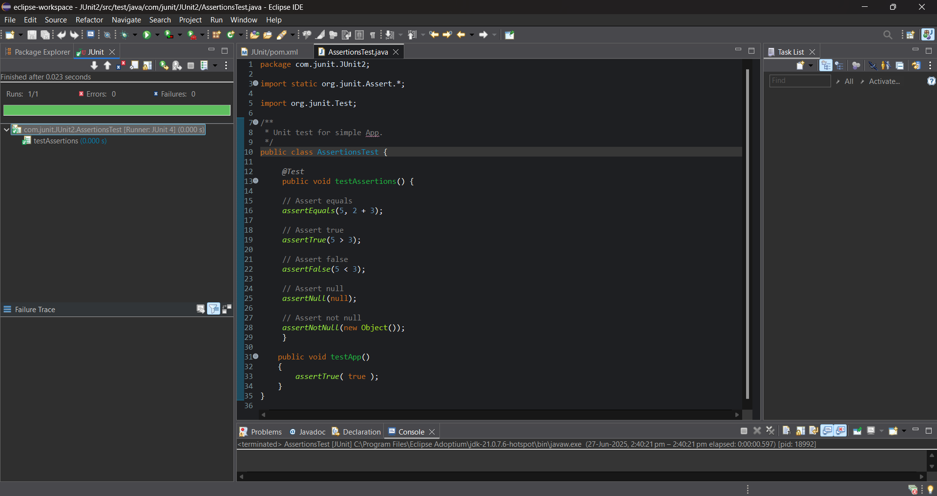

**Exercise 4: Arrange-Act-Assert (AAA) Pattern, Test Fixtures, Setup and Teardown Methods in JUnit**

**Pom.sql:**

<?xml version="1.0" encoding="UTF-8"?>

<project xmlns="http://maven.apache.org/POM/4.0.0" xmlns:xsi="http://www.w3.org/2001/XMLSchema-instance"

xsi:schemaLocation="http://maven.apache.org/POM/4.0.0 http://maven.apache.org/xsd/maven-4.0.0.xsd">

<modelVersion>4.0.0</modelVersion>

<groupId>com.junit</groupId>

<artifactId>JUnit4</artifactId>

<version>0.0.1-SNAPSHOT</version>

<name>JUnit4</name>

<description>A simple JUnit4.</description>

<!-- FIXME change it to the project's website -->

<url>http://www.example.com</url>

<properties>

<project.build.sourceEncoding>UTF-8</project.build.sourceEncoding>

<maven.compiler.source>8</maven.compiler.source>

<maven.compiler.target>8</maven.compiler.target>

</properties>

<dependencies>

<dependency>

<groupId>junit</groupId>

<artifactId>junit</artifactId>

<version>4.13.2</version>

</dependency>

</dependencies>

<build>

<pluginManagement><!-- lock down plugins versions to avoid using Maven defaults (may be moved to parent pom) -->

<plugins>

<plugin>

<artifactId>maven-clean-plugin</artifactId>

<version>3.4.0</version>

</plugin>

<plugin>

<artifactId>maven-site-plugin</artifactId>

<version>3.12.1</version>

</plugin>

<plugin>

<artifactId>maven-project-info-reports-plugin</artifactId>

<version>3.6.1</version>

</plugin>

<!-- see http://maven.apache.org/ref/current/maven-core/default-bindings.html#Plugin_bindings_for_jar_packaging -->

<plugin>

<artifactId>maven-resources-plugin</artifactId>

<version>3.3.1</version>

</plugin>

<plugin>

<artifactId>maven-compiler-plugin</artifactId>

<version>3.13.0</version>

</plugin>

<plugin>

<artifactId>maven-surefire-plugin</artifactId>

<version>3.3.0</version>

</plugin>

<plugin>

<artifactId>maven-jar-plugin</artifactId>

<version>3.4.2</version>

</plugin>

<plugin>

<artifactId>maven-install-plugin</artifactId>

<version>3.1.2</version>

</plugin>

<plugin>

<artifactId>maven-deploy-plugin</artifactId>

<version>3.1.2</version>

</plugin>

</plugins>

</pluginManagement>

</build>

<reporting>

<plugins>

<plugin>

<artifactId>maven-project-info-reports-plugin</artifactId>

</plugin>

</plugins>

</reporting>

</project>

**CalculatorTest.java:**  
  
package com.junit.JUnit4;

import org.junit.After;

import org.junit.Before;

import org.junit.Test;

import static org.junit.Assert.*;

public class CalculatorTest {

Calculator calc;

*@Before*

public void setUp() {

calc = new Calculator();

}

*@After*

public void tearDown() {

calc = null;

}

*@Test*

public void testAdd() {

// Arrange

int a = 10;

int b = 20;

// Act

int result = calc.add(a, b);

//Assert

*assertEquals*(30, result);

}

*@Test*

public void testSubtract() {

// Arrange

int a = 15;

int b = 6;

// Act

int result = calc.subtract(a, b);

//Assert

*assertEquals*(9, result);

}

*@Test*

public void testMultiply() {

// Arrange

int a = 420;

int b = 69;

// Act

int result = calc.multiply(a, b);

//Assert

*assertEquals*(28980, result);

}

*@Test*

public void testDivide() {

// Arrange

int a = 49;

int b = 7;

// Act

int result = calc.divide(a, b);

//Assert

*assertEquals*(7, result);

}

*@Test*

public void testModulo() {

// Arrange

int a = 69;

int b = 5;

// Act

int result = calc.modulo(a, b);

//Assert

*assertEquals*(4, result);

}

}

**Calculator.java:**

package com.junit.JUnit4;

public class Calculator {

public int add(int num1, int num2) {

return (num1 + num2);

}

public int subtract(int num1, int num2) {

return (num1 - num2);

}

public int multiply(int num1, int num2) {

return (num1 * num2);

}

public int divide(int num1, int num2) {

return (num1 / num2);

}

public int modulo(int num1, int num2) {

return (num1 % num2);

}

}

**OUTPUT:**

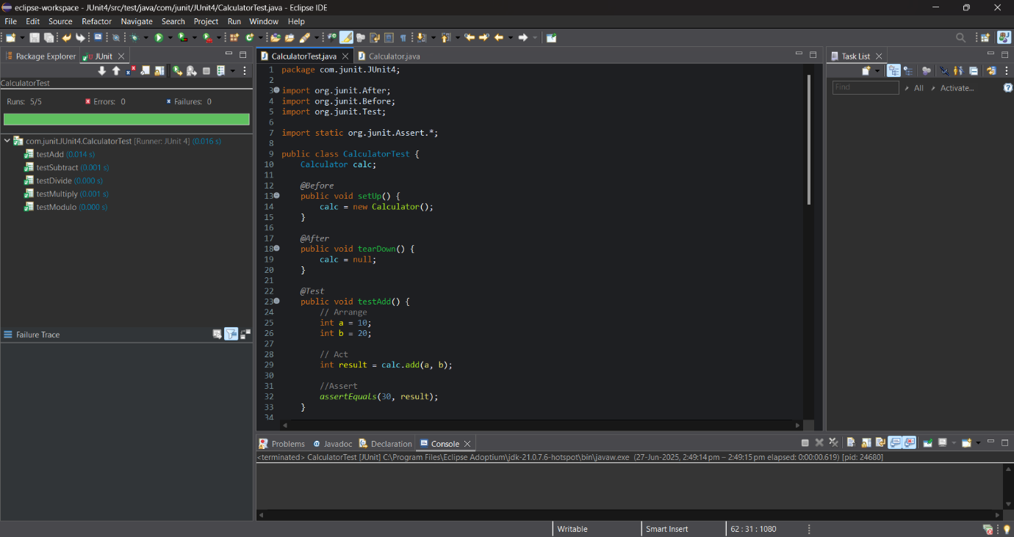

**Mockito Hands-On Exercise**

**Exercise 1: Mocking and Stubbing**

**Pom.xml:**

<?xml version="1.0" encoding="UTF-8"?>

<project xmlns="http://maven.apache.org/POM/4.0.0" xmlns:xsi="http://www.w3.org/2001/XMLSchema-instance"

xsi:schemaLocation="http://maven.apache.org/POM/4.0.0 http://maven.apache.org/xsd/maven-4.0.0.xsd">

<modelVersion>4.0.0</modelVersion>

<groupId>com.mockito</groupId>

<artifactId>Mockito1</artifactId>

<version>0.0.1-SNAPSHOT</version>

<name>Mockito1</name>

<description>A simple Mockito1.</description>

<!-- FIXME change it to the project's website -->

<url>http://www.example.com</url>

<properties>

<project.build.sourceEncoding>UTF-8</project.build.sourceEncoding>

<maven.compiler.source>8</maven.compiler.source>

<maven.compiler.target>8</maven.compiler.target>

</properties>

<dependencies>

<dependency>

<groupId>junit</groupId>

<artifactId>junit</artifactId>

<version>3.8.1</version>

</dependency>

<dependency>

<groupId>org.junit.jupiter</groupId>

<artifactId>junit-jupiter-api</artifactId>

<version>5.13.1</version>

<scope>test</scope>

</dependency>

<dependency>

<groupId>org.mockito</groupId>

<artifactId>mockito-core</artifactId>

<version>2.28.2</version>

<scope>test</scope>

</dependency>

</dependencies>

<build>

<pluginManagement><!-- lock down plugins versions to avoid using Maven defaults (may be moved to parent pom) -->

<plugins>

<plugin>

<artifactId>maven-clean-plugin</artifactId>

<version>3.4.0</version>

</plugin>

<plugin>

<artifactId>maven-site-plugin</artifactId>

<version>3.12.1</version>

</plugin>

<plugin>

<artifactId>maven-project-info-reports-plugin</artifactId>

<version>3.6.1</version>

</plugin>

<!-- see http://maven.apache.org/ref/current/maven-core/default-bindings.html#Plugin_bindings_for_jar_packaging -->

<plugin>

<artifactId>maven-resources-plugin</artifactId>

<version>3.3.1</version>

</plugin>

<plugin>

<artifactId>maven-compiler-plugin</artifactId>

<version>3.13.0</version>

</plugin>

<plugin>

<artifactId>maven-surefire-plugin</artifactId>

<version>3.3.0</version>

</plugin>

<plugin>

<artifactId>maven-jar-plugin</artifactId>

<version>3.4.2</version>

</plugin>

<plugin>

<artifactId>maven-install-plugin</artifactId>

<version>3.1.2</version>

</plugin>

<plugin>

<artifactId>maven-deploy-plugin</artifactId>

<version>3.1.2</version>

</plugin>

</plugins>

</pluginManagement>

</build>

<reporting>

<plugins>

<plugin>

<artifactId>maven-project-info-reports-plugin</artifactId>

</plugin>

</plugins>

</reporting>

</project>

**MyServiceTest.java:**

package com.mockito.Mockito1;

import static org.junit.jupiter.api.Assertions.*;

import static org.mockito.Mockito.*;

import org.junit.jupiter.api.Test;

import org.mockito.Mockito;

public class MyServiceTest {

*@Test*

public void testExternalApi() {

ExternalApi mockApi = Mockito.*mock*(ExternalApi.class);

*when*(mockApi.getData()).thenReturn("Mock Data");

MyService service = new MyService(mockApi);

String result = service.fetchData();

*assertEquals*("Mock Data", result);

}

}

**ExternalApi.java:**

package com.mockito.Mockito1;

public class ExternalApi {

public String getData() {

return "Mock Data";

}

}

**MyService.java:**

package com.mockito.Mockito1;

public class MyService

{

ExternalApi ea;

public MyService(ExternalApi ea) {

this.ea = ea;

}

public String fetchData() {

return ea.getData();

}

}

**OUTPUT:**

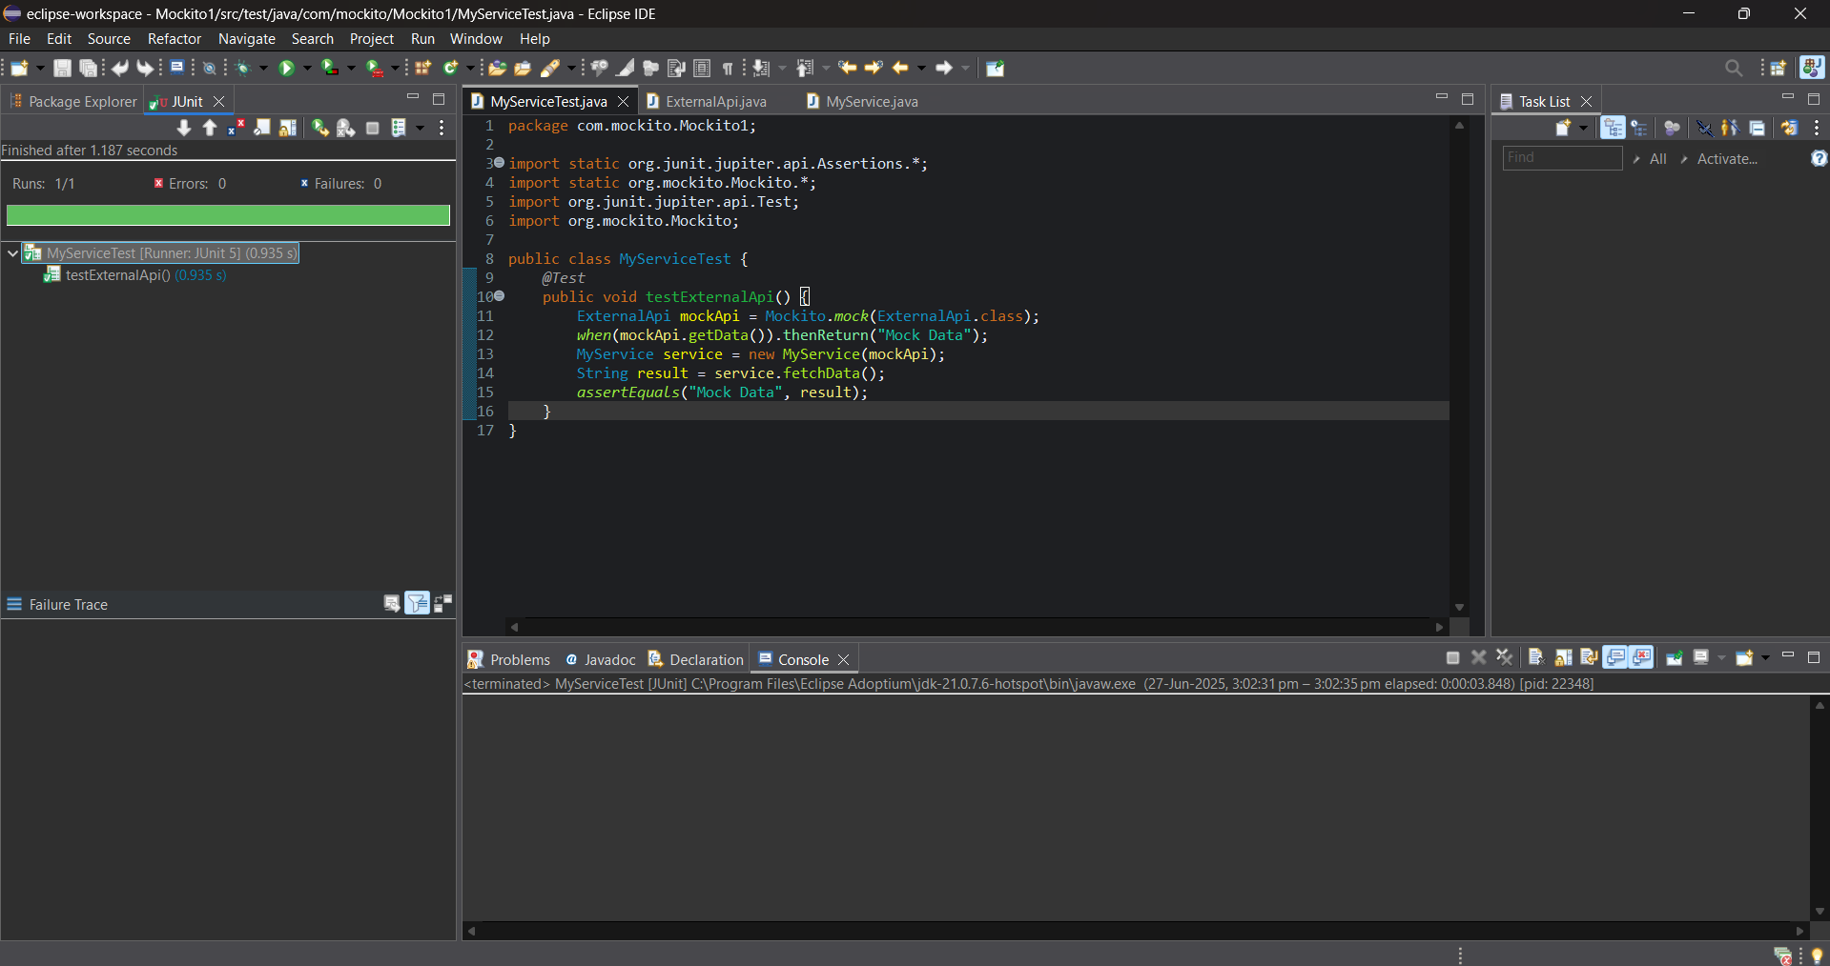

**Exercise 2: Verifying Interaction**

**Pom.xml:**

<?xml version="1.0" encoding="UTF-8"?>

<project xmlns="http://maven.apache.org/POM/4.0.0" xmlns:xsi="http://www.w3.org/2001/XMLSchema-instance"

xsi:schemaLocation="http://maven.apache.org/POM/4.0.0 http://maven.apache.org/xsd/maven-4.0.0.xsd">

<modelVersion>4.0.0</modelVersion>

<groupId>com.mockito</groupId>

<artifactId>Mockito2</artifactId>

<version>0.0.1-SNAPSHOT</version>

<name>Mockito2</name>

<description>A simple Mockito2.</description>

<!-- FIXME change it to the project's website -->

<url>http://www.example.com</url>

<properties>

<project.build.sourceEncoding>UTF-8</project.build.sourceEncoding>

<maven.compiler.source>8</maven.compiler.source>

<maven.compiler.target>8</maven.compiler.target>

</properties>

<dependencies>

<dependency>

<groupId>junit</groupId>

<artifactId>junit</artifactId>

<version>3.8.1</version>

</dependency>

<dependency>

<groupId>org.junit.jupiter</groupId>

<artifactId>junit-jupiter-api</artifactId>

<version>5.13.1</version>

<scope>test</scope>

</dependency>

<dependency>

<groupId>org.mockito</groupId>

<artifactId>mockito-core</artifactId>

<version>2.28.2</version>

<scope>test</scope>

</dependency>

</dependencies>

<build>

<pluginManagement><!-- lock down plugins versions to avoid using Maven defaults (may be moved to parent pom) -->

<plugins>

<plugin>

<artifactId>maven-clean-plugin</artifactId>

<version>3.4.0</version>

</plugin>

<plugin>

<artifactId>maven-site-plugin</artifactId>

<version>3.12.1</version>

</plugin>

<plugin>

<artifactId>maven-project-info-reports-plugin</artifactId>

<version>3.6.1</version>

</plugin>

<!-- see http://maven.apache.org/ref/current/maven-core/default-bindings.html#Plugin_bindings_for_jar_packaging -->

<plugin>

<artifactId>maven-resources-plugin</artifactId>

<version>3.3.1</version>

</plugin>

<plugin>

<artifactId>maven-compiler-plugin</artifactId>

<version>3.13.0</version>

</plugin>

<plugin>

<artifactId>maven-surefire-plugin</artifactId>

<version>3.3.0</version>

</plugin>

<plugin>

<artifactId>maven-jar-plugin</artifactId>

<version>3.4.2</version>

</plugin>

<plugin>

<artifactId>maven-install-plugin</artifactId>

<version>3.1.2</version>

</plugin>

<plugin>

<artifactId>maven-deploy-plugin</artifactId>

<version>3.1.2</version>

</plugin>

</plugins>

</pluginManagement>

</build>

<reporting>

<plugins>

<plugin>

<artifactId>maven-project-info-reports-plugin</artifactId>

</plugin>

</plugins>

</reporting>

</project>

**MyServiceTest.java:**

package com.mockito.Mockito2;

import static org.mockito.Mockito.*;

import org.junit.jupiter.api.Test;

import org.mockito.Mockito;

public class MyServiceTest {

*@Test*

public void testVerifyInteraction() {

ExternalApi mockApi = Mockito.*mock*(ExternalApi.class);

MyService service = new MyService(mockApi);

service.fetchData();

*verify*(mockApi).getData();

}

}

**ExternalApi.java:**

package com.mockito.Mockito2;

public class ExternalApi {

public String getData() {

return "Mock Data";

}

}

**MyService.java:**

package com.mockito.Mockito2;

public class MyService

{

ExternalApi ea;

public MyService(ExternalApi ea) {

this.ea = ea;

}

public String fetchData() {

return ea.getData();

}

}

**OUTPUT:**

