**Spring Data JPA with Spring Boot, Hibernate**

**Hands on 1 Spring Data JPA - Quick Example:**

**Pom.xml:**

<?xml version="1.0" encoding="UTF-8"?>

<project xmlns="http://maven.apache.org/POM/4.0.0" xmlns:xsi="http://www.w3.org/2001/XMLSchema-instance"

xsi:schemaLocation="http://maven.apache.org/POM/4.0.0 https://maven.apache.org/xsd/maven-4.0.0.xsd">

<modelVersion>4.0.0</modelVersion>

<parent>

<groupId>org.springframework.boot</groupId>

<artifactId>spring-boot-starter-parent</artifactId>

<version>3.5.3</version>

<relativePath/> <!-- lookup parent from repository -->

</parent>

<groupId>com.cognizant</groupId>

<artifactId>orm-learn</artifactId>

<version>0.0.1-SNAPSHOT</version>

<name>orm-learn</name>

<description>Demo project for Spring Data JPA and Hibernate</description>

<url/>

<licenses>

<license/>

</licenses>

<developers>

<developer/>

</developers>

<scm>

<connection/>

<developerConnection/>

<tag/>

<url/>

</scm>

<properties>

<java.version>17</java.version>

</properties>

<dependencies>

<dependency>

<groupId>org.springframework.boot</groupId>

<artifactId>spring-boot-starter-data-jpa</artifactId>

</dependency>

<dependency>

<groupId>org.springframework.boot</groupId>

<artifactId>spring-boot-devtools</artifactId>

<scope>runtime</scope>

<optional>true</optional>

</dependency>

<dependency>

<groupId>com.mysql</groupId>

<artifactId>mysql-connector-j</artifactId>

<scope>runtime</scope>

</dependency>

<dependency>

<groupId>org.springframework.boot</groupId>

<artifactId>spring-boot-starter-test</artifactId>

<scope>test</scope>

</dependency>

</dependencies>

<build>

<plugins>

<plugin>

<groupId>org.springframework.boot</groupId>

<artifactId>spring-boot-maven-plugin</artifactId>

</plugin>

</plugins>

</build>

</project>

**Application.properties:**

spring.application.name=orm-learn

# Spring Framework and application log

logging.level.org.springframework=info

logging.level.com.cognizant=debug

# Hibernate logs for displaying executed SQL, input and output

logging.level.org.hibernate.SQL=trace

logging.level.org.hibernate.type.descriptor.sql=trace

# Log pattern

logging.pattern.console=%d{dd-MM-yy} %d{HH:mm:ss.SSS} %-20.20thread %5p %-25.25logger**{25}** %25M %4L %m%n

# Database configuration

spring.datasource.driver-class-name=com.mysql.cj.jdbc.Driver

spring.datasource.url=jdbc:mysql://localhost:3306/ormlearn

spring.datasource.username=root

spring.datasource.password=root

# Hibernate configuration

spring.jpa.hibernate.ddl-auto=validate

spring.jpa.properties.hibernate.dialect=org.hibernate.dialect.MySQLDialect

**Database Creation:**

**Country table creation:**

* Create a new table country with columns for code and name. For sample, let us insert one country with values 'IN' and 'India' in this table.

create table country(code varchar(2) primary key, name varchar(50));

* Insert couple of records into the table

insert into country values ('IN', 'India');

insert into country values ('US', 'United States of America');

**CountryService.java:**

package com.cognizant.orm_learn.service;

import com.cognizant.orm_learn.model.Country;

import com.cognizant.orm_learn.repository.CountryRepository;

import org.springframework.beans.factory.annotation.Autowired;

import org.springframework.stereotype.Service;

import org.springframework.transaction.annotation.Transactional;

import java.util.List;

*@Service*

public class CountryService {

*@Autowired*

private CountryRepository countryRepository;

*@Transactional*

public List<Country> getAllCountries() {

return countryRepository.findAll();

}

}

**CountryRepository.java:**

package com.cognizant.orm_learn.repository;

import com.cognizant.orm_learn.model.Country;

import org.springframework.data.jpa.repository.JpaRepository;

import org.springframework.stereotype.Repository;

*@Repository*

public interface CountryRepository extends JpaRepository<Country, String> {

}

**Country.java:**

package com.cognizant.orm_learn.model;

import javax.persistence.*;

*@Entity*

*@Table*(name = "country")

public class Country {

*@Id*

*@Column*(name = "co_code")

private String code;

*@Column*(name = "co_name")

private String name;

public String getCode() {

return code;

}

public void setCode(String code) {

this.code = code;

}

public String getName() {

return name;

}

public void setName(String name) {

this.name = name;

}

*@Override*

public String toString() {

return "Country{" +

"code='" + code + '\'' +

", name='" + name + '\'' +

'}';

}

}

**OrmLearnApplication.java:**

package com.cognizant.orm_learn;

import com.cognizant.orm_learn.model.Country;

import com.cognizant.orm_learn.service.CountryService;

import org.slf4j.Logger;

import org.slf4j.LoggerFactory;

import org.springframework.boot.SpringApplication;

import org.springframework.boot.autoconfigure.SpringBootApplication;

import org.springframework.context.ApplicationContext;

import java.util.List;

*@SpringBootApplication*

public class OrmLearnApplication {

private static final Logger ***LOGGER*** = LoggerFactory.*getLogger*(OrmLearnApplication.class);

private static CountryService *countryService*;

public static void main(String[] args) {

***LOGGER***.info("Inside main");

ApplicationContext context = SpringApplication.*run*(OrmLearnApplication.class, args);

*countryService* = context.getBean(CountryService.class);

*testGetAllCountries*();

}

private static void testGetAllCountries() {

***LOGGER***.info("Start");

List<Country> countries = *countryService*.getAllCountries();

***LOGGER***.debug("countries={}", countries);

***LOGGER***.info("End");

}

}

**OUTPUT:**

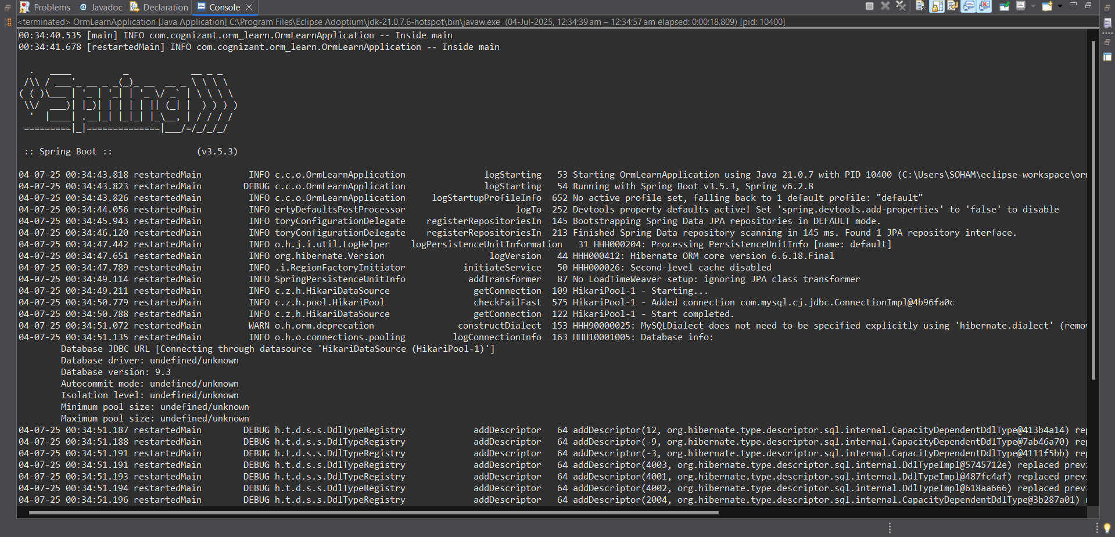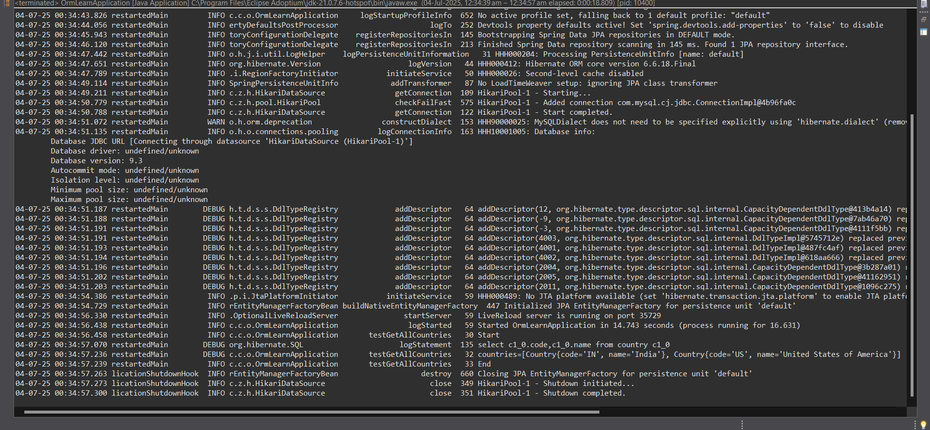

**Hands on 4 Difference between JPA, Hibernate and Spring Data JPA:**

Java Persistence API (JPA)

* JSR 338 Specification for persisting, reading and managing data from Java objects
* Does not contain concrete implementation of the specification
* Hibernate is one of the implementation of JPA

Hibernate

* ORM Tool that implements JPA

Spring Data JPA

* Does not have JPA implementation, but reduces boiler plate code
* This is another level of abstraction over JPA implementation provider like Hibernate
* Manages transactions

| **Feature** | **JPA (Java Persistence API)** | **Hibernate** | **Spring Data JPA** |
| --- | --- | --- | --- |
| **Type** | Specification (API) | Implementation of JPA + extra features | Abstraction layer on top of JPA (e.g., Hibernate) |
| **Implements** | No concrete implementation | Implements JPA | Uses any JPA implementation (commonly Hibernate) |
| **Purpose** | Define how to persist data using annotations and interfaces | ORM tool to interact with DB using objects | Simplifies data access using repositories and less boilerplate code |
| **Requires boilerplate?** | Yes | Yes | No (much less) |
| **Transaction Handling** | Manual or Declarative | Manual or Declarative | Declarative, automatic with annotations |
| **Usage Level** | Low-level (pure specification) | Mid-level (ORM engine) | High-level (Spring-friendly API over JPA) |

Refer code snippets below on how the code compares between Hibernate and Spring Data JPA  
Hibernate –

**Using Hibernate**

public Integer addEmployee(Employee employee){

Session session = factory.openSession();

Transaction tx = null;

Integer employeeID = null;

try {

tx = session.beginTransaction();

employeeID = (Integer) session.save(employee); // Save object

tx.commit();

} catch (HibernateException e) {

if (tx != null) tx.rollback();

e.printStackTrace();

} finally {

session.close();

}

return employeeID;

}

* Needs explicit Session, Transaction handling
* Hibernate manages ORM and DB mapping
* Verbose boilerplate

**Using Spring Data JPA**

**Repository Interface:**

public interface EmployeeRepository extends JpaRepository<Employee, Integer> {

}

**Service Layer:**

@Service

public class EmployeeService {

@Autowired

private EmployeeRepository employeeRepository;

@Transactional

public void addEmployee(Employee employee) {

employeeRepository.save(employee);

}

}

* No need to write SQL or session management
* Leverages Spring’s dependency injection, auto-transactional
* Very readable and clean