2014057983 컴퓨터공학과 지소현

1. Summary of Algorithm

-Collaborative Filtering(CF) is a technique used by recommender system and has (1) user-based CF and (2) item-based CF. It find only information that you are interested in.

1. User-based CF

: The most commonly used method is also called Nearest Neighbor Algorithm, and its processing is as follows.

-Step 1: Find a user with the same pattern. For example, if you have a customer who gave you five stars for an item named A, you will find a customer named B who has given you this rating.

-Step 2: Provide the pattern of the same type of people as Prediction information.

1. Item-based CF

:Amazon is known to have used it for the first time, and is commonly known as “users who bought x also bought y”. The processing process for this method is as follows.

-Step 1: Create a matrix that shows the relationship of items to each other.  
-Step 2: Find the data that matches the user and assign it to the matrix to predict the current user’s preference.

🡪 Getting similarity

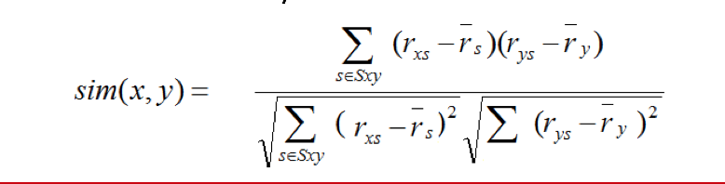

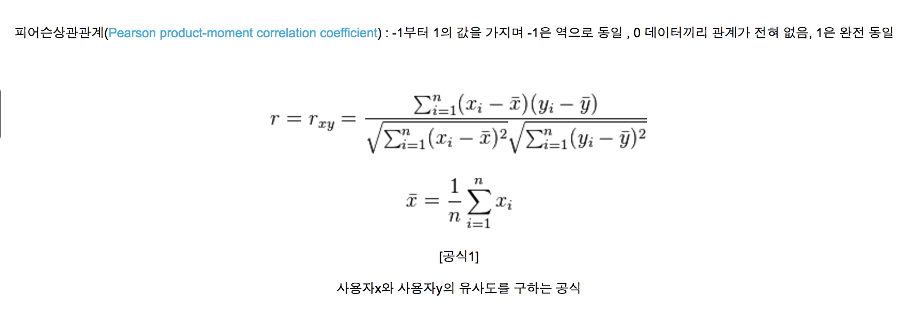

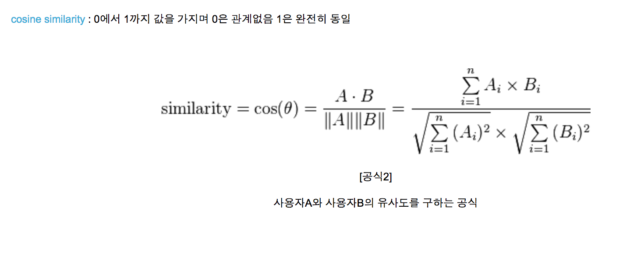

1. Detailed description of codes
2. LoadMovieLens function is getting data from the input file data. Data must be saved into user,movie,rating separately.

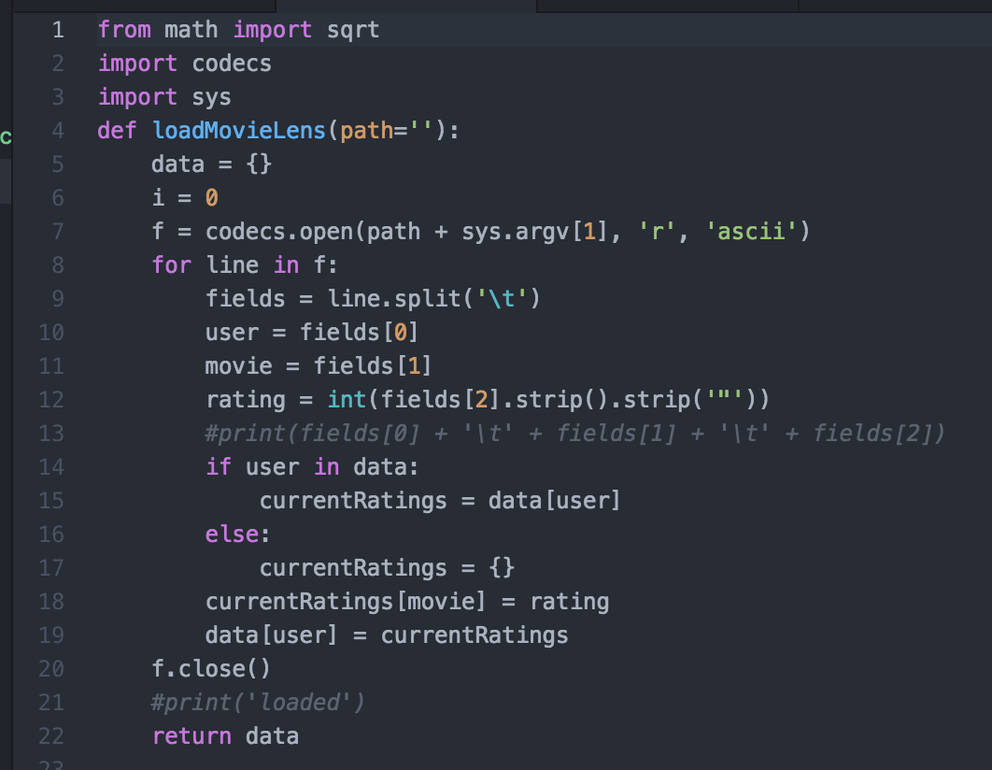

1. nomalizeData function is adding rating to user’s rating sum and getting average the user’s rating sum.

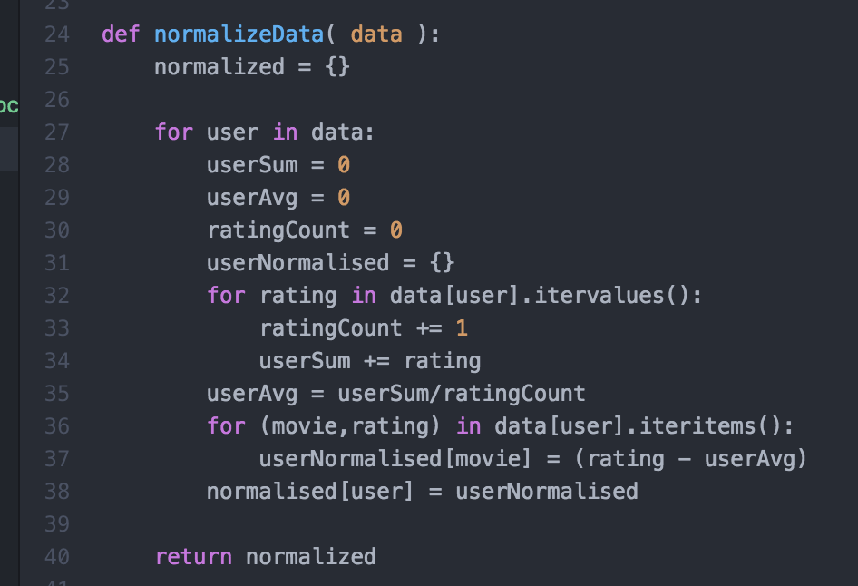

1. createSimMatrix function is calling normalizedData function and calculating the similarity of user’s rating. The result is saved into similarity matrix.

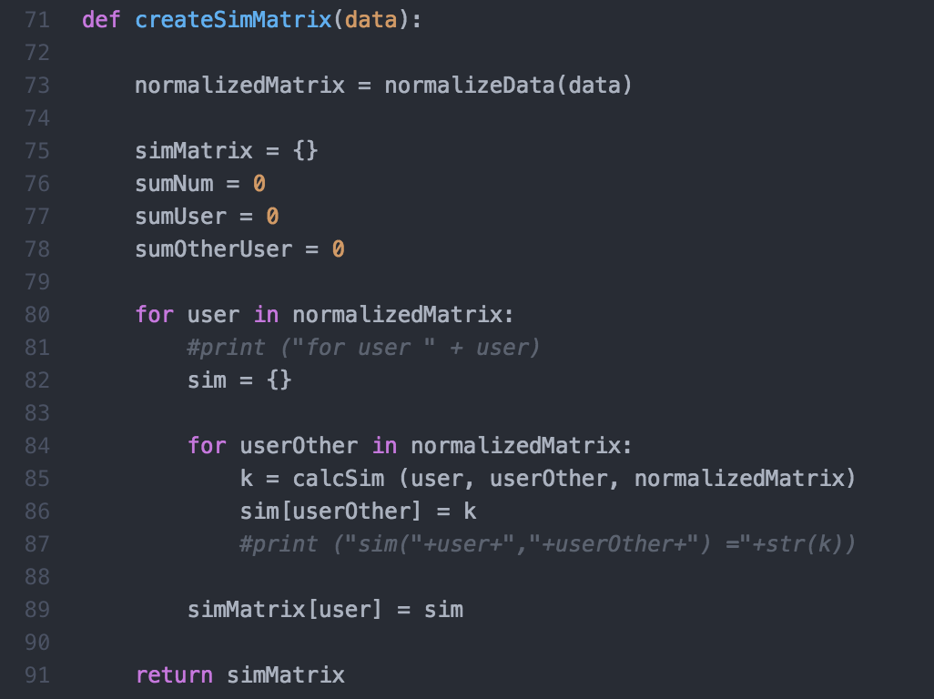

1. calcSim Function is calculating similarity from user and other user data.

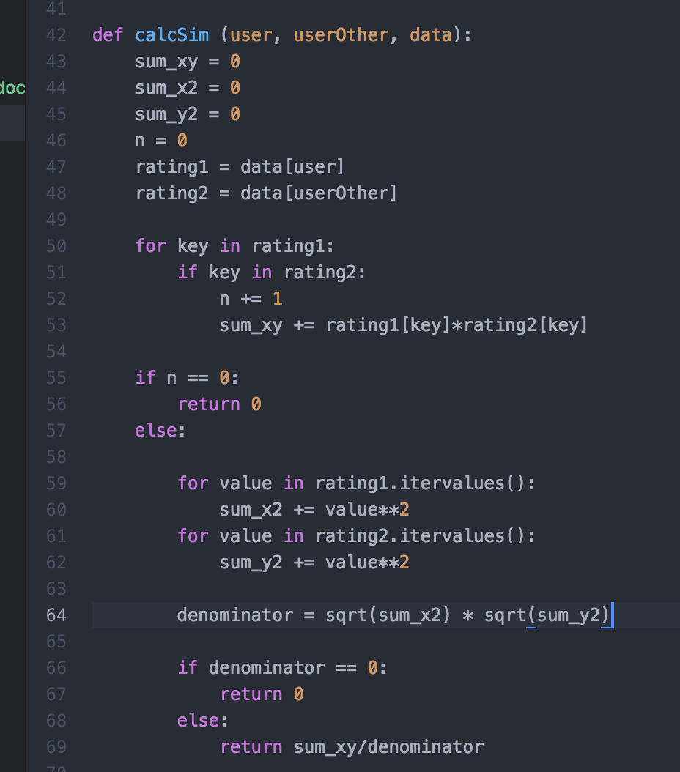

1. computeNearestNeighbor function is calculating each user’s Nearest Neighbor and returning the result.

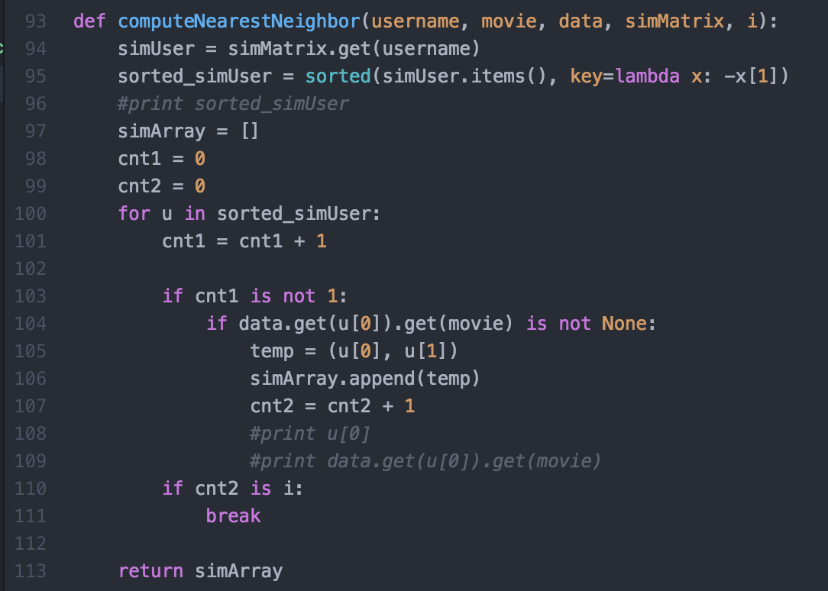

1. calculateRating function is calculating from NearestNeighbors’ rating.

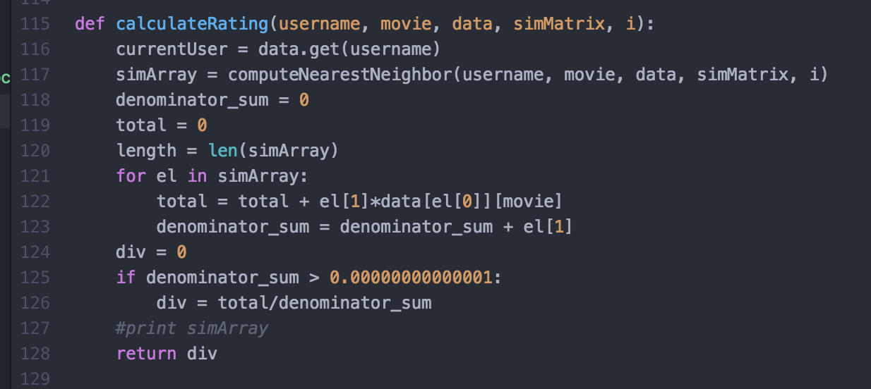

1. Main Function calls load a file and call similarityMatrix and calculateRating function.

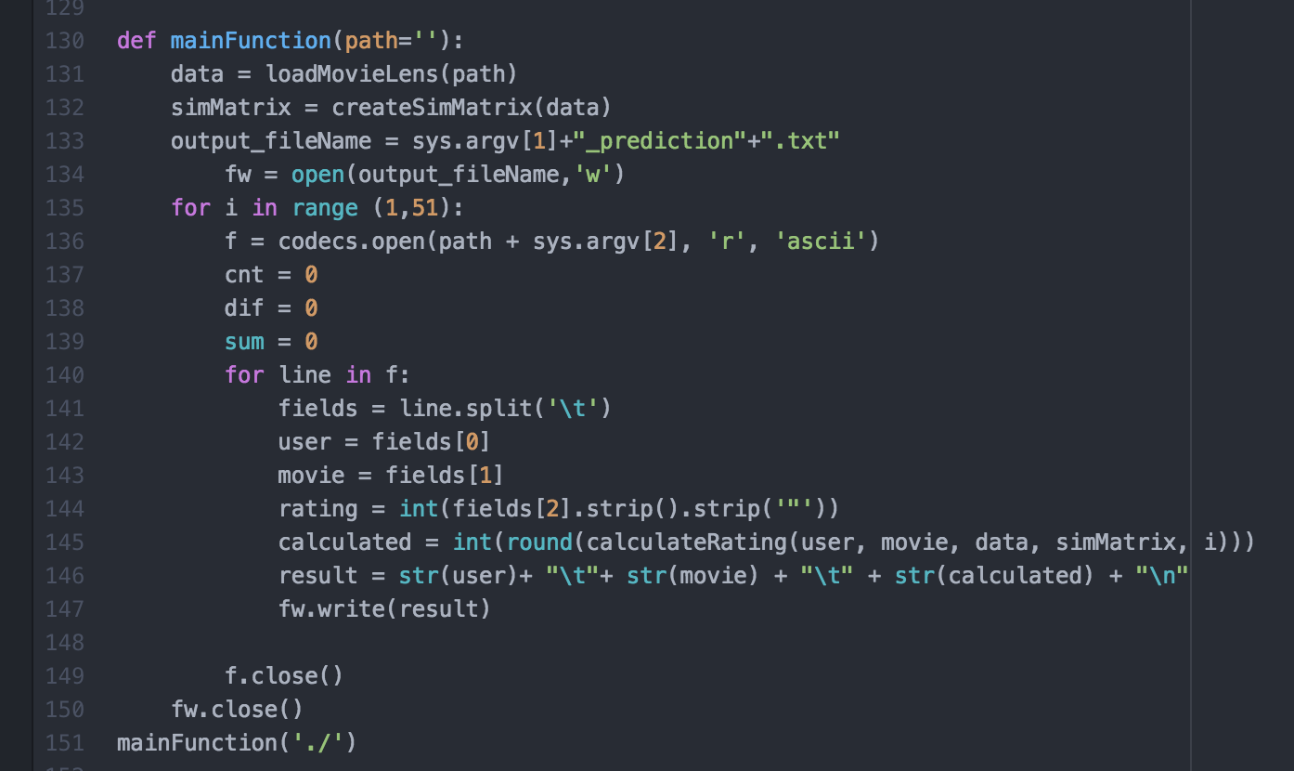

1. Insrtuctions for compiling my source code(e.g screenshot)

Use this command…

**python recommender.py u1.base u1.test**

