<Database PDA1>
2014057983
Ji So Hyun
<a> Write description of online open market you propose to work with throughout the course;
-I want to management for Milk with Database system.
Milk is crucial to keep freshness. So,it must deliver quickly to customer.So,it must mark the expiration date and it must be managed with expiration date by seller.

<b> Write analysis of requirements for your application.
-Product(milk) :
Product is delivered quickly to customer(to keep freshness)
=>expiration date
Product added to cart with quantity and total price
-Seller :
Seller manage stock about the product
-Customer :
Customer rate a product with comment=>purchase Postscript
Customer purchase order about product
-Order :
Order consists of products in cosumer’s Cart
Order is made by customer(purchase)

<c>
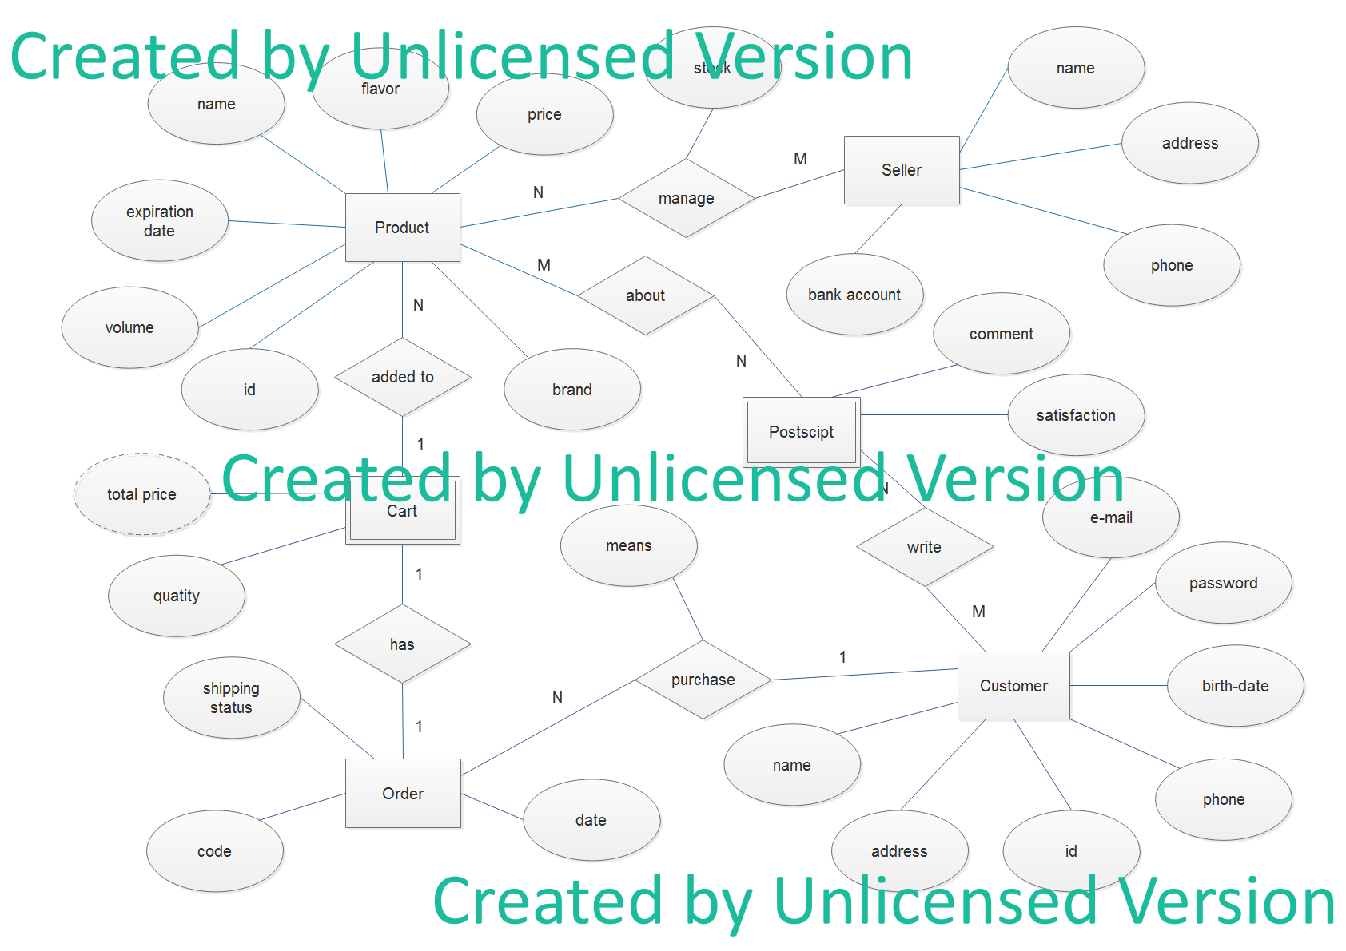

<d>
Sellers post and manage products. Then,Customer purchase the products. First, the products they wanted to buy are in cart.Then,they ordered these products. That is,Order consists of products that they wanted to buy.
Products are milk. The milk is important to quickly deliver.So, products have expiration date. Products are catergorized accoriding to price,volume,id,name,flavor,brand attribute.So, products can be searched by customers.
Customer buy product and can write comment and safisfaction.(=>purchase postscript) They have id,password,name,e-mail,address and phone to receive order.
Seller have name,address,phone number,bank account.They manage their product. And management includes checking stock.They send product according to customer’s order.
To deliver products,order has code,address,quantity,ship date,order date.

