I rewrite pda….
<Database PDA1>
2014057983
Ji So Hyun
<a> Write description of online open market you propose to work with throughout the course;
-I want to management open market for books with Database system.
Every publishing company(Seller) can participate this open market and can sell their books.
They produce books and book’s table contents.

<b> Write analysis of requirements for your application.
-Product(Book) :
Product must be produced its table of contents,author,publishing company name(its seller’s attribute).
So customer can know about Product and sell it.
-Seller(publishing company) :
Sellers manage about the product.
They must post product and product’s produce.
-Customer :
Customer rate a product with review and satisfaction.=>purchase Postscript weak entity
Customer read product’s tabled of content and review, and then purchase order about products.
-Order :
Order consists of products’ quantity,shipping status and total price(derive from product’s price and quantity)
Order is made by customer(purchase) and has order date,order number.
Customer must select purchasing means before order.

-Postscript :
Customer can write review and rate satisfaction score after purchasing product.
Customer can write only one postscript about each books.(1 product : 1 postscript)

<c>

<d>
Products are books. The book is important to produce information for customer to know it.Products are categorized to genre,name,author and publishing company.So, products can be searched by customers.
Customer buy product and can write review and rate satisfaction score.(=>purchase postscript)They must register id,password,name,e-mail,address and phone to receive order.
Sellers are publishing company.Seller can post and manage products.Seller have name,address,telephone number,bank account.They manage their product. The management includes checking products’ quantity(stock).They send product according to customer’s order.
To deliver products,order has total price,order number,quantity,ship date,order date and customer’s address.Customer must register their address and select purchasing means before order.

<Database PDA2>
2014057983
Ji So Hyun

1. Er to relational model
A. Convert strong entities
i. Customer(c_id, c_name, c_address, c_phone,email)
ii. Seller(s_id, s_phone, s_registerNo)
iii. Product(p_no, p_price, s_id, p_name, author)
iv.
Order(o_no,o_quantity,p_no,o_date,o_totalprice)

B. Convert weak entities
i. Postscript(c_id, ps_registerNo, satisfaction)

B. Convert relationships
i. 1:1 Relationships
1. Postscript(1) –Product(1) : about
Postscript(p_id, ps_registerNo,review, satisfaction)
ii. 1:N Relationships
1. Product(n) – Order(1) : added to Order(o_no,o_quantity,p_no,o_date,o_shippingstate,o_totalprice)
2. Seller(1) – Product(N) : manage
Product(p_no, s_id, p_name,p_price,author)
3. Customer(1) -Order(N) : purchase
Customer(c_id,o_no,c_name,email,c_phone,c_address)

Relational Schema

Customer(c_id, o_no,c_name, c_address, c_phone,email)

Order(o_no, o_quantity,p_no,o_date,o_shippingstatus
,o_totalprice)

Seller(s_id, s_phone, s_registerNo)

Product(p_no, p_price, s_id, p_name, author)

Postscript(c_id, ps_registerNo,satisfaction)

D. Convert multi-valued attributes None
E. Convert n-ary relationships None

2. creating tables & insertion, mysql
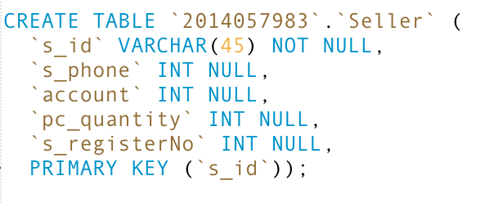
A. Creating Tables

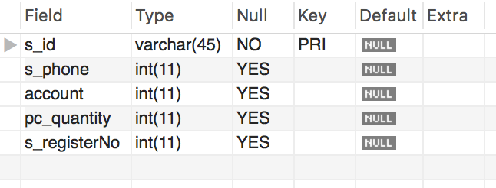

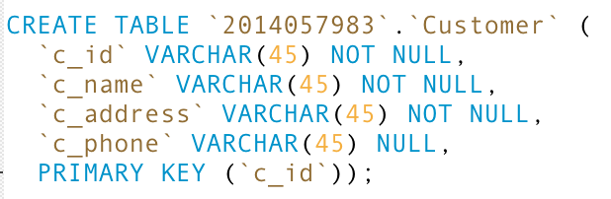

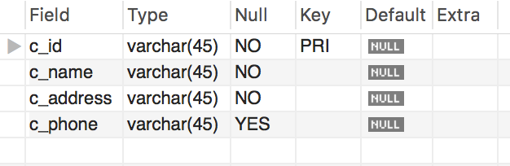
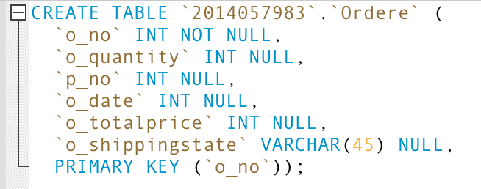

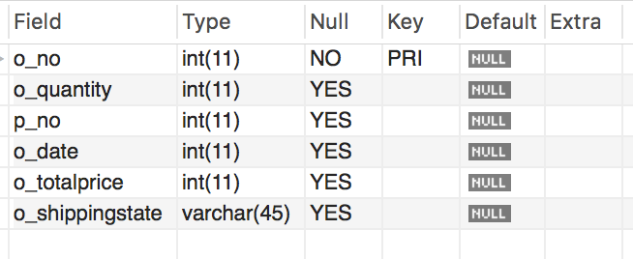

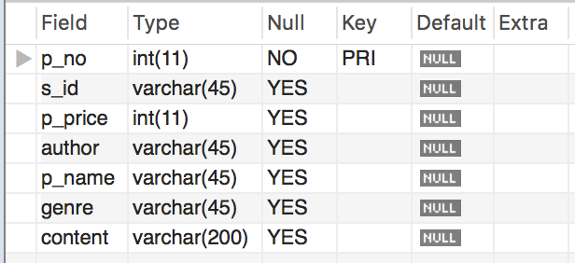
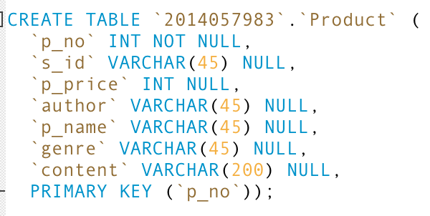

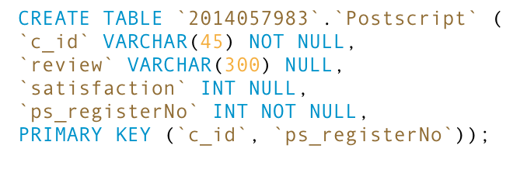
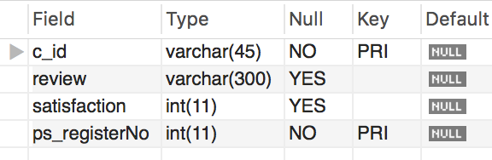
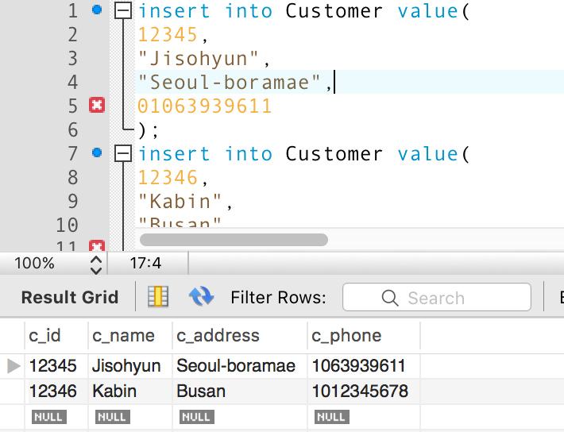

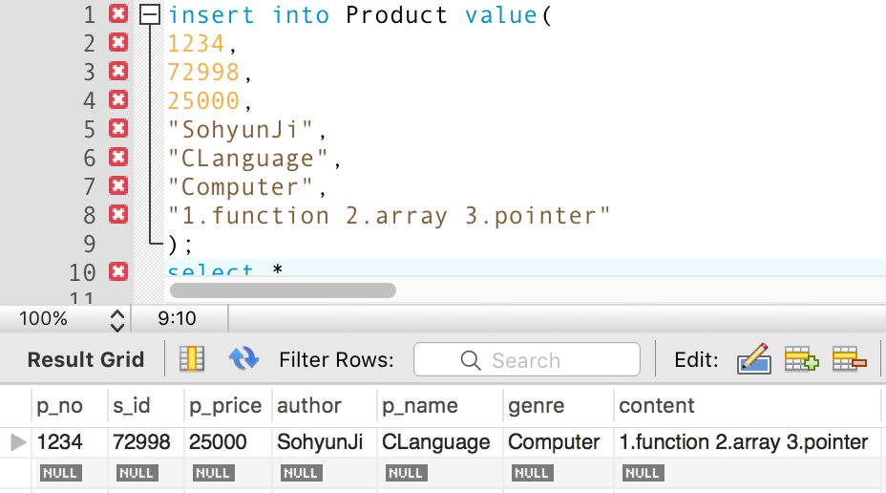

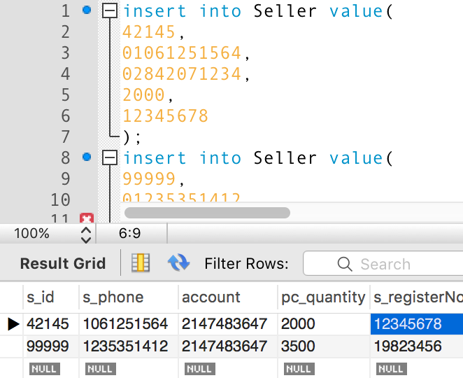

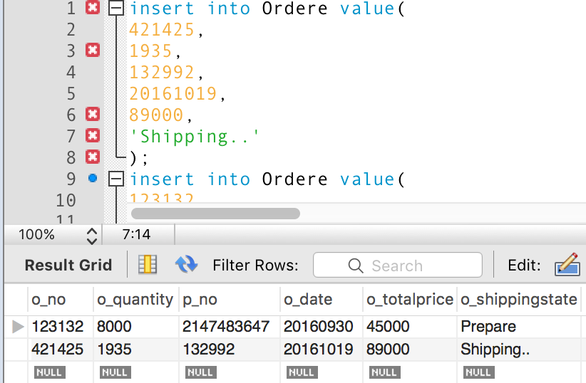
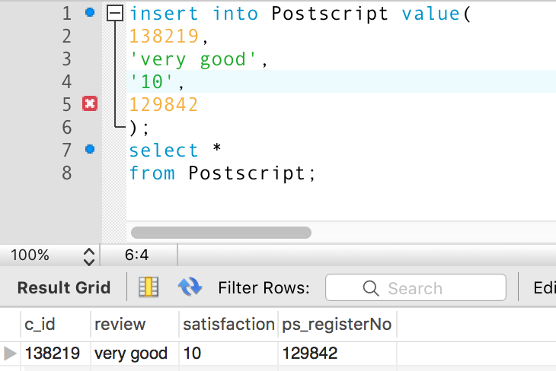

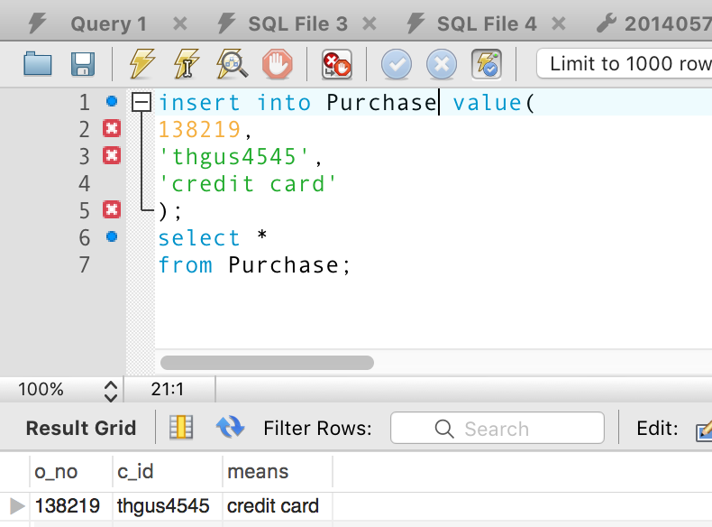

<Database PDA3>
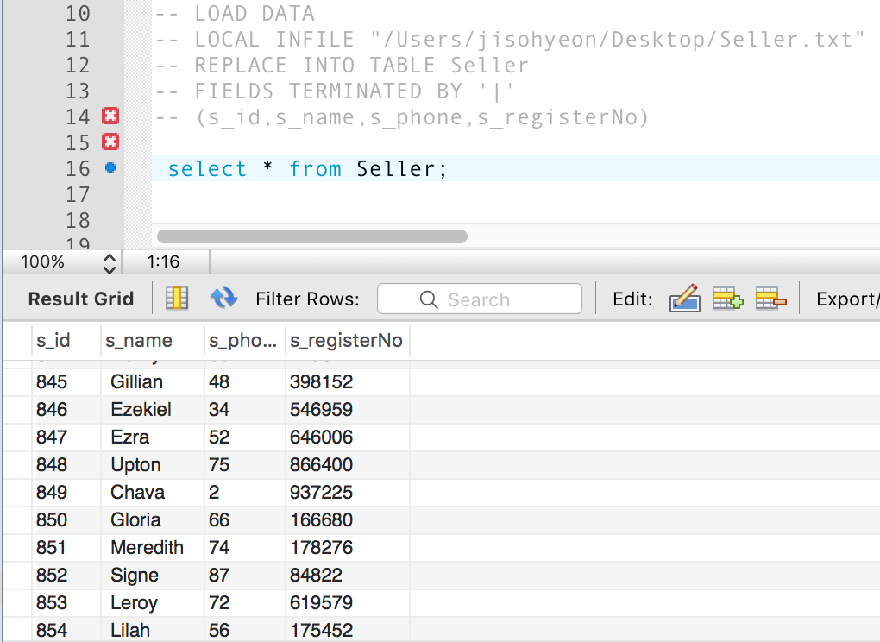
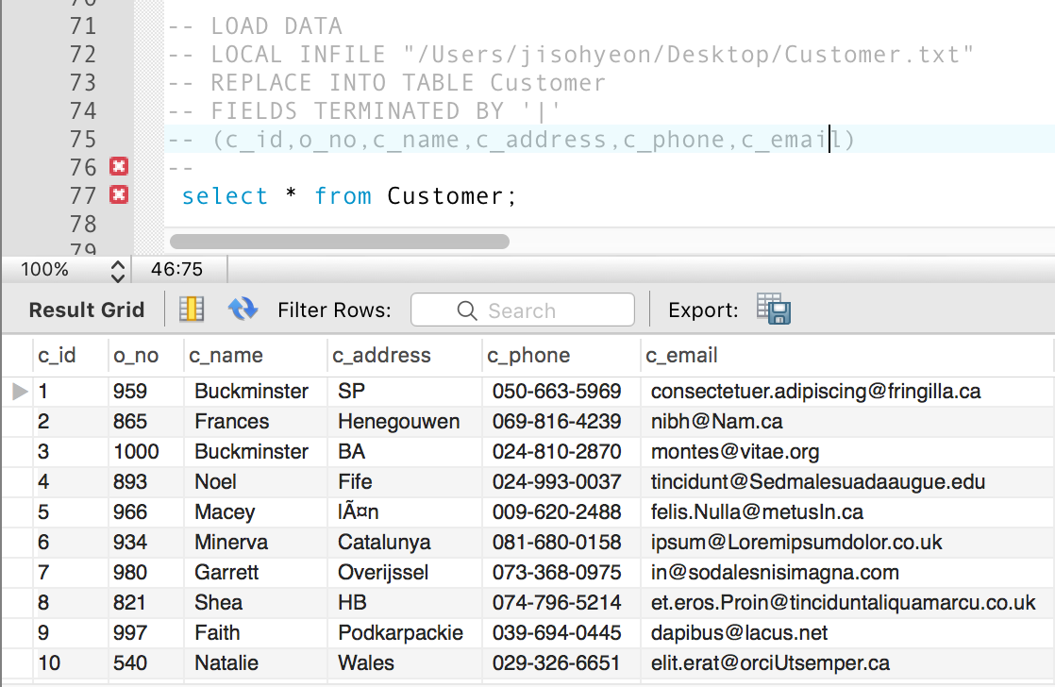
<c>Load data and input into table
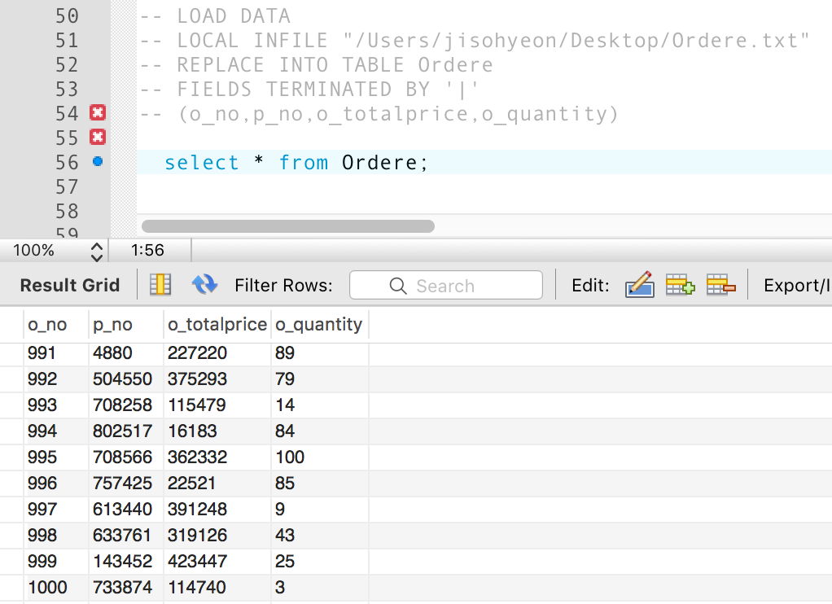
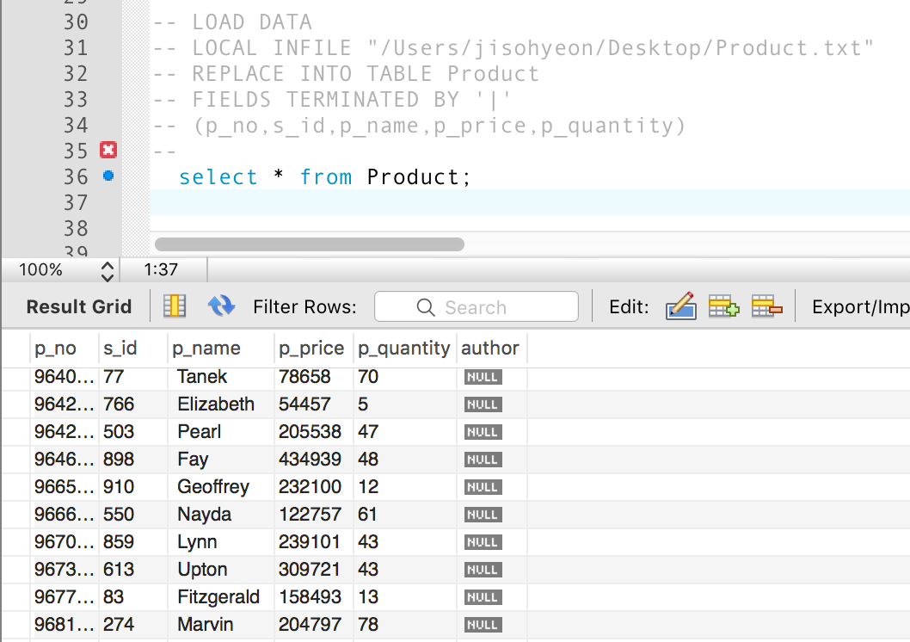

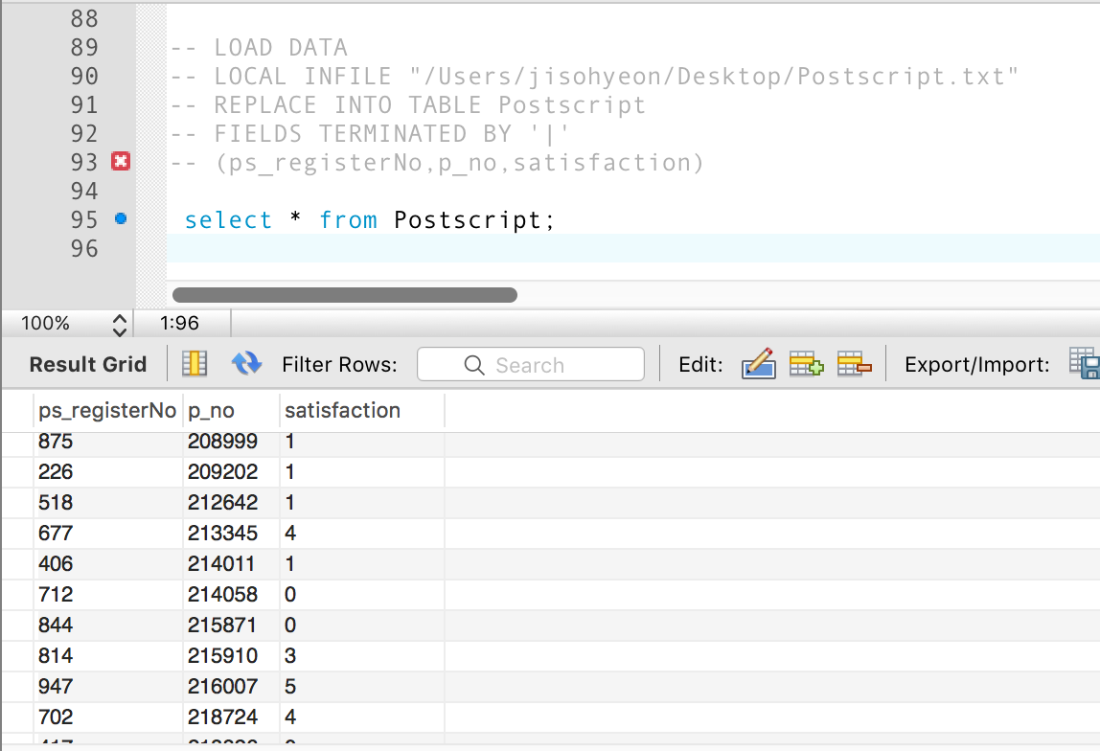
<a>
#include <stdio.h>
#include <stdlib.h>
int main(int argc, const char * argv[]) {

FILE *fi1 = fopen("ProductNumber.txt", “r");
//first txt file open “read option”. the file includes data.

FILE *fo = fopen("Product.txt","w");
//Second txt file open “write option”. the file will save the read data.
char pno[100];
int i;

for (i=0; i<1000; i++) {
fscanf(fi1,”%s",pno);
// 1000 times read data
fprintf(fo, "%d | %s | %d \n”,i+1,pno,rand()%6);
// 1000 times write data into result file
}

fclose(fi1);
fclose(fo);
// finally, close file

return 0;

} // other code same as this.

<b> I use the web sites to generate 1000 data.
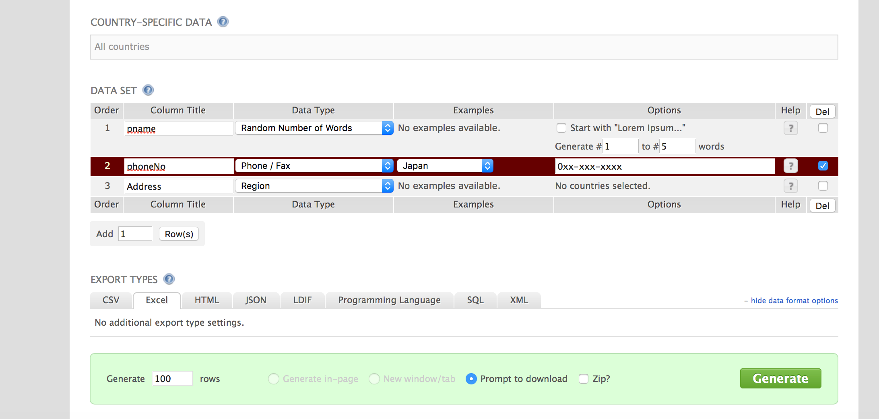
First write column title(=Attribute) and choose data type and then generate rows.
web site : http://generatedata.com/#t3

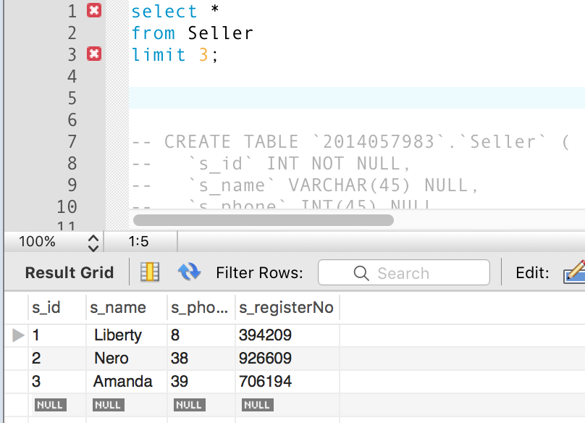
<d> A small sample of the records generated from any two entities and a relationship relating them. Show (5 or so records per relation), and a screen shot showing the loading of your data into any one of your tables.

