**PDA 5: Procedures and Triggers**

Step 5 of your Personal Database Application (PDA)

Step 5 of your PDA is to incorporate MySQL Routines (stored procedures and functions) in your database and to implement triggers.

1. Write three MySQL routines to perform operations on your PDA.
2. My function ‘satisfaction_score_toString’ changes data type from int to string(varchar).

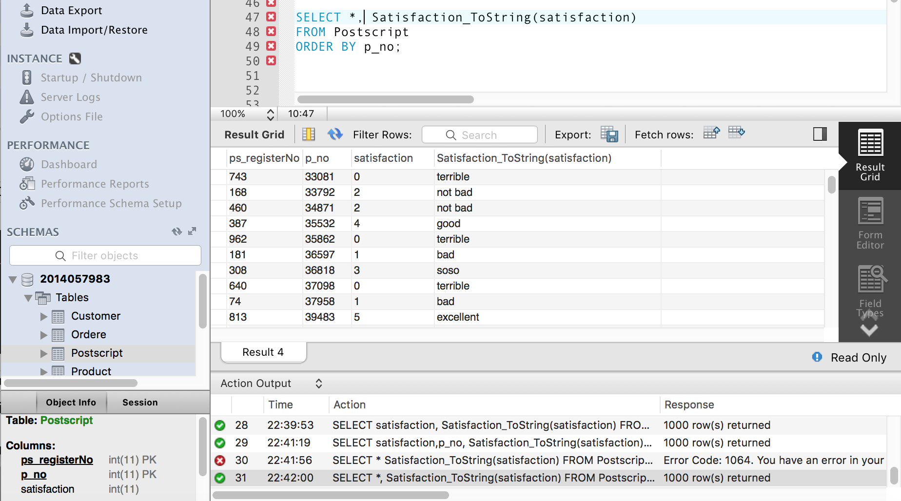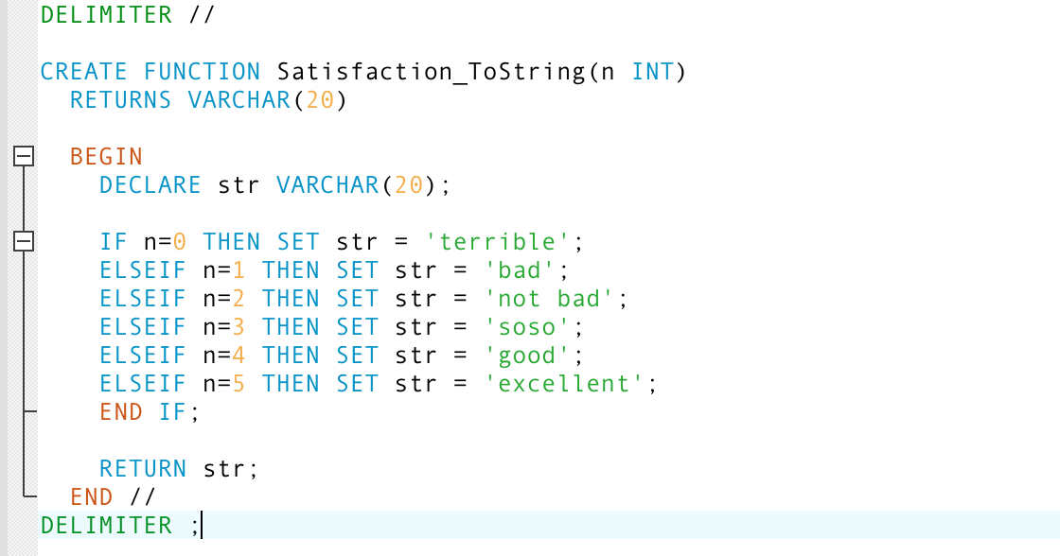Score scope is from zero to five.

1. My function ‘SetMileage’ returns order totalprice * 0.05. (this means 5%)

When customers buy product, they can receive mileage.

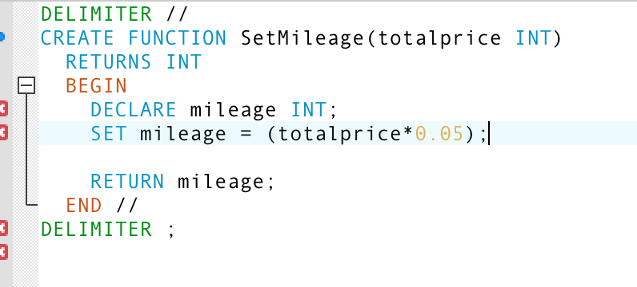

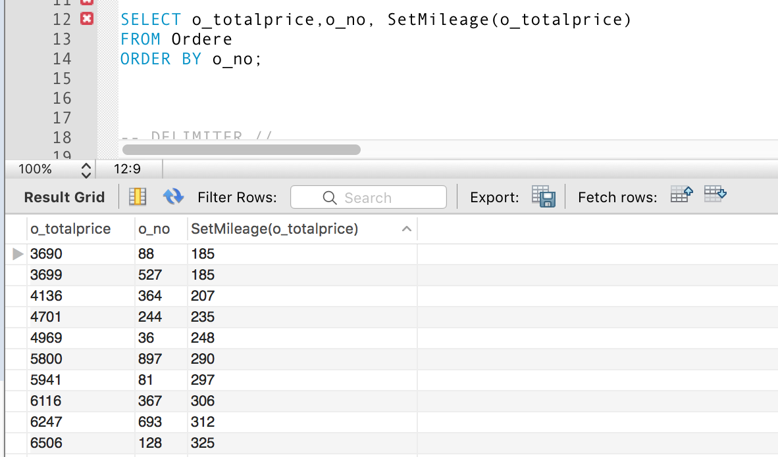

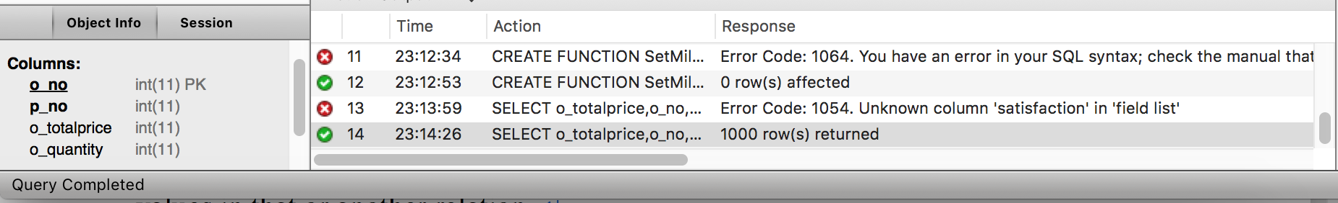

1. ‘BOOKS’ Table saves initialized book information and ‘BOOK_SELL’ table saves selling books. Using My procedure ‘UPDATE_BOOK’, I can adjust books’ price by booktype. When I read the ‘BOOKS’table , I use cursor ‘CURSOR_BOOK’.

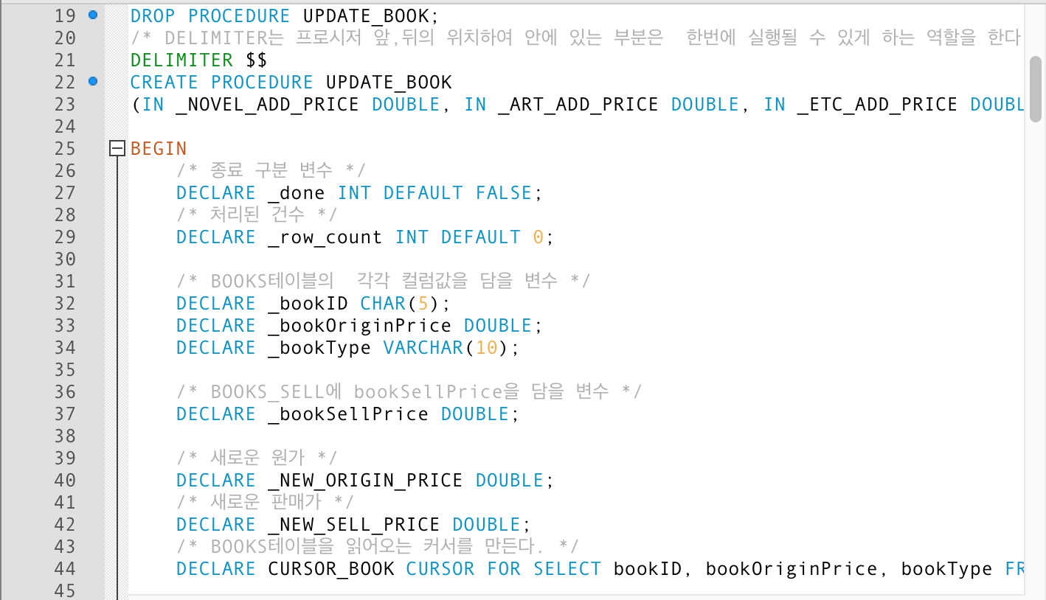

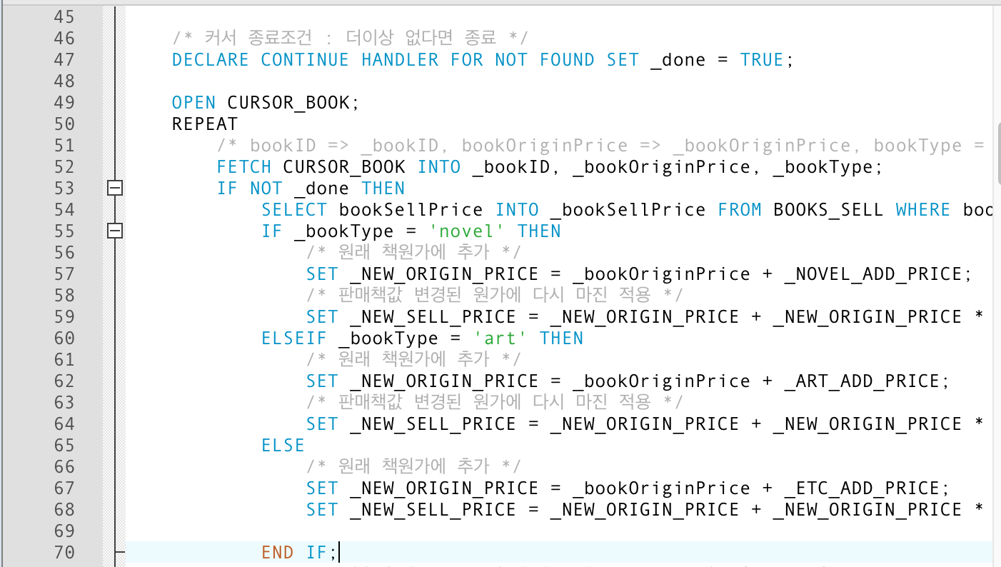

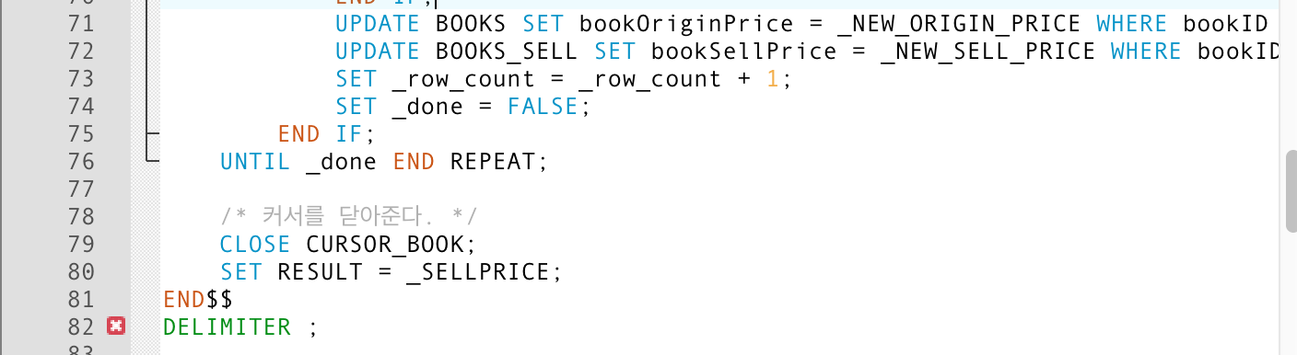



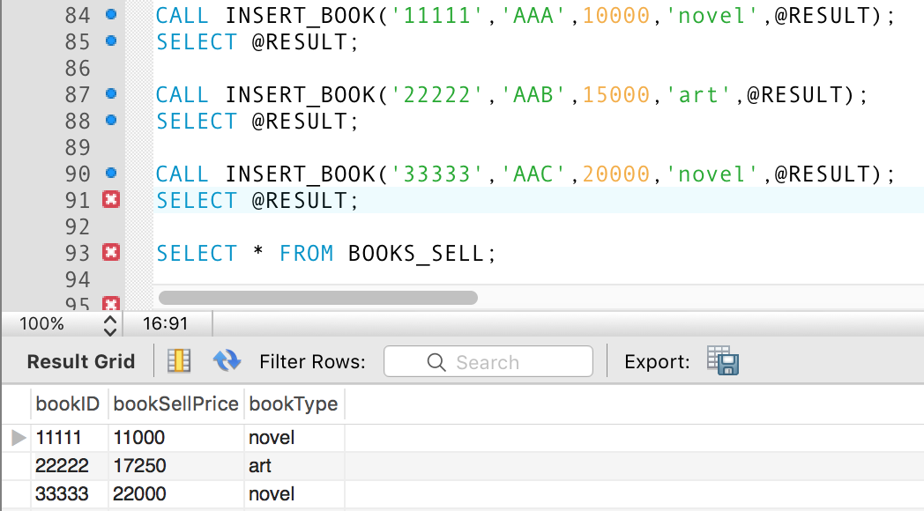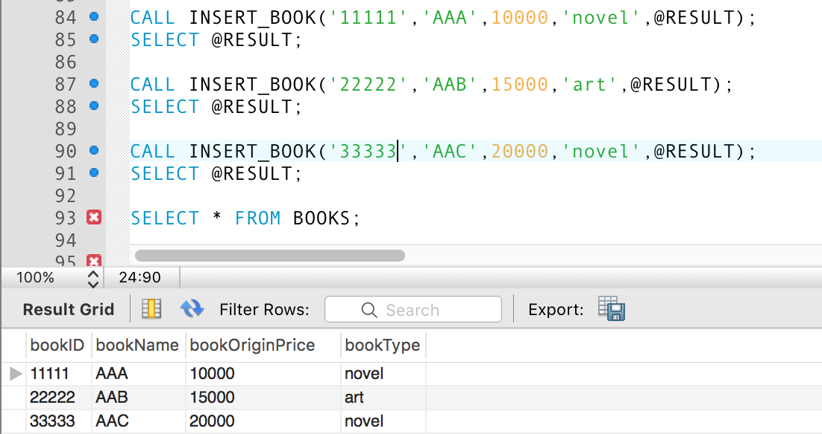

BEFORE Procedure(original price) AFTER Procedure(added price)

1. Write two MySQL triggers and then show that these triggers work.

1.‘bookSale’ table is product table. It saves information about product.

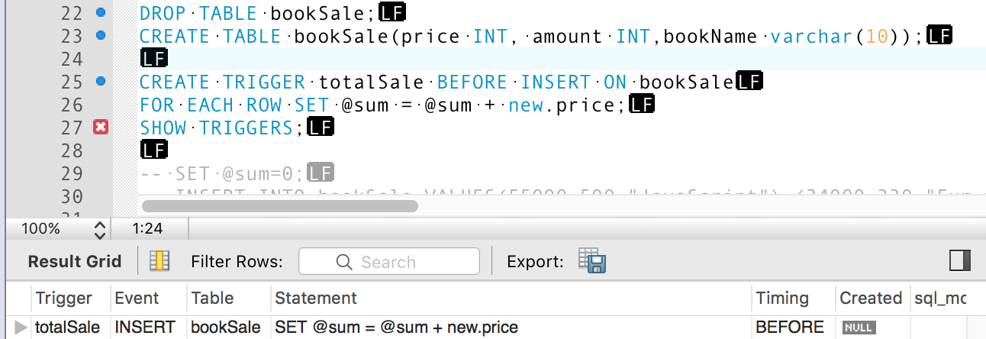 ‘TotalSale’ is trigger about bookSale Talble. So this trigger has total Price about sold book.(trigger occurs before insert)

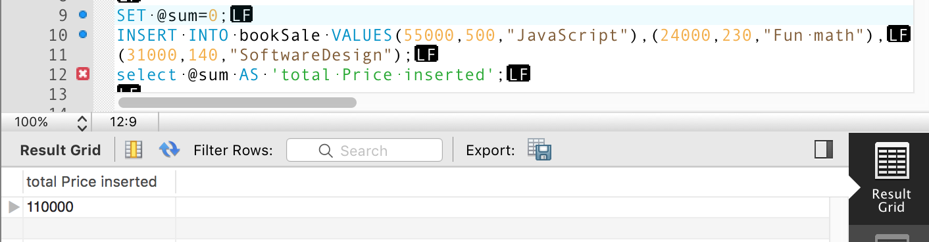

2. My ‘SetSale’ trigger is setting price 50% . So we can changed Price this trigger(it occurs before update)

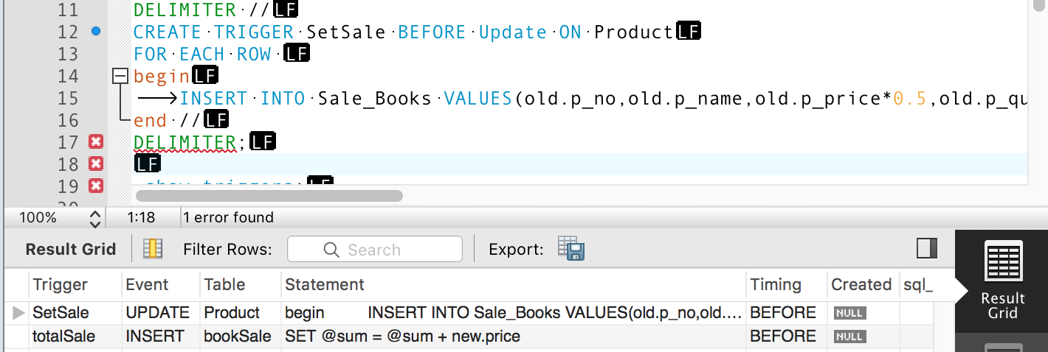

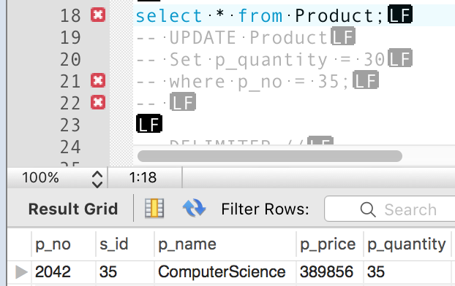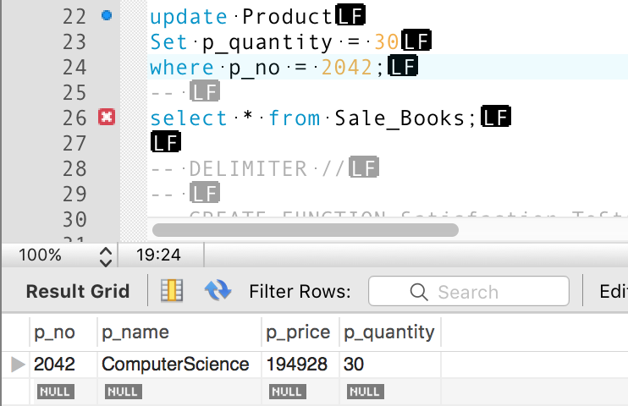

Before update After update(trigger occurs)