2016.11.16

2014057983 지소현

pda4

# write three queries

Write three queries on your PDA, using the select-from-where construct of SQL. To receive full credit your queries should be as given below. None of your queries should return more than 20 tuples. Hand in screen shots of your queries along with a print out of the execution of the three queries (query results).

## 1. Simple select from one relation with 20 or fewer tuple

# 

# Two way join with a limit 20 or fewer

# 

# thIS QUERY IMPLIES CUSTOMERS WHO MADE ORDER WHICH CONTAINS PRODUCTS...(CUSTOMER 1 : ORDER N)

## 3.Aggregate using a group by

# 

# this query implies price are sorted in ascending order… and counts the products with same prices.

# three data modifications

* Write three data modification commands on your PDA. One should be a simple insert, one a simple update, and one an update that updates several tuples at once. Each of these commands should be legal, given the constraints you created for you database in PDA 1 and PDA 2. You might want to try out your commands on small data before trying it on your full database. Hand in screen shots that show your modification commands running in a convincing fashion.

## 1. Simple insert

# 

# -- CREATE TABLE `2014057983`.`Seller` (

# -- `s_id` INT NOT NULL,

# -- `s_name` VARCHAR(45) NULL,

# -- `s_phone` INT(45) NULL,

# -- `s_registerNo` INT(45) NULL,

# -- PRIMARY KEY (`s_id`)

# -- );

# Simple update(several tuples at once)

**I tried to give 40% off discount,**



# Before UPDATE IN order’s total price AFTER UPDATE

# 

## 3.Simple update

## Before Update

## 

## 

## After Update

## 

## <C>. Views

## 1. create view and show the view

## Create a view based on a simple relation. Show your CREATE VIEW statements and the response of the system. Also, show a query involving the view and the system response. Your query should return at most 20 tuples.

## 

## 2. show an insert statement

## Show an insert statement the system response to running the statement. Run before and after(the insert) select statements on both the view and the base table to show how both change.

## 

I tried to insert into seller_info. And I can get new data in Seller_info.

3. Create a view based two relations (a join). Show your CREATE VIEW statements and the response of the system. Also, show a query involving the view and the system response. Your query should return at most 20 tuples.

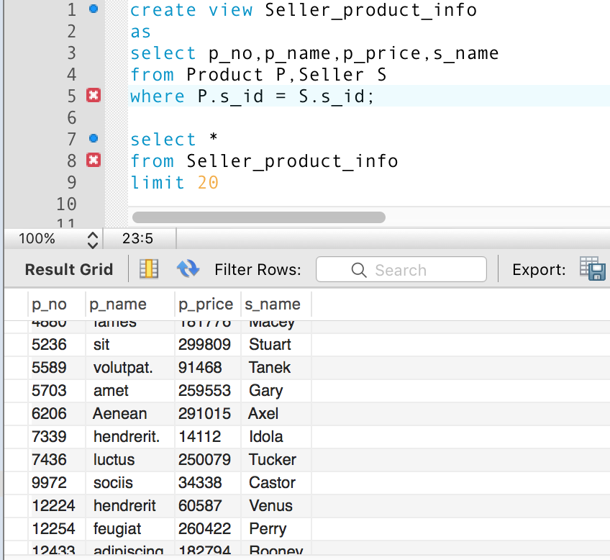

4. Show a system response to and insert statement into this join based view.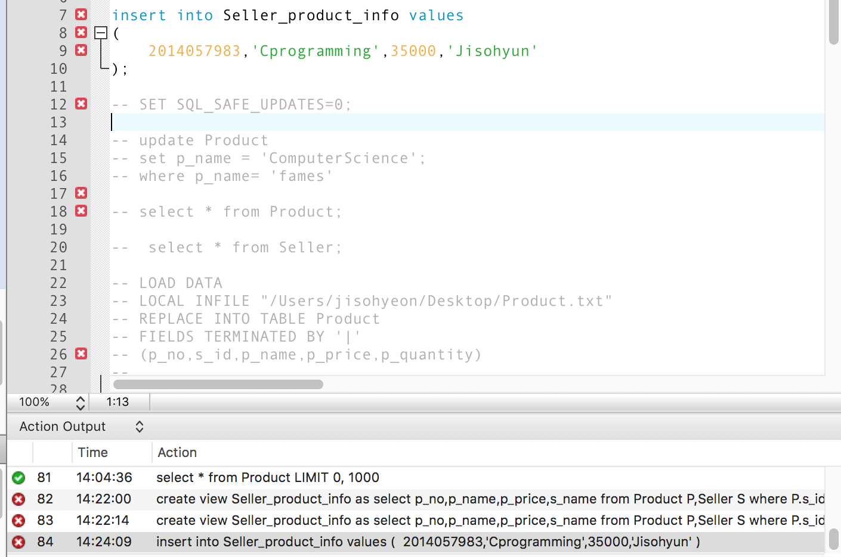

## ERROR!!!!