# Use Case Overview

## Use Case Diagram Level 1: Repairs Management Sub-System (UC100)

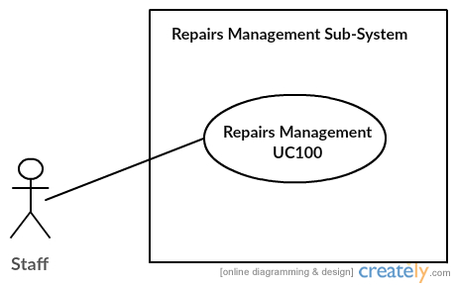

## Use Case Diagram Level 2: Repairs Management Sub-System (UC100)

