**Use Case Diagram Level 1: Divice’s Management Sub-System (UC200)**

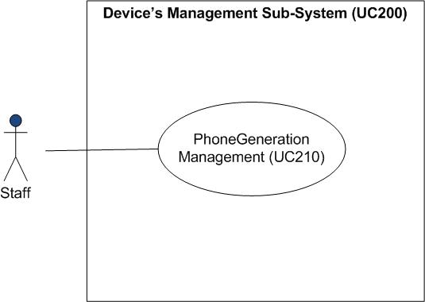

**Use Case Diagram Level 2 : PhoneGeneration Management (UC210)**

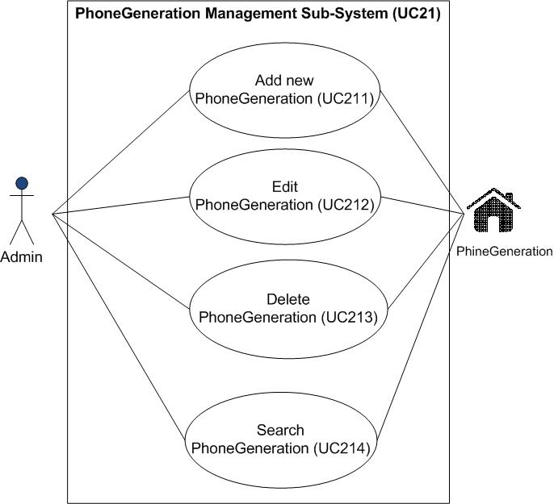

PhoneGeneration

Staff

**Model-View-Controller (MVC) Model**

**Sequence Diagram demonstrating operation “add new PhoneGeneration”**

This diagram describes the system scenario of **“UC211: Add new PhoneGeneration”**

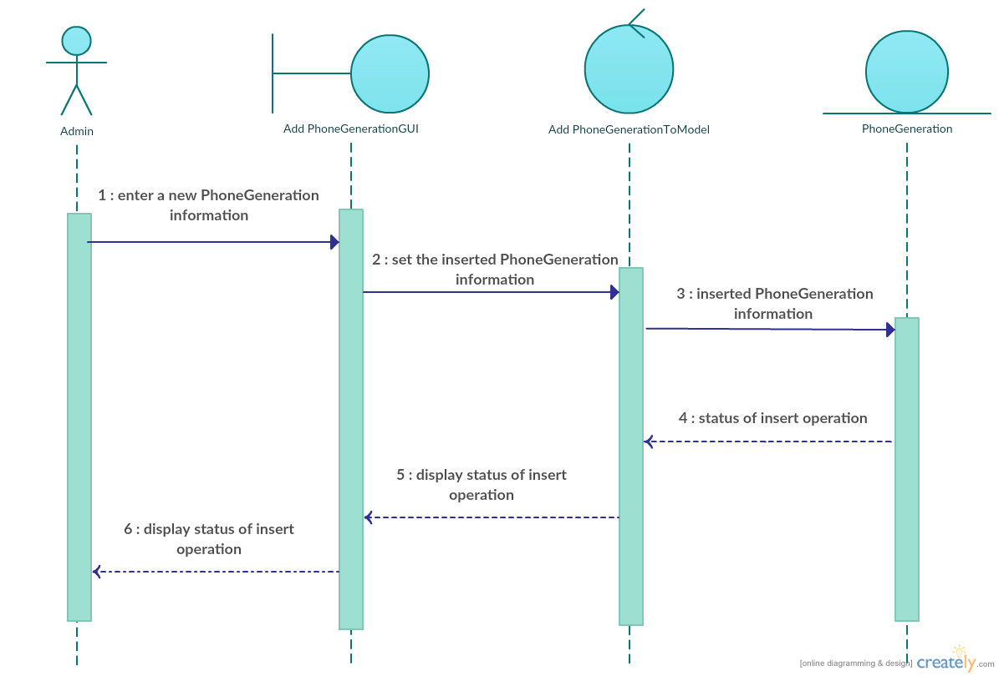

Staff

**Sequence Diagram demonstrating operation “edit PhoneGeneration”**

This diagram describes the system scenario of **“UC212: Edit PhoneGeneration”**

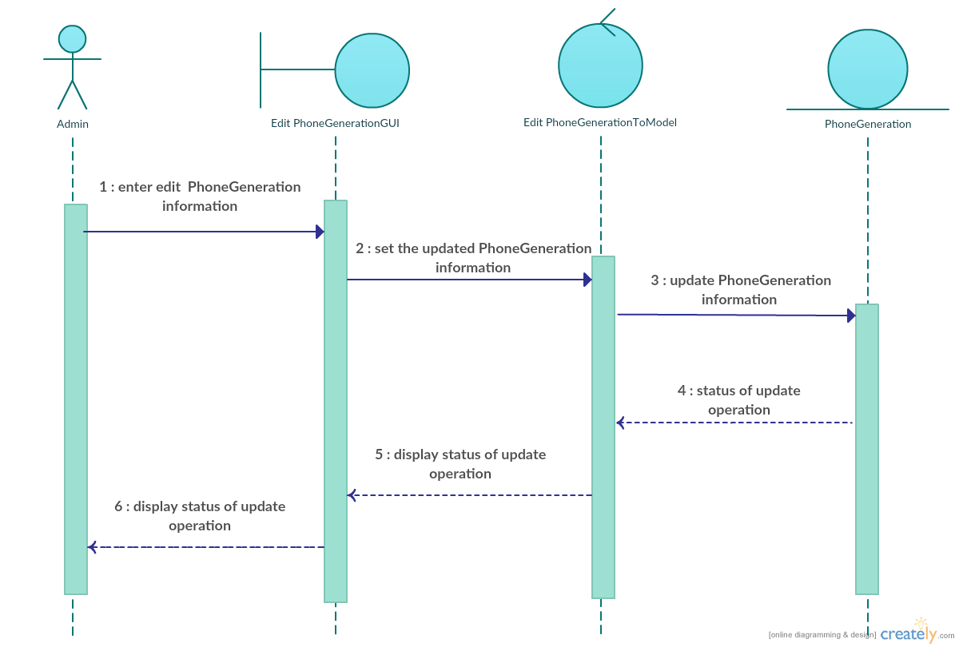

Staff

**Sequence Diagram demonstrating operation “delete PhoneGeneration”**

This diagram describes the system scenario of **“UC211: Delete PhoneGeneration”**

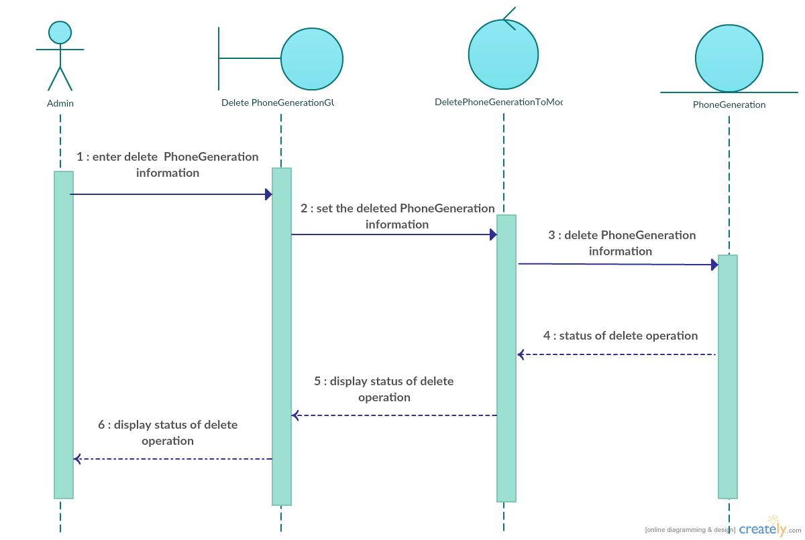

Staff

**Sequence Diagram demonstrating operation “search PhoneGeneration”**

This diagram describes the system scenario of **“UC211: Search PhoneGeneration”**

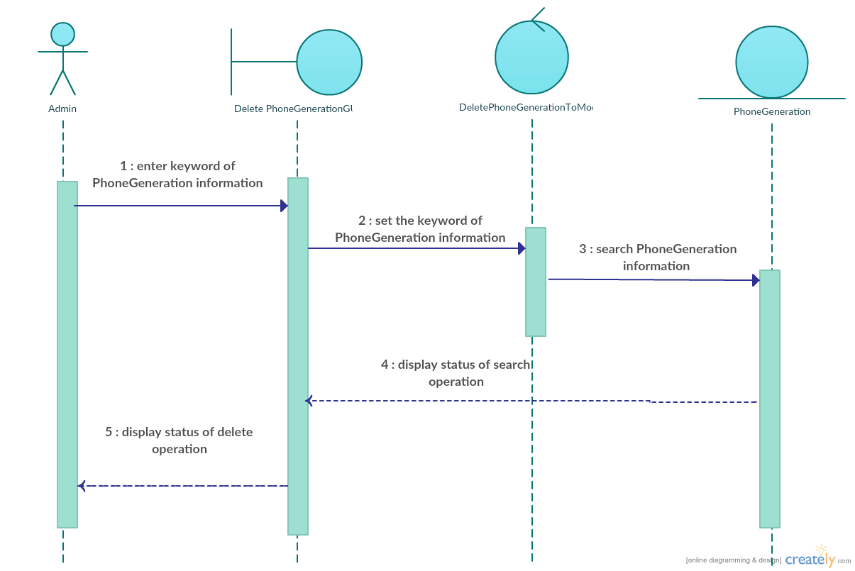

Staff