**Use Case Diagram Level 1: Divice’s Management Sub-System (UC200)**

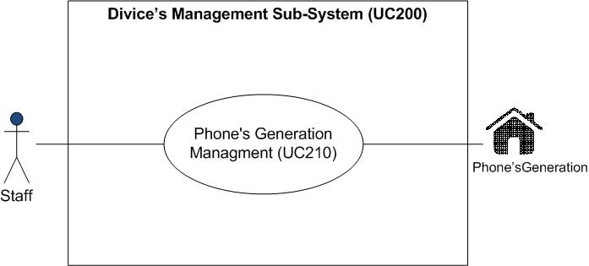

MissPuttinun Duangsamran 5730213038

**Use Case Diagram Level 2 : Phone’s Generation Management (UC210)**

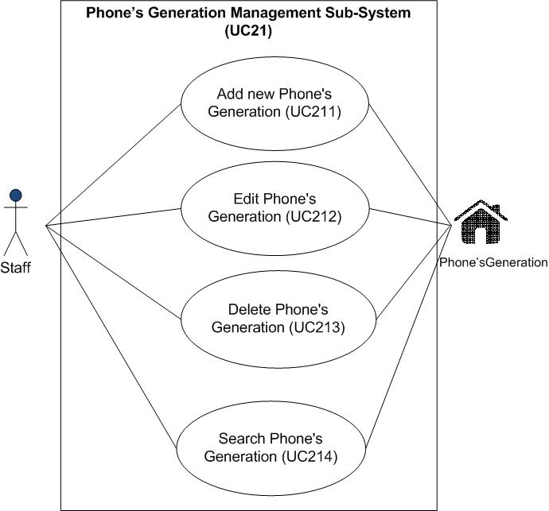

MissPuttinun Duangsamran 5730213038

**Model-View-Controller (MVC) Model**

MVC Add Phone’s Generation

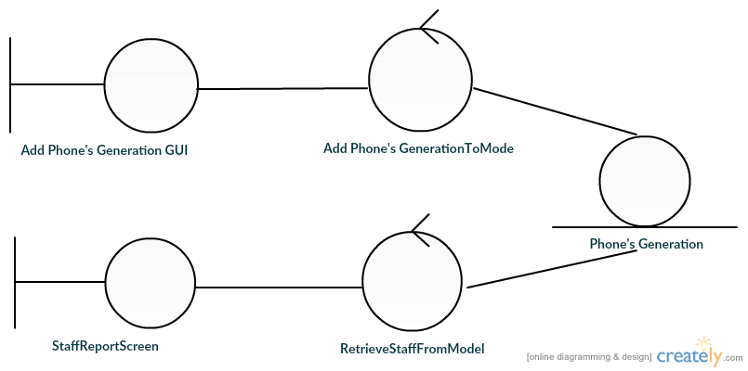

**MissPuttinun Duangsamran 5730213038**

**MVC Edit Phone’s Generation**

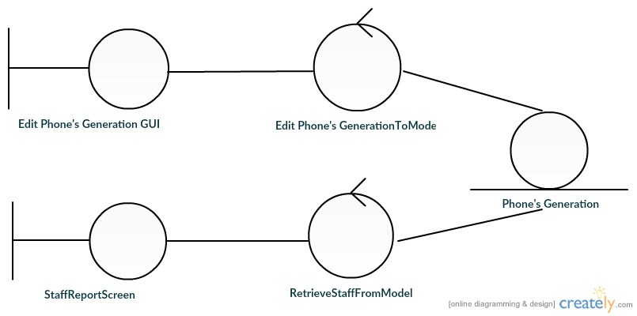

**MissPuttinun Duangsamran 5730213038**

MVC Delete Phone’s Generation

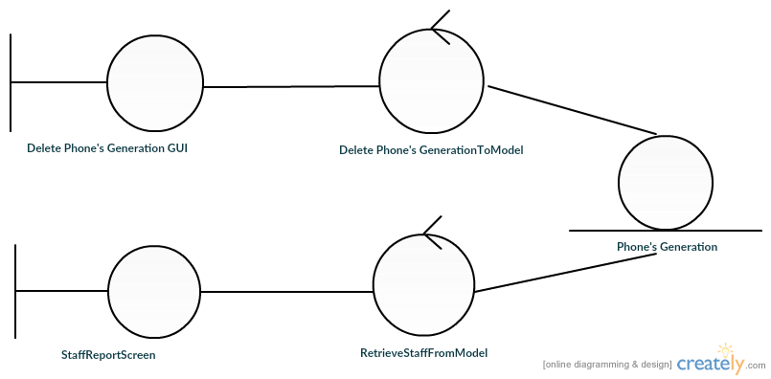

MissPuttinun Duangsamran 5730213038

MVC Search Phone’s Generation

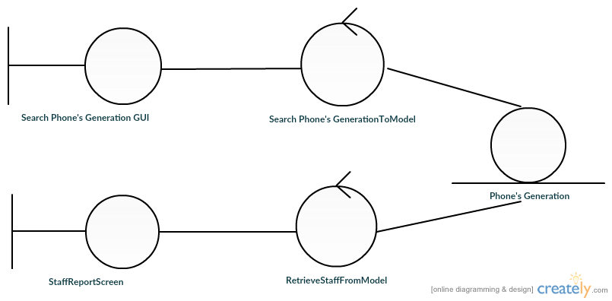

MissPuttinun Duangsamran 5730213038

**Sequence Diagram demonstrating operation “add new Phone’s Generation”**

This diagram describes the system scenario of **“UC211: Add new Phone’s Generation”**

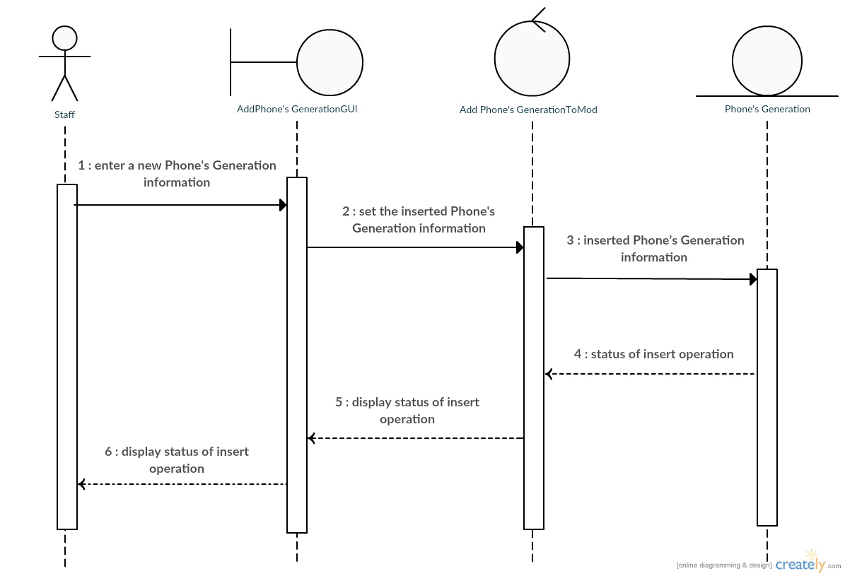

**MissPuttinun Duangsamran 5730213038**

**Sequence Diagram demonstrating operation “update Phone’s Generation”**

This diagram describes the system scenario of **“UC212: Edit Phone’s Generation”**

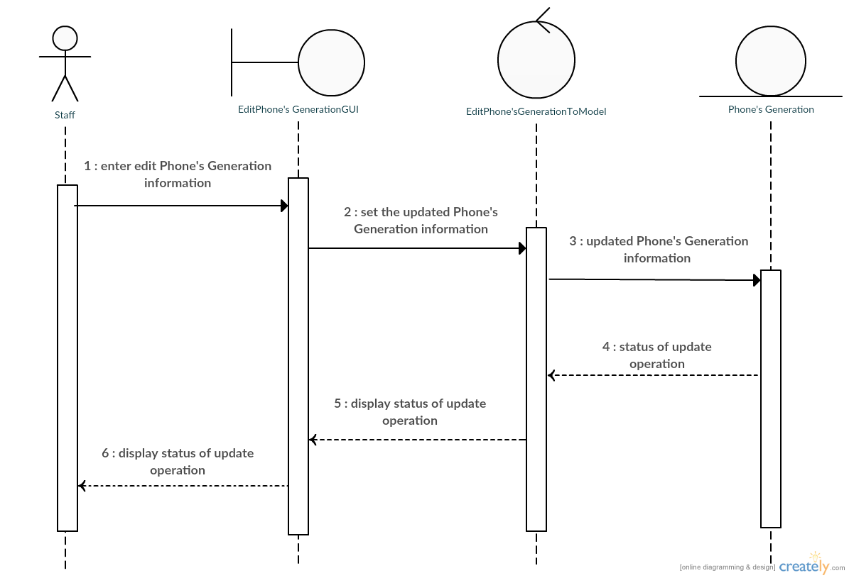

MissPuttinun Duangsamran 5730213038

**Sequence Diagram demonstrating operation “delete Phone’s Generation”**

This diagram describes the system scenario of **“UC211: Delete Phone’s Generation”**

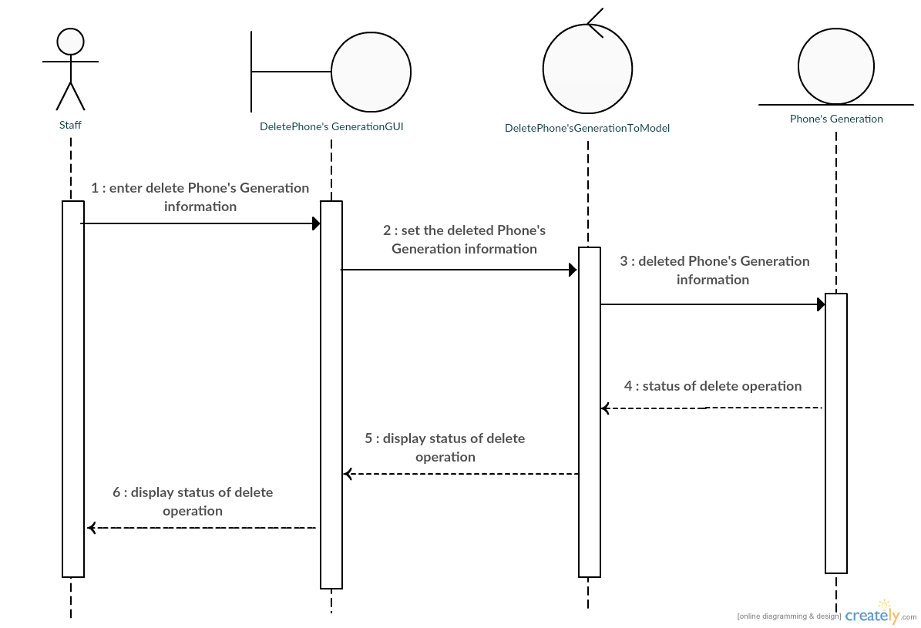

MissPuttinun Duangsamran 5730213038

**Sequence Diagram demonstrating operation “search Phone’s Generation”**

This diagram describes the system scenario of **“UC211: Search Phone’s Generation”**

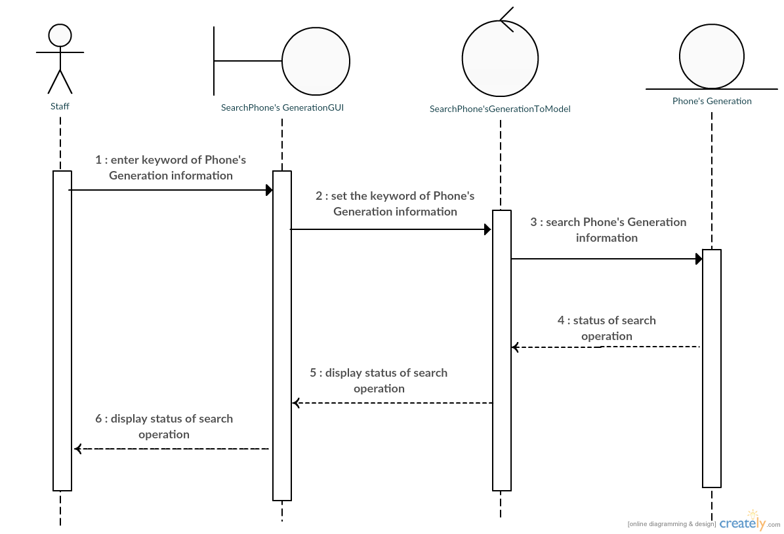

MissPuttinun Duangsamran 5730213038