**Use Case Overview**

**Use Case Diagram Level 1: Personal’s Management Sub-System (UC400)**

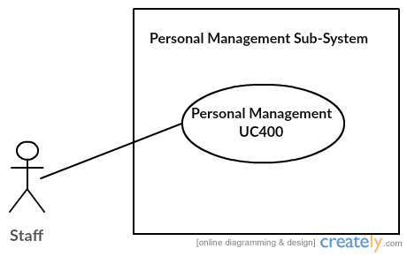

**Use Case Diagram Level 2: Personal’s Management Sub-System (UC400)**

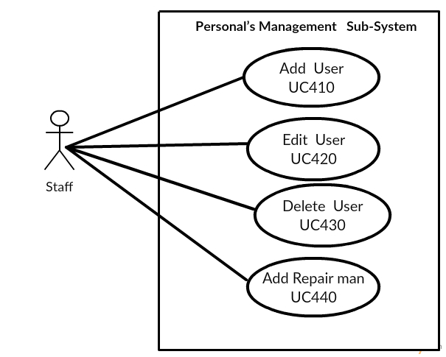

Sitta Chumklaew 5730213074

**Static Structure and Data Analysis**

**Model-View-Controller (MVC) Model**

**• Add User**

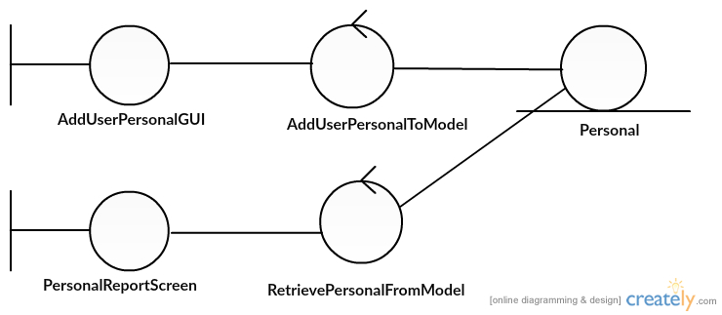

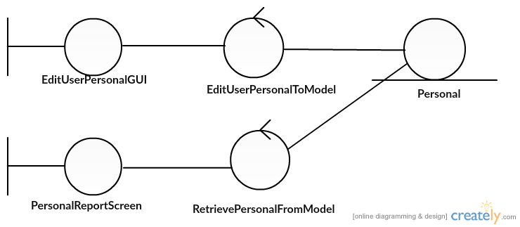**• Edit User**

Sitta Chumklaew 5730213074

* 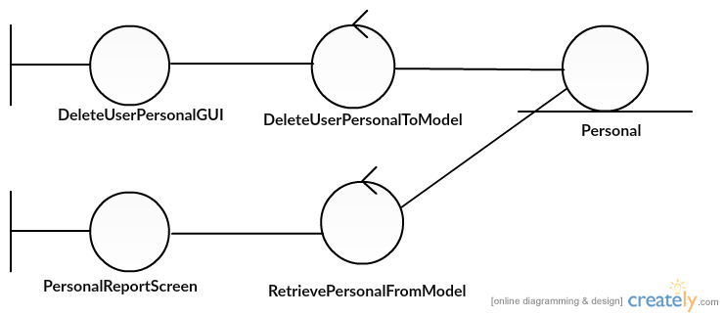**Delete**
* **Add Repairman**

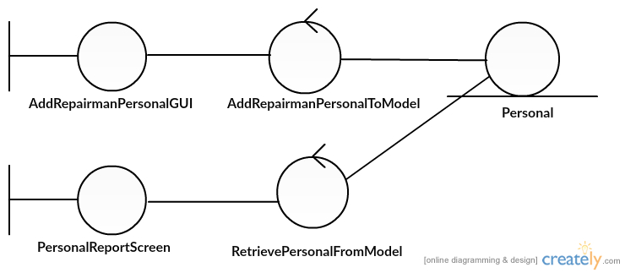

Sitta Chumklaew 5730213074

**System Behaviour Model**

**Sequence Diagram demonstrating operation “Add User, Edit User, Delete User,Add repairman”**

**4. Pesonal**

* 1. **Add User**
* 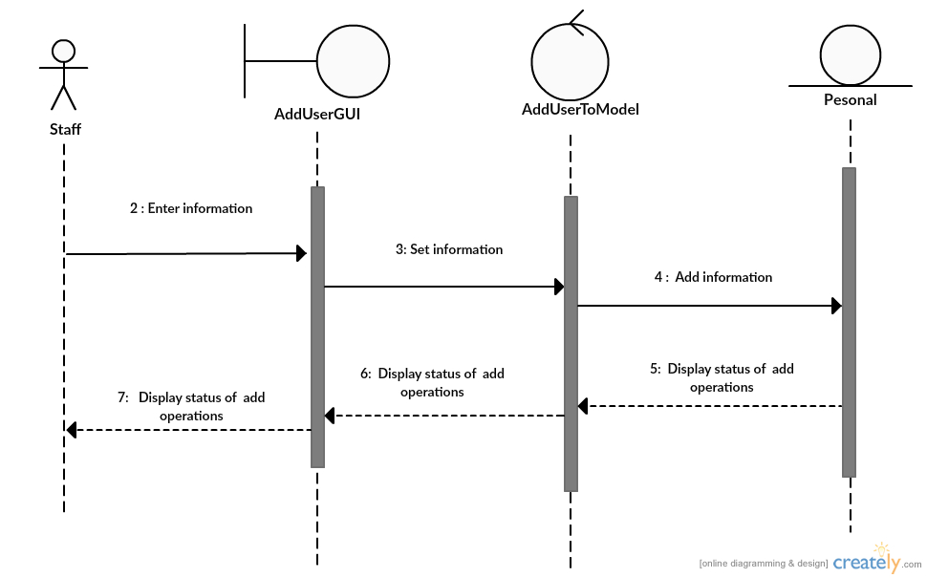This diagram describes the system scenario of “UC410: Add User”

Sitta Chumklaew 5730213074

* 1. **Edit Repairs**
* This diagram describes the system scenario of “UC420: Edit User”

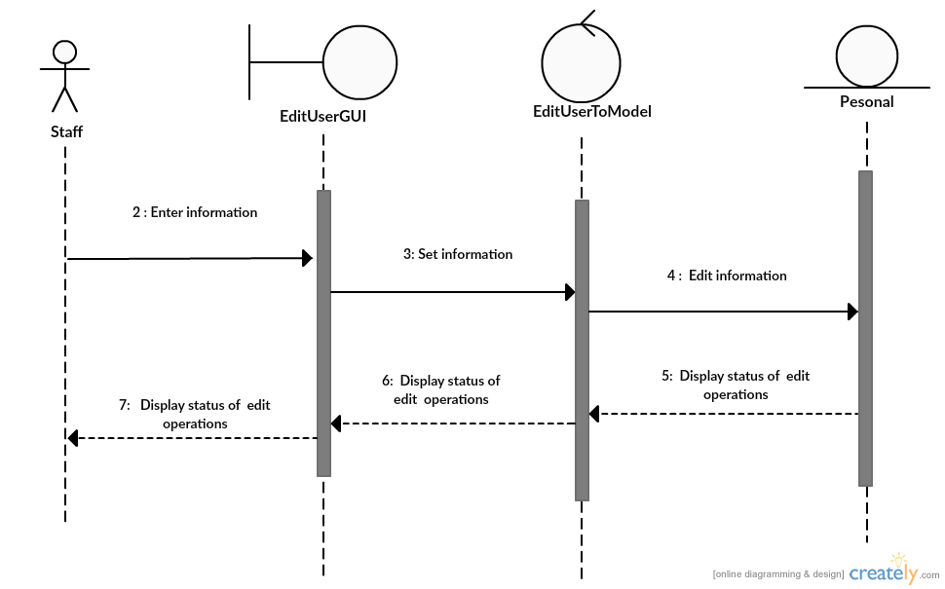

Sitta Chumklaew 5730213074

* 1. **Delete User**
* This diagram describes the system scenario of “UC430:Delete User”

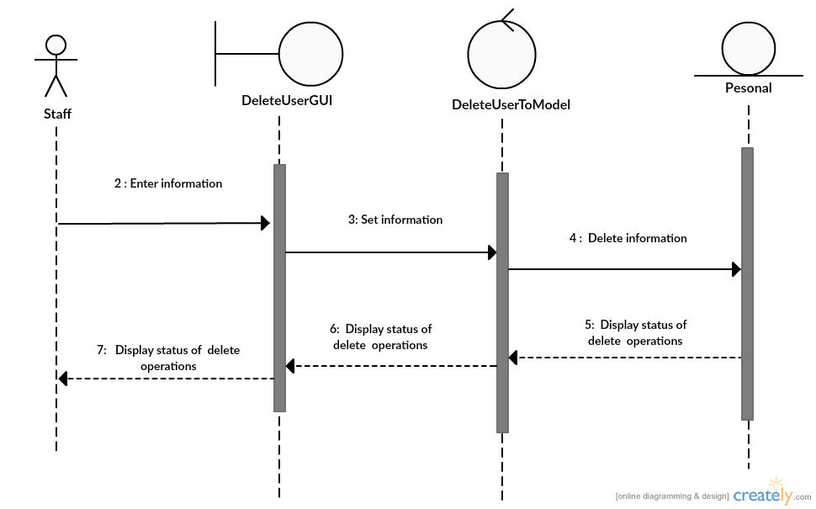

Sitta Chumklaew 5730213074

* 1. **Add Repairman**
* This diagram describes the system scenario of “UC440:Bill Repairs”

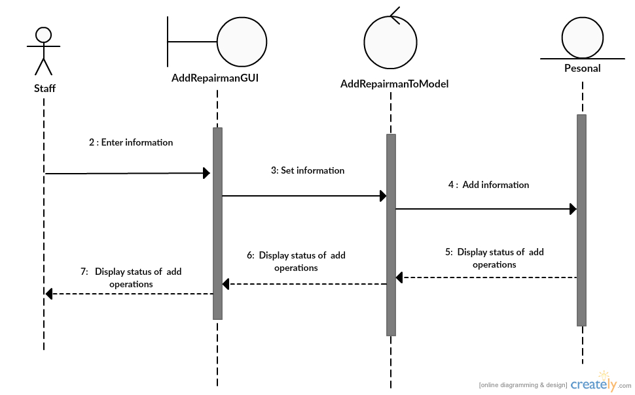

Sitta Chumklaew 5730213074