**Static Structure and Data Analysis**

**Model-View-Controller (MVC) Model**

* **Add Repairs**

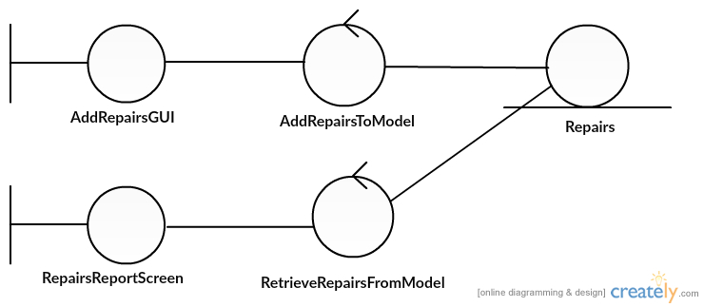

Miss Uraiwan Puekphet 5730213031 SE3

* **Edit Repairs**

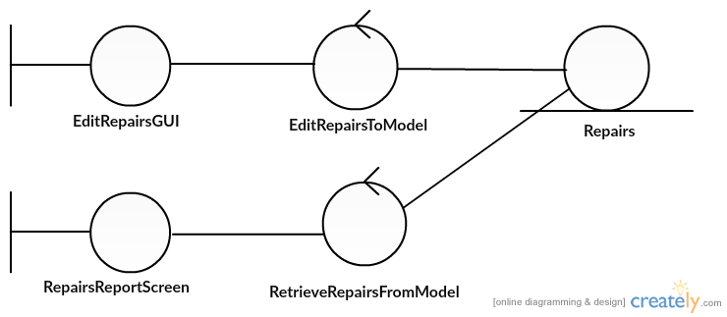

Miss Uraiwan Puekphet 5730213031 SE3

* **Delete Repairs**

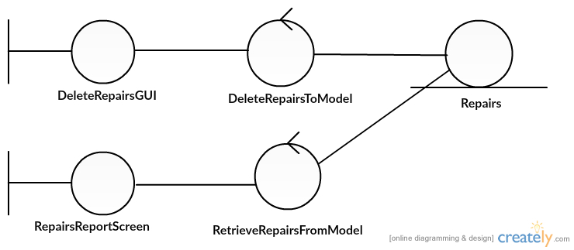

Miss Uraiwan Puekphet 5730213031 SE3

* **Print bill Repairs**

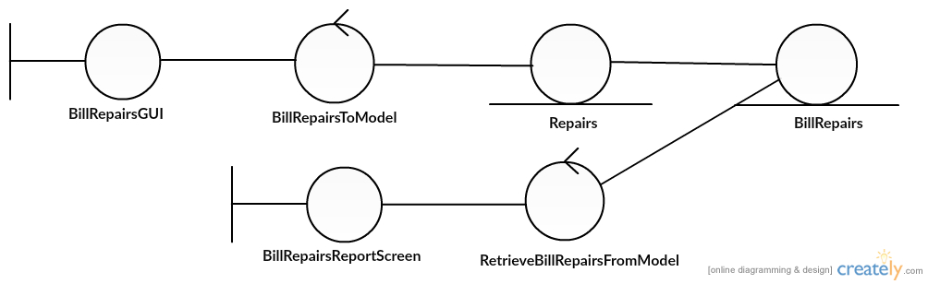

Miss Uraiwan Puekphet 5730213031 SE3

**System Behaviour Model**

**Sequence Diagram demonstrating operation “add, update, delete, bill repairs”**

1. **Repairs**
   1. **Add Repairs**

* This diagram describes the system scenario of “UC110: Add Repairs”

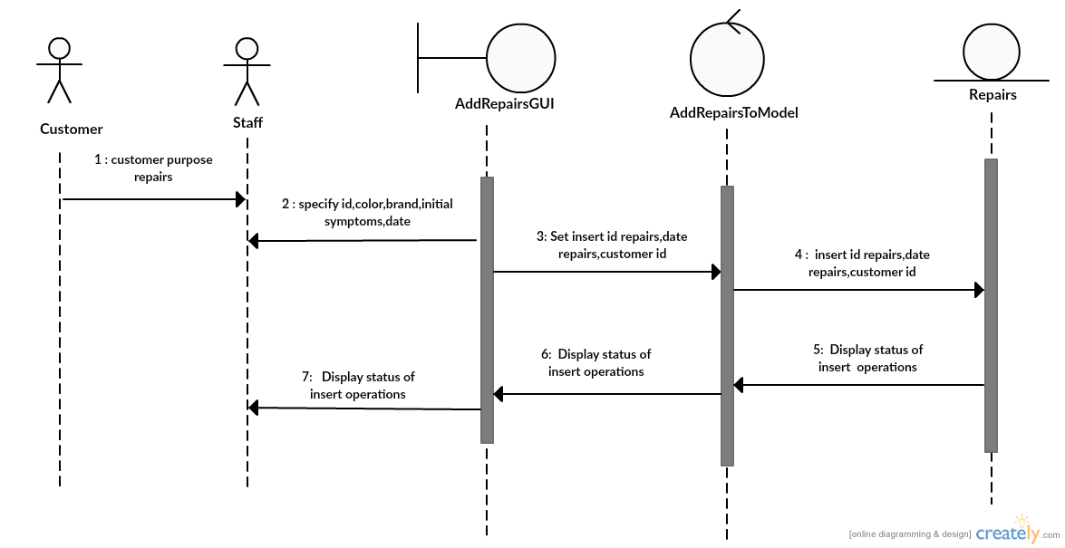

Miss Uraiwan Puekphet 5730213031 SE3

* 1. **Edit Repairs**
* This diagram describes the system scenario of “UC120: Edit Repairs”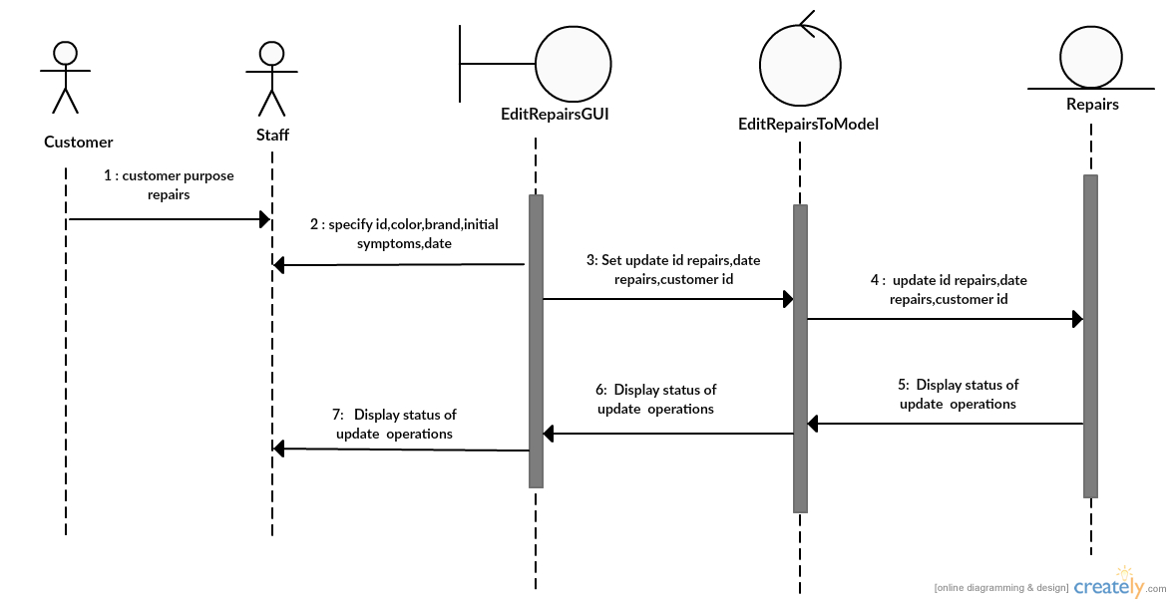

Miss Uraiwan Puekphet 5730213031 SE3

* 1. **Delete Repairs**
* This diagram describes the system scenario of “UC130:Delete Repairs”

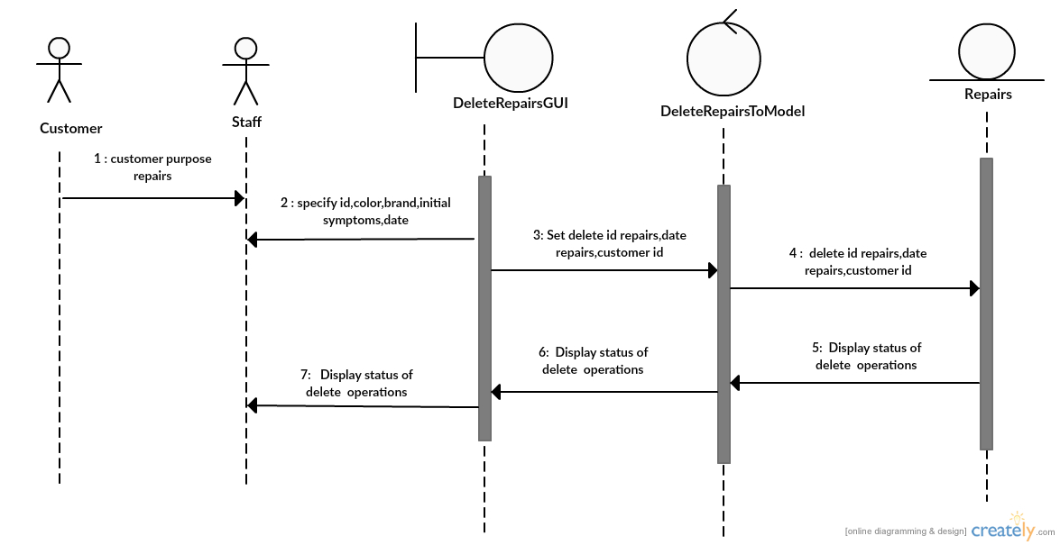

Miss Uraiwan Puekphet 5730213031 SE3

* 1. **Print bill Repairs**
* This diagram describes the system scenario of “UC140:Bill Repairs”

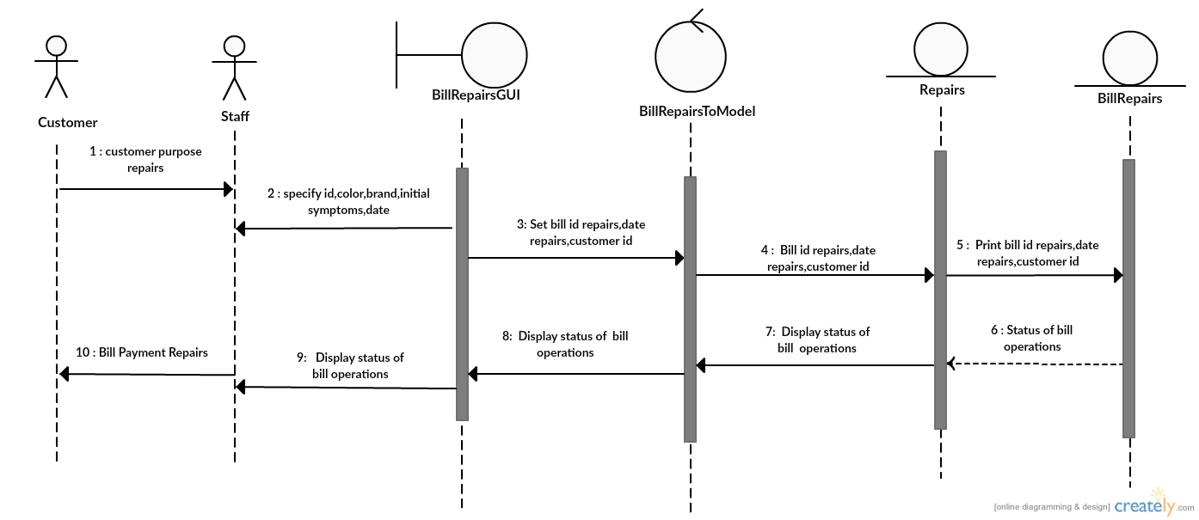

Miss Uraiwan Puekphet 5730213031 SE3