**Central Europe Women in STEM**

**Databases research:**

**Data set #1**

* **Women researchers by country (latest available)**

|  |  |  |  |  |  |
| --- | --- | --- | --- | --- | --- |
| **Country** | **Participation of female researchers (% of total for both sexes)** | **Engineering and technology (total number of researchers, both sexes)** | **Engineering and technology – Female researchers (%) (Head Count)** | **Natural Sciences – researchers (total number of researchers, both sexes)** | **Natural Sciences – Female researchers (%) (HC)** |
|  | | | | | |
| Armenia | 50,4 | 604 | 42,1 | 1580 | 46,5 |
| Azerbaijan | 58,6 | 1 773 | 52 | 4820 | 61,4 |
| Georgia | 53 | 1 913 | 38,2 | 2224 | 46,6 |
| Turkey | 37 | 63 757 | 25,5 | 17091 | 37,5 |
|  | | | | | |
| Belarus | 39,3 | 10 650 | 28,7 | 3 573 | 48,9 |
| Moldova | 48,6 | 445 | 23,1 | 1 083 | 50 |
| Ukraine | 44,7 | 24 138 | 34,1 | 14634 | 43 |
|  | | | | | |
| Albania | 44.3 | n/a | n/a | n/a | n/a |
| Bosnia and Herzegovina | 47,1 | 646 | 37 | 349 | 48,7 |
| Kosovo* | n/a | n/a | n/a | n/a | n/a |
| Montenegro | 49,9 | 376 | 35,6 | 245 | 49,8 |
| North Macedonia | 53,4 | 875 | 42,9 | 758 | 57 |
| Serbia | 51,4 | 4 553 | 40,4 | 3 676 | 58,1 |
|  | | | | | |
| Kazakhstan | 52,8 | 4 785 | 44 | 5 281 | 53,4 |
| Kyrgyzstan | 46,5 | 543 | 33,3 | 1 085 | 44,9 |
| Uzbekistan | 40,8 | 5 261 | 31,2 | 8 959 | 56,1 |
| Tajikistan | 37,5 | 158 | 24,1 | 541 | 36,2 |
| Turkmenistan | n/a | n/a | n/a | n/a | n/a |

Data source: [Human Resources in R&D UIS Statistics](http://data.uis.unesco.org/) ;   
Methodological note: latest available no older than 2014.

* **Education (latest available)**

|  |  |  |  |  |  |  |  |  |  |  |  |
| --- | --- | --- | --- | --- | --- | --- | --- | --- | --- | --- | --- |
| **Country** | **Women as % of total graduates from master's programs (all disciplines) (2017)** | **Female tertiary students (% of total) (latest available)** | **Engineering manufacturing and construction**  **(tertiarylevel; female students; %)** | **Information and communication technologies**  **(tertiary level; female students; %)** | **Natural sciences mathematics and statistics**  **(tertiary level; female students; %)** | **Share of womenSTEM Graduates (World Bank)** | **School entrolment, tertiary (men, % of total)** | **School entrolment, tertiary (women, % of total)** | **Women share of graduates in engineering., manufacturing and construction, tertiary (% of both sexes) (WB)** | **Women graduates of ICT programmes (tertiary, % of both sexes) (WB)** | **Women graduates in Science programmes (tertiary, % of boh sexes) (WB)** |
| Caucasus and Turkey | | | | | |  |  |  |  |  |  |
| Armenia | n/a | 56,3 | n/a | n/a | n/a | 33 | 44,4 | 59,4 | 22,4 | 38,5 | 60,5 |
| Azerbaijan | 57,4 | 51 | 25,7 | 30,5 | 60,9 | 40 | 29,3 | 34 | 26,6 | 46 | 65,3 |
| Georgia | 65,1 | 50,2 | 13,8 | 15 | 62,2 | 44 | 60,2 | 68,1 | 15,7 | 20,6 | 68,1 |
| Turkey | 44,6 | 46,5 | 24,2 | 26,2 | 50 | n/a | n/a | n/a | n/a | n/a | n/a |
| Western CIS | | | | | |  |  |  |  |  |  |
| Belarus | 50,3 | 52,9 | 21,7 | 21,3 | 62,3 | 27 | 80,2 | 95,1 | 23,2 | 23 | 62 |
| Moldova | 62,6 | 56,1 | n/a | n/a | n/a | 32 | 33,5 | 45,2 | 29,7 | 22,9 | 54,8 |
| Ukraine | 53,8 | 51,6 | 24,6 | 16,9 | 55,5 | 27 | n/a | n/a | 25,2 | 17,5 | 58,3 |
| Western Balkans | | | | | |  |  |  |  |  |  |
| Albania | 65 | 56,7 | 33,3 | 38,5 | 66,6 | 49 | 46,9 | 73,3 | 38,3 | 43,7 | 69,9 |
| Bosnia and Herzegovina | 61,6 | 56 | 37,8 | 24,9 | 69,3 | 43 | 32,4 | 48,5 | 39,4 | 28,2 | 71,9 |
| Kosovo* | n/a | n/a | n/a | n/a | n/a | n/a | n/a | n/a | n/a | n/a | n/a |
| Montenegro | n/a | 55,5 | n/a | n/a | n/a | n/a | 46,6 | 62,4 | n/a | n/a | n/a |
| North Macedonia | 59,2 | 55,5 | 43,9 | 31,4 | 67,8 | 45 | 37,3 | 49,2 | 47,2 | 35,1 | 69,5 |
| Serbia | n/a | 55,8 | 38,2 | 27,4 | 66,1 | 40 | 57 | 79,3 | 38,5 | 28,6 | 71,2 |
| Central Asia | | | | | |  |  |  |  |  |  |
| Kazakhstan | 60,3 | 55,5 | 30,9 | 31,9 | 63,7 | 33 | 55,4 | 68,4 | 28,5 | 30,4 | 67 |
| Kyrgyzstan | 55,7 | 55,5 | n/a | n/a | n/a | 39 | 37,4 | 47,4 | 18,4 | 47,4 | 72,9 |
| Uzbekistan | n/a | 40,0 | n/a | n/a | n/a | n/a | 13,7 | 11,4 | 17,7 | 17,8 | 52,3 |
| Tajikistan | n/a | 39,3 | n/a | n/a | n/a | n/a | 35,5 | 26,9 | n/a | n/a | n/a |
| Turkmenistan | n/a | 38,5 | n/a | n/a | n/a | n/a | 15,6 | 12,8 | n/a | n/a | n/a |

Source: UNECE: [Graduates by type of programme and sex](https://w3.unece.org/PXWeb2015/pxweb/en/STAT/STAT__30-GE__04-EducatAndcommunicat/005_en_GEECGraduates_r.px/); [Tertiary students by field of study (ISCED-F 2013) and sex](https://w3.unece.org/PXWeb2015/pxweb/en/STAT/STAT__30-GE__04-EducatAndcommunicat/007_en_GEECTertStudISCEDF_r.px/); [Female tertiary students, % of total](https://w3.unece.org/PXWeb2015/pxweb/en/STAT/STAT__10-CountryOverviews__01-Figures/ZZZ_en_CoSummary_r.px/), World Bank [Share of female STEM graduates](https://blogs.worldbank.org/opendata/there-are-fewer-female-male-stem-graduates-107-114-economies), [Gender Statistics - graduates by field](https://databank.worldbank.org/source/gender-statistics) School enrollment, tertiary ([men](https://databank.worldbank.org/indicator/SE.TER.ENRR.MA?id=2ddc971b&report_name=Gender_Indicators_Report&populartype=series), [women](https://databank.worldbank.org/indicator/SE.TER.ENRR.FE?id=2ddc971b&report_name=Gender_Indicators_Report&populartype=series))

Methodological note: based on the most recent data available no older than 2013.

* **Gender pay gap**

|  |  |  |
| --- | --- | --- |
| Country | Gender pay gap in monthly earnings | Gender pay gap in monthly earnings (tertiary education) |
| Caucasus and Turkey | |  |
| Armenia | 32,5 | n/a |
| Azerbaijan | 49,4 | n/a |
| Georgia | 35,7 | n/a |
| Turkey | n/a | n/a |
| Western CIS | |  |
| Belarus | 25,4 | 35,9 |
| Moldova | 13,5 | n/a |
| Ukraine | 21,2 | 27,6 |
| Western Balkans | |  |
| Albania | 10,5 | 14,8 |
| Bosnia and Herzegovina | n/a | n/a |
| Kosovo* | n/a | n/a |
| Montenegro | n/a | n/a |
| North Macedonia | 8,8 | 16,3 |
| Serbia | 18 | n/a |
| Central Asia | |  |
| Kazakhstan | 32,2 | n/a |
| Kyrgyzstan | 27,5 | n/a |
| Uzbekistan | n/a | n/a |
| Tajikistan | n/a | n/a |
| Turkmenistan | n/a | n/a |

Source: UNECE ([Country overview...](https://w3.unece.org/PXWeb2015/pxweb/en/STAT/STAT__10-CountryOverviews__01-Figures/))

* **Computer use (latest available, no older than 2012)**

|  |  |  |  |  |
| --- | --- | --- | --- | --- |
| **Country** | **Computer use (women, age: 16-24; %)** | **Computer use (men, age: 16-24; %)** | **Computer use (women, age: 25-54; %)** | **Computer use (men, age: 25-54; %)** |
| Caucasus and Turkey | | | |  |
| Armenia | 80,5 | 76 | 72 | 71,3 |
| Azerbaijan | 92,6 | 90,3 | 68,3 | 70,3 |
| Georgia | 93 | 87,3 | 73 | 71 |
| Turkey | 60 | 76 | 38 | 57 |
| Western CIS | | | |  |
| Belarus | 95,5 | 97,3 | 85,9 | 81,7 |
| Moldova | n/a | n/a | n/a | n/a |
| Ukraine | n/a | n/a | n/a | n/a |
| Western Balkans | | | |  |
| Albania | 51,5 | 62,7 | 18,5 | 24,4 |
| Bosnia and Herzegovina | n/a | n/a | n/a | n/a |
| Kosovo* | n/a | n/a | n/a | n/a |
| Montenegro | 95 | 87,1 | 64,3 | 67,8 |
| North Macedonia | 81 | 94 | 72 | 79 |
| Serbia | 93,9 | 96,9 | 80,1 | 85,5 |
| Central Asia | | | |  |
| Kazakhstan | 19,9 | 22,6 | 68,6 | 67,1 |
| Kyrgyzstan | n/a | n/a | n/a | n/a |
| Uzbekistan | 67,8 | 75,3 | 38 | 45,7 |
| Tajikistan | n/a | n/a | n/a | n/a |
| Turkmenistan | n/a | n/a | n/a | n/a |

Source: UNECE: [Computer use](https://w3.unece.org/PXWeb2015/pxweb/en/STAT/STAT__10-CountryOverviews__01-Figures/ZZZ_en_CoSummary_r.px/)

* **Women teachers in tertiary education and in leadership positions (latest available)**

|  |  |  |  |  |  |  |  |  |  |
| --- | --- | --- | --- | --- | --- | --- | --- | --- | --- |
| **Country** | **Women academic staff in tertiary education (% of total for both sexes)** | **Women heads of universities (% of total)** | **Women in managerial positions**  **(% of total)** | **Women in in senior and middle management positions**  **(% of total)** | **Firms with women top manager (% of total; World Bank)** | **Share of women business owners (% of total business owners)** | **Share of women-directors (% of total directors)** | **Self-employed women (% of female employment)** | **Self-employed men (% of male employment)** |
| Caucasus and Turkey | | | |  |  |  |  |  |  |
| Armenia | 59,5 | 15,4 | 25,8 | n/a | 19,1 | n/a | n/a | 38,4 | 41,1 |
| Azerbaijan | 56,2 | n/a | 35,8 | n/a | 16,5 | 16 | 11,1 | 72,9 | 63,5 |
| Georgia | 56,8 | 21,3 | 36,6 | n/a | 16,5 | 27 | 27,5 | 50,6 | 51,4 |
| Turkey | 44,4 | n/a | 16,2 | 17,5 | 3,9 | 16,6 | n/a | 33,3 | 30,6 |
| Western CIS | | | |  |  |  |  |  |  |
| Belarus | 60,6 | 10,9 | 49,1 | n/a | 21,1 | 24,8 | 24,1 | 2,8 | 5,6 |
| Moldova | 57,4 | 21,4 | 45,7 | n/a | 18,6 | n/a | n/a | 34,1 | 41,3 |
| Ukraine | n/a | 2,8 | 41,3 | n/a | 17,7 | n/a | n/a | 13,5 | 17,8 |
| Western Balkans | | | |  |  |  |  |  |  |
| Albania | 56,6 | 9,1 | 34,1 | 41,3 | 18,1 | 18,8 | 19,8 | 53,8 | 56,5 |
| Bosnia and Herzegovina | 45 | n/a | 24,3 | 25,4 | 16,6 | n/a | n/a | 20,7 | 21,3 |
| Kosovo* | n/a | n/a | n/a | n/a | 2,7 | 18,6 | n/a | n/a |  |
| Montenegro | 48,7 | n/a | 35,8 | 28,2 | 15 | n/a | n/a | 13,7 | 27,6 |
| North Macedonia | 46,4 | n/a | 26,3 | 28,1 | 21,3 | 29,9 | 31,2 | 19 | 26,1 |
| Serbia | 47,9 | 11,8 | 32,7 | 33,6 | 18,2 | 26,7 | 26,9 | 23,4 | 31,4 |
| Central Asia | | | |  |  |  |  |  |  |
| Kazakhstan | 66,3 | 12,3 | 37 | n/a | 26 | 28,6 | n/a | 23,7 | 25,4 |
| Kyrgyzstan | 64,0 | n/a | 37,8 | n/a | 32,9 | n/a | n/a | 28,9 | 39,4 |
| Uzbekistan | 43,6 | n/a | n/a | n/a | 12,4 | n/a | n/a | 45,3 | 42,1 |
| Tajikistan | 37,3 | n/a | 14,8 | n/a | 6,6 | 7,8 | 27,6 | 46,9 | 40,5 |
| Turkmenistan | 46,5 | n/a | n/a | n/a | n/a | n/a | n/a | 25,9 | 27,9 |

Source: UNECE [Teachers by Level of Education, Sex, Measurement, Country and Year](https://w3.unece.org/PXWeb2015/pxweb/en/STAT/STAT__30-GE__04-EducatAndcommunicat/008_en_GEECTeachers_r.px/table/tableViewLayout1/), [Heads of universities by Sex, Measurement, Country and Year](https://w3.unece.org/PXWeb2015/pxweb/en/STAT/STAT__30-GE__05-PublicAnddecision/909_en_GEPDHeadsUni_r.px/table/tableViewLayout1/), [Goal 5: Gender equality by Indicator, Country and Year](https://w3.unece.org/PXWeb2015/pxweb/en/STAT/STAT__92-SDG__01-sdgover/005_en_sdGoal5_r.px/), ILO [Female share of employment in managerial positions](https://www.ilo.org/shinyapps/bulkexplorer4/?lang=en&segment=indicator&id=SDG_0552_OCU_RT_A) ; World Bank:  [Gender Statistics](https://databank.worldbank.org/indicator/IC.FRM.FEMM.ZS?id=2ddc971b&report_name=Gender_Indicators_Report&populartype=series), [Tertiary education, academic staff, female](https://databank.worldbank.org/indicator/SE.TER.TCHR.FE.ZS?id=2ddc971b&report_name=Gender_Indicators_Report&populartype=series)

* **Medium and high-tech industry value added in total value added**

|  |  |  |  |  |
| --- | --- | --- | --- | --- |
| **Country / Year** | **2002** | **2007** | **2012** | **2017** |
| **Caucasus and Turkey** | | | | |
| **Armenia** | 7.8 | 3.9 | 4.5 | 4.6 |
| **Azerbaijan** | 24.9 | 19.9 | 12.5 | 19.1 |
| **Georgia** | 15.0 | 15.8 | 16.0 | 8.6 |
| **Turkey** | 27.3 | 31.6 | 32.0 | 32.2 |
| **Western CIS** | | | | |
| **Belarus** | 42.0 | 42.0 | 43.3 | 38.8 |
| **Moldova** | 7.2 | 7.8 | 12.3 | 19.5 |
| **Ukraine** | 33.1 | 33.1 | 35.0 | 29.2 |
| **Western Balkans** | | | | |
| **Albania** | 7.8 | 18.9 | 17.1 | 4.5 |
| **Bosnia and Herzegovina** | 16.1 | 16.1 | 19.3 | 17.3 |
| **Kosovo\*** | n/a | n/a | n/a | n/a |
| **Montenegro** | 16.3 | 16.3 | 18.9 | 14.9 |
| **North Macedonia** | 8.0 | 12.7 | 23.5 | 29.6 |
| **Serbia** | 24.4 | 22.1 | 20.1 | 26.8 |
| **Central Asia** | | | | |
| **Kazakhstan** | 7.1 | 6.9 | 14.1 | 13.3 |
| **Kyrgyzstan** | 5.7 | 8.9 | 6.7 | 2.7 |
| **Tajikistan** | 2.7 | 1.3 | 3.0 | 2.2 |
| **Turkmenistan** | n/a | n/a | n/a | n/a |
| **Uzbekistan** | n/a | n/a | n/a | n/a |

Source: UNECE [Goal 9: Industry, innovation and infrastructure by Indicator, Country and Year](https://w3.unece.org/PXWeb2015/pxweb/en/STAT/STAT__92-SDG__01-sdgover/009_en_sdGoal9_r.px/table/tableViewLayout1/)

Figure [Medium and high-tech Industry (including construction) (% manufacturing value added) - Armenia, Azerbaijan, Georgia, Turkey](https://data.worldbank.org/indicator/NV.MNF.TECH.ZS.UN?locations=AM-AZ-GE-TR), World Bank

Figure [Medium and high-tech Industry (including construction) (% manufacturing value added) - Belarus, Moldova, Ukraine](https://data.worldbank.org/indicator/NV.MNF.TECH.ZS.UN?locations=BY-MD-UA), World Bank

Figure [Medium and high-tech Industry (including construction) (% manufacturing value added) - Albania, Bosnia and Herzegovina, Montenegro, North Macedonia, Serbia](https://data.worldbank.org/indicator/NV.MNF.TECH.ZS.UN?locations=AL-BA-ME-MK-RS), World Bank

Figure [Medium and high-tech Industry (including construction) (% manufacturing value added) - Kazakhstan, Kyrgyz Republic, Tajikistan, Uzbekistan](https://data.worldbank.org/indicator/NV.MNF.TECH.ZS.UN?locations=KZ-KG-TJ-UZ), World Bank

**Regional statistics (Open Source):**

* The vast majority of data are presented in headcounts (HC), which are the total number of persons employed in R&D. This includes staff employed both full-time and part-time. The regional averages for the share of female researchers (based on available data only) for 2016 are:   
  48.2% for Central Asia   
  45.1% for Latin America and the Caribbean   
  41.5% for Arab States   
  39.3% for Central and Eastern Europe   
  32.7% for North America and Western Europe   
  31.8% for Sub-Saharan Africa   
  29.3% for World   
  23.9% for East Asia and the Pacific   
  18.5% for South and West Asia

Source: [Fact Sheet No. 55: Women in Science](http://uis.unesco.org/sites/default/files/documents/fs55-women-in-science-2019-en.pdf) UNESCO

* Brain drain:

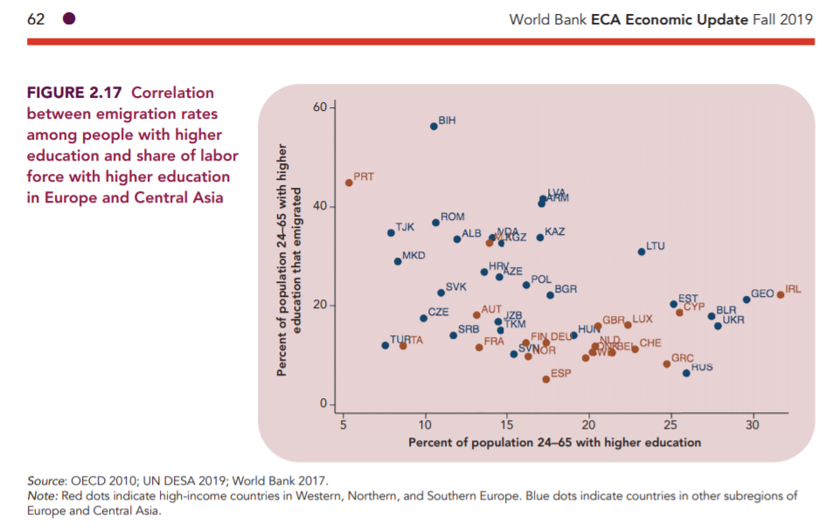

* **Women ICT specialists in Montenegro, North Macedonia, Serbia and Turkey (EUROSTAT)**

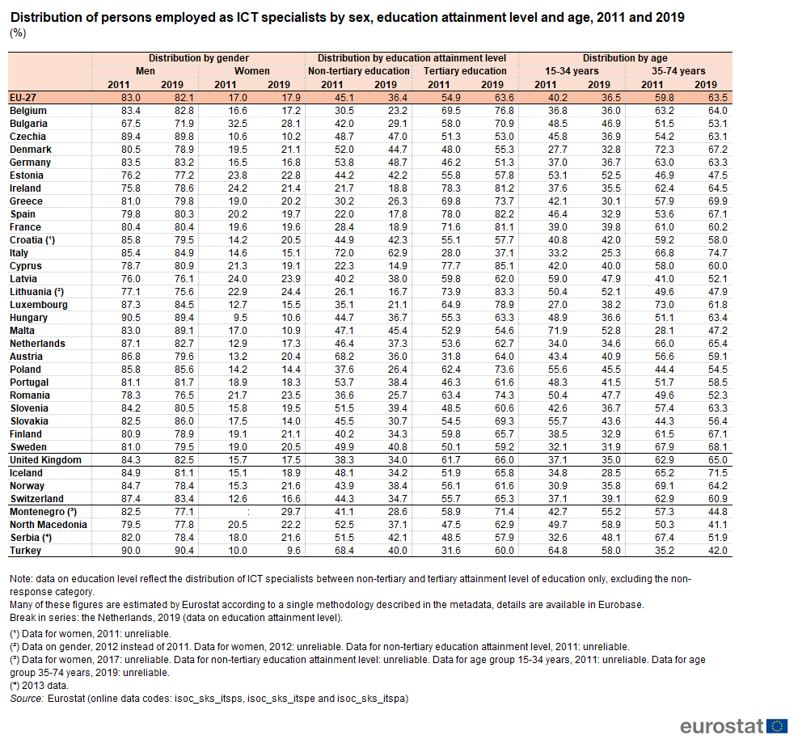

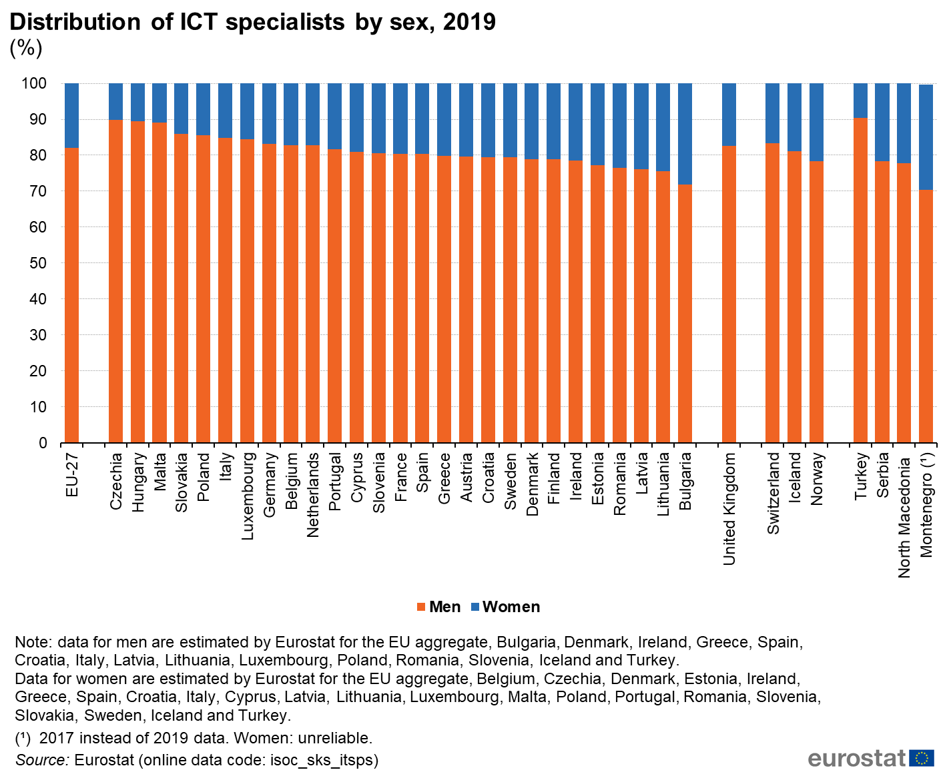

Link : [EUROSTAT](https://ec.europa.eu/eurostat/statistics-explained/index.php/ICT_specialists_in_employment#ICT_specialists_by_sex); databases: [(isoc_sks_itsps)](https://ec.europa.eu/eurostat/databrowser/view/isoc_sks_itsps/default/table?lang=en), [(isoc_sks_itspe)](https://ec.europa.eu/eurostat/databrowser/view/isoc_sks_itspe/default/table?lang=en) and [(isoc_sks_itspa)](https://ec.europa.eu/eurostat/databrowser/view/isoc_sks_itspa/default/table?lang=en)

* [Women’s empowerment](http://hdr.undp.org/en/content/dashboard-3-women%E2%80%99s-empowerment-0) Human Development Reports UNDP (2019);

**Country profiles (Open Source):**

**Armenia**

* 7,7 % - Percentage of adult respondents who reported plans to move permanently to another country in the next 12 months (estimate), ([Gallup](http://gmdac.iom.int/gmdac-data-briefing-measuring-global-migration-potential-2010-2015), 2016)
* Information and Communications Technology (ICT) is one of the fastest growing sectors in Armenia. In 2018, Software and Services and Internet Service Providers accounted for 7.4% of Armenia’s GDP of $12.4 billion, up from 3.6% of GDP in 2013. (EU4Digital)
* **In 2018 19,522 employees were registered in Armenia’s Information and Communication Technologies sector, 27% more than the previous year. However, the vast majority of professionals in the industry – 68% – remain male (**[**EU4Digital**](https://eufordigital.eu/how-to-ensure-rapid-development-in-the-it-sector-eu4digital-highlights-women-as-the-key-to-growth/)**).**
* Population of Armenia is fewer than 3 million, around 1 000 000 lives in Yerevan and out of that number more than 22,000 are working in the IT industry. Around 3,000 positions are open ([IT is Armenia](http://itis.am/womenintech/eng))
* the country’s tech sector employs 30 percent women–larger than the 20 percent global average of women employed in IT ([Forbes](https://www.forbes.com/sites/jackieabramian/2020/08/07/two-women-tech-executives-in-armenia-navigate-the-once-male-dominated-sector/?sh=302392a241c9)).
* According to the statistics provided by the Ministry of Labour and Social Affairs, there are about 193,000 persons with disabilities registered in Armenia in 2018, of which 90,000 are women with disabilities ([IFES](https://www.ifes.org/sites/default/files/armenia_agate_research_report_eng_august_2018.pdf) 2018)

**Azerbaijan**

* 1,3% - Percentage of adult respondents who reported plans to move permanently to another country in the next 12 months (estimate), ([Gallup](http://gmdac.iom.int/gmdac-data-briefing-measuring-global-migration-potential-2010-2015), 2016)
* **Women now account for 29.7% of the 26,500 employees working in the field. The number of women using technologies is on the rise every year. For example, nowadays 47% of** employees who use the Internet are women. Women are actively involved in social media. In Azerbaijan, 34% of Facebook users and 36% of Instagram users are women ([EU4digital](https://eufordigital.eu/digital-growth-working-towards-gender-equality-in-it-in-azerbaijan/))
* [The world needs science and science needs women and girls — today, tomorrow and every day](https://medium.com/@azerbaijan.undp/the-world-needs-science-and-science-needs-women-and-girls-today-tomorrow-and-every-day-c30742346ccf) Meduza

**Georgia**

* The study conducted in 2017 by CRRC in Georgia for the GYLA and the CIPDD shows that before leaving the country 37% of emigrants had acquired secondary education, 19% had obtained secondary technical or secondary special education, 11% held a Bachelor’s degree, 7% held a Master’s degree, and 22% had five years of higher education (specialist diploma) ([Prague Process](https://www.pragueprocess.eu/phocadownload/userupload/Irina/migration_profile_2017_eng__final_.pdf))
* just 12% of women in Georgia are employed in science, technology and engineering; An average of 25% of students on IT programmes are girls ([EU4Digital](https://eufordigital.eu/how-women-can-change-the-field-of-innovation-in-georgia/))
* 0,4% - Percentage of adult respondents who reported plans to move permanently to another country in the next 12 months (estimate), ([Gallup](http://gmdac.iom.int/gmdac-data-briefing-measuring-global-migration-potential-2010-2015), 2016)

**Turkey**

* 1,6% - Percentage of adult respondents who reported plans to move permanently to another country in the next 12 months (estimate), ([Gallup](http://gmdac.iom.int/gmdac-data-briefing-measuring-global-migration-potential-2010-2015), 2016)
* From 2016 to 2018, TURKSTAT data shows that the number of women in IT fell from 61,000 to 52,000 ([Pulitzer Center](https://pulitzercenter.org/reporting/turkeys-booming-tech-industry-where-are-women))
* Gender Wage Gap is 15.6% (…) In 2018, the highest gender wage gap is observed (38.6%) among wage workers with elementary or less education and the lowest (15.8%) among workers with a tertiary education and higher ([ILO](https://www.ilo.org/wcmsp5/groups/public/---europe/---ro-geneva/---ilo-ankara/documents/publication/wcms_756660.pdf))
* <https://www.honeypot.io/women-in-tech-2018/>
* **The gender gap among ICT specialists in 2019 in Turkey: men accounted for 90.4 % of the ICT workforce compared with 9.6 % for women (**[**EUROSTAT**](https://ec.europa.eu/eurostat/statistics-explained/index.php/ICT_specialists_in_employment#ICT_specialists_by_sex)**)**

**Belarus**

* 0,6 % - Percentage of adult respondents who reported plans to move permanently to another country in the next 12 months (estimate), ([Gallup](http://gmdac.iom.int/gmdac-data-briefing-measuring-global-migration-potential-2010-2015), 2016)

**Moldova**

* 5% - Percentage of adult respondents who reported plans to move permanently to another country in the next 12 months (estimate), ([Gallup](http://gmdac.iom.int/gmdac-data-briefing-measuring-global-migration-potential-2010-2015), 2016)
* In the Republic of Moldova, the ICT sector accounts for about 6.8% of the country’s Gross Domestic Product, with a turnover of over 13 billion lei in 2018. In the last three years, the volume of IT exports has increased by 89%, from a value of $59 million to $148 million, of which 70% are IT services exported to Great Britain, the USA, France, Germany, the Netherlands, and Romania. The 2019 International Data Corporation (IDC) report estimates that the most successful segment in the coming years will be research and development (R&D) and engineering services in the IT field ([EU4Digital](https://eufordigital.eu/embracing-a-career-in-it-how-support-for-ict-innovation-is-reversing-the-brain-drain-in-moldova-and-setting-an-example-in-the-region/))
* **There are now about 27,000 working IT specialists in the Republic of Moldova, of which 10,000 in the more than 500 resident companies operating in the Moldova IT Park. Of the total number of employees, almost 30% are women (**[**EU4Digital**](https://eufordigital.eu/embracing-a-career-in-it-how-support-for-ict-innovation-is-reversing-the-brain-drain-in-moldova-and-setting-an-example-in-the-region/)**)**

**Ukraine**

* 1,3 % - Percentage of adult respondents who reported plans to move permanently to another country in the next 12 months (estimate), ([Gallup](http://gmdac.iom.int/gmdac-data-briefing-measuring-global-migration-potential-2010-2015), 2016)
* According to the [data](http://www.n-ix.com/software-development-in-ukraine-2019-2020-market-report/) provided by the Ukrainian digital company N-iX, information and communications technology (ICT) take third place in volume of services export, representing one-fifth of Ukraine’s service exports. Revenue in the ICT sector by itself is growing by 26% each year, the number of companies in the field overtaking 4,000. The number of specialists employed in the industry in 2020 reached almost 200,000 ([EU4Digital](https://eufordigital.eu/ukrainian-it-industry-looking-for-further-growth-and-opening-opportunities-for-women/))
* **The number of women employed in the IT industry in Ukraine is steadily growing, but still represents hardly a quarter of the total number of IT specialists. Ukrainian online service YouControl calculated how many female individual entrepreneurs there were in the IT-industry in Ukraine. In 2019 in comparison to 2017, the number of individual female entrepreneurs in IT grew by 62%. Moreover, in comparison to 2018, in 2019 the number of female individual entrepreneurs in IT grew faster than the overall number (+24% of women against +19% overall). (**[**EU4Digital**](https://eufordigital.eu/ukrainian-it-industry-looking-for-further-growth-and-opening-opportunities-for-women/)**)**

**Albania**

* 15,8 % - Percentage of adult respondents who reported plans to move permanently to another country in the next 12 months (estimate), ([Gallup](http://gmdac.iom.int/gmdac-data-briefing-measuring-global-migration-potential-2010-2015), 2016)

**Bosnia and Herzegovina**

* 4,4% - Percentage of adult respondents who reported plans to move permanently to another country in the next 12 months (estimate), ([Gallup](http://gmdac.iom.int/gmdac-data-briefing-measuring-global-migration-potential-2010-2015), 2016)

**Kosovo\***

* **Only 22% of Internet Communication Technology (ICT) sector employees are women (**[**Kosovo Gender Analysis**](https://womensnetwork.org/wp-content/uploads/2018/10/womens-network.pdf) **2018)**

**Montenegro**

* 1 % - Percentage of adult respondents who reported plans to move permanently to another country in the next 12 months (estimate), ([Gallup](http://gmdac.iom.int/gmdac-data-briefing-measuring-global-migration-potential-2010-2015), 2016)

**North Macedonia**

* 5% - Percentage of adult respondents who reported plans to move permanently to another country in the next 12 months (estimate), ([Gallup](http://gmdac.iom.int/gmdac-data-briefing-measuring-global-migration-potential-2010-2015), 2016)

**Serbia**

* 2,5% - Percentage of adult respondents who reported plans to move permanently to another country in the next 12 months (estimate), ([Gallup](http://gmdac.iom.int/gmdac-data-briefing-measuring-global-migration-potential-2010-2015), 2016)
* The average annual growth of ICT specialists in employment was observed in Serbia, with rates of 8.9 % for men and 13.0 % for women ([EUROSTAT](https://ec.europa.eu/eurostat/statistics-explained/index.php/ICT_specialists_in_employment#ICT_specialists_by_sex))

**Kazakhstan**

* 0,7 % - Percentage of adult respondents who reported plans to move permanently to another country in the next 12 months (estimate), ([Gallup](http://gmdac.iom.int/gmdac-data-briefing-measuring-global-migration-potential-2010-2015), 2016)

**Kyrgyzstan**

* 1,3% - Percentage of adult respondents who reported plans to move permanently to another country in the next 12 months (estimate), ([Gallup](http://gmdac.iom.int/gmdac-data-briefing-measuring-global-migration-potential-2010-2015), 2016)

**Tajikistan**

* 0,5% - Percentage of adult respondents who reported plans to move permanently to another country in the next 12 months (estimate), ([Gallup](http://gmdac.iom.int/gmdac-data-briefing-measuring-global-migration-potential-2010-2015), 2016)

**Turkmenistan**

* 0,7 % - Percentage of adult respondents who reported plans to move permanently to another country in the next 12 months (estimate), ([Gallup](http://gmdac.iom.int/gmdac-data-briefing-measuring-global-migration-potential-2010-2015), 2016)

**Uzbekistan**

* 0,2% - Percentage of adult respondents who reported plans to move permanently to another country in the next 12 months (estimate), ([Gallup](http://gmdac.iom.int/gmdac-data-briefing-measuring-global-migration-potential-2010-2015), 2016)