***My Website Demo: Task 5.1***

***Video Demonstration (Please watch this video for website demonstration):*** <https://youtu.be/LgkKomRkyCM>

***Github Link:*** [***https://github.com/SoVinhou/SIT313-5.1C***](https://github.com/SoVinhou/SIT313-5.1C)

***Screenshot:***

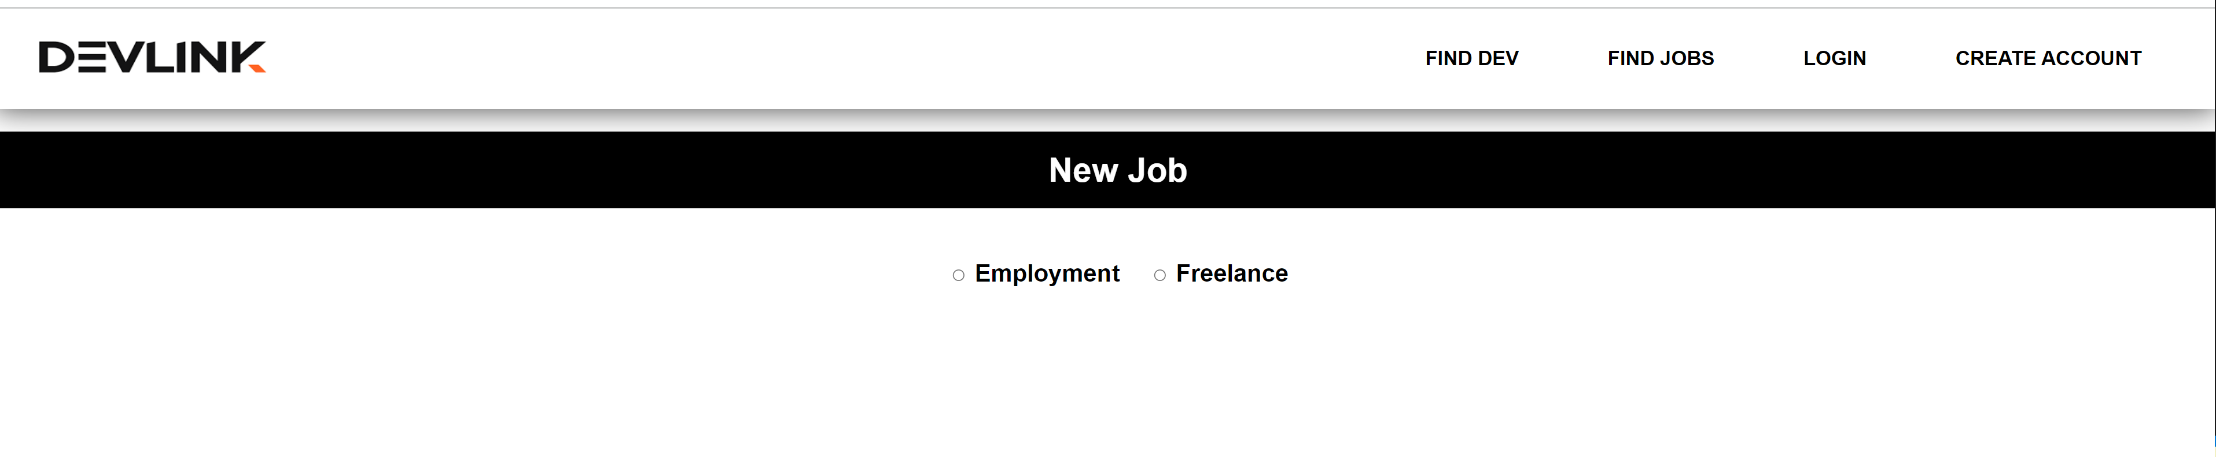

* ***Freelancing:***

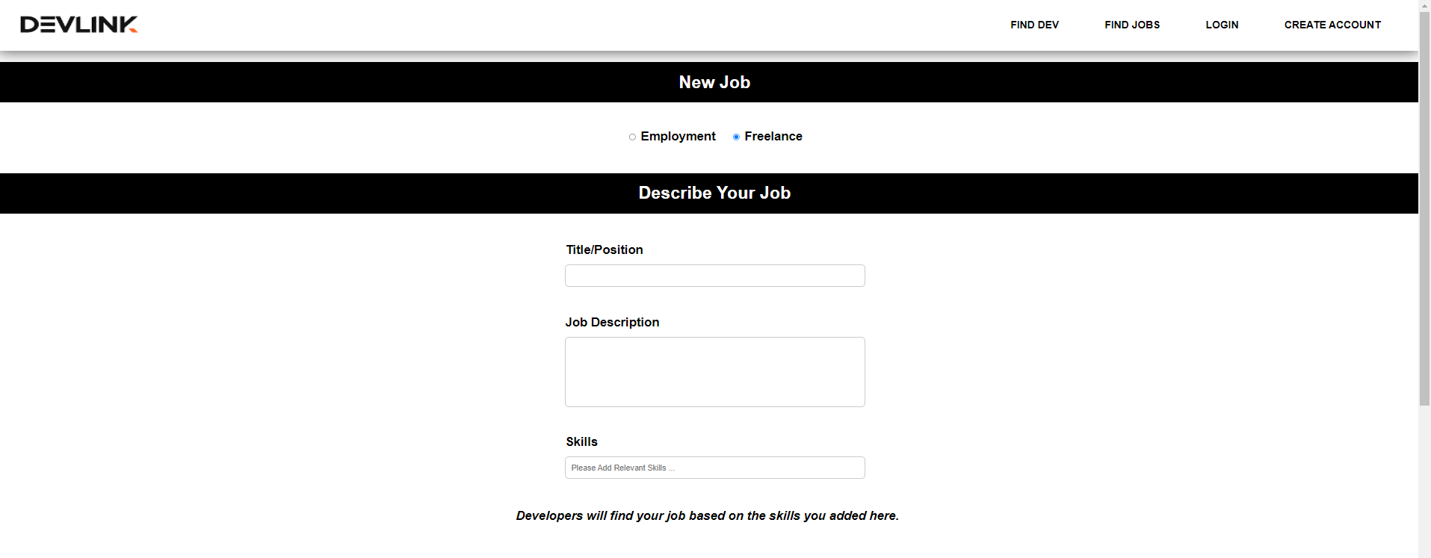



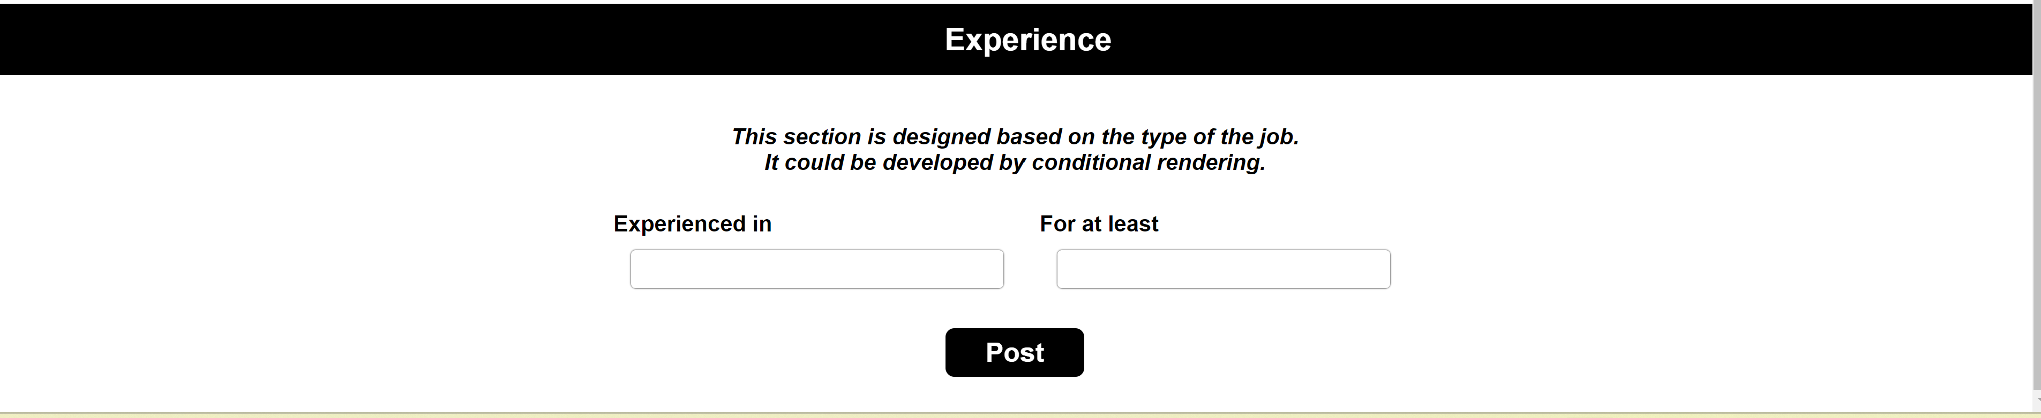

* ***Employment:***



