https://{hostname}:{port}/api/v1/products

Get all products’ details

Return JSON stating id, name, category and price

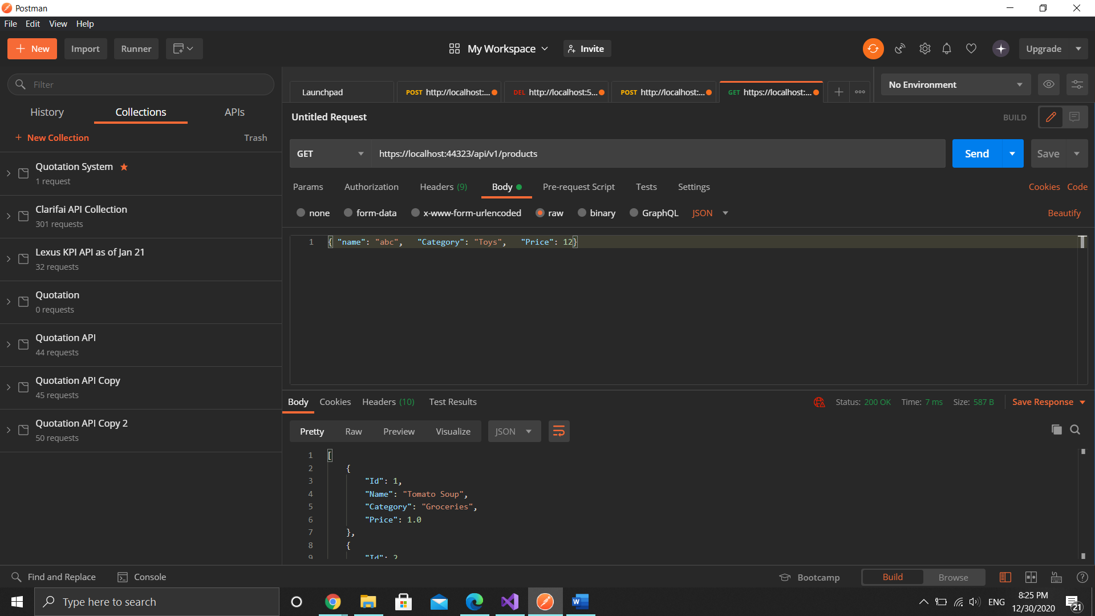

https://{hostname}:{port}/api/v1/products/{id}

Get products’ details by ID

Return JSON stating id, name, category and price

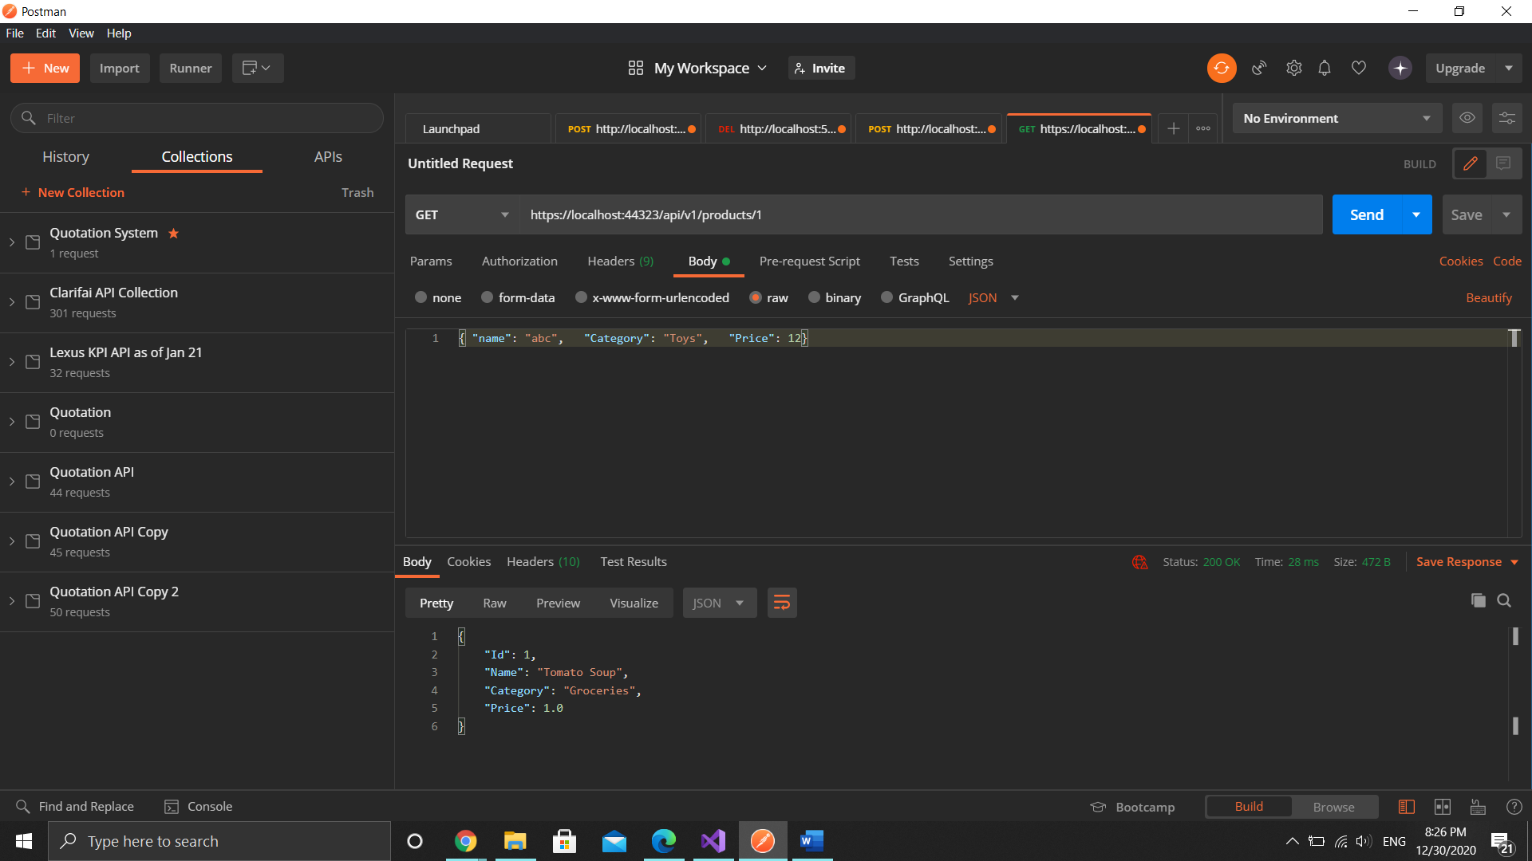

https://{hostname}:{port}/api/v2/products

Get all products’ details

Return JSON stating id, name, category and price

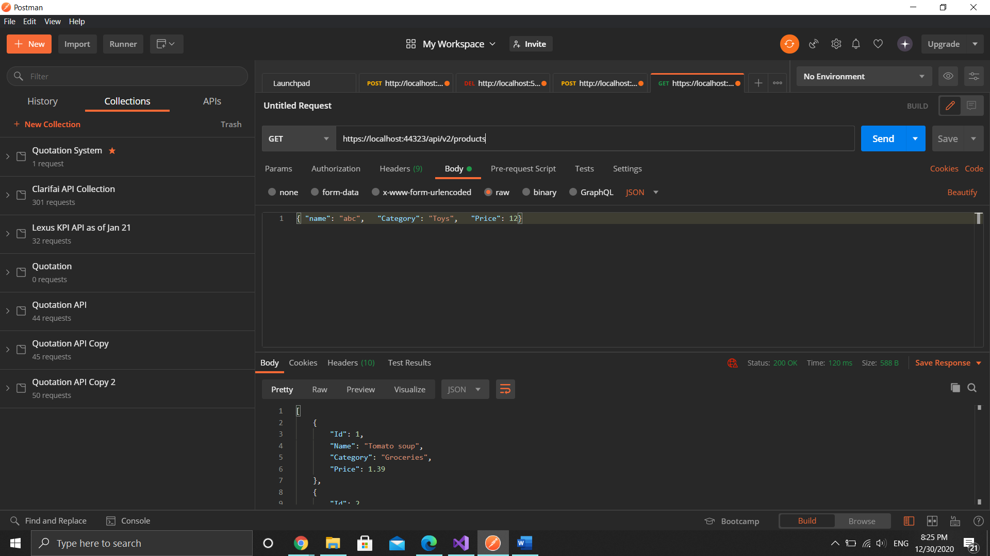

https://{hostname}:{port}/api/v2/products/{id}

Get products’ details by ID

Return JSON stating id, name, category and price

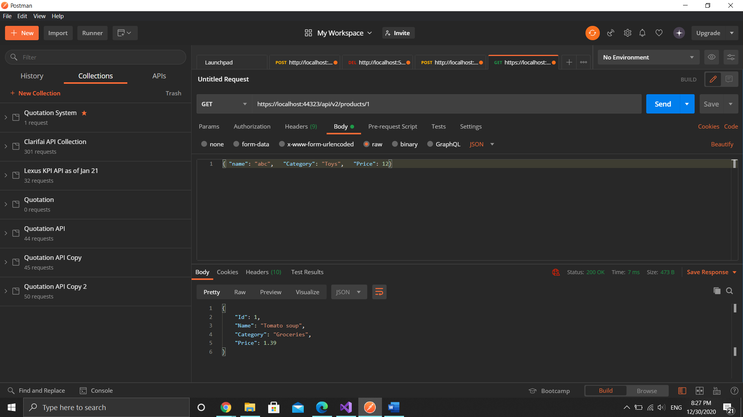

https://{hostname}:{port}/api/v3/products

Get all products’ details

Return JSON stating id, name, category and price

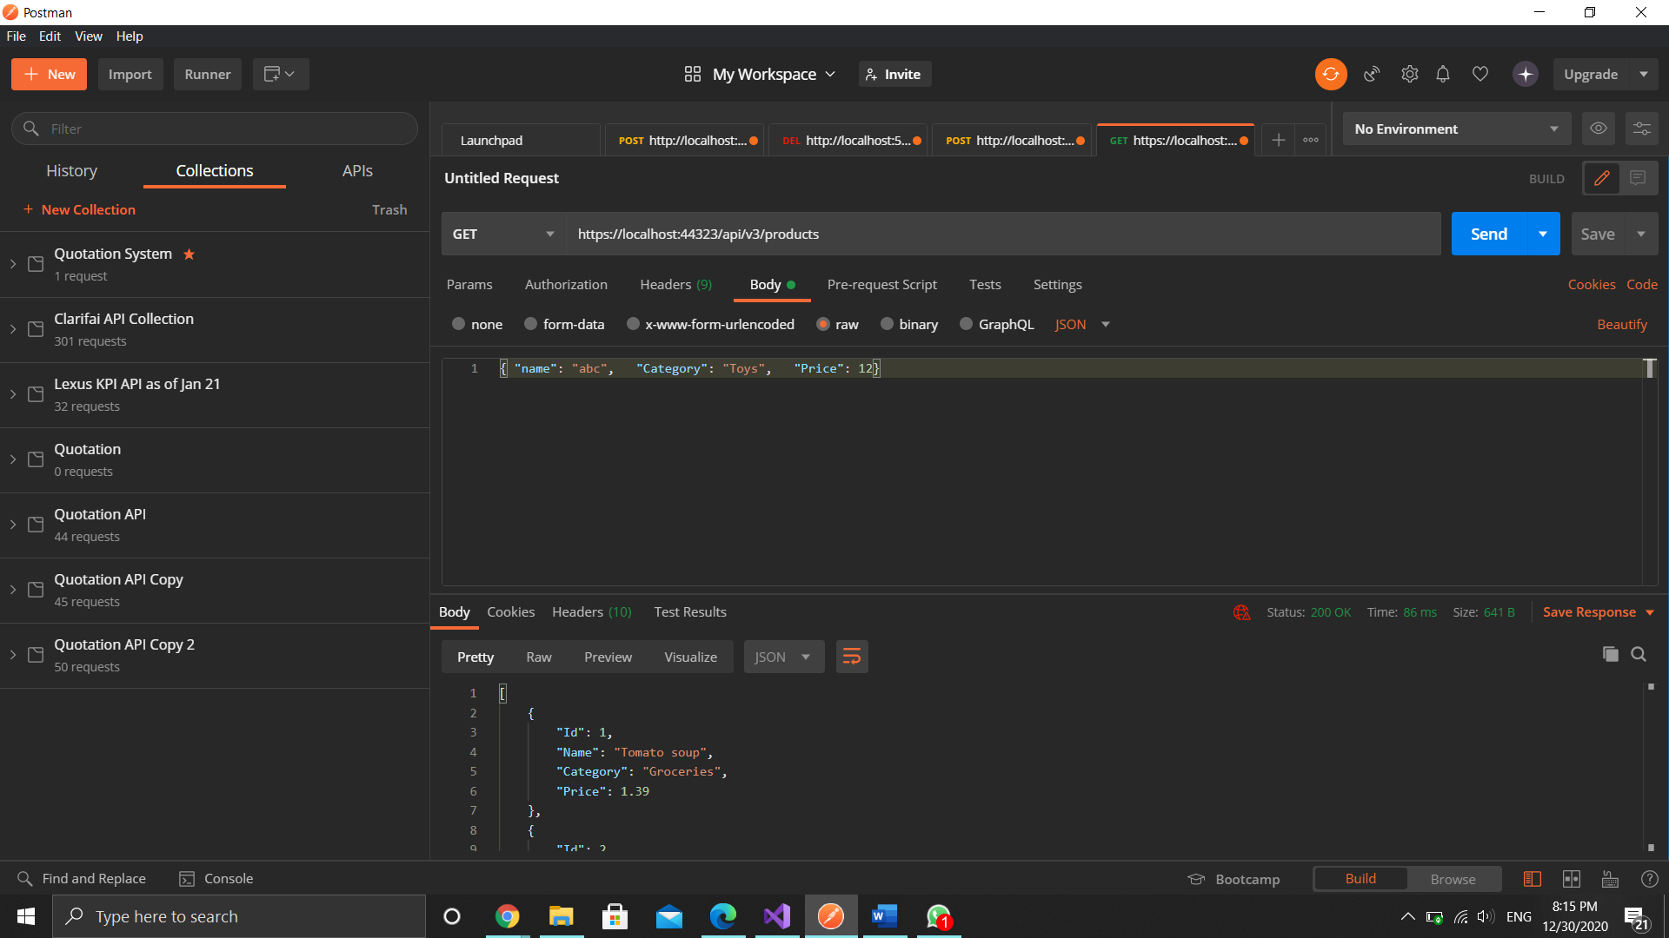

https://{hostname}:{port}/api/v3/products/{id}

Get products’ details by ID

Return JSON stating id, name, category and price

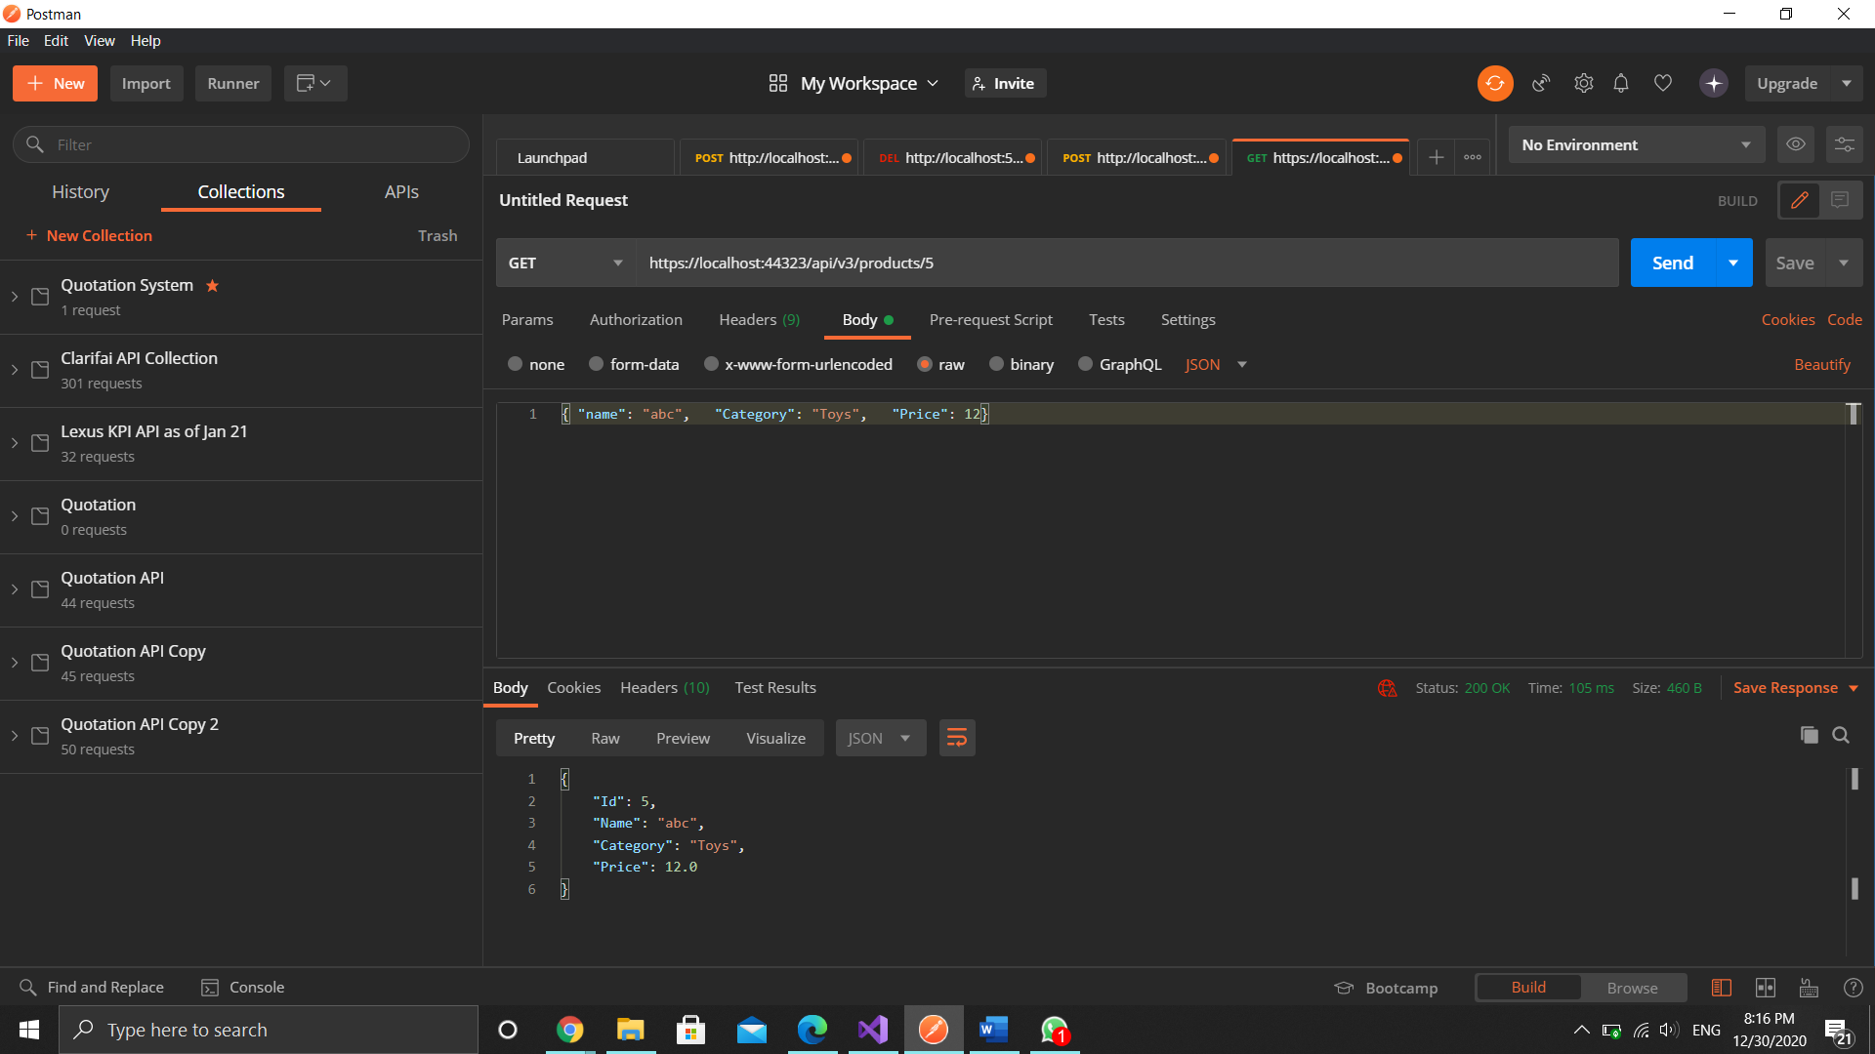

https://{hostname}:{port}/api/v3/products

Create new product record

Post name, category and price.

Return JSON stating id, name, category and price

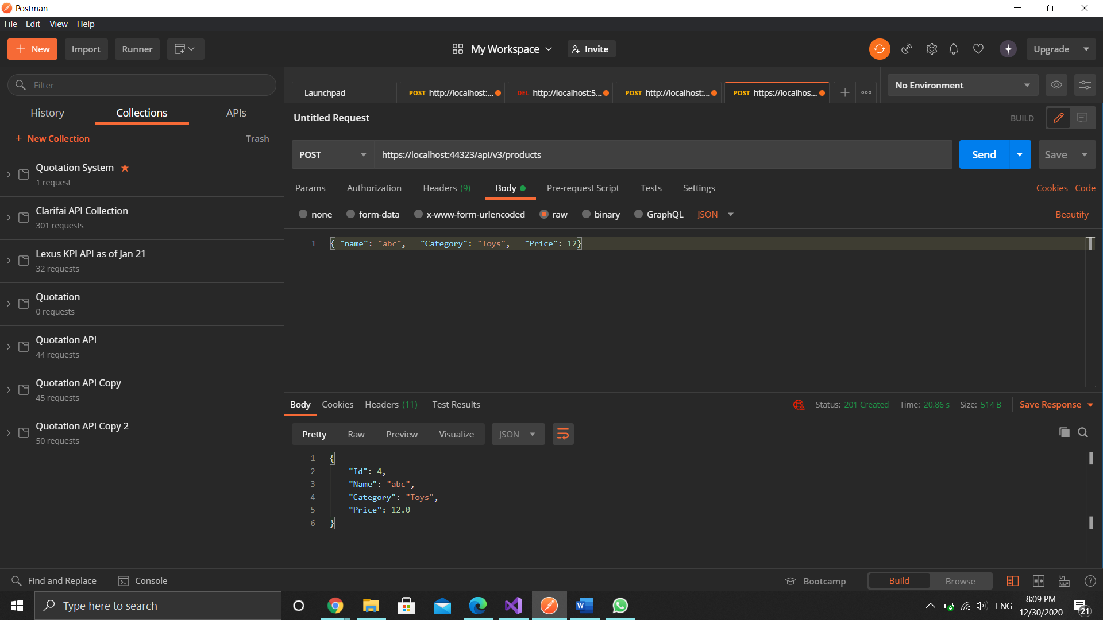

Sequence Diagram

Underposting

