**OVERVIEW**

The F1 series of games support the outputting of key game data via a UDP data stream. This data can be interpreted by external apps or connected peripherals for a range of different uses, including providing additional telemetry information, customised HUD displays, motion platform hardware support or providing force feedback data for custom steering wheels. The following information is a summary of the data that is outputted so that developers of supporting hardware or software are able to configure these to work with the F1 game correctly. If the information you require is not contained here, or if you have any issues with the UDP data itself, then please let us know and a member of the dev team will respond to your query as soon as possible.

**PACKET TYPES**

 The main change for 2018 is the introduction of multiple packet types: each packet can now carry different types of data rather than having one packet which contains everything. A header has been added to each packet as well so that versioning can be tracked and it will be easier for applications to check they are interpreting the incoming data in the correct way.

Each packet has the following header:

struct PacketHeader

{

uint16 m_packetFormat; // 2018

uint8 m_packetVersion; // Version of this packet type, all start from 1

uint8 m_packetId; // Identifier for the packet type, see below

uint64 m_sessionUID; // Unique identifier for the session

float m_sessionTime; // Session timestamp

uint m_frameIdentifier; // Identifier for the frame the data was retrieved on

uint8     m_playerCarIndex;       // Index of player's car in the array

};

[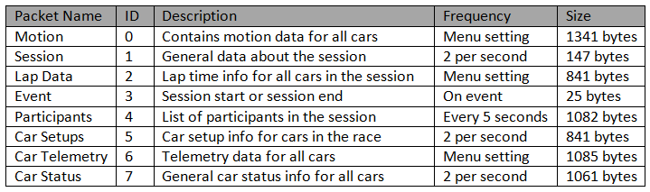](https://us.v-cdn.net/5021484/uploads/editor/i2/fj958zeqdhf8.png)

**MOTION PACKET**The motion packet gives physics data for all the cars being driven. There is additional data for the car being driven with the goal of being able to drive a motion platform setup.

***N.B.*** For the normalised vectors below, to convert to float values divide by 32767.0f. 16-bit signed values are used to pack the data and on the assumption that direction values are always between -1.0f and 1.0f.  
Frequency: Rate as specified in menus  
Size: 1341 bytes

struct CarMotionData

{

float m_worldPositionX; // World space X position

float m_worldPositionY; // World space Y position

float m_worldPositionZ; // World space Z position

float m_worldVelocityX; // Velocity in world space X

float m_worldVelocityY; // Velocity in world space Y

float m_worldVelocityZ; // Velocity in world space Z

int16 m_worldForwardDirX; // World space forward X direction (normalised)

int16 m_worldForwardDirY; // World space forward Y direction (normalised)

int16 m_worldForwardDirZ; // World space forward Z direction (normalised)

int16 m_worldRightDirX; // World space right X direction (normalised)

int16 m_worldRightDirY; // World space right Y direction (normalised)

int16 m_worldRightDirZ; // World space right Z direction (normalised)

float m_gForceLateral; // Lateral G-Force component

float m_gForceLongitudinal; // Longitudinal G-Force component

float m_gForceVertical; // Vertical G-Force component

float m_yaw; // Yaw angle in radians

float m_pitch; // Pitch angle in radians

float m_roll; // Roll angle in radians

};

struct PacketMotionData

{

PacketHeader m_header; // Header

CarMotionData m_carMotionData[20]; // Data for all cars on track

// Extra player car ONLY data

float m_suspensionPosition[4]; // Note: All wheel arrays have the following order:

float m_suspensionVelocity[4]; // RL, RR, FL, FR

float m_suspensionAcceleration[4]; // RL, RR, FL, FR

float m_wheelSpeed[4]; // Speed of each wheel

float m_wheelSlip[4]; // Slip ratio for each wheel (added v1.2.1)

float m_localVelocityX; // Velocity in local space

float m_localVelocityY; // Velocity in local space

float m_localVelocityZ; // Velocity in local space

float m_angularVelocityX; // Angular velocity x-component

float m_angularVelocityY; // Angular velocity y-component

float m_angularVelocityZ; // Angular velocity z-component

float m_angularAccelerationX; // Angular velocity x-component

float m_angularAccelerationY; // Angular velocity y-component

float m_angularAccelerationZ; // Angular velocity z-component

float m_frontWheelsAngle; // Current front wheels angle in radians (added v1.2.1)

};

**SESSION PACKET**

The session packet includes details about the current session in progress.

Frequency: 2 per second

Size: 147 bytes (updated v1.3)

struct MarshalZone

{

float m_zoneStart; // Fraction (0..1) of way through the lap the marshal zone starts

int8 m_zoneFlag; // -1 = invalid/unknown, 0 = none, 1 = green, 2 = blue, 3 = yellow, 4 = red

};

struct PacketSessionData

{

PacketHeader m_header; // Header

uint8 m_weather; // Weather - 0 = clear, 1 = light cloud, 2 = overcast

// 3 = light rain, 4 = heavy rain, 5 = storm

int8 m_trackTemperature; // Track temp. in degrees celsius

int8 m_airTemperature; // Air temp. in degrees celsius

uint8 m_totalLaps; // Total number of laps in this race

uint16 m_trackLength; // Track length in metres

uint8 m_sessionType; // 0 = unknown, 1 = P1, 2 = P2, 3 = P3, 4 = Short P

// 5 = Q1, 6 = Q2, 7 = Q3, 8 = Short Q, 9 = OSQ

// 10 = R, 11 = R2, 12 = Time Trial

int8 m_trackId; // -1 for unknown, 0-21 for tracks, see appendix

uint8 m_era; // Era, 0 = modern, 1 = classic

uint16 m_sessionTimeLeft; // Time left in session in seconds

uint16 m_sessionDuration; // Session duration in seconds

uint8 m_pitSpeedLimit; // Pit speed limit in kilometres per hour

uint8 m_gamePaused; // Whether the game is paused

uint8 m_isSpectating; // Whether the player is spectating

uint8 m_spectatorCarIndex; // Index of the car being spectated

uint8 m_sliProNativeSupport; // SLI Pro support, 0 = inactive, 1 = active

uint8 m_numMarshalZones; // Number of marshal zones to follow

MarshalZone m_marshalZones[21]; // List of marshal zones – max 21

uint8 m_safetyCarStatus; // 0 = no safety car, 1 = full safety car

// 2 = virtual safety car (added v1.3)

unint8 m_networkGame; // 0 = offline, 1 = online (added v1.3)

};

**LAP DATA PACKET**

The lap data packet gives details of all the cars in the session.

Frequency: Rate as specified in menus

Size: 841 bytes (updated v1.3)

struct LapData

{

float m_lastLapTime; // Last lap time in seconds

float m_currentLapTime; // Current time around the lap in seconds

float m_bestLapTime; // Best lap time of the session in seconds

float m_sector1Time; // Sector 1 time in seconds

float m_sector2Time; // Sector 2 time in seconds

float m_lapDistance; // Distance vehicle is around current lap in metres – could

// be negative if line hasn’t been crossed yet

float m_totalDistance; // Total distance travelled in session in metres – could

// be negative if line hasn’t been crossed yet

float       m_safetyCarDelta;        // Delta in seconds for safety car (added v1.3)

uint8 m_carPosition; // Car race position

uint8 m_currentLapNum; // Current lap number

uint8 m_pitStatus; // 0 = none, 1 = pitting, 2 = in pit area

uint8 m_sector; // 0 = sector1, 1 = sector2, 2 = sector3

uint8 m_currentLapInvalid; // Current lap invalid - 0 = valid, 1 = invalid

uint8 m_penalties; // Accumulated time penalties in seconds to be added

uint8 m_gridPosition; // Grid position the vehicle started the race in

uint8 m_driverStatus; // Status of driver - 0 = in garage, 1 = flying lap

// 2 = in lap, 3 = out lap, 4 = on track

uint8 m_resultStatus; // Result status - 0 = invalid, 1 = inactive, 2 = active

// 3 = finished, 4 = disqualified, 5 = not classified

// 6 = retired

};

struct PacketLapData

{

PacketHeader m_header; // Header

LapData m_lapData[20]; // Lap data for all cars on track

};

**EVENT PACKET**

This packet gives details of events that happen during the course of the race.

Frequency: When the event occurs

Size: 25 bytes (updated v1.3)

struct PacketEventData

{

PacketHeader m_header; // Header

uint8 m_eventStringCode[4]; // Event string code, see above

};

[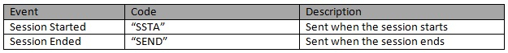](https://us.v-cdn.net/5021484/uploads/editor/3p/n40iwrzvzhwq.jpg)

**PARTICIPANTS PACKET**

This is a list of participants in the race. If the vehicle is controlled by AI, then the name will be the driver name. If this is a multiplayer game, the names will be the Steam Id on PC, or the LAN name if appropriate. On Xbox One, the names will always be the driver name, on PS4 the name will be the LAN name if playing a LAN game, otherwise it will be the driver name.

Frequency: Every 5 seconds

Size: 1082 bytes (updated v1.3)

struct ParticipantData

{

uint8 m_aiControlled; // Whether the vehicle is AI (1) or Human (0) controlled

uint8 m_driverId; // Driver id - see appendix

uint8 m_teamId; // Team id - see appendix

uint8      m_raceNumber;             // Race number of the car (added v1.3)

uint8      m_nationality;            // Nationality of the driver (added v1.3)

char m_name[48]; // Name of participant in UTF-8 format – null terminated

// Will be truncated with … (U+2026) if too long

};

struct PacketParticipantsData

{

PacketHeader m_header; // Header

uint8 m_numCars; // Number of cars in the data

ParticipantData m_participants[20];

// m_playerCarIndex removed in v1.3

};

**CAR SETUPS PACKET**

This packet details the car setups for each vehicle in the session. Note that in multiplayer games, other player cars will appear as blank, you will only be able to see your car setup and AI cars.

Frequency: Every 5 seconds

Size: 841 bytes (updated in v1.3)

struct CarSetupData

{

uint8 m_frontWing; // Front wing aero

uint8 m_rearWing; // Rear wing aero

uint8 m_onThrottle; // Differential adjustment on throttle (percentage)

uint8 m_offThrottle; // Differential adjustment off throttle (percentage)

float m_frontCamber; // Front camber angle (suspension geometry)

float m_rearCamber; // Rear camber angle (suspension geometry)

float m_frontToe; // Front toe angle (suspension geometry)

float m_rearToe; // Rear toe angle (suspension geometry)

uint8 m_frontSuspension; // Front suspension

uint8 m_rearSuspension; // Rear suspension

uint8 m_frontAntiRollBar; // Front anti-roll bar

uint8 m_rearAntiRollBar; // Front anti-roll bar

uint8 m_frontSuspensionHeight; // Front ride height

uint8 m_rearSuspensionHeight; // Rear ride height

uint8 m_brakePressure; // Brake pressure (percentage)

uint8 m_brakeBias; // Brake bias (percentage)

float m_frontTyrePressure; // Front tyre pressure (PSI)

float m_rearTyrePressure; // Rear tyre pressure (PSI)

uint8 m_ballast; // Ballast

float m_fuelLoad; // Fuel load

};

struct PacketCarSetupData

{

PacketHeader m_header; // Header

CarSetupData m_carSetups[20];

};

**CAR TELEMETRY PACKET**

This packet details telemetry for all the cars in the race. It details various values that would be recorded on the car such as speed, throttle application, DRS etc.

Frequency: Rate as specified in menus

Size: 1085 bytes (updated in v1.3)

struct CarTelemetryData

{

uint16 m_speed; // Speed of car in kilometres per hour

uint8 m_throttle; // Amount of throttle applied (0 to 100)

int8 m_steer; // Steering (-100 (full lock left) to 100 (full lock right))

uint8 m_brake; // Amount of brake applied (0 to 100)

uint8 m_clutch; // Amount of clutch applied (0 to 100)

int8 m_gear; // Gear selected (1-8, N=0, R=-1)

uint16 m_engineRPM; // Engine RPM

uint8 m_drs; // 0 = off, 1 = on

uint8 m_revLightsPercent; // Rev lights indicator (percentage)

uint16 m_brakesTemperature[4]; // Brakes temperature (celsius)

uint16 m_tyresSurfaceTemperature[4]; // Tyres surface temperature (celsius)

uint16 m_tyresInnerTemperature[4]; // Tyres inner temperature (celsius)

uint16 m_engineTemperature; // Engine temperature (celsius)

float m_tyresPressure[4]; // Tyres pressure (PSI)

};

struct PacketCarTelemetryData

{

PacketHeader m_header; // Header

CarTelemetryData m_carTelemetryData[20];

uint32              m_buttonStatus;        // Bit flags specifying which buttons are being

// pressed currently - see appendices (added in v1.3)

};

**CAR STATUS PACKET**

This packet details car statuses for all the cars in the race. It includes values such as the damage readings on the car.

Frequency: 2 per second

Size: 1061 bytes (updated v1.3)

struct CarStatusData

{

uint8 m_tractionControl; // 0 (off) - 2 (high)

uint8 m_antiLockBrakes; // 0 (off) - 1 (on)

uint8 m_fuelMix; // Fuel mix - 0 = lean, 1 = standard, 2 = rich, 3 = max

uint8 m_frontBrakeBias; // Front brake bias (percentage)

uint8 m_pitLimiterStatus; // Pit limiter status - 0 = off, 1 = on

float m_fuelInTank; // Current fuel mass

float m_fuelCapacity; // Fuel capacity

uint16 m_maxRPM; // Cars max RPM, point of rev limiter

uint16 m_idleRPM; // Cars idle RPM

uint8 m_maxGears; // Maximum number of gears

uint8 m_drsAllowed; // 0 = not allowed, 1 = allowed, -1 = unknown

uint8 m_tyresWear[4]; // Tyre wear percentage

uint8 m_tyreCompound; // Modern - 0 = hyper soft, 1 = ultra soft

// 2 = super soft, 3 = soft, 4 = medium, 5 = hard

// 6 = super hard, 7 = inter, 8 = wet

// Classic - 0-6 = dry, 7-8 = wet

uint8 m_tyresDamage[4]; // Tyre damage (percentage)

uint8 m_frontLeftWingDamage; // Front left wing damage (percentage)

uint8 m_frontRightWingDamage; // Front right wing damage (percentage)

uint8 m_rearWingDamage; // Rear wing damage (percentage)

uint8 m_engineDamage; // Engine damage (percentage)

uint8 m_gearBoxDamage; // Gear box damage (percentage)

uint8 m_exhaustDamage; // Exhaust damage (percentage)

int8 m_vehicleFiaFlags; // -1 = invalid/unknown, 0 = none, 1 = green

// 2 = blue, 3 = yellow, 4 = red

float m_ersStoreEnergy; // ERS energy store in Joules

uint8 m_ersDeployMode; // ERS deployment mode, 0 = none, 1 = low, 2 = medium

// 3 = high, 4 = overtake, 5 = hotlap

float m_ersHarvestedThisLapMGUK; // ERS energy harvested this lap by MGU-K

float m_ersHarvestedThisLapMGUH; // ERS energy harvested this lap by MGU-H

float m_ersDeployedThisLap; // ERS energy deployed this lap

};

struct PacketCarStatusData

{

PacketHeader m_header; // Header

CarStatusData m_carStatusData[20];

};

[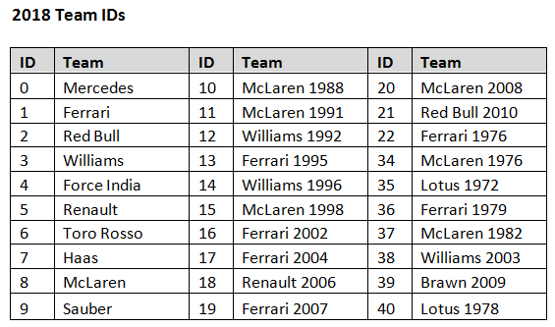](https://us.v-cdn.net/5021484/uploads/editor/48/y1yaxadoggmk.png)

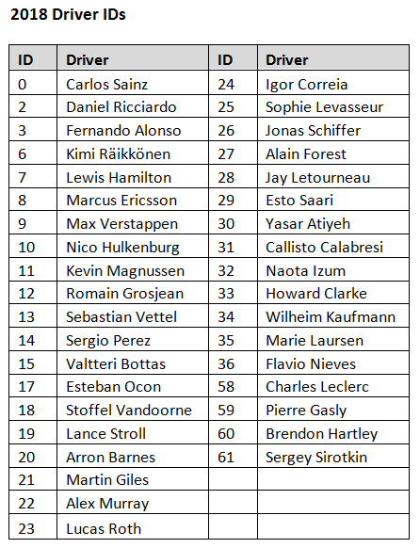

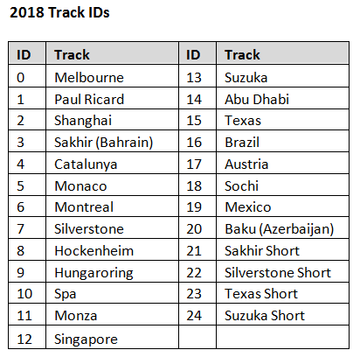

[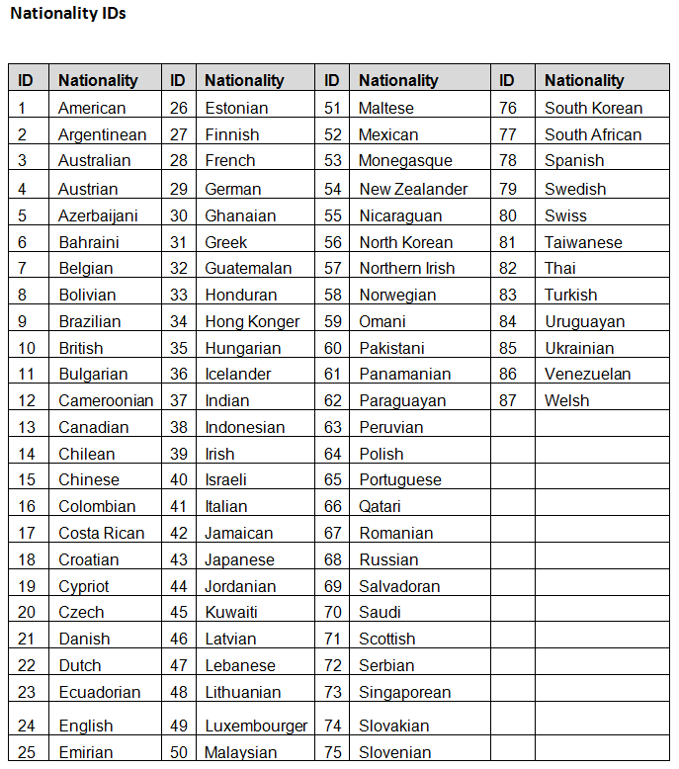](https://us.v-cdn.net/5021484/uploads/editor/0o/9wqezks7xzky.png)

[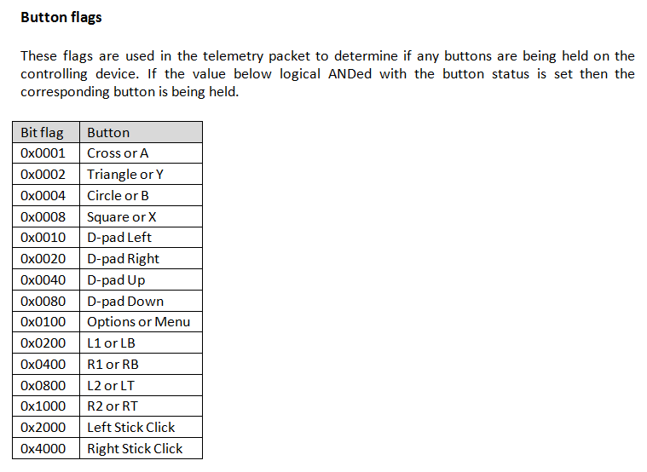](https://us.v-cdn.net/5021484/uploads/editor/9b/66rgj8cv225n.png)

**FAQS**

**How do I enable the UDP Telemetry Output?**

In F1 2018, UDP telemetry output is controlled via the menus. To enable this, enter the options menu from the main menu (triangle / Y), then enter the settings menu - the UDP option will be at the bottom of the list. From there you will be able to enable / disable the UDP output, configure the IP address and port for the receiving application, toggle broadcast mode and set the send rate. Broadcast mode transmits the data across the network subnet to allow multiple devices on the same subnet to be able to receive this information. When using broadcast mode it is not necessary to set a target IP address, just a target port for applications to listen on.

**Can I configure the UDP output using an XML File?**

PC users can edit the game’s configuration XML file to configure UDP output. The file is located here (after an initial boot of the game):

   ...\Documents\My Games\<game_folder>\hardwaresettings\hardware_settings_config.xml

You should see the tag:

   <motion>

     ...

     <udp enabled="false" broadcast=”false” ip="127.0.0.1" port="20777" sendRate=”20” format=”2018” />

     ...

   </motion>

Here you can set the values manually. Note that any changes made within the game when it is running will overwrite any changes made manually.

**What is the order of the wheel arrays?**

All wheel arrays are in the following order:

   0 – Rear Left (RL)

   1 – Rear Right (RR)

   2 – Front Left (FL)

   3 – Front Right (FR)

**Do the vehicle indices change?**

During a session, each car is assigned a vehicle index. This will not change throughout the session and all the arrays that are sent use this vehicle index to dereference the correct piece of data.

**What encoding format is used?**

All values are encoded using Little Endian format.

**Is the data packed?**

Yes, all data is packed.

**Will my F1 2017 app still work with F1 2018?**

F1 2018 uses a new format for the UDP data. However, the F1 2017 implementation is still supported by the game and is referred to as the “legacy” format. This should allow most apps implemented using the previous data format to work with little or no change from the developer. To use the old format, please enter the UDP options menu and set “UDP Format” to “legacy”. Specifications for the legacy format can be seen here: <http://forums.codemasters.com/discussion/53139/f1-2017-d-box-and-udp-output-specification/p1>.

**How do I enable D-BOX output?**

D-BOX output is currently supported on the PC platform. In F1 2018, the D-BOX activation can be controlled via the menus. Navigate to **Game Options->Settings->UDP Telemetry Settings->D-BOX** to activate this on your system.

*Advanced PC Users:*It is possible to control D-BOX by editing the games’ configuration XML file. The file is located here (after an initial boot of the game):

...\Documents\My Games\<game_folder>\hardwaresettings\hardware_settings_config.xml

You should see the tag:

  <motion>

    <dbox enabled="false" />

    ...

  </motion>

Set the “enabled” value to “true” to allow the game to output to your D-BOX motion platform. Note that any changes made within the game when it is running will overwrite any changes made manually.

**How can I disable in-game support for LED device?**

The F1 game has native support for some of the basic features supported by some external LED devices, such as the *Leo Bodnar SLI Pro* and the *Fanatec* steering wheels. To avoid conflicts between Codemasters’ implementation and any third-party device managers on the PC platform it may be necessary to disable the native support. This is done using the following **led_display** flags in the **hardware_settings_config.xml**. The file is located here (after an initial boot of the game):

  ...\Documents\My Games\<game_folder>\hardwaresettings\hardware_settings_config.xml

The flags to enabled/disable LED output are:

  <led_display fanatecNativeSupport="true" sliProNativeSupport="true" />

The **sliProNativeSupport** flag controls the output to SLI Pro devices. The **fanatecNativeSupport** flag controls the output to Fanatec (and some related) steering wheel LEDs. Set the values for any of these to “false” to disable them and avoid conflicts with your own device manager.

Please note there is an additional flag to manually control the LED brightness on the SLI Pro:

  <led_display sliProForceBrightness="127" />

This option (using value in the range 0-255) will be ignored when setting the **sliProNativeSupport** flag to “false”.

Also note it is now possible to edit these values on the fly via the **Game Options->Settings->UDP Telemetry Settings**menu.