Docker run image-name

Look for image in local cache if not found go to docker hub then run it

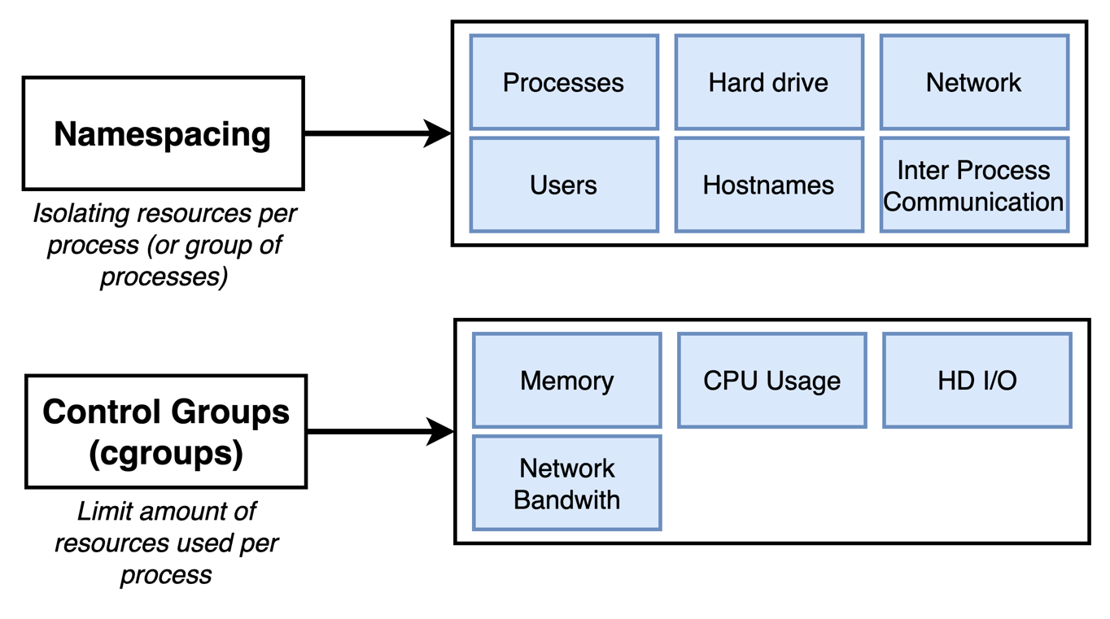

## Container

A container is really a process or a set of processes that have a grouping of resources specifically assigned to it.

Container is running image, Image is file system snapshot and start up commands

Namespace and control group is specific to Linux operating system, so installing docker on mac/windows creates Linux VM which would be used to create isolation

Doubts: then what would the stack if OS is already linux

I

Image always comes with some default start-up command which would be executed first

Overriding default start-up command

For busybox image programs like echo and ls works because in there file snapshot there exists ls and echo executable programs, but if we try to do same with hello-world image it won’t work because it contains only one file that would print out some predefined message.

Creating a container = moving image snapshot to namespace

Starting a container = running a start-up command

-a = attach mode, show all outputs if any in terminal

Docker run (-a is implicit)

Docker start (-a is explicit)

As container is immutable, so once container is created with some start-up command, whenever that container is restarted it would always run the same command, we cannot give new command as argument while docker start <container-id>

docker system prune to delete all exited container

docker create hello-world

cb33d8567f941a1cdd3770301b7612e99e5836ac1f05c66

docker start cb

docker logs cb to prints logs after container is started

Stopping the running container

Docker stop issues SIGTERM to process which would not immediately terminate the process rather gives some time to perform do last minute task

Docker kill issues SIGKILL to process which would immediately terminate the process, docker stop has 10 sec timeouts if not terminated then it would fall back to docker kill



docker exec -it 8dd18ae26351 redis-cli

is equivalent to

docker exec -i -t 8dd18ae26351 redis-cli

-i flag is used to enable STDIN

Opening shell within the running process inside a container

docker exec -it <container-id> bash

docker exec -it <container-id> sh

Starting with shell

docker run -it busybox sh

## Creating docker image

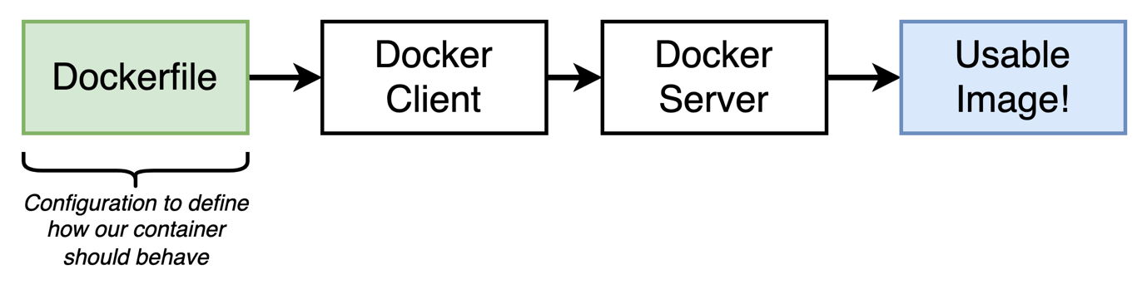

Dokerfile

docker build .

If use file name other than Dockerfile docker build -f Dockerfile.dev .

Port mapping docker run -p external-port:internal-port

Docker volume:

Setting up a flie maping from container to local file system

Docker run -p 4000:3000 -v /app/node_modules -v $(pwd):/app <image-id>