Eaters Version 2004
John Duchi
University of Michigan

This document intends to give an overview of the Java version of the Eaters engine, ignoring for the moment questions about how input, output, and interaction with Soar will work.

There are two main components to Eaters. These are the main class, which we will call EaterControl from here, and the Eater class, which manages an individual eater. The basic idea of the software is to have a strong listening structure, allowing listeners to EaterControl and the Eater class, so that it will be easy to add and turn off extensions to Eaters, including the graphics or some sort of program output.

MAIN STRUCTURE

EaterControl

EaterControl is the main class behind Eaters; it handles creation and destruction of all the aspects of Eaters. Its main data structure is a matrix of Objects containing all the data about the Eaters world. Maintaining this internal map will not be difficult, and EaterControl is able to randomly generate its own maps as well as be able to load user-specified maps. The contents of the map (when loaded) are defined by static final ints, which will be specified in EaterControl. EaterControl also maintains a list of the active eaters, which can then be removed via method calls to destroy different eaters.

Methods EaterControl will support center around running Eaters and providing information to the different eaters about their environments. As such, EaterControl will respond to createEater(Location, Color) messages, and EaterControl will respond to a getLocationContents(x, y), which will return the contents of the cell specified by coordinates (x, y), or will return a Wall object if x and y are outside the boundaries of the simulation. EaterControl, once begun can be sent startSimulation() and stopSimulation() messages to start and stop the simulation. umber of decisions that have been made.

The way users can control the simulation’s settings—whether to load a map, show the graphic board, control panel, load agents—is through the command line. Different arguments can be specified after invoking “java Eaters” from the command line.* There is a parser for this text—it is the EatersParser.java file, and it provides static methods that return a structure that contains the information about windowing (whether to have agents windows on or off, whether to show a map, etc.) necessary to run Eaters.

In the future, EaterControl may implement a SoarSimulation interface, but this is still to be worked out. If it does, it will not change the implementation of the other things very much, except that listeners may become SoarSimulationListeners rather than EaterControlListeners.

EaterControlListener

The EaterControlListener interface defines a way for the EaterControl class to interact with the rest of the world, but it will also will allow simulations to be run with as many or as few extras (such as graphics) as wanted. Methods are simStarted, simEnded, locationChanged, eaterCreated, eaterDestroyed, worldCountChanged, and foodCountChanged notifications, which should allow listeners to make adjustments to themselves to mesh with the EaterControl.

The classes that are listeners to the EaterControl, thus far, are the visual board for the simulation (VisMap), the ControlPanel, and SWindowManager..

Eater

An instance of Eater will exist for every eater running around in the simulation. The Eater will be constructed each time the user asks to construct a new eater. In this version of Eaters, there is also a human-controllable eater.

The Eater maintains a pointer to EaterControl so that it can notify EaterControl whenever it moves or makes a change, and the Eater also has a set of listeners that it notifies when changes happen. The Eater will control its own movement; with the method makeDecision, it returns the move it decides on (any of the moves or jumps, or NoDecision as an integer value defined in Eater). The EaterControl completes the move, notifying the Eater if it has eaten anything or actually moved. Since the EaterControl takes care of movement, all implementers of an Eater need to do is implement makeDecision. Each of the movement methods will be able to message the EaterControl to add an Eater to a specified location in its internal map of the eater’s world.

Maintained in the Eater class are the Eater’s location, its score. There are getters and setters for each of these data. There are methods provided to check whether a certain location is within x number of spaces from the Eater, with diagonals also counting as one space.

Underlying the Eater will be a Soar agent, how this will work I don’t know yet.

EaterControl queries each of the eaters for its move every cycle EaterControl makes.

Eater implements the SoarAgent interface.

EaterListener

The EaterListener interface \allows the Eater to interact with other structures without making the pointer structure too complicated. It will define methods for score change, location changes, and steps taken changes.

GUI COMPONENTS

GUI components will be created by the Eaters class by default, that is, if a command line argument turning them off is not invoked, they will exist (because that is what EatersParser, which the main Eaters.java class uses, defaults to). When created, they will all have pointers to the EaterControl, and will add themselves as listeners to it. They can then add themselves as listeners to any of the Eaters necessary.

They are built using the SWT (Standard Widget Toolkit) provided by Eclipse.org, which provides somewhat more platform-specific looks than Swing and the AWT.

SWindowManager

This class is created by Eaters.java, the main class, when the program begins. It listens to the ControlPanel and maintains a Display used by all the visual representations. SWindowManager also keeps control of the ControlPanel, VisMap, and agent view maps, notifying them of changes and receiving messages from them when users press buttons.

ControlPanel

This will be almost identical to the current version of the ControlPanel for eaters; it will have loading and destruction of eaters (but will be able to be reused for TankSoar).

The visual structure is slightly different from the current version of the control panel; there is a Load button that will bring up a file-chooser rather than having drop down menus, so that any file (of type .soar) can be loaded. It implements the EaterControlListener interface, so that it can be notified if an eater is created or destroyed and when games have started or stopped. It has the same drop-down menus along the top as the original—File, Eaters, Map, and Window.

ControlPanel messages EaterControl to find which eater colors have been used, so the menus will display correctly.

VisMap

This is the visible map, and it shows the map and all the drops of deliciousness that are normalfood and bonusfood.

It will implements both EaterControlListener and EaterListener interfaces, so that on creation/deletion of eaters, square changes, and eater movements, it can update its drawing using the information passed with the notifications.

VisMap does not have mouse listeners that on clicks select different Eaters to monitor in windows.

EaterWindow

EaterWindow is the viewing window of what is observable to an Eater at any given time. It is currently the EatersInfo window. Kept by SWindowManager, it implements EaterControlListener and EaterListener interfaces to keep track of food and world counts to be displayed to the user.

EaterView

A subclass of Canvas, this draws the 5x5 view that the Eater can supposedly see. Based on my design, an Eater could see as far as it wanted, if it asked, but that seems unlikely, especially given the Java to Soar interface that will be developed.

*Command line arguments:
-b [on/off] Lets the visible board (VisMap) be turned on or off.
-c [on/off] Sets the ControlPanel to be turned on or off
-m [path] Specifies a path to a map file to be used as the eaters map.
-e [path] A path to a file that describes an eater (location and color)
-w [on/off] Sets all the windows to be off if off, all to be on if on (in on case, overridden by –b and –c and –a)
-a [on/off] Sets agent windows to be on or off (viewing one specific Eater).
*.soar Any argument ending in .soar the simulation will attempt to load as an Eater.
DIAGRAMS OF BASIC STRUCTURE IDEAS
(OUTDATED)
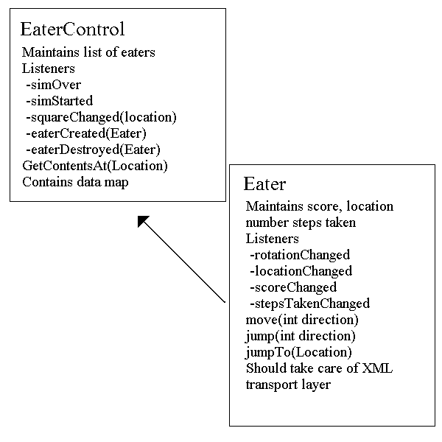
Note: Arrows represent pointers from one class to another, not listeners. The pointers will allow queries from one class to another, the listener structure passes notifications where necessary.
