gSKI Design Document
Soar Technology

{jcrossman, wessling, rdf, wallace}@soartech.com

1. Purpose

This document provides a detailed description of the general Soar Kernel Interface (gSKI). Included are system level descriptions, detailed design, test process, configuration management and use cases. This document does not include requirements (### SEE REQUIREMENTS DOC).
The purpose of gSKI is to provide an easy to use, encapsulated and flexible interface into the Soar kernel. Part of this flexibility includes cross platform and cross language compatibility as well as transparent out-of-process and cross network transport layers. The goal is to make the job of interfacing any system with the Soar kernel, including simulations, Soar development tools, knowledge management tools and agent introspection tools, as simple and low cost as possible. To this end, the gSKI abstracts away the internal kernel structures providing only a high-level, object-oriented view into the kernel. Furthermore, it encapsulates complex details like multi-threading support and cross process communications.
The rest of this document describes the Soar system, and gSKI in particular, in detail and from many different perspectives.

2. System Design

2.1 Whole System Description

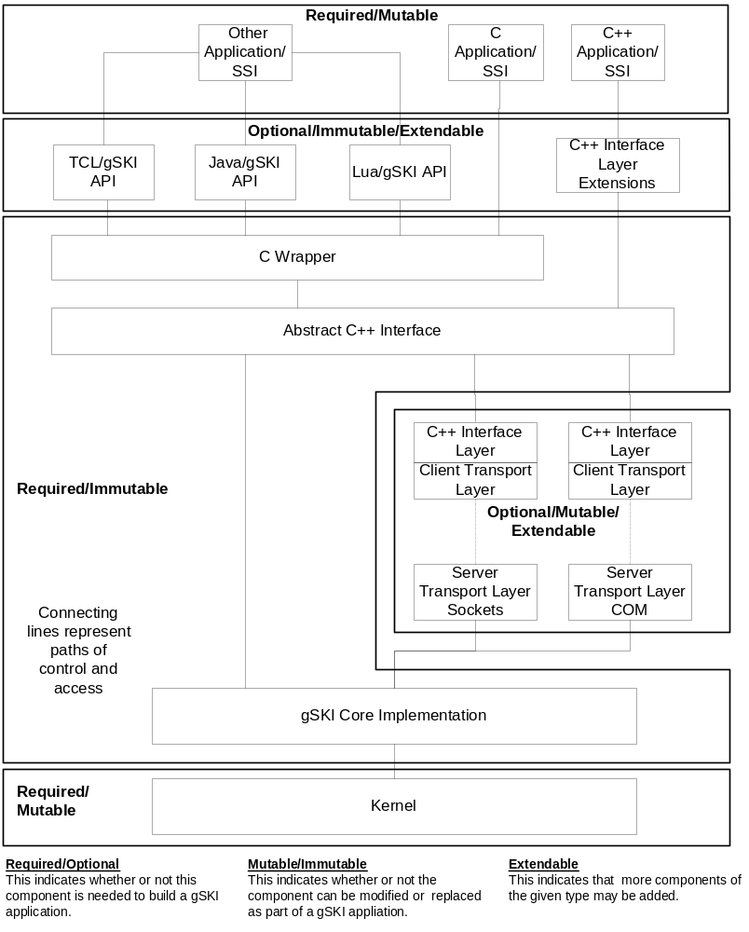
Figure 1: Diagram of Soar systems focusing on gSKI

At its highest level, gSKI is simply an API into the kernel. This API is not specific to any language, operating system or hardware system. It is the definition of how any component interacts with the Soar kernel and Soar agents.
The native implementation of this abstract interface is in C++ in the form of pure virtual interfaces given by the “Abstract C++ Interface” in the diagram. Below this virtual interface are several concrete implementations. The core implementation is a wrapper around the Soar kernel itself, providing encapsulation of the kernel and transformations of gSKI commands to kernel commands. Additional implementations encapsulate other types of transport layers (e.g. sockets, memory mapped files) and are essentially just proxies for the core gSKI implementation. Though not shown by the diagram, the transport layers do not have to implement their client side API in C++; however, the standard transport layers will be implemented in C++ to support maximum reuse. The important point here is that the client need not be aware of the transport layer details because the additional implementations all map to the same interface.
The C Wrapper is a thin implementation that transforms C calls into C++ calls. Support for C is essential for implementing the gSKI API in other languages as most other languages support C function calls.
The gSKI API will be implemented in several other higher-level languages as a wrapper around the C API. The TCL version is required for backward compatibility. The Java version will be useful for interfacing with Visual Soar, SAPs and other Java tools.
The C++ abstract API interface will be simple. It will not include advanced C++ such as complex templates. This will allow the abstract interface to be used in systems with older C++ compilers. For more modern systems, a C++ extension library is provided. This library provides template wrappers and other small utility objects primarily to do automated resource management.
The Soar kernel will be entirely abstracted away from any application or library developer. The only libraries interfacing with the kernel itself will be the core gSKI implementation and legacy systems that don’t use gSKI.

2.2 Knowledge Flow

To help understand how real applications and Soar programmers will interact with a gSKI-based Soar system, in figure ### we present a data flow diagram focusing on where knowledge data comes from, how it is transformed and how it is eventually used.

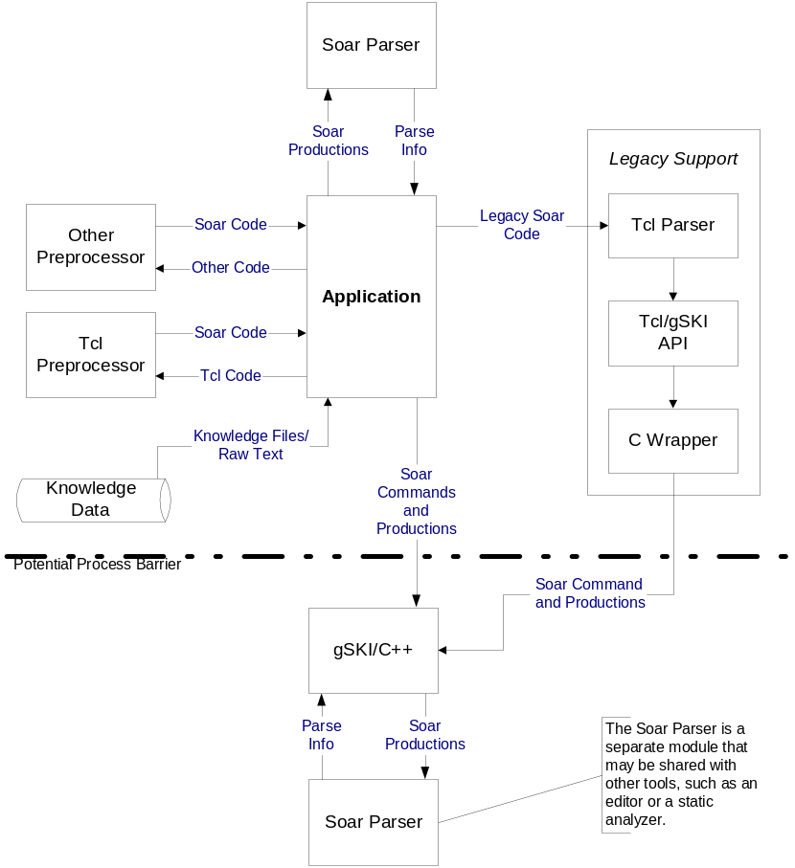
Figure 2: Knowledge flow through a gSKI-based system

Knowledge enters a Soar system through some data store, typically a file system, but potentially a database or network connection. At this point the data could be in one of several forms. In most cases it will be in the form of Soar files (a collection of productions), but it may be a TCL file with TCL commands, an XML file, or an extension language file. The application is responsible for loading or retrieving this data.
After loading the data, the application must choose how to process it. For legacy systems a TCL parser (e.g. TSI replacement) is provided to parse files with TCL, Soar Productions, and TCL-Soar commands embedded. In this path shown on the right side of the diagram, the TCL parser breaks the source file into individual productions and loads the productions one at a time. TCL-Soar commands are converted to gSKI function calls implemented by the TCL gSKI implementation, which operates on top of the C gSKI wrapper.
If the raw file consists of extension language code such as TCL templates or some new language, the application can load and run a preprocessor for that extension language. A preprocessor is a component that takes as input some extension language and outputs Soar productions in the form of a Soar file (or other input stream). Standard preprocessors all conform to the same interface and provide consistent mechanisms for dynamically loading and querying them. Therefore, an application is not required to hard code in support for any particular pre-processor.
Soar language files, whether they are loaded directly or generated by a preprocessor, are input into the standard Soar parser. The parser processes these files and outputs a parse tree and other parse information used by the kernel to generate the rete. Other applications may load the Soar parser as an extended service and process productions internally for some purpose such as syntax checking or highlighting (e.g. in an editor). In general, these other applications will not share the same instance of the parser, but instead will load their own copy.

2.3 Key Modules and Layers

2.3.1 Kernel

The kernel is the core implementation of the Soar architecture. It will not be fundamentally changed to support gSKI; however, its implementation may be cleaned up and reorganized to better support the gSKI API. Key changes to the kernel may include:

- Converting the kernel to compile in C++. This will provide better type checking and support for debugging (out of lining macros, etc).
- Improving buffer management in the kernel. Buffer overflow errors are common in the kernel due heavy use of small fixed sized buffers. To ensure robust Soar system behavior, the buffer overflow issue must be addressed.
- Clean up memory leaks. It will be difficult to run systems that run agents for long periods of time, or create and destroy agents often without addressing memory leaks within the kernel.
- Make the kernel safe for reentrance. It will help efforts for multi-threading if the kernel were made re-entrant on a separate agent basis. That is if we allow multiple simultaneous into the kernel given different agent instances

It is important to note that the end user (client programmer) will not need to know about these changes. In fact the kernel could be swapped out completely and replaced with another implementation of the Soar kernel without effecting client programs.

2.3.2 Native gSKI

The native gSKI implementation is the subject of much of the rest of this document.

2.3.3 Client-Side gSKI

Clients will interact with instances of the gSKI interface which are most convenient for their given system. A Java program will interact with a Java implementation, while a C++ program will interface with a C++ implementation. The important point is that these interfaces should be thin, meaning they should have very little code and virtually no state management behind them. They must implement the gSKI abstract API to be considered gSKI client implementations.

2.3.4 Extended Services

The complete set Soar system services will include a collection of extension libraries used to provide common services. Examples of such services include a Soar production parser, an agent query manager, and (perhaps) an HLA agent connection library.
An extension library must interface to the kernel through the gSKI API (if at all). It should provide a service useful to multiple independent applications. Each extended service will be implemented as its own library that can be accessed by any Soar system implementation.
The gSKI API and API implementations will not cover extended services. This advantage of this approach is that gSKI can remain relatively stable not having to change with every new service provided. Furthermore, it allows extended service writers to provide an interface to their service that maps well to its needs and uses. The disadvantage of this approach is that extended services will not be covered by the various gSKI transport layers and will have to implement their own transport layers if needed. Additionally, extended services will not have the multi-language support of gSKI unless it is built for that service separately.

2.4 In Process Connection

The gSKI libraries will allow in-process connections using either static or dynamic linking. In either case the system architecture is fairly simple as shown in figure ### below.

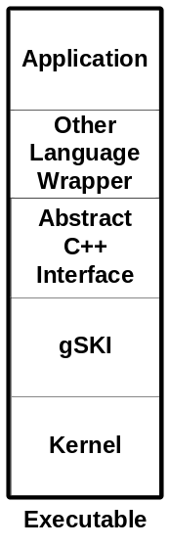
Figure 3: Layers of a process running Soar

The kernel and the core gSKI implementation are always used together. The main application accesses the kernel through the native abstract C++ interface directly, or it can go through one of the other gSKI API implementations. There is no need for a complex transport layer in single process applications.
2.5 Out of Process Connection

Multi-process applications are somewhat more complex. Figure ### below gives an overview of such a system with five applications accessing a single soar kernel instance simultaneously (the actual number of applications is variable).

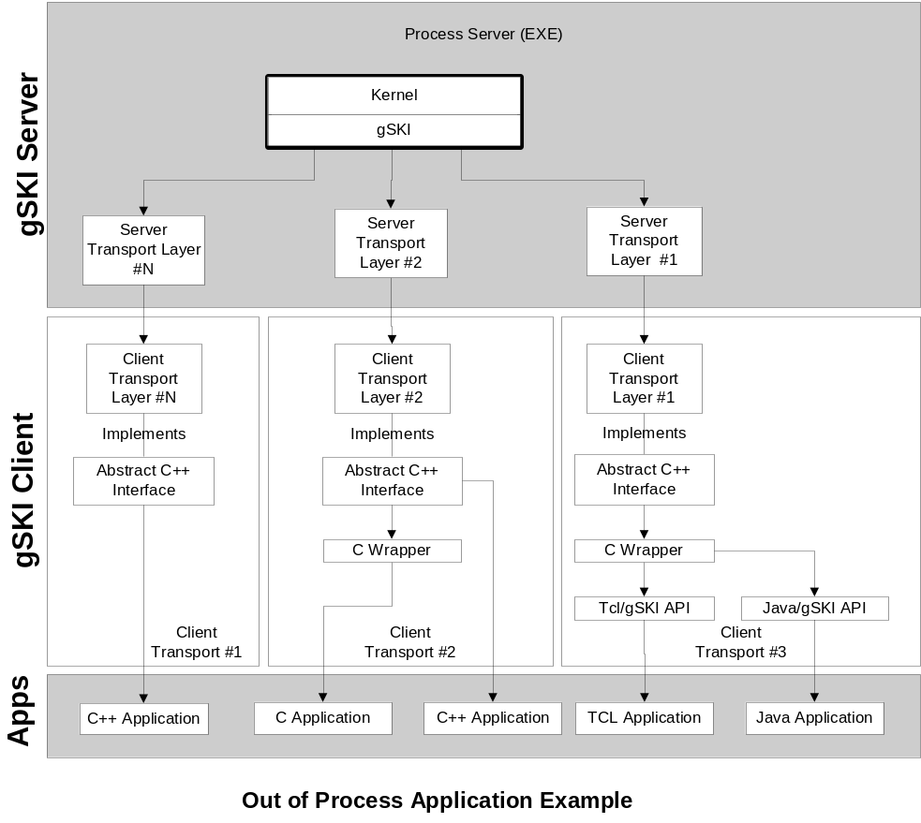
Figure 4: Using Soar out-of-process across multiple applications

A multi-process configuration requires a kernel server. The kernel server can be a stand-alone server (i.e. all it does is serve and manage kernel instances) or it can be part of another bigger process. A standalone server will be provided as part of the Soar system distribution once at least one inter-process transport layer is completed.
In general Soar kernel servers will support multiple connections from multiple clients through multiple transport layers simultaneously. Though not shown in the diagram, if the server is embedded in another application (e.g. a simulation), the gSKI implementations will allow both in-process and out-of-process interactions simultaneously.
To enable inter-process connections with the server (and thus the kernel) one or more transport layers must be provided. A transport layer is, in its simplest conceptualization, a remote procedure call (RPC) mechanism. It is responsible for remote calls to the server appear to be local calls that conform to the gSKI API on the client.
Transport layers require two parts. First is the server side implementation which listens for client connections, de-marshals function calls, and interfaces with the core gSKI implementation. Second is the client side implementation which acts as a proxy for gSKI API calls. The client is responsible for establishing and maintaining a connection with the server as well as marshalling function calls. Together the client and server side of the transport layer must carefully implement multi-threading support and buffering schemes to ensure efficient and correct implementation of the gSKI API.
It is important to emphasize that the transport layer is transparent to the client. The client will access gSKI through either the native C++ abstract API or through one of the other language implementation. The transport layer does not effect the other language implementations because they are implemented in terms of the abstract C++ API and are dependent only on it. In fact, accept for the C wrapper interface, most of the other language implementations depend only on the C API for gSKI.
2.6 Libraries and Linking (how to create and connect to kernel instances)

To support both simple and flexible access to the soar kernel, gSKI provides a powerful but straightforward factory system. This system control kernel instance creation and attachment (to running instances) and provides interfaces to allow new transport layer developers to add their own creation and load mechanisms.
To help understand the kernal loading process, we list the possible ways a user might wish to load a kernel instance.

- As a static library, in process. Static libraries are the simplest case and should be very simple to link to and instantiate.
- As a dynamic library, in process. Dynamically loaded libraries are not much more complex than static libraries. However, they introduce the ability to load one of several versions of the Soar kernel at runtime.
- As an external process. This requires the loading of a transport layer proxy (the client side of the transport layer) to handle client side gSKI access. It also requires a kernel server to be running somewhere that is accessible.

To allow for all of these possibilities while not overwhelming the client programmer, the gSKI system provides the following:

- Each gSKI library must provide a method to retrieve an iterator into the list of factories available in that library.
- Each gSKI library must provide a method to obtain the first instance of a factory that meets provided criteria.
- Each factory must provide information on the following:
  - Name of library
  - Location of library
  - Version of library
  - In-process/out-of-process flag
  - Dynamic/static load flag
  - Named list of existing instances it can attach to (if any)
- Each factory must provide a Create method to create a new instance of the kernel and an Attach method to attach to an existing instance of the kernel.

To see how a client uses these factories and methods we look at three different use cases.

2.6.1 Static Link Use Case:

The client programmer wants to include the soar kernel as a statically linked library. Static linking forces the kernel to be loaded in process. This is similar to what is done in JSAF, and is the simplest case. The client side steps are:

- Set up project to link to the static version of the gski/soar library.
- Call the GetFactory in the library with default parameters to obtain the only factory available in the static library.
- Call the Create method of the factory to create a kernel instance.

2.6.2 Dynamic Link Use Case:

The client program wants to include the soar kernel as a shared library. Additionally, the client wants to be able to load the most recent among several versions of the library.

- Setup project to link to the dynamic soar loader library (a small library to act as a proxy to a collection of other soar kernel libraries).
- Call the GetFactoryIterator method exposed by the loader library.
- Iterate over the factories and keep a reference to the one with the most recent version number.
- Call the Create method of that factory.

The dynamic loader library does not have to be used when dynamic linking. You can choose to hard link to a particular version of the kernel library. The dynamic loader is explained in more detail later.

2.6.3 Out-of-process Use Case:

The client program wants to link to an out-of-process soar kernel server. If there is already a running instance of the soar kernel server, it should be used. If there is not currently a running instance of the soar kernel server, one should be created. The client doesn’t care if the server is local or remote.

- Setup project to link to the dynamic soar loader library.
- Call the GetFactory method with parameters indicating that only out-of-process servers are to be returned. GetFactory will return the first out-of-process server factory it finds.
- Call the GetRunningInstanceIterator method of the factory to find if any running instances of the kernel already exist (that use the given factory).
- Load the kernel by …
  - Calling the factory Create method if there is no running instance of the kernel server.
  - Calling the factory Attach method with the name of a running kernel server instance (if there is already one running).

Note that these use cases are just three of many possible creation uses, but they cover some common cases.

2.6.4 Linking Options

The gSKI libraries provide great flexibility in linking. Figure ### below shows the primary ways you can link to the gSKI libraries and the Soar kernel.

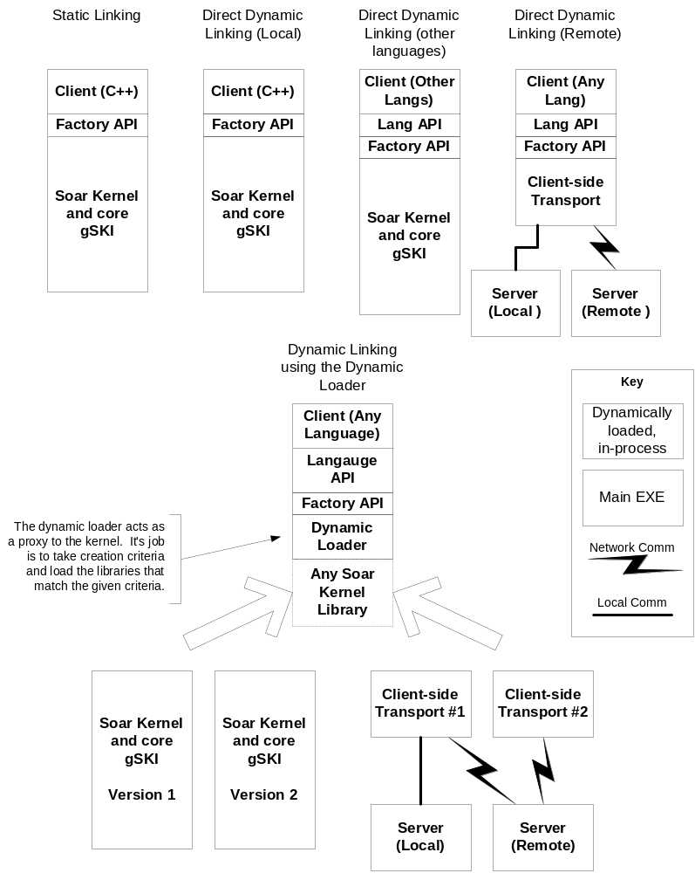
Figure 5: Different types of linking to the gSKI libraries

Static linking is the simplest case. There is only one application and you know at compile time exactly which library you are going to use. GetFactory and GetFactoryIterator are provided by the static Factory API; however, there is only one factory available and it can only create new instances and (possibly) attach to existing in-process instances of the kernel in the same process.
Direct dynamic linking is just a bit more complex. The term “direct” is used to indicate that the client knows in advance which library it will be using; however, that library is not loaded until runtime. This is the simplest form of dynamic loading, and the least flexible. The client can be written in any language that supports the gSKI API and it can use either an in-process or remote kernel instance. The only catch is that the decision on what kernel to link to is made at compile time by specifying the library to link to directly in the code. Just like the static library, the dynamic libraries export the two key functions: GetFactory and GetFactoryIterator.
Indirect dynamic linking through the dynamic loader is the most powerful and flexible way to link to the gSKI libraries. The dynamic loader is a tiny library that’s only job is to implement GetFactory and GetFactoryIterator. It does this job by searching a given path for any libraries that support these methods (gSKI libraries and transport layers) and calling their exported methods. The dynamic loader allows the client to choose at runtime the instance of the kernel and type of connection it desires. The client can even present the user with a choice if that makes sense. The nice part is that using the dynamic loader is only marginally more complex than regular dynamic linking. The client program must load the dynamic loader library instead of a particular gSKI library. That is the only difference.

2.6.5 Library Table

Following is a tentative list of all of the gSKI libraries provided with the standard release.

 | Windows | Linux
Static | gski_soar.lib  gski_soar_debug.lib | gski_soar.a  gski_soar_debug.a
Dynamic | gski_soar.dll & lib  gski_soar_debug.dll & lib | gski_soar.so  gski_soar_debug.so
Dynamic Loader | gski_soar_dynamic.dll & lib | gski_soar_dynamic.so
Transport Layers | transport1.dll & lib  transport2.dll & lib  … | transport1.so  transport2.so  …
Server | gski_soar_server.exe | gski_soar_server
Table 1: List of gSKI libraries

2.7 Extending the System

2.7.1 New transport layers

The Soar system design makes adding transport layers nearly transparent to both kernel maintainers and developer and client side tool and simulation developers. The gSKI core Implementation gives the transport layer developer a clean implementation to wrap, while the abstract gSKI API clearly delineates the client interface as well as providing a base abstract implementation (i.e. the abstract C++ interface).
Transport layer developers must do the following things to add a new transport layer:

- Implement a client side interface that matches the abstract gSKI API. The preferred language for this is C++. In the case of C++ the client should create objects which inherit from the abstract C++ interface objects.
- Implement a server to transform client side calls to in-process gSKI function calls in the kernel’s process.
- Implement the transfer protocol.
- Provide a library (preferably dynamic) to distribute the transport layer.
- Provide a factory method to allow an instance of the new transport layer client to be created. If this factory is in the standard form (discussed in section ###) clients will immediately be able to take advantage of this new transport layer with little effort.

2.7.2 New extended services

Extended services are relatively independent of the rest of the soar system. They are required to interact with the kernel (if necessary) through one of the abstract gSKI interface implementations. To be considered a service, the service must be provided through some in-process or out-of-process library. Furthermore, it must have general purpose, cross-application value to multiple Soar-based systems.
Extended services may be written in any language, in whatever way the developer wishes; however, to be included with the standard extended services, they must be approved by the core Soar system maintainers.
Note that collections of extended services may have their own design specifications and requirements (e.g. preprocessors). These should be examined before attempting to add a new extended service to make sure the new service will fit in well with other services and can be integrated easily by legacy clients.

2.7.3 New languages

Support for most new languages is easily added by creating a gSKI API implementation for that language. The preferred implementation technique for this API is a thin wrapper around either the abstract C++ API or the C API. To be considered a true implementation of the gSKI API, all available objects and methods of gSKI must be implemented.
2.7.4 Compatability

2.7.4.1 Compilers and Languages

Table ### shows the compatibility of the various Soar sub-systems. This table only shows the systems and languages that the soar sub-systems are tested against. Other systems or languages may be compatible, but are not guaranteed to be compatible.
Table 2: Compatability of soar sub-systems with systems and languages.
 | System | Interfacing Language | Build Languages | Compiler
Kernel | Windows 32 Linux | C++ | C++ | VC++ 6.0, VC .NET  gcc 2.??, gcc 3.x
gSKI | Windows 32  Linux | C, C++ | C++ | VC++ 6.0, VC .NET  gcc 2.??, gcc 3.x
Client | Any | C, C++, Java, TCL, Lua, etc | C, C++, Java, TCL, Lua, etc | Whatever required for language

The system compatibility lists the systems under which the components are tested and run. The interface language lists the programming languages available for interfacing with that component. The build language is the language in which the component itself is written. The compiler column lists the compilers used for testing and running that component.
Compatibility will be focused on the 95% of systems that Soar is or may be interfaced with. The thought is that making the system compatible with the other 5% in general is not worth the extra costs in either development, testing or maintenance. If we are required to interface with incompatible systems, solutions for those systems must be developed case by case. In the worst case, we will need to revert to an older version of the kernel for such systems.

2.7.4.2 TCL support

TCL support is required in the system for backward compatibility. TCL backward compatibility will be ensured by the re-implementation of a TSI as a gSKI API implementation. Furthermore, a version of the TCL debugger will be adapted to the new interface so that old Soar files (really tcl files) that contain commands an other non-standard elements will still load correctly.
A new TCL preprocess that can be used for template-based programming will be provided as a tool for soar systems. This preprocessor will not include support for old TCL-Soar commands or for GUIs (using tk). It will only do soar language preprocessing.

3. Detailed Design

Most of this section is still incomplete. Right now there are a large set of static diagrams that make up the core gSKI interface.

3.1 Module View of Core gSKI

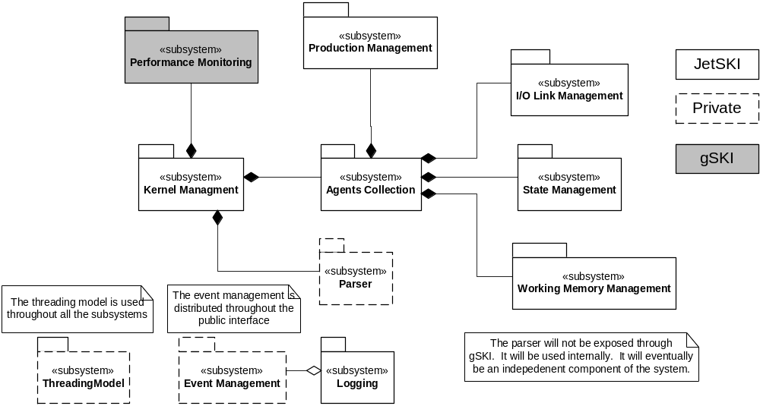
Figure 6: Major subsystems of gSKI

gSKI can be broken into several multi-object modules or “packages” conceptually. We list this modules in figure ###.
The kernel management subsystem provides the central structure for the rest of the subsystems. It provides objects for instantiating the Soar system in-process, out-of-process and remotely. The core object is the IKernel object from which all other important system objects can be obtained. The kernel subsystem contains a private copy of the Soar parser, which is used internally to parse Soar files.
The threading model is not directly exposed through gSKI. The client can choose either multi-threaded or single-threaded support when the kernel is instantiated. All objects in the system share the threading model, using to synchronize access to their data where necessary.
The agents collection subsystem manages the soar agents. It provides objects for managing and accessing the agents as well as objects for running the agents. From the agent object the client can obtain much detailed information including working memory, the input and output links, current state and productions.
Memory management is handled through three sub-systems. The state management subsystem manages the highly structured state and operator information. This includes an object to represent states and substates, an object to represent the goal dependency stack (GDS) and an object to represent operators. The working memory subystem manages access to the low-level details of working memory. It consists mainly of a working memory graph and other helper objects. The IO Link subsystem is responsible for managing the connection of other systems to the Soar system. It provides objects useful for setting up input and output callbacks as well as for managing the input and output links.
The production subsystem provides access to an agent’s productions set. This subsystem supports searching for productions as well as examination of productions and production matches.
The event system is decentralized. It consists of a set of listener interfaces and listener registration methods. The client registers a listener with whatever object fires a given event. This system allows many events to be associated with filters. The filters allow the client to limit the callbacks it receives to the ones it cares about. Filters are provided mainly to improve event system efficiency. Finally, the event system allows for asynchronous event notification. The client can choose to listen to a given event synchronously (as it happens) or asynchronously (any time after it happens). This provides a mechanism for speeding up remote event delivery.
The logging subsystem uses the event subsystem to listen for events and log them to a file. The logging subsystem is mostly independent from the rest of gSKI.
The performance monitoring system provides an interface for measuring kernel and agent performance, including memory usage, cpu usage and timing statistics.
3.2 Major Subsystems

3.2.1 Kernel

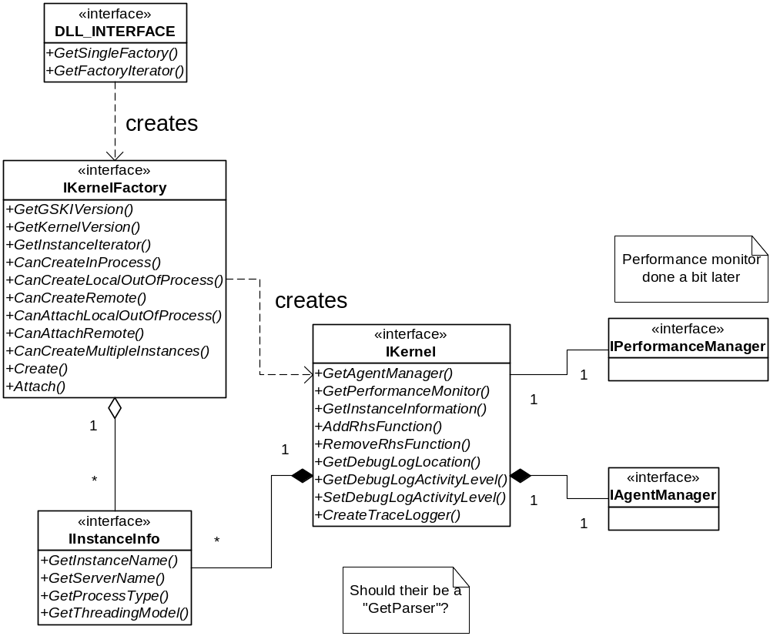
Figure 7: Static object diagram for the kernel subsystem

3.2.1.1 Objects

DLL_INTERFACE
IKernelFactory
IInstanceInfo
IKernel

3.2.1.2 Processes

* Creation Process
* Rhs Functions

3.2.3 Agents

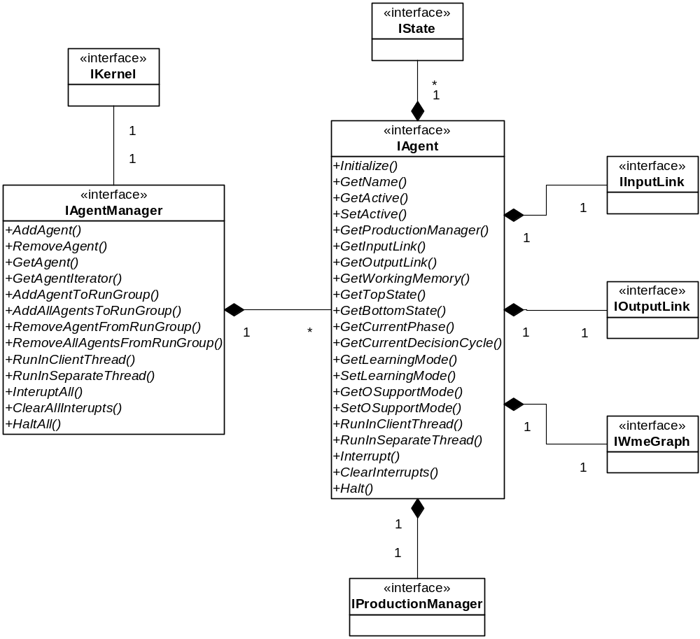
Figure 8: Agent management subsystem

3.2.3.1 Objects:

IAgentManager
IAgentThreadGroup
IAgent

3.2.3.2 Processes:

*Agent Creation Process
*Agent Initialization
*Running an Agent
- Single Thread
- Multi Thread

3.2.4 States and Operators

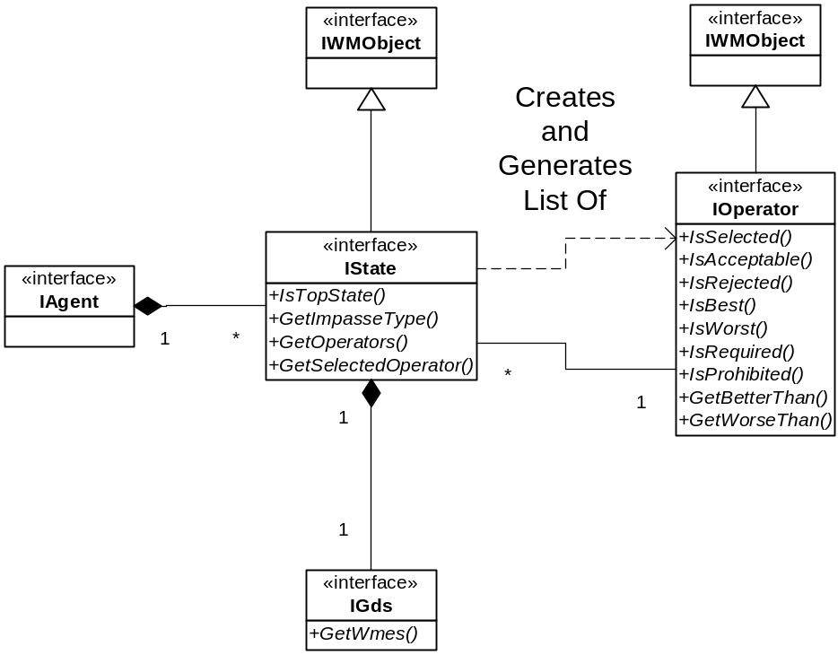
Figure 9: States and operators

3.2.4.1 Objects:
IState
IGds
IOperator

3.2.4.2 Processes:

3.2.5 Working Memory

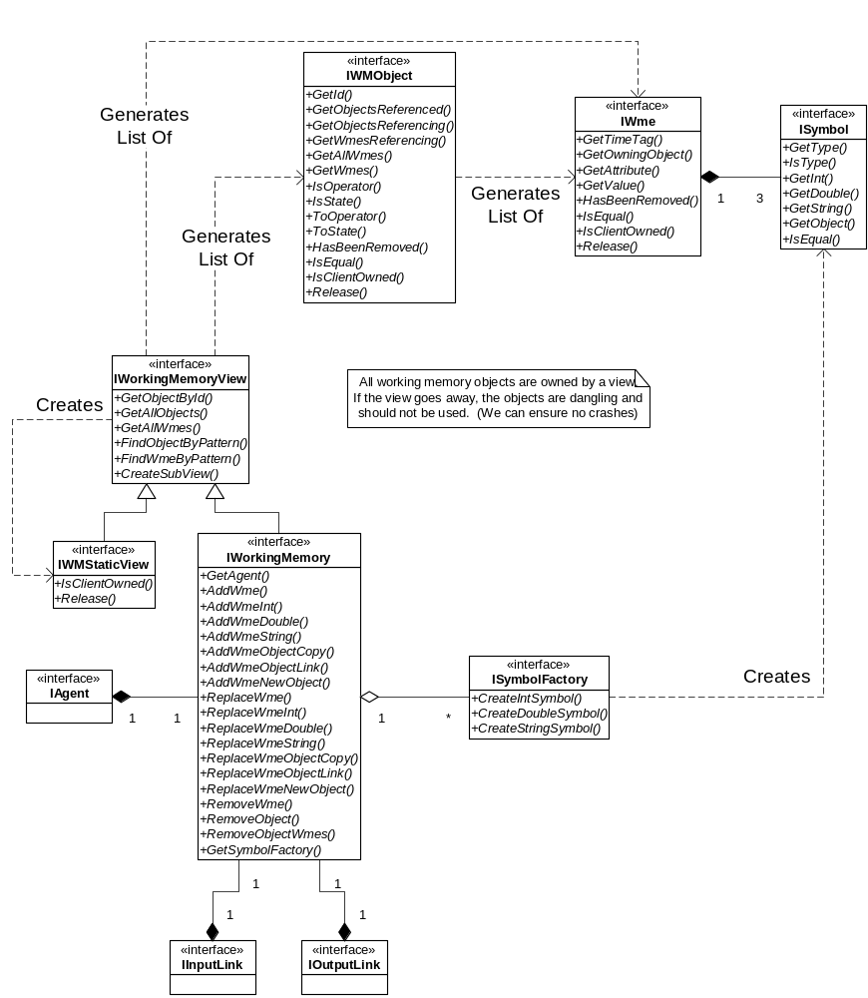
Figure 10: Working memory interfaces

3.2.5.1 Objects:
IWmeGraph
IWme
ISymbol
ISymbolFactory

3.2.5.2 Processes:
*Finding a Wme
*Finding a Wme’s preferences
*Adding a Wme
*Removing a Wme

3.2.6 I/O Link

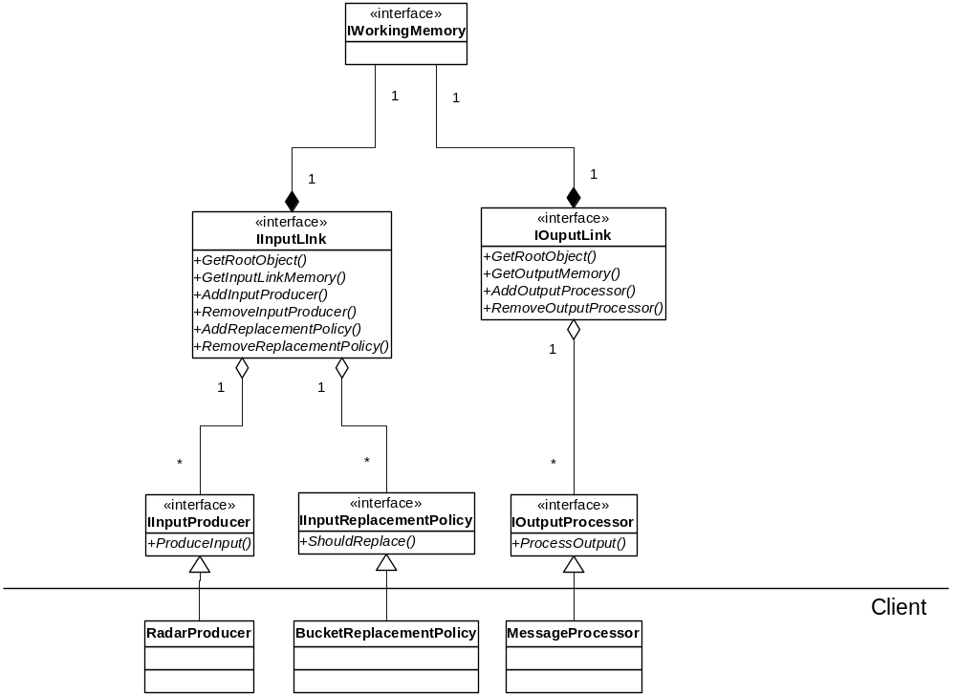
Figure 11: IO link subsystem
3.2.6.1 Objects:
IInputLink
IInputWme
IInput Producer
IInputChangePolicy
IOutputLink
IOutputConsumer

3.2.6.2 Processes:
*Producing Input
*Creating the Input Link
*Updating directly
*Updating through producers and policies
*Processing Output
*Updating directly
*Updating through consumers
3.2.7 Productions

Currently the production manager does not represent productions completely. This can be done with a bit more design and thought.

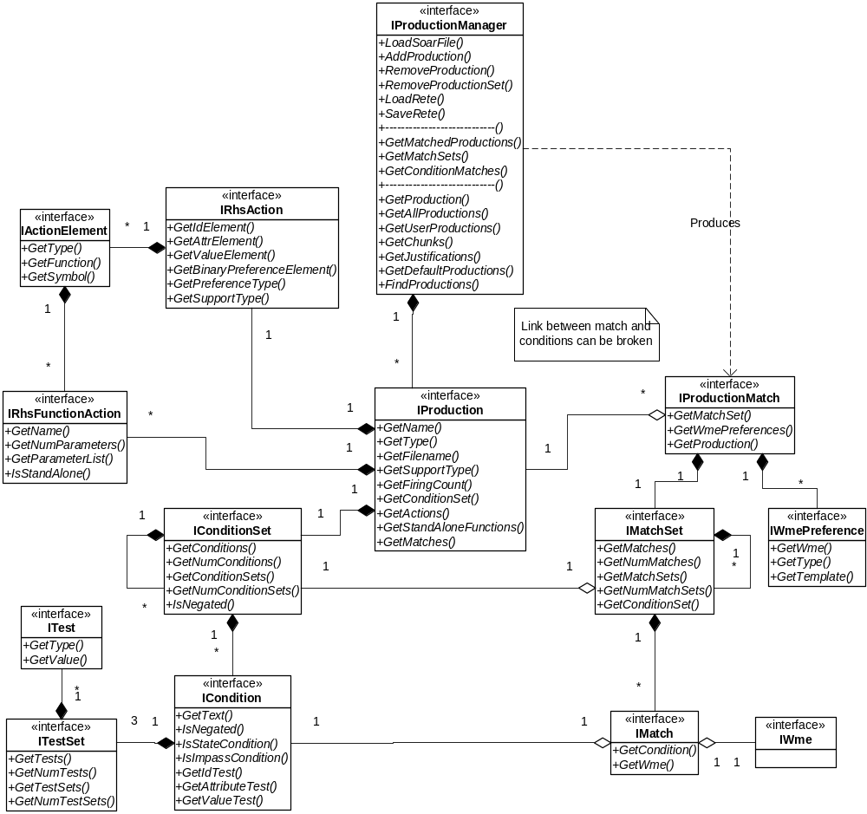
Figure 12: Production subsystem

3.2.7.1 Objects:
IProductionManager
IProduction
IConditionSet
ICondition
IActionSet
IRhsFunction
IPreferenceTemplate
IProductionMatch
IMatchSet
IMatch
IWmePreference

3.2.7.2 Processes:
*Find a production
*Add a production
*Remove a production
*Load a Soar File
*Load a Rete
*Save a Rete
*Find wme’s produced by production
*Find all current complete matches
*Find matches on a wme
*Find partial matches on a wme

3.2.8 Parsing

N/A

3.2.9 Logging

N/A

3.2.10 Events

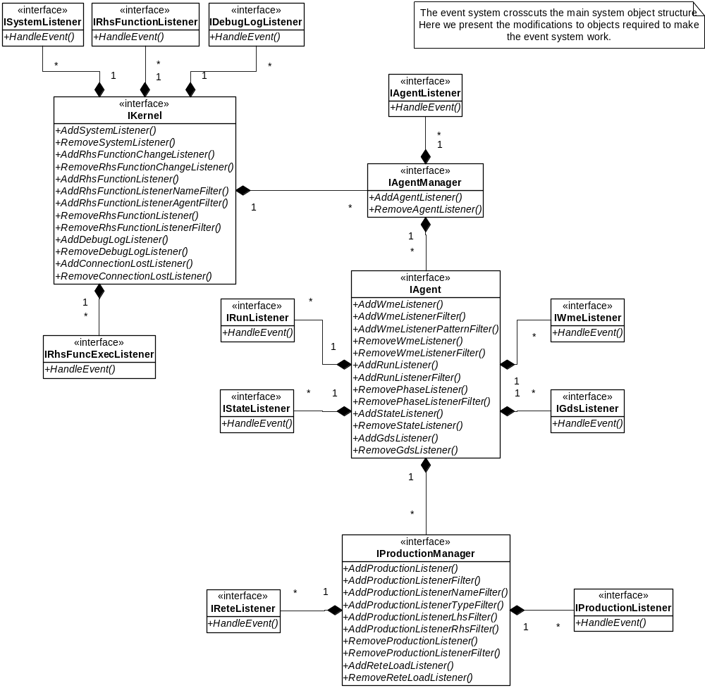
Figure 13: Event management subsystem

3.2.10.1 Event Interfaces

Because the event system crosscuts the system and handles many types, it doesn’t fit well into object oriented structures. Despite the fact that almost all event sources and listener do almost exactly the same thing, it is impossible to build a concise object-oriented solution to event propagation. C++ provides templates for generic programming which can handles this type of design well, but gSKI is targeting older systems which to not support templates well. Therefore the design is distributed and somewhat repetitive. Despite this fact, we can present an abstract view of the event source and listener interfaces.
Event sources all implement the a method with the following signature for every listener type they manage:

void Add???Listener(EVENT_ID,
PRE/POST,
Listener,
ASYNC/SYNC);

The event id and the pre/post indicator together identify the event. So to receive callbacks just before a WME is added you would specify ADD_WME as your event id and PRE as your pre/post indicator. The listener is a client defined and owned object that implements an event handler method with a signature that depends on the particular class of event being fired. The ASYNC/SYNC flag tells the system whether it must synchronize calls to the listener or whether it can send events any time after the event occurs (events are received by the listener in order whether they are synchronous or not).

Event sources provide a method to remove a listener when the client is finished listening to an event:

void Remove???Listener(EVENT_ID,
PRE/POST,
Listener);

The id, pre/post indicator and listener together form the identifier for a single callback. You need to specify all of them to remove a listener.
Some events can be filtered on the server side to ensure that the client doesn’t receive too many updates. Filters are added on an individual callback basis. For each event that supports filters, the event source object provides one or more of the following methods:

void Add???Listener???Filter(EVENT_ID,
PRE/POST,
Listener,
filter params …);

The event id, pre/post indicator and Listener identify the particular callback to filter. The filter parameters are specific to the event being filtered. Typical filter parameters are regular expressions that are matched against event data names though there are filters. If multiple filters are specified for the same listener, the event must pass through all the filters before it is passed to the listener. Essentially this means that filters for a callback are conjuncted or “ANDed” together.
Event sources provide a method to remove all filters from a particular callback using the following method:

void Remove???ListenerFilters(EVENT_ID,
PRE/POST,
Listener);

All filters for a particular callback are always removed simultaneously.
3.2.10.3 List of system events

Table ### below lists all of the events that are fired by gSKI. All events have a pre and post callback (except system shutdown, which does not have a post). Event listeners are grouped by their event handler method’s signature. If two events result in the same event callback signature, the same event listener can be used to handle both events (if desired).

Event Object: Object associated with the event
Event: Name of the event
Event Data: Type of data passed to event handler.
Managing Object: Object with which to register a handler. This object fires the event.
Listener Type: Type of listener class required to listen for that event.
Filter: Restriction on event firings. Typically this is an event data pattern.

Filters are implemented on the server side. Essentially, a filter is a pattern against which the event data is matched. If the event data matches the pattern, the event is propagated to the listener; otherwise, the event is not sent to the listener. The purpose of the filter is to reduce event callbacks for high-frequency callbacks, thus increasing performance.

Event Object | Event | Event Data | Event Propagation Object | Listener Type | Filter
WME | Added | new WME | IWorkingMemory | WME Listener | wme pattern
WME | Removed | removed WME | IWorkingMemory | WME Listener | wme pattern OR  wme instance
WMObject | Added | new WMObject | IWorkingMemory | WMObjectListener | id or id pattern
WMObject | Removed | removed WMObject | IWorkingMemory | WMobjectListener | id or id pattern
Production | Added | new Production | IProductionManager | Production Listener | production pattern
Production | Excised | excised Production | IProductionManager | Production Listener | production pattern
Production | Fired | fired production & new match | IProductionManager | Production Listener | production pattern OR  production instance
Production | Retracted | retracted production | IProductionManager | Production Listener | production pattern OR production instance
operator | Proposed | operator (WMObject) & state | IAgent | Operator Listener | wme pattern
operator | Selected | operator (WMObject)  & state | IAgent | Operator Listener | wme pattern
operator | Retracted | retracted operator (WMObject) & state | IAgent | Operator Listener | wme pattern
operator | Preference Added | operator (s), state, preference type | IAgent | Preference Listener? | wme pattern AND preference type
GDS | Violated | WME & state | IAgent | GDS Listener | wme pattern
GDS | Wme Added | WME & state | IAgent | GDS Listener | wme pattern
State | State Created | state | IAgent | State Listener | state type, state name
State | State Destroyed | state | IAgent | State Listener | state type, state name
Running | Begin | Agent & phase | IAgent | Run Listener | NONE
Running | End | Agent & phase | IAgent | Run Listener | NONE
Decision Phase | Begin | Agent & phase | IAgent | Run Listener | type of phase
Decision Phase | End | Agent & phase | IAgent | Run Listener | type of phase
Elaboration Cycle | Begin | Agent & phase | IAgent | Run Listener | type of phase AND  cycle count condition
Elaboration Cycle | End | Agent & phase | IAgent | Run Listener | type of phase AND cycle count condition
Decision Cycle | Begin | Agent & phase | IAgent | Run Listener | cycle count condition
Decision Cycle | End | Agent & phase | IAgent | Run Listener | cycle count condition
Rete | Load | Production Manager? | IAgent | Rete Listener | NONE
Rhs Function | Added | Function Name | IKernel | Rhs Function Changed Listener | NONE
Rhs Function | Removed | Function Name | IKernel | Rhs Function Changed Listener | NONE
Rhs Function | Executed | Symbol Iterator | IKernel | Rhs Function Listener | Rhs function name AND agent name
Agent | Created | new agent | IAgentManager | Agent Listener | NONE
Agent | Initialized | agent | IAgentManager | Agent Listener | NONE
Agent | Destroyed | agent being destroyed | IAgentManager | Agent Listener | NONE
Agent | Run Started | agent | IAgent | Agent Listener | NONE
Agent | Run Stopped | agent | IAgent | Agent Listener | NONE
Agent | Request Input | input WME | IInputLink | Input Link Listener | input WME
Agent | Process Output | output WME | IOutputLink | Out-Link Listener | wme pattern
Kernel | Shutdown | kernel | IKernel | System Listener | NONE
Kernel | Restart | kernel | IKernel | System Listener | NONE
Table 3: List of all system events

3.2.10.3 Process:
*Registering to receive an event
*Filtering an event
*Handling an event
*When events occur
*How to break
*What you can do in callbacks

3.2.11 Threading Support

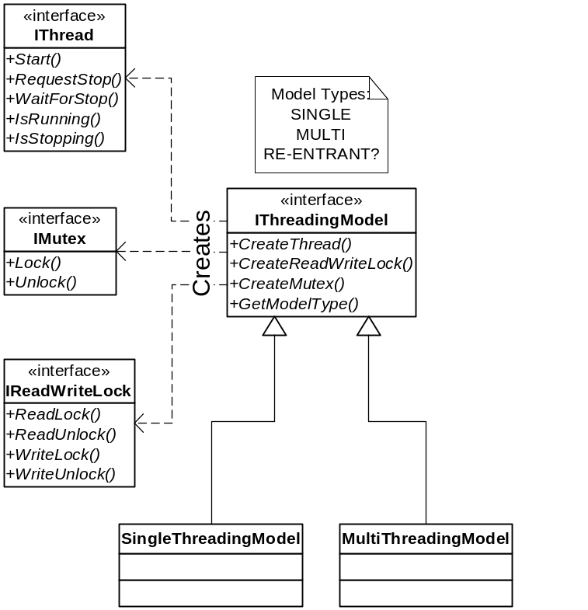
Figure 14: Threading model interface (private)

There will be (at least) two threading models. Each of those will result in a new class inheriting from IThreadingModel.

3.2.11.1 Re-entrance

It will be really helpful to make the kernel re-entrant.

3.2.11.2 Synchronization

3.2.11.3 Thread-Agent Groups

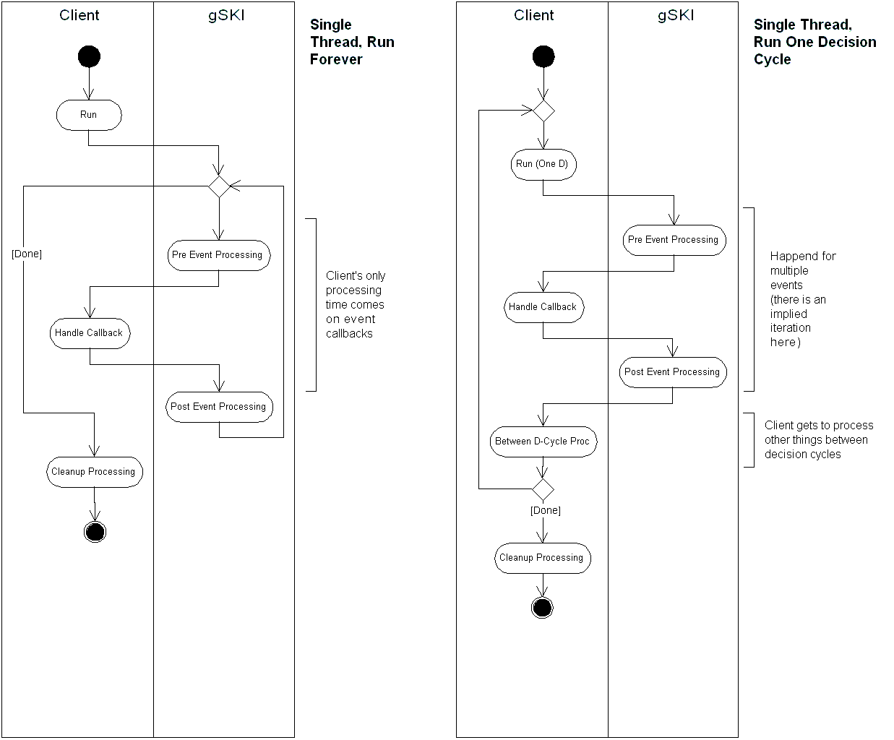
Figure 15: Single threaded agent execution

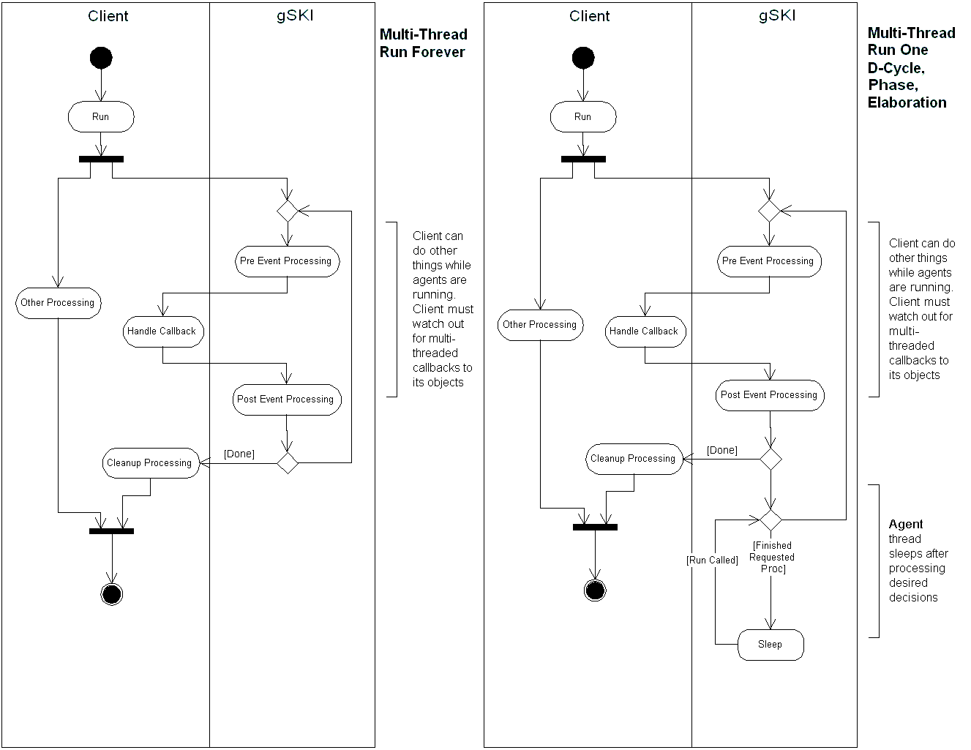
Figure 16: Multithreaded agent execution
3.2.12 Common Utility Support

3.2.12.1 Object Lifetime

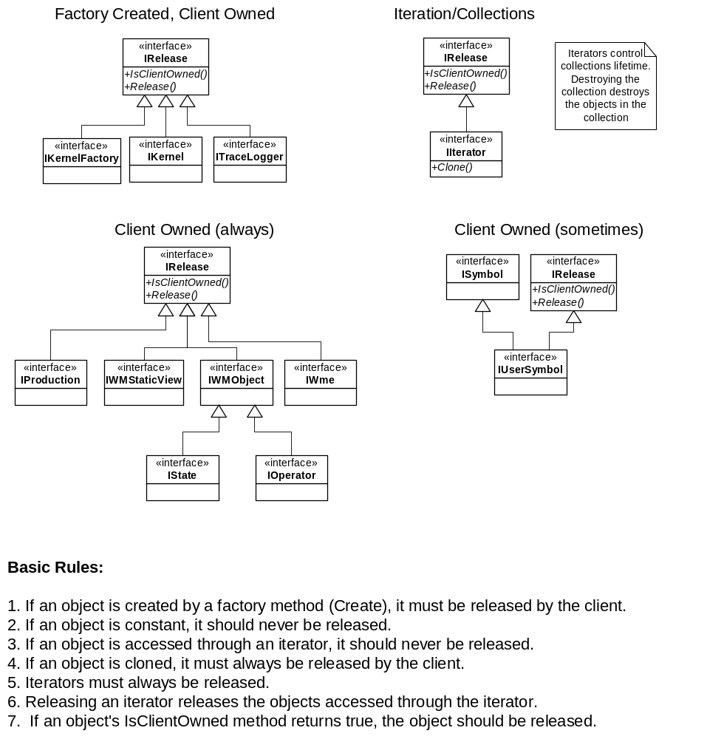
Figure 17: Object ownership and lifetime management

3.2.12.2 Collections

Collections are managed by the object that owns them. If a client-owned collection is produced (e.g. for search results), the client is given an iterator into the collection which controls the lifetime of the collection. If the iterator goes away (is destroyed), the collection goes away.

3.2.12.3 Iterators

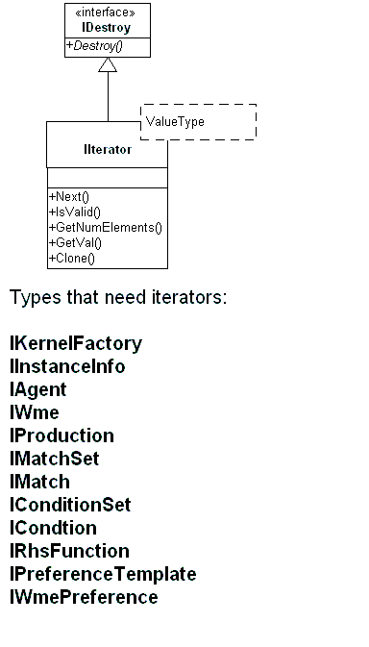
Figure 18: Iterators

4. Testing Procedures

Automated build process
Regression testing on kernel
White box testing on gSKI
Black box testing on gSKI

5. Configuration Management

Module layout and directory structure
Windows project
Linux project
General procedures (checkin, merging, etc)

6. The gSKI API

