From Detroit Metro Airport:
I-94 west to M-23 north
Take Exit 41 (third exit, Plymouth Road) and turn left (toward Ann Arbor)
Proceed over freeway
Turn left at light onto Green Road (the first intersection)
About a quarter-mile down the hill, after the shopping center, turn left onto Green Court (Plymouth Green Technology Center). Go past the new Altarum building on the right, and turn left, then either right into parking area on the south side of the building, or continue past Hawthorn Suites hotel to the parking area north of our building.
The Soar 25 Workshop will be in the Kiva Room in the low, one-story building across from the Hawthorn Suites hotel. There is additional parking between the building and the Microtel/Holiday Inn.
There are multiple entrances to the building, but only the main entrance across from the hotel is open.

From Detroit & Northern Suburbs:
I-96 west to M-14 west to M-23 south. Exit at first opportunity on Plymouth Road, proceed to Green Road and follow directions above.

From West (Jackson):
I-94 east to M-14 East (Detroit) to M-23 South (Toledo)
Take first exit (Exit 41, Plymouth Road) and turn right (toward Ann Arbor).
Duplicate directions above.
Red Roof Inn

Hampton Inn

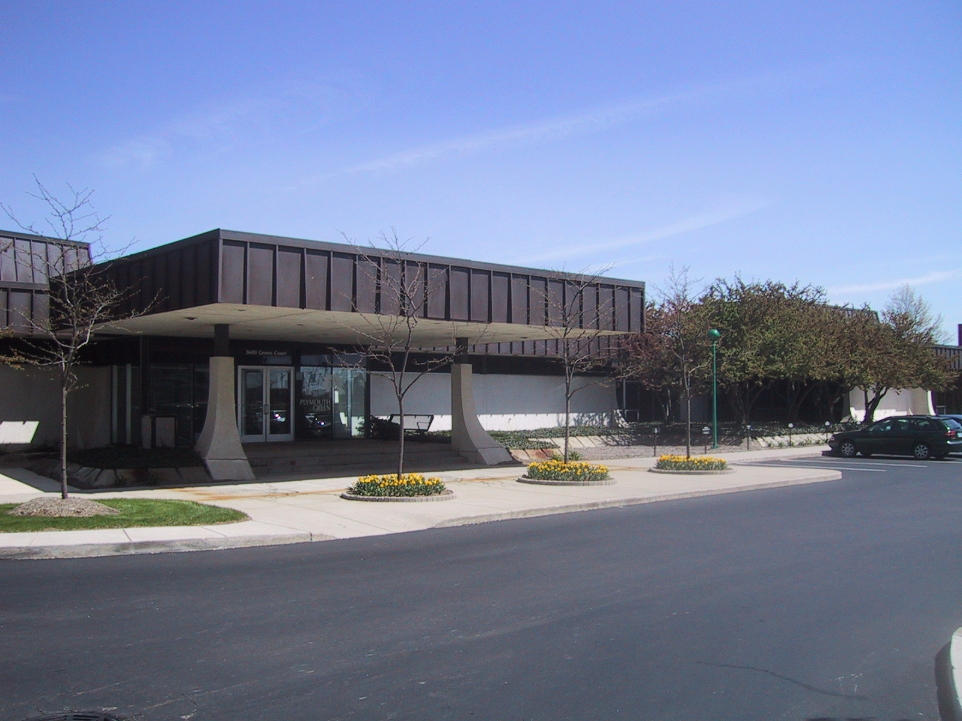
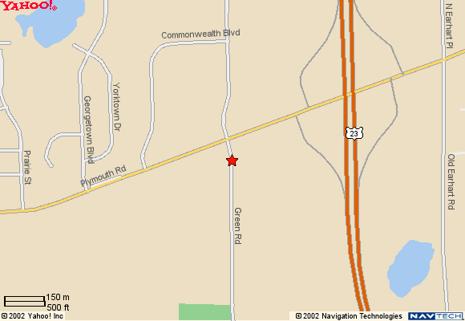
Hawthorn
Suites
Holiday
Inn
Microtel

To U Michigan North Campus & Ann Arbor

North
Building Entrance
25th North American Soar Workshop
Green Court
Soar Technology, Inc.
3600 Green Court, Suite 600
Altarum Bldg
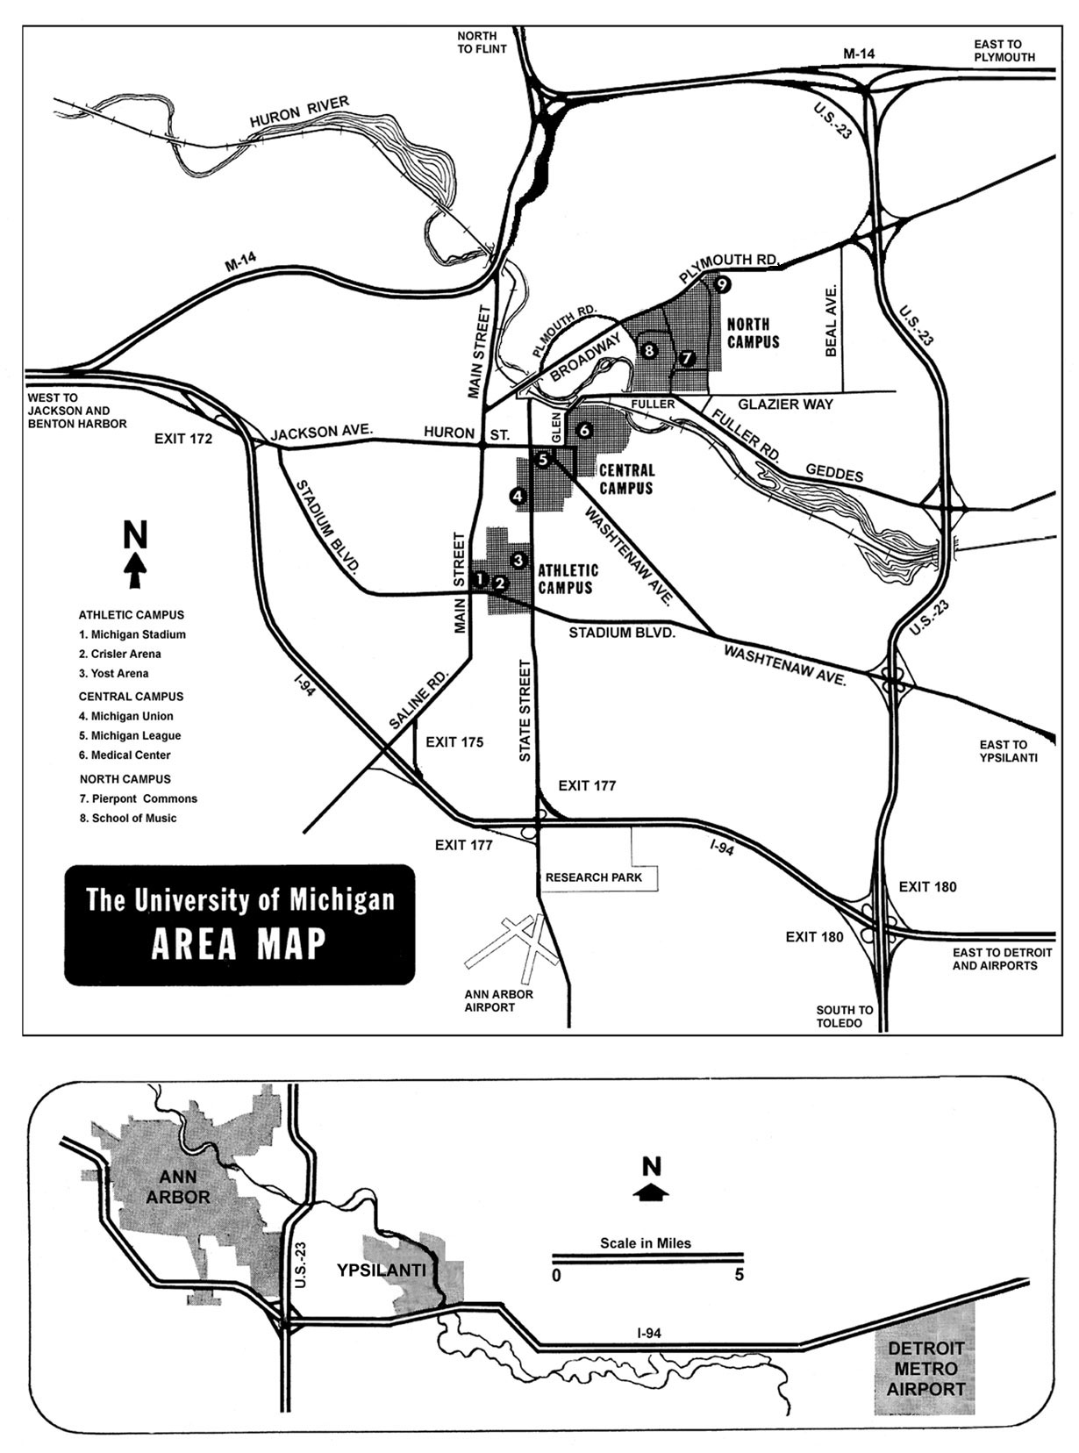

Soar
Workshop

Soar
Workshop

Monday & Tuesday Tutorial
At ATL

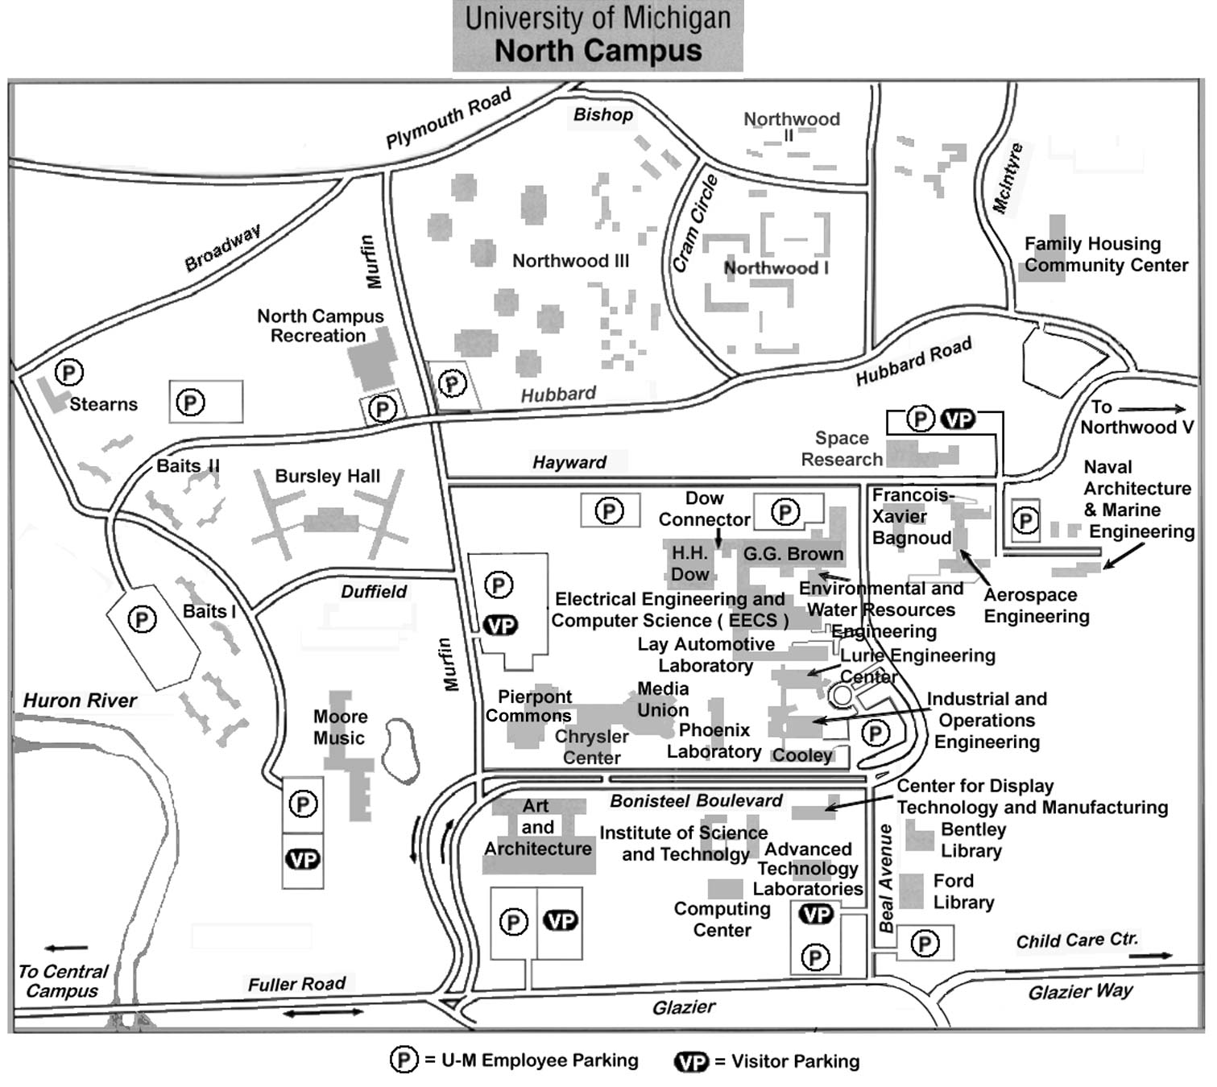
Parking
To Hotels

ATL
(Monday & Tuesday Tutorial)
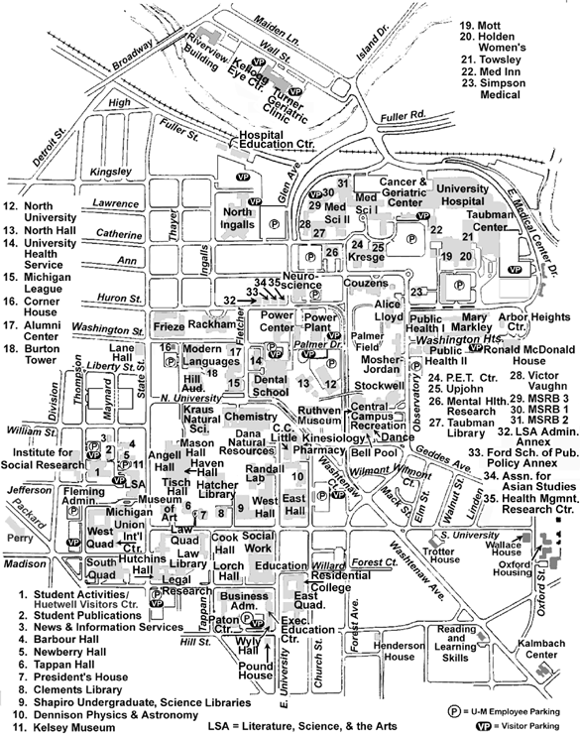
U of Michigan
Central Campus
To North Campus
To Soar Workshop via Geddes
Pizza House
(Tuesday night 6:30 pm)

Soar 25 Workshop Kickoff Dinner
Sponsored by Soar Technology, Inc.

PIZZA HOUSE
618 Church St., Ann Arbor, MI Tuesday June 14, 6 – 8:30 PM

From SoarTech & Hotels near SoarTech, go out Green Court
- turn left on Green Road
- take 2nd right on Hubbard
- take second left (at traffic light) onto Huron Parkway
- after light and bridge over River, make immediate left onto Geddes Road, which takes you around left (270 degrees) into Ann Arbor
- after about 1 mile, Geddes crosses Washtenaw Ave.
- Continue on Geddes but then make a left on Church Street
- Pizza House is just below South University. Park on the street or in parking structure on Forrest a short block away.
