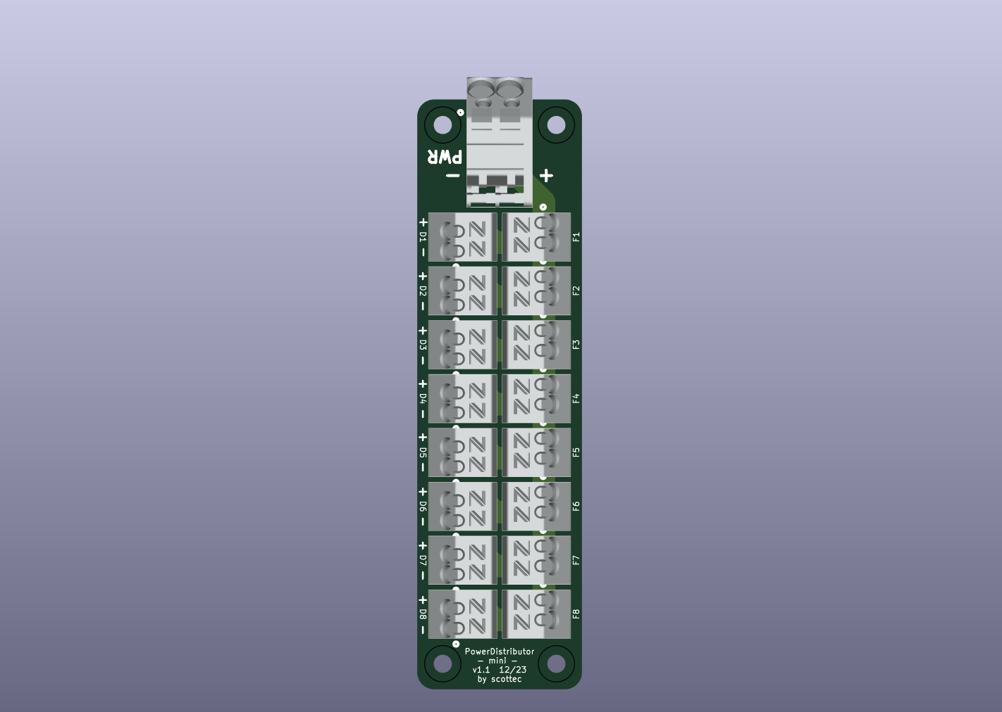



Connect main supply  
Polarity VERY relevant



M3 Mounting Holes



Device



Device



**Fuse  
Switch**



**Fuse**

Connect fuse for device 1  
Polarity not relevant

Connect device 1  
Polarity VERY relevant