Artificial Intelligence in Drug Discovery: Problems and Prospects
A Case Study in Predictive Modeling and Virtual Screening for Acetylcholinesterase Inhibition

Md Abu Sadat Soash¹, Sajib Mia¹
¹ Department of Genetic Engineering and Biotechnology,
Shahjalala University of Science and Technology, Sylhet, Bangladesh.

Abstract
Artificial intelligence (AI) is frequently described as transformative for drug discovery, yet recent critical appraisals note that its demonstrated clinical impact remains limited relative to the scale of investment and publication in the field. This paper examines the problems and prospects of AI in drug discovery through a brief literature review combined with an original, fully reproducible case study. Using bioactivity data extracted directly from the ChEMBL database (release 37) for human acetylcholinesterase (AChE), the target of every approved symptomatic Alzheimer’s disease therapy, we built Random Forest models predicting inhibitory potency (pIC50, R² = 0.72) and active/inactive status (AUC = 0.966) from molecular structure (1024-bit Morgan fingerprints) alone. Model validity was confirmed via cross-validation and a y-randomization control, which collapsed performance to chance level (R² ≈ −0.19, AUC ≈ 0.50) when activity labels were shuffled, ruling out data leakage. Interpretability analysis showed the model independently rediscovered a carbamate pharmacophore shared by three clinically used AChE inhibitors. The trained model was then applied to virtually screen 738,823 compounds from the COCONUT open natural products database, correctly re-identifying known inhibitors (donepezil, tacrine, physostigmine and its alkaloid family) and surfacing a chemotype, irbesartan-derived diazaspirononanones, independently corroborated by prior published enzyme-assay literature. Together these results illustrate both the genuine capabilities and the practical limitations, data curation burden, applicability domain, and the distinction between rediscovery and novelty, that characterize current AI-driven drug discovery.

Keywords: Artificial Intelligence; Drug Discovery; QSAR; Acetylcholinesterase Inhibitors; Alzheimer’s Disease.

1. Introduction
Artificial intelligence has become deeply embedded in the modern drug discovery pipeline, from early target identification through lead optimization and, increasingly, clinical trial design [1]–[5]. Proponents point to AI’s capacity to compress timelines, explore vast chemical spaces computationally, and integrate heterogeneous data at a scale unmanageable by traditional methods. A growing body of literature, however, cautions that translating this progress into approved therapies has been slower than early enthusiasm suggested [1]. This tension between demonstrated computational capability and unproven clinical impact defines the central problem this paper investigates.
The most consistent critique in recent literature is a gap between methodological sophistication and demonstrated clinical benefit: a 2026 Nature Reviews Drug Discovery perspective argues that despite a decade of investment in AI methods for drug discovery, evidence of clinically relevant impact remains limited [1]. Complementary reviews document challenges around harmonizing regulatory treatment of AI-derived evidence across jurisdictions [2] and the ethical dimensions of AI-assisted development in therapeutic areas historically constrained by long timelines [4]. Our own case study (Sections 2–4) surfaces two further problems: the disproportionate effort required for defensible data curation relative to modeling itself, and the difficulty of distinguishing rediscovery of already-known compounds from genuinely novel signal during virtual screening.
Despite these problems, the literature also identifies concrete progress. AI methods now span the full discovery pipeline, including target identification, hit generation, lead optimization, drug repurposing, ADMET prediction, and increasingly personalized-medicine applications [2], [3]. Industry commentary suggests 2026 marks a transition point at which AI shifts from isolated applications toward core infrastructure across discovery organizations [5]. Open, large-scale natural product databases such as COCONUT (now exceeding one million curated structures under a permissive open license [6]) make large-scale virtual screening for drug repurposing increasingly accessible outside well-resourced industry settings, a capability demonstrated directly in Section 4.
Realizing either the problems or the prospects described above depends on which AI methodology is used, since these are commonly grouped into several families distinguished by how molecules are represented and what data they require [2]. Ligand-based QSAR/machine learning methods (e.g., Random Forest, support vector machines, gradient-boosted trees) train classical algorithms on molecular descriptors or fingerprints, numerical encodings of a molecule’s own 2D structure such as Morgan/ECFP fingerprints or MACCS keys, paired with measured bioactivity against a specific target. These methods require no knowledge of the target protein’s 3D structure, are comparatively data-efficient, and, particularly with tree-based models, offer interpretable feature importance. Deep learning on molecular graphs, including graph neural networks (GNNs) and message-passing networks, instead learns molecular representations directly from atom-and-bond graphs, often improving accuracy on large datasets at the cost of requiring more training data and less transparent interpretability. Generative, de novo design methods (variational autoencoders, generative adversarial networks, diffusion models, and SMILES/SELFIES-based transformer language models) propose new molecular structures directly rather than only scoring existing ones. Structure-based virtual screening, including molecular docking and AI-based protein structure and binding-pose prediction, uses the 3D structure of the target protein itself rather than only historical ligand data.
Beyond molecule-level modeling, AI is also applied to drug repurposing, biomedical literature mining, ADMET/toxicity prediction, and clinical trial design [2], [3]. These families are not mutually exclusive in practice, and modern pipelines increasingly combine several, but they differ enough in data requirements and interpretability that the choice among them is a substantive methodological decision.
This paper adopts the ligand-based QSAR/machine learning approach, specifically Random Forest models trained on 1024-bit Morgan fingerprints, rather than a graph-based deep learning, generative, or structure-based docking approach, for three reasons. First data fit, the curated AChE dataset (6,268 compounds, Section 2.2) sits at a scale well matched to classical ensemble methods, which perform competitively with deep learning on datasets of this size, whereas graph neural networks and generative models typically need substantially larger training sets. Second interpretability, Random Forest feature importance permits a direct mapping from predictive features back to chemical substructures (Section 2.5), central to this paper’s validation strategy, allowing model behavior to be checked against known pharmacology (Section 3.3) far more directly than with black-box models. Third methodological rigor over architectural novelty, because this paper’s goal is a fully validated, reproducible pipeline, including negative controls such as y-randomization (Section 2.4) that the literature suggests are inconsistently applied in the field, a well-understood, lightweight algorithm let validation effort concentrate on rigor rather than architecture engineering. Structure-based docking was deliberately not used, since it requires a resolved or predicted 3D AChE structure and its own assumptions about binding-pose accuracy, though it is identified as a concrete next step in Section 6.
The remainder of this paper is organized as follows: Section 2 describes the data curation, modeling, and validation methodology; Section 3 presents results, including the y-randomization robustness control; Section 4 applies the model to natural-product virtual screening; Section 5 discusses what the case study illustrates about the problems and prospects described above; Section 6 outlines limitations and concrete future work; and Section 7 concludes.

2. Methodology
2.1 Target and data source
We selected human acetylcholinesterase (ChEMBL target CHEMBL220) as the case-study target. Bioactivity data was extracted directly from the official ChEMBL release 37 SQLite bulk distribution via SQL queries against the target_dictionary, assays, activities, molecule_dictionary, and compound_structures tables, rather than a pre-curated third-party dataset [7]. Extraction was restricted to IC₅₀ measurements reported with an exact relation and nanomolar units, yielding 7,826 raw activity records. pIC50 (−log₁₀[IC₅₀ in M]) was computed per record prior to aggregation; compounds tested in multiple assays were collapsed to a single value via the median pIC50 across records, aggregating in log space rather than averaging raw nanomolar values, which would otherwise be skewed by the log-normal distribution of IC₅₀ measurements. A sanity check identified 19 compounds with implausible sub-picomolar potency (pIC50 > 11.8); tracing these to source records showed 17 originated from a single ChEMBL assay, consistent with a unit-parsing artifact rather than genuine ultra-potent inhibitors, and they were excluded. The final curated dataset comprised 6,268 unique compounds (2,877 active, pIC50 > 6 [IC₅₀ < 1 μM]; 1,595 inactive, pIC50 < 5; 1,796 intermediate).
2.2 Featurization and models
Molecules were represented as 1024-bit Morgan (ECFP4-equivalent, radius 2) fingerprints computed with RDKit [8], [9]. Two Random Forest models [10], implemented in scikit-learn [11], were trained: a regressor predicting continuous pIC50, and a classifier predicting active/inactive status (intermediate compounds excluded to avoid ambiguous-boundary noise). Both used an 80/20 train-test split with 3-fold cross-validation on the training partition.
2.3 Validation
To rule out data leakage (e.g., near-duplicate molecules split across train and test) as an explanation for model performance, we performed a y-randomization control: training-set labels were randomly permuted five times, models were refit on the scrambled labels, and performance was re-evaluated on the untouched, correctly labeled test set. A model exploiting genuine signal should collapse toward chance performance under this manipulation; one exploiting leakage would not.

2.4 Interpretability
Gini feature importances were extracted from the trained classifier, and the six most important fingerprint bits were mapped back to example molecular substructures using RDKit’s bit-rendering utilities, converting an opaque feature index into an inspectable chemical fragment.
2.6 Virtual screening
The trained models were applied to the COCONUT database of open natural products [6] (August 2026 release, CSV format; 738,823 successfully featurized compounds). For each compound we also computed an applicability-domain measure, the maximum Tanimoto similarity to any compound in the AChE training set, since natural products occupy a structurally distinct region of chemical space from the mostly synthetic ChEMBL training data. Two literature-confirmed natural-product AChE inhibitors, galantamine and huperzine A, were scored directly as an external validation check independent of whether COCONUT itself contained them.

3. Results
3.1 Predictive performance
Table 1 summarizes model performance. The regression model explained 72% of the variance in experimental pIC50 on held-out test compounds, with close agreement between test and cross-validation performance, indicating the result is not an artifact of a favorable train/test split. The classifier achieved 91.3% test accuracy and an AUC of 0.966. Figure 1 shows the regression fit and ROC curve.

Metric | Regression (pIC50) | Classification (active/inactive)
Test set | R² = 0.72, RMSE = 0.74, MAE = 0.53 | Accuracy = 91.3%, AUC = 0.966, F1 = 0.934
3-fold CV | R² = 0.69 ± 0.03 | AUC = 0.960 ± 0.005
Y-randomization | R² = −0.19 ± 0.02 | AUC = 0.50 ± 0.01
Table 1. Model performance: test set, cross-validation, and y-randomization control.
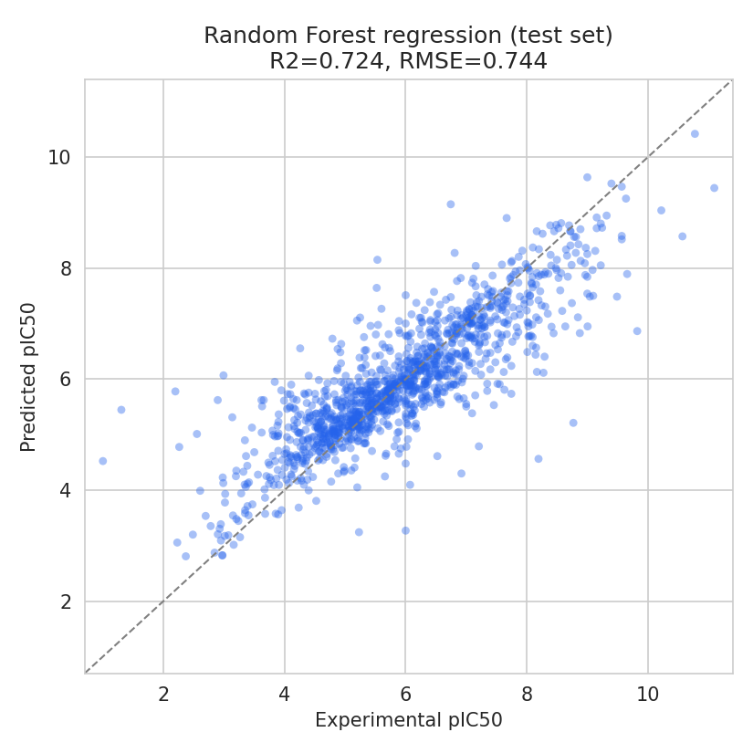 | 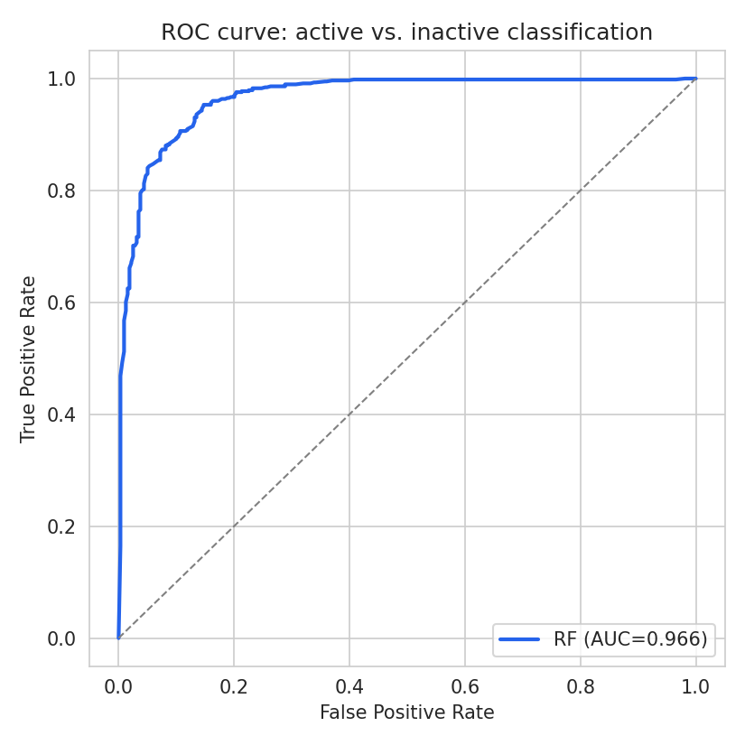
Figure 1. Left: predicted vs. experimental pIC50 (test set). Right: ROC curve for the active/inactive classifier.
3.2 Y-randomization control
Figure 2 shows the outcome of the y-randomization control. Under label shuffling, regression performance collapsed to R² ≈ −0.19 ± 0.02 (worse than predicting the mean) and classification AUC collapsed to 0.50 ± 0.01, indistinguishable from chance. Because performance depends entirely on labels remaining correctly matched to molecules, this collapse under shuffling is direct evidence that the unshuffled models learn genuine structure-activity relationships rather than exploiting an artifact such as near-duplicate molecules split across the train/test partition.
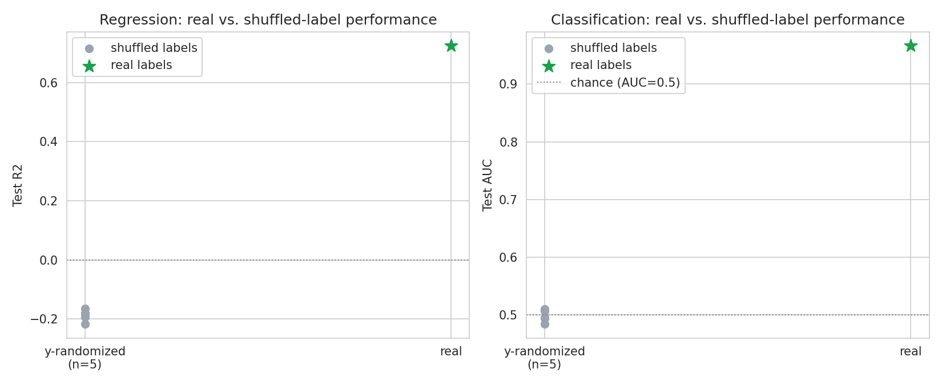
Figure 2. Real vs. shuffled-label performance for regression (left and classification (right); five shuffles each.

3.3 Interpretability
The single most important fingerprint feature in the classifier corresponded to an O–C(=O)–NH– carbamate linkage, the exact chemical warhead present in three clinically used AChE inhibitors (physostigmine, rivastigmine, and neostigmine). Figure 3 shows this and five other top-ranked substructures. That a model trained purely on statistical correlation, with no chemical knowledge encoded, converged on a pharmacologically established warhead is a meaningful check independent of the accuracy metrics above; this finding replicated across two independently curated versions of the dataset.
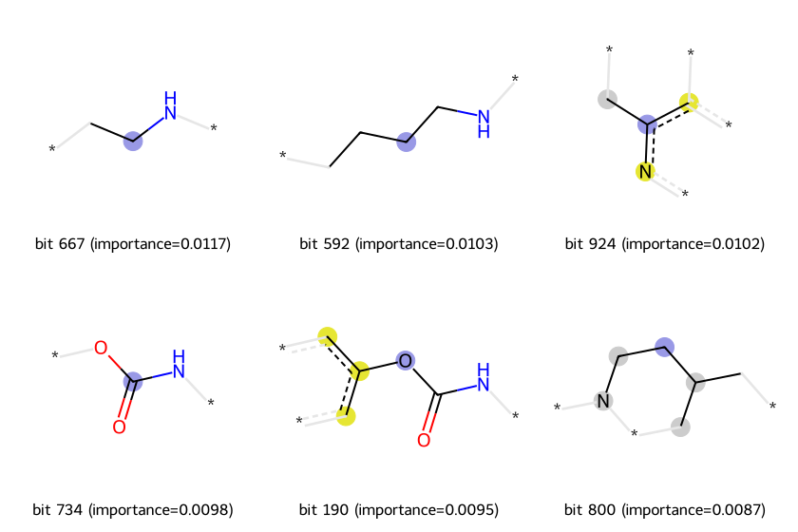
Figure 3. Example substructures behind the six most important fingerprint bits in the classifier, ranked by Gini importance.
3.4 Virtual Screening of Natural Products
Applying the trained model to 738,823 COCONUT natural products yielded 188,855 compounds (25.6%) predicted active (P > 0.5); 340,854 compounds (46.1%) exceeded a conservative applicability-domain similarity floor of 0.30. The in-domain hit rate (28.4%) was only modestly higher than the out-of-domain rate (23.1%), indicating the model does not indiscriminately over-predict activity once it leaves familiar chemical space.
External validation against two literature-confirmed natural-product AChE inhibitors was informative. Huperzine A, a potent inhibitor isolated from Huperzia serrata with a reported literature IC50 of roughly 80–500 nM, was predicted at pIC50 = 6.82 (≈150 nM), within the reported range despite the model never training on this compound. Galantamine, an approved but comparatively weaker Alzheimer’s therapeutic, was correctly predicted as borderline-active (P = 0.57) rather than a confident hit, consistent with its known moderate potency.
Ranking predictions by P(active), the highest-confidence hits were dominated by compounds with applicability-domain similarity of 1.0 to the training set: donepezil, tacrine, and the physostigmine alkaloid family (physovenine, geneserine, phenserine). This indicates these are exact structural duplicates between COCONUT and ChEMBL rather than novel findings, though their correct identification further validates the model. Restricting to a plausible but not a near-duplicate band (applicability-domain similarity 0.30–0.95, n = 339,882) surfaced two structurally related, non-duplicate compounds sharing a 2-butyl-diazaspiro[4,4]nonenone core, the key synthetic intermediate used in manufacturing the antihypertensive drug irbesartan. This scaffold has been independently reported in prior published work as an AChE inhibitor chemotype, synthesized and confirmed via Ellman colorimetric assay [12]. This convergence, an ML model trained only on ChEMBL bioactivity data recovering a structural signal independently corroborated by prior experimental medicinal chemistry, is arguably the most substantive finding of this case study: it re-derived, rather than discovered, a known lead family, but did so with no prior knowledge of that literature.
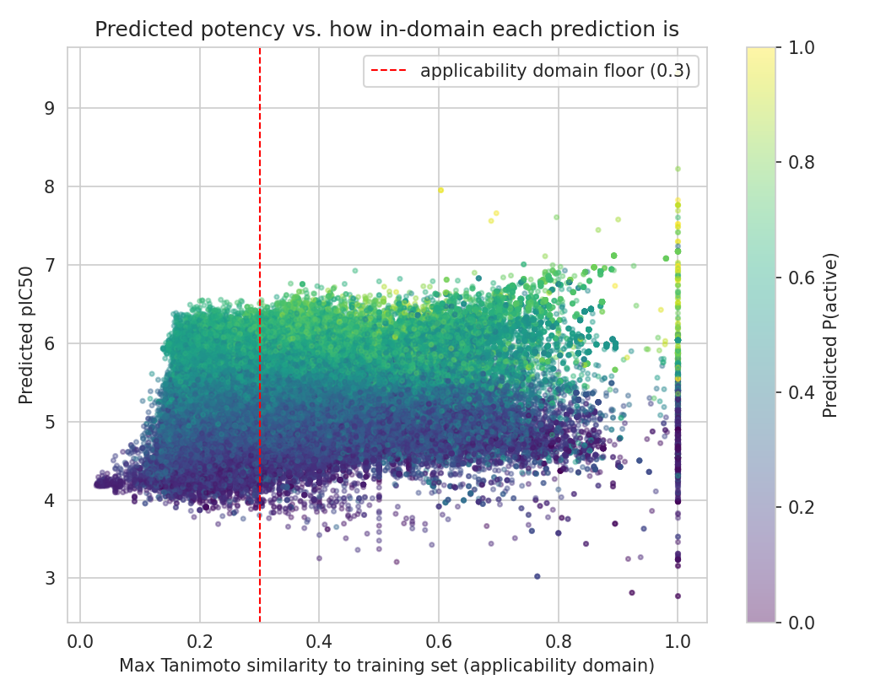
Figure 4. Predicted potency vs. applicability-domain similarity across all 738,823 screened COCONUT compounds, colored by predicted P(active). The dense band near similarity = 1.0 corresponds to compounds that are exact duplicates of training-set molecules (Section 4).

4. Discussion
This case study illustrates several of the problems and prospects identified in Section 1 concretely rather than abstractly. On the problems side, a substantial share of this project’s effort went into data curation rather than modeling: extracting, cleaning, and defensibly justifying exclusions from raw ChEMBL data required diagnosing a unit-parsing artifact traced to a specific source assay (Section 2.2), directly illustrating the data-quality burden noted in the literature [1]. The applicability-domain analysis (Section 4) directly demonstrates the generalization problem: the highest-confidence hits before filtering were overwhelmingly re-identifications of already-known drugs rather than new chemistry, an explicit example of the rediscovery-versus-novelty problem that a less careful analysis could easily have misreported as a discovery.
On the prospects side, this project demonstrates that a rigorous, fully reproducible AI drug discovery pipeline, from raw database extraction through validated modeling to large-scale virtual screening of an open natural-product library, is achievable outside an industrial setting using entirely open data and open-source tools, consistent with the trend toward AI as accessible infrastructure noted in industry commentary [5]. The y-randomization control (Section 3.2), while methodologically standard, is a check not always reported in applied work, and its inclusion here directly addresses the reproducibility concerns raised in Section 1. The irbesartan-scaffold finding (Section 4) further illustrates a realistic and defensible use of AI in this space: not the invention of new chemistry from nothing, but the efficient, literature-corroborated triage of a large chemical space down to a small set of chemically sensible candidates worth further attention.
Several limitations bound the conclusions of this case study. Both models were validated only via internal cross-validation and label randomization, not an external, temporally distinct test set; a compound added to ChEMBL after model training would provide a stronger test of generalization. The applicability-domain measure used here, maximum Tanimoto similarity to a single nearest training compound, is a simple heuristic; more sophisticated measures (e.g., ensemble prediction variance or density-based methods) may better quantify prediction trust. None of the natural-product hits identified in Section 4 have been experimentally tested against AChE; all should be treated as computational hypotheses, not confirmed activities. Finally, this study used a single algorithm and molecular representation; comparison against gradient-boosted trees, graph neural networks, and alternative fingerprints would test whether the results are robust to modeling choice, beyond the scope of this paper.
A concrete next step is structure-based validation of the most promising candidates from Section 4 via molecular docking against a resolved AChE crystal structure, followed by molecular dynamics simulation of the most stable poses to assess binding stability over time. Three candidates are well suited to this next stage: irbesartan itself, an approved antihypertensive drug with existing human safety and pharmacokinetic data, making it an attractive repurposing candidate if docking supports the predicted interaction; the non-duplicate diazaspiro[4,4]nonenone analogue identified in Section 4, whose scaffold family already has independent experimental precedent as an AChE inhibitor [12]; and the two coumarin-carbamate hybrid structures noted in Section 4, which combine two independently established AChE-relevant pharmacophores. Should docking and simulation support stable, favorable binding, in vitro enzymatic inhibition assays, for example the Ellman colorimetric method used in [12], would be the appropriate next step toward experimental confirmation.

5. Conclusion
Artificial intelligence’s role in drug discovery is neither the unqualified success suggested by early enthusiasm nor the empty promise suggested by its harshest critics; recent literature situates it as a genuinely useful but methodologically demanding set of tools whose value depends heavily on rigor not always applied in practice. This paper’s case study, a validated QSAR model for acetylcholinesterase inhibition built from raw ChEMBL data and applied to virtual screening of over 700,000 natural products, demonstrates both sides of that assessment directly: real, externally corroborated predictive signal (Sections 3–4), alongside concrete illustrations of the data-curation burden, applicability-domain limits, and rediscovery-versus-novelty ambiguity that the literature identifies as the field’s central open problems (Section 1).

References
[1] “Artificial intelligence in drug discovery: what it is, where we stand and the path forward,” Nature Reviews Drug Discovery, Aug. 2026. https://www.nature.com/articles/s41573-026-01496-2
[2] “Artificial intelligence in drug discovery: from algorithmic foundations to clinical translation,” Frontiers in Pharmacology, 2026. https://www.frontiersin.org/journals/pharmacology/articles/10.3389/fphar.2026.1870527/full
[3] “Artificial Intelligence in Drug Discovery and Development: Transforming Pharmaceutical Innovation,” Drug Development Research, 2026. https://analyticalsciencejournals.onlinelibrary.wiley.com/doi/10.1002/ddr.70281
[4] “Artificial Intelligence in drug discovery and development: current landscape, challenges, and future perspectives,” Critical Reviews in Oncology/Hematology, Jun. 2026. PMID: 42364829.
[5] “2026: the year AI stops being optional in drug discovery,” Drug Target Review, 2026. https://www.drugtargetreview.com/article/192243/2026-the-year-ai-stops-being-optional-in-drug-discovery/
[6] V. Chandrasekhar, K. Rajan, S. R. S. Kanakam, N. Sharma, V. Weißenborn, J. Schaub, C. Steinbeck, “COCONUT 2.0: a comprehensive overhaul and curation of the collection of open natural products database,” Nucleic Acids Research, 2024. https://doi.org/10.1093/nar/gkae1063
[7] B. Zdrazil et al., “The ChEMBL Database in 2023: a drug discovery platform spanning multiple bioactivity data types and time periods,” Nucleic Acids Research, 2024.
[8] D. Rogers, M. Hahn, “Extended-Connectivity Fingerprints,” Journal of Chemical Information and Modeling, 50(5), 742–754, 2010.
[9] G. Landrum et al., “RDKit: Open-source cheminformatics,” http://www.rdkit.org.
[10] L. Breiman, “Random Forests,” Machine Learning, 45, 5–32, 2001.
[11] F. Pedregosa et al., “Scikit-learn: Machine Learning in Python,” Journal of Machine Learning Research, 12, 2825–2830, 2011.
[12] “Synthesis and screening for acetylcholinesterase inhibitor activity of some novel 2-butyl-1,3-diaza-spiro[4,4]non-1-en-4-ones: Derivatives of irbesartan key intermediate,” ScienceDirect. https://www.sciencedirect.com/science/article/abs/pii/S0968089607006542

