How to configure the Firefox with burp suit:

1)Go to the setting and open proxy setting check manual proxy and write your local host Ip:

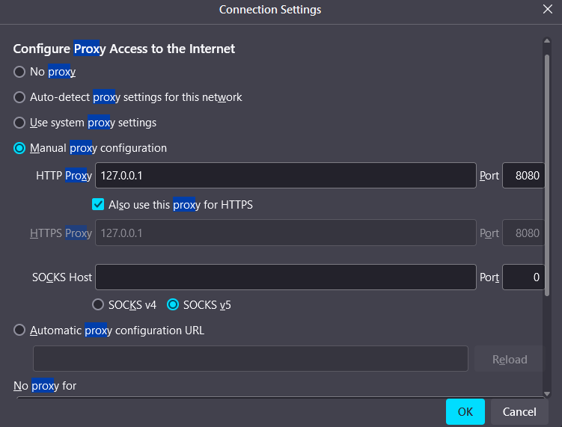  
Open the browser and write localhost Ip with port 8080 And download the CA certificate:

<https://127.0.0.1:8080>  
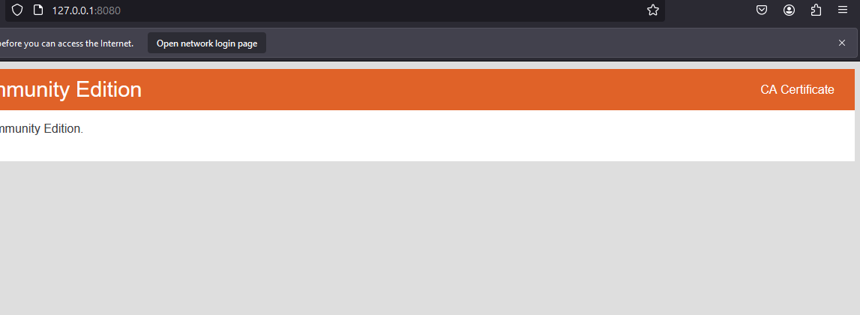  
  


After downloading go the setting and search the certificate manager and import the certificate here :  
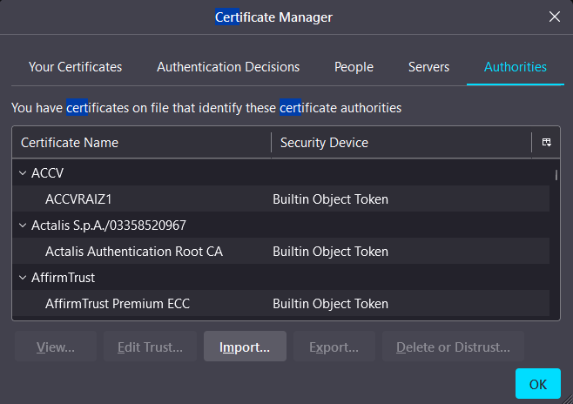

Open the burp suite and go to the proxy tab and on the interception:

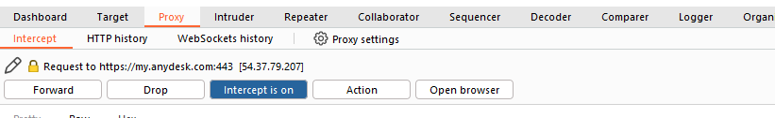  
Then testing the website <https://my.anydesk.com/pwdreset> :  
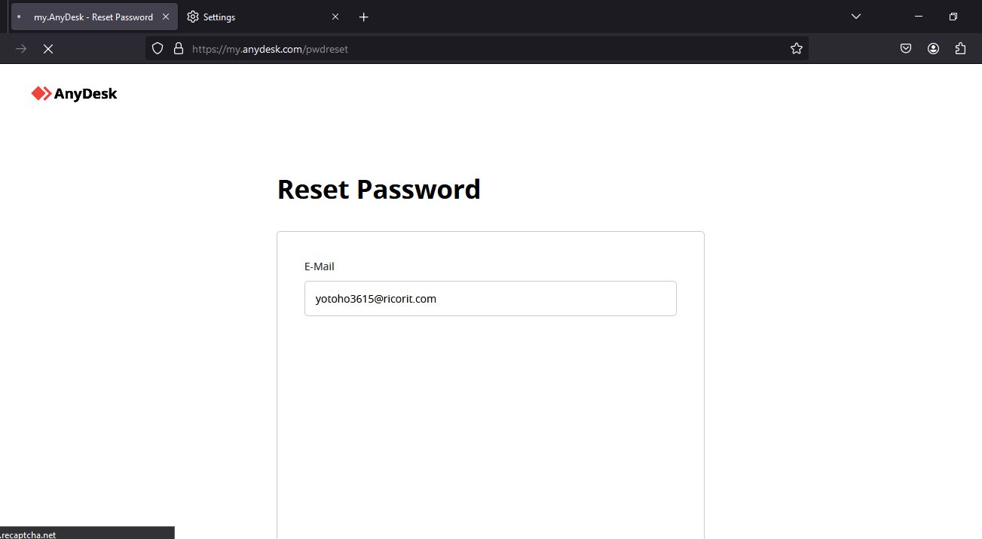  
**Accept-Language**: This is the name of the HTTP header field. It indicates that the client is specifying the languages it prefers for the content it receives from the server.

**en-US:** This is the primary language preference of the client. In this case, it's English as spoken in the United States. The format is a language tag, where "en" represents English and "US" represents the United States locale.

**en;q=0.5:** This is a secondary language preference, denoted by the language tag "en" for English. However, the q=0.5 parameter indicates the client's preference for this language compared to the primary language. The q parameter specifies the "quality" or preference level for that language, with 1 being the highest preference and 0 being the lowest. Here, 0.5 means the client prefers English (generic) but not as strongly as it prefers English (US).

When a client sends this header to a server, it's telling the server that it prefers content in English (US) but is also willing to accept content in English (generic), albeit with a lower preference level. The server can then use this information for content negotiation, potentially serving content in the preferred language if available or falling back to another language if necessary.  
  
  
  
  
  
