UNI-THRIFT
A Peer-to-Peer Academic Resource Exchange & Emergency Borrowing System

Course | Fundamentals of Software Engineering
Deliverable | Deliverable #2 — Iteration 1 / Sprint 1
Date of Submission | March 24, 2026

GROUP MEMBERS
# | Name | Roll Number | Role
1 | Muhammad Soban Sohail | 24L-2545 | Lead & Database Architect
2 | Saad Jahangir | 24L-2516 | Full-Stack Developer
3 | Mahad Jawad | 24L-2504 | Requirement Engineer & QA

Project Title and Introduction

Project Title: UniThrift: A Peer-to-Peer Academic Resource Exchange and Emergency Borrowing System

UniThrift provides a digitized solution to the traditional "senior-to-junior" hand-off by creating a secure, verified marketplace exclusive to the university community.
Sprint 1 focuses on the core module: User Management & Foundation. This initial iteration establishes the foundational database architecture, secure user registration restricted to university email domains, login flows, and the primary frontend interfaces for user profile management.

User Stories (Sprint Backlog)

US-01: University Email Sign-up

Story ID | US-01 | Story Title | University Email Sign-up
Priority | Critical | Est. Hours | 8
User Story
As a student, I want to register and log in securely using my university email so that the platform maintains a safe, verified community of FAST-NUCES users.
Description
This story covers the backend and frontend implementation of authentication. It includes secure password hashing, strict email validation, and profile picture uploading.
Sub User Stories
- As a user, I want to register an account with my Name, @nu.edu.pk Email, Password, and Department.
- As a user, I want to upload a profile picture during signup.
- As a user, I want to log in and access the main application.
Acceptance Criteria
- Email must strictly end with @nu.edu.pk; otherwise, registration is blocked.
- Passwords must be hashed in the database.
- Duplicate emails must trigger a 'User already exists' error.

US-02: Profile Management

Story ID | US-02 | Story Title | Profile Management
Priority | High | Est. Hours | 6
User Story
As a registered user, I want to view and edit my profile details so that my peers know who they are trading with.
Description
This story involves developing the User-Page dashboard where profile stats (sold/bought/borrowed) and details are displayed, alongside a modal to update user information dynamically.
Sub User Stories
- As a user, I want to view my profile picture, name, and bio on a dedicated page.
- As a user, I want to open an edit modal to update my bio, department, and password.
- As a system, I want to prevent users from changing their name to one already taken by another student.
Acceptance Criteria
- The profile must fetch session data on load.
- A mechanical-themed modal must open for edits without reloading the page.
- Submitting a duplicate name must trigger an alarming red error box.
- Successful saves must automatically reload the page to reflect new data.

US-03: Secure Authentication & Theming

Story ID | US-03 | Story Title | Secure Authentication & Theming
Priority | Medium | Est. Hours | 4
User Story
As a user, I want a responsive, visually distinct interface so that the application feels cohesive and easy to navigate on any device.
Description
This story covers the setup of the React Router navigation, the global CSS variables, and the mechanical/dithered UI aesthetic (dotted backgrounds, clipped panels) for the main dashboard and profile page.
Sub User Stories
- As a user, I want to navigate between the Main Page and Profile Page seamlessly.
- As a user, I want to see a consistent dotted-grid background across the platform.
Acceptance Criteria
- Global CSS must apply a radial-gradient dotted pattern.
- Navigation ribbons must use clip-path for the mechanical aesthetic.
- The UI must scale fluidly using CSS clamp() functions for 1280px-1920px displays.

Structured Specifications

US-01.1: Restrict Registration to University Domain

Type | Specification
Functional | The backend API /api/signup must parse the incoming email string and enforce an .endsWith('@nu.edu.pk') check before proceeding with database insertion.
UX | A clear error message must be returned to the frontend if an invalid email domain is attempted.

US-02.1: Edit Profile Data Conflict Prevention

Type | Specification
Functional | The PUT /api/users/update/:id endpoint must query the database to ensure the requested full_name is not already assigned to a different user_id (id != @id).
UX | Name conflicts must trigger a Status 409 response, which the frontend renders inside a pulsing, high-contrast red .error-message-box.

US-03.1: Application Background Rendering

Type | Specification
Performance | The global dotted background must be generated using a CSS radial-gradient rather than a static image file to minimize network payload and CPU load.
UX | The background must utilize background-attachment: fixed; so the mechanical dots remain stationary during vertical scrolling.

Scrum Board

The team used Trello to manage the sprint. The following snapshots capture the board state at the start, middle, and end of Sprint 1.

Snapshot 1 — Start of Sprint

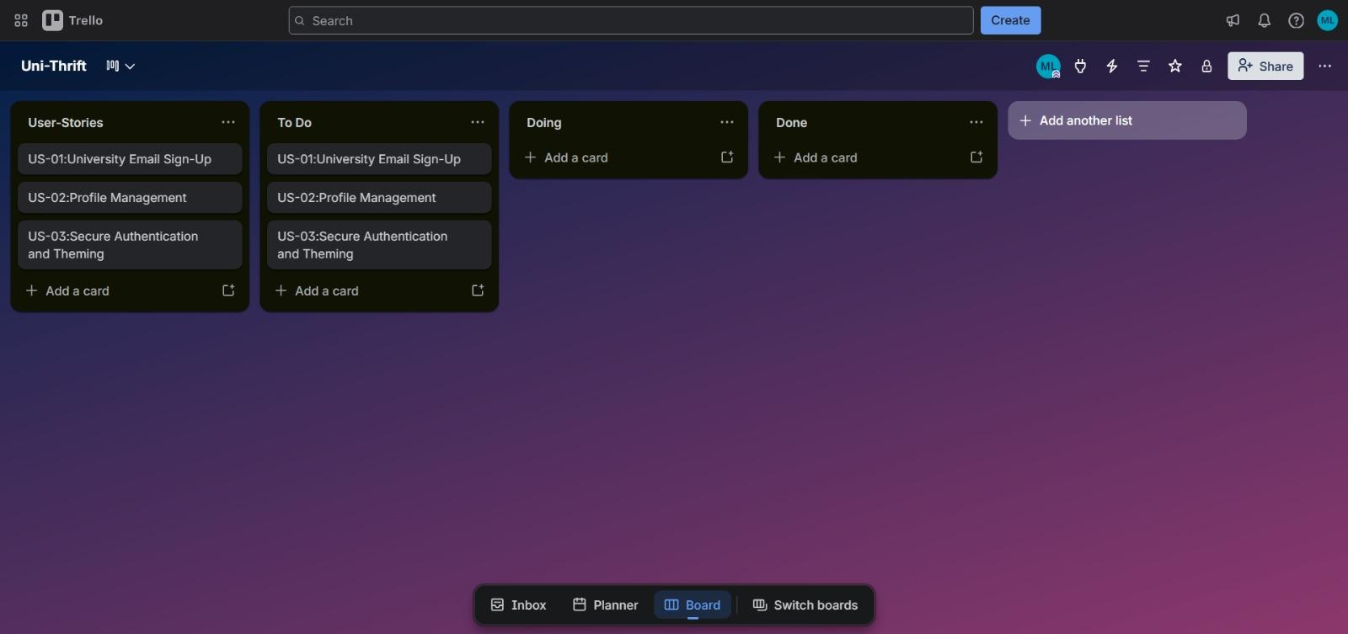
Figure 1: All user stories in 'To Do' — sprint begins

Snapshot 2 — Middle of Sprint

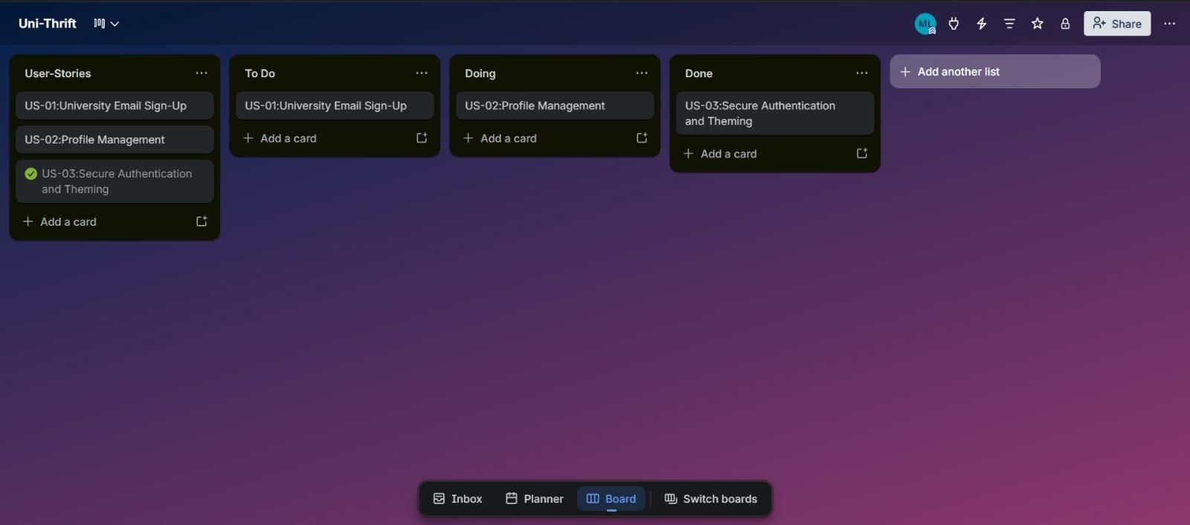
Figure 2: US-01 and US-02 in progress; US-03 complete

Snapshot 3 — End of Sprint

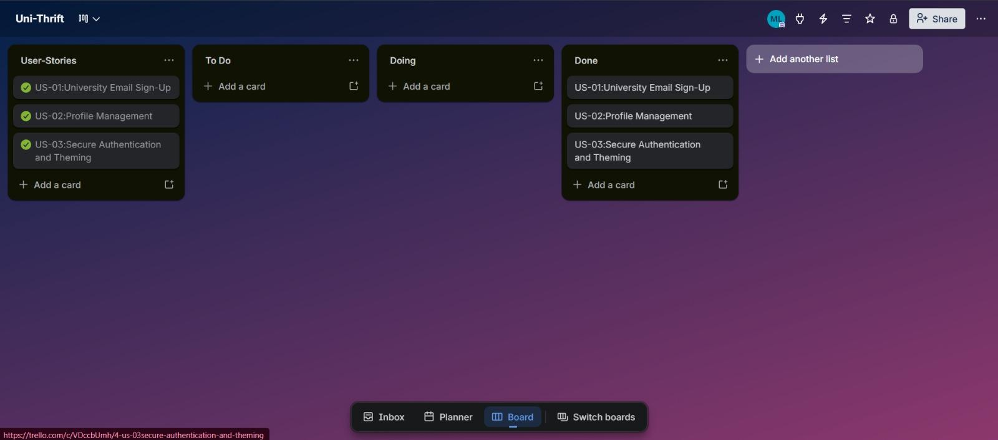
Figure 3: All user stories moved to 'Done' — sprint complete

Product Burn-Down Chart

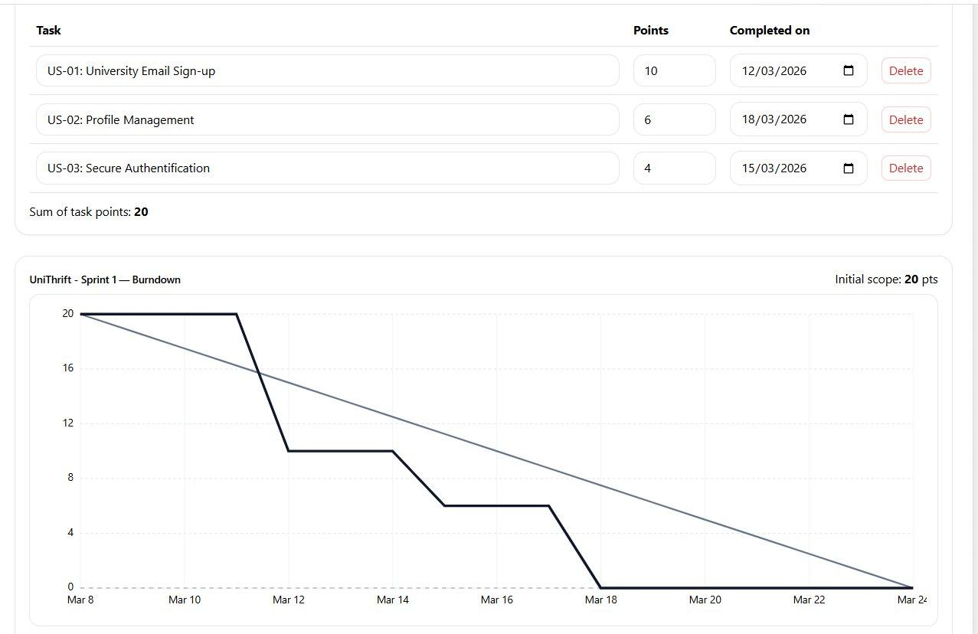
UniThrift — Sprint 1 Burndown | Initial scope: 20 pts

NFR Specification

- Security: All user passwords must be hashed using industry-standard bcrypt before database insertion.
- Performance: The platform must utilize CSS-generated patterns (gradients) and optimized image serving (Multer disk storage) to keep API load times under 2 seconds.
- Usability: The web application must employ fluid scaling principles (using CSS clamp()) to ensure all interfaces, modals, and profile cards are fully operable and aesthetically consistent across varying monitor resolutions (1280px–1920px).

Iteration 1 — Implementation Screenshots

The following screenshots demonstrate the completed frontend implementation across all four pages of the UniThrift web application.

Database Tables (SQL Server)
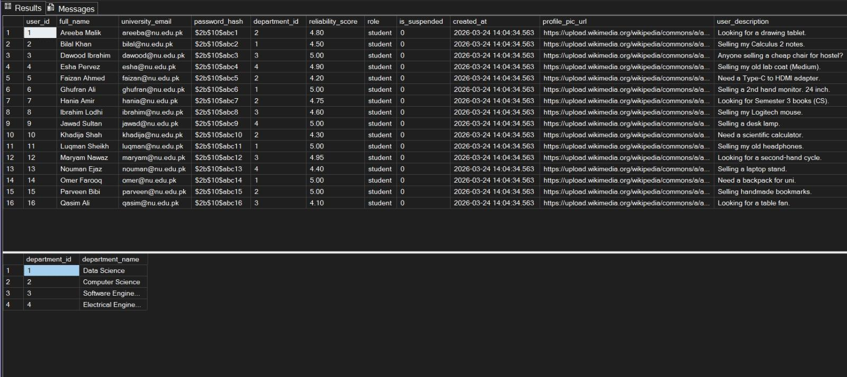

Home Page (Main Dashboard)

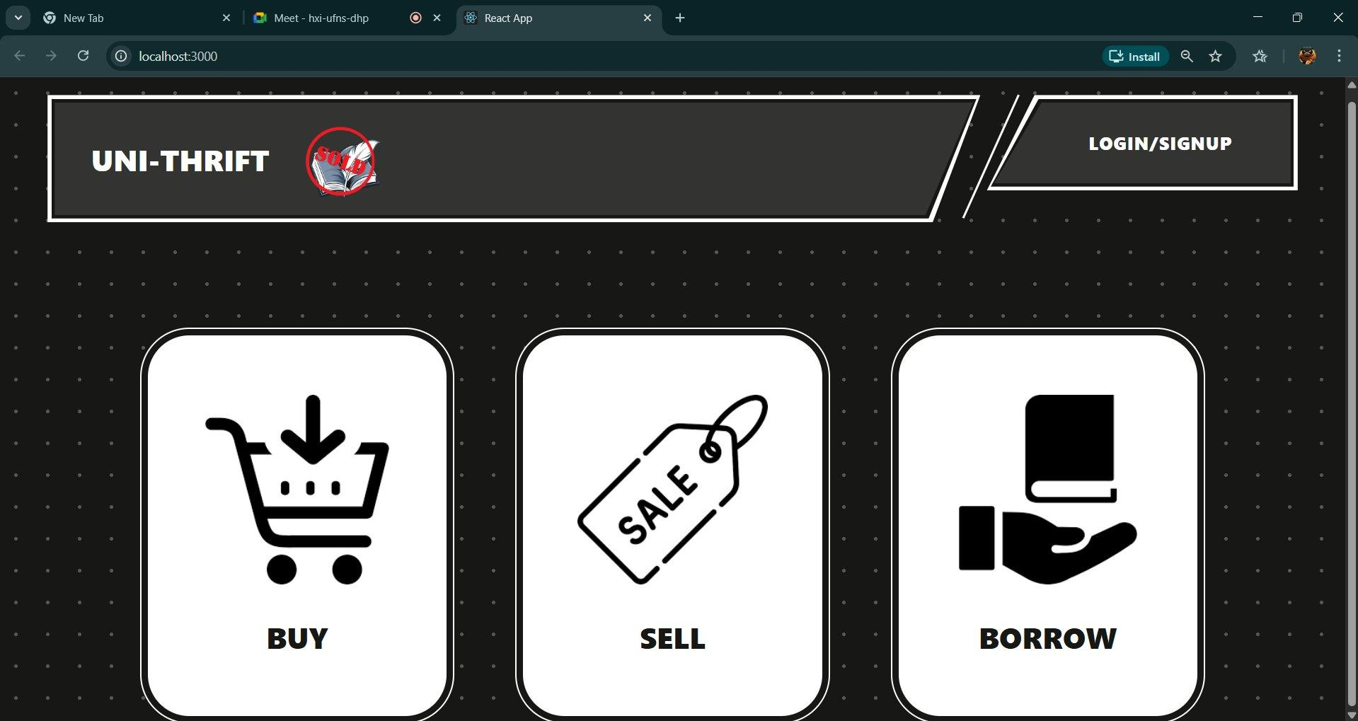
Figure 4: UniThrift main dashboard with Buy, Sell, and Borrow navigation cards

Login Page

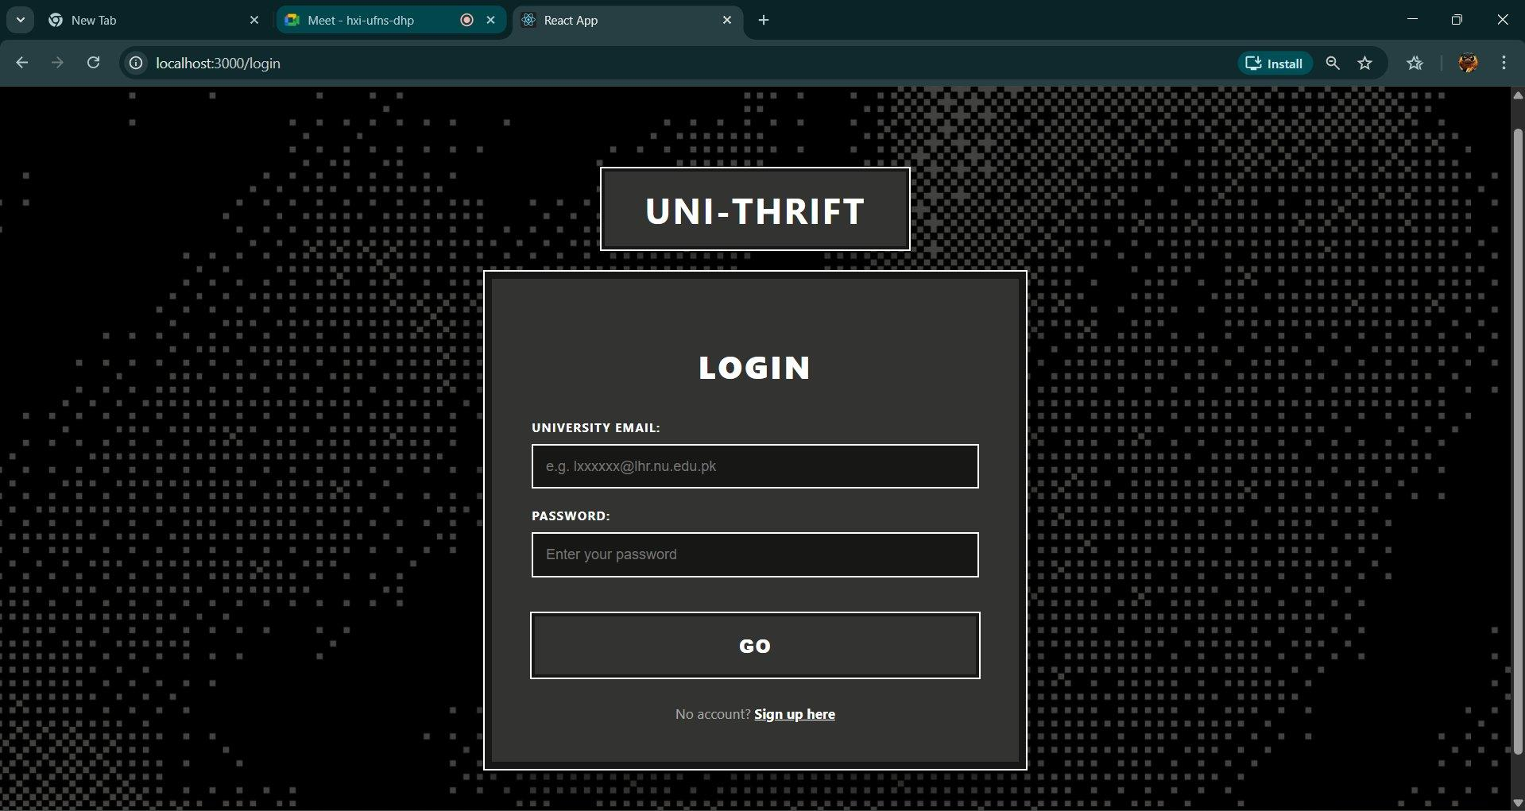
Figure 5: University email login screen with mechanical dark-themed UI

Registration / Sign-Up Page

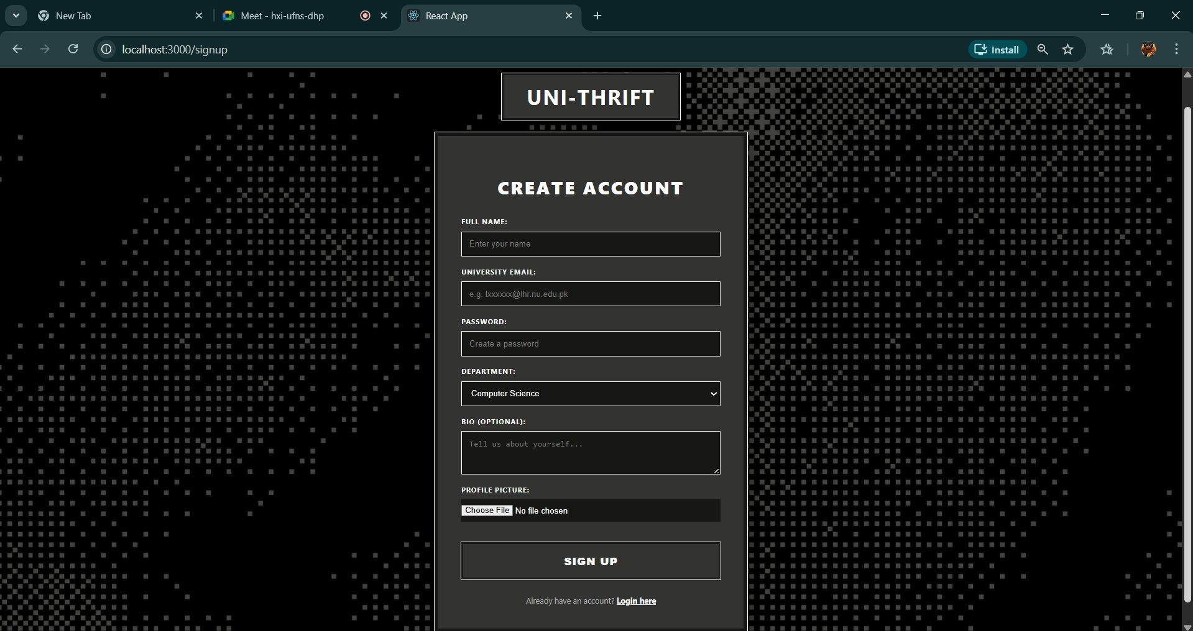
Figure 6: Create Account form with university email validation and profile picture upload

User Profile Page

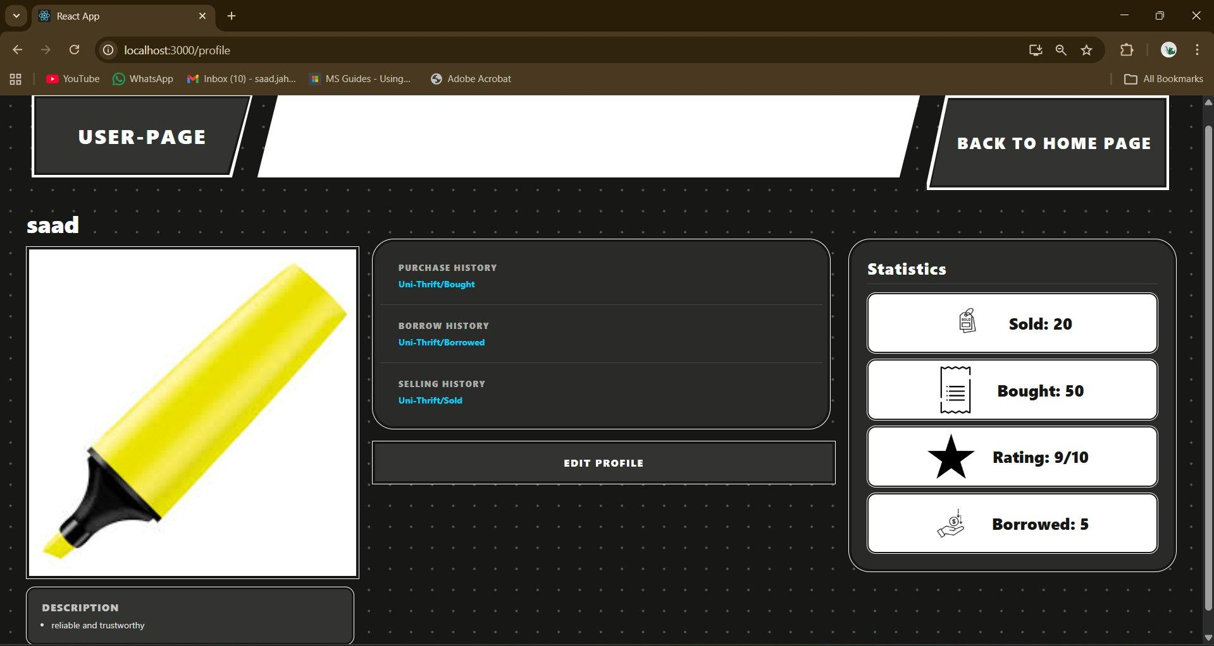
Figure 7: Profile dashboard with purchase/borrow/sell history and user statistics

Work Division

Team Member & Role | Responsibilities
Muhammad Soban Sohail  Lead & Database Architect | Designing SQL relational schemas, managing transaction integrity, overseeing project progress and sprint planning.
Saad Jahangir  Full-Stack Developer | Implementing backend logic in Node.js, building React.js frontend components, and integrating the authentication API.
Mahad Jawad  Requirement Engineer & QA | Mapping user stories to features, drafting acceptance criteria, managing the Trello board, and conducting system testing.

