**Assignment Title**

**Name & student no.**

**1 INTRODUCTION**

Concise description of task asked and your approach(es).

**2 BACKGROUND RESEARCH**

Use clear referencing and avoid including material directly unless carefully indicated as from another source. Half to a whole page expected.

**3 EXPERIMENTATION**

Describe your basic algorithm so anyone who knows about basic EAs could hopefully repeat what you have done. Describe the representation, the parameters, the fitness calculation, etc.

Present your results as averaged behaviour over more than one run, eg (graph not of assignment):

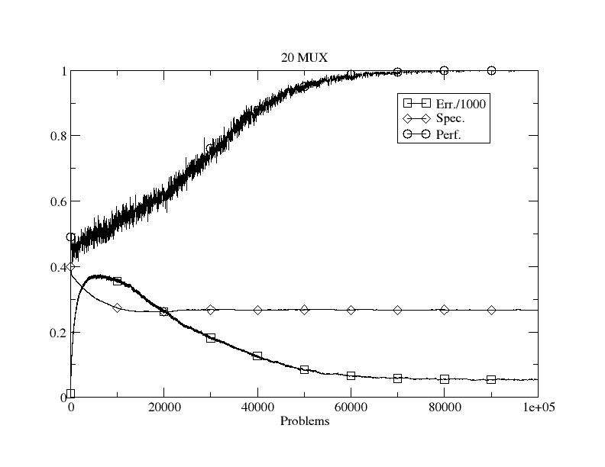

Figure Example: Initial performance.

Show the effects of varying parameters and give potential explanations as to why the behaviour/performance changes. Eg vary the mutation rate or population size. Show example solutions. Try different operators from the lectures or wider literature.

Depending on how much work you managed after the third worksheet, results from it do not need to be included in this report.

For the very keen, it would be great to see comparative performance on either benchmark optimisation problems/data or algorithms. You don’t need to implement other algorithms, use of Weka, etc. is fine.

4 CONCLUSIONS

Concise summary of what you found and learned. Identification of ways you might do things differently next time, and why.

REFERENCES

Author, A. (1970) The best way to do AI ever. *IEEE Transactions on Data Mining* 1(1): 209-238.

**Source code as an appendix**