MA6212 Robotic Manipulation & Advanced Control
Group Project Report
Modelling and Simulation of a Robotic Pick-and-Place Cell
for Elbow-Pipe Gasket Assembly and Box Packing (ABB IRB 1300, RobotStudio)
Group members
No. | Full name | Matriculation no. | Main contribution
1 | [Name] | [Matric no.] | CAD modelling
2 | [Name] | [Matric no.] | Station setup & Smart Components
3 | [Name] | [Matric no.] | RAPID programming & cycle time
4 | [Name] | [Matric no.] | Report & documentation
5 | [Name] | [Matric no.] | [Contribution]

[INSERT GROUP PHOTOGRAPH – label each member by name]
Submission date: 9 November 2026

1. Introduction and Objectives
Robotic pick-and-place is one of the most common applications of serial manipulators in manufacturing, where repeatable handling of moulded parts removes manual work from the end of a production line. This project models and simulates the robotic cell shown in the reference video (Robotic cell for tube gasket assembly), in which an ABB IRB 1300 equipped with a vacuum suction gripper picks freshly moulded elbow pipes from a conveyor, transfers them to an interim station where a rubber gasket is inserted, re-grips them at a second contact point and packs them in an orderly, indexed layout inside a carton.
The complete cell was modelled in ABB RobotStudio. Custom 3D models were created for the elbow pipe, gasket, interim station, packing box, vacuum gripper and carton conveyor; the motion was programmed in RAPID; and the run was simulated for a batch of parts to assess cycle time and throughput.
Objectives
- Model a realistic industrial pick-and-place system in ABB RobotStudio using the IRB 1300.
- Integrate random workpiece positioning on the conveyor with a simulated vision input.
- Apply RAPID programming for motion control, including vision offset handling and box indexing.
- Analyse and optimise robot cycle time, safety and throughput.
- Evaluate precision, collision risk and the industrial applicability of the cell.

2. Video Analysis
The reference video was reviewed frame by frame to extract the layout and the motion sequence of one cycle. The observations below were used as the basis for the simulation model.
Aspect | Observation from video | Modelling decision
Pick source | Elbows drop from an injection-moulding machine onto a flat belt conveyor; position and yaw vary from part to part. | Belt conveyor with Smart Component source; part pose varied by a simulated vision offset (±20 mm, ±10°).
Interim station | Robot places the elbow on a fixture of the gasket-insertion unit; gaskets are fed from a rod magazine and pressed into the pipe socket. | Static fixture with cradle blocks and a press unit facing pipe end A; insertion represented by a timed dwell.
Re-grip | After insertion the robot grips the part again at a different surface before packing. | Second contact point CP2 at 75° of the bend (CP1 is at 45°).
Place target | Carton on a roller conveyor; parts packed in rows and stacked in layers; full cartons leave on the conveyor. | Indexed 2 × 2 slots × 2 layers (8 parts per box); doBoxFull indexes the carton conveyor.
Vacuum tool | Single bellows-type suction cup on a compact body; part released by venting. | Single-cup gripper, TCP at cup lip 175 mm from flange; Attacher/Detacher Smart Component.
Approach / retract | Vertical approach to each pick/place point, fast joint moves between zones. | MoveJ between zones, MoveL for the last 150 mm with a slow final 10–30 mm.
Cycle | Approximately 8–10 s per part (estimated from the video). | Used as a benchmark for the simulated cycle time.
Table 1. Video analysis and corresponding modelling decisions

3. Assumptions and Specifications

3.1 Robot and equipment
Item | Specification
Robot | ABB IRB 1300-7/1.4 (7 kg payload, 1.4 m reach, ±0.02 mm repeatability) mounted on a 400 mm stand
Controller | Virtual controller in RobotStudio [state RobotWare / controller version used]
End effector | Vacuum suction gripper, 1.2 kg, single bellows cup Ø66 mm; TCP 175 mm along flange Z
Payload check | Gripper 1.2 kg + pipe 2.5 kg = 3.7 kg < 7 kg rated payload
Workpiece | 90° elbow, OD 215 mm, ID 185 mm (wall 15 mm), centre-to-end 150 mm, mass 2.5 kg
Gasket | Rubber ring OD 185 / ID 161 mm, width 20 mm, inserted in pipe end A
Infeed conveyor | Belt, width 400 mm, surface height 600 mm
Interim station | Table top at 600 mm, cradle top at 630 mm, gasket press facing end A
Packing box | Inner 560 × 560 × 460 mm on a roller conveyor (top of rollers 400 mm)
Table 2. Robot and equipment specifications

3.2 Modelling assumptions
- The elbow height of 150 mm in the brief is interpreted as the centre-to-end dimension, i.e. a bend radius of 150 mm. The resulting volume (2.22 L) gives a density of 1.13 g/cm³ for 2.5 kg, consistent with a moulded polymer fitting.
- Only the pick-and-place of the elbow pipe is simulated, as required by the brief; the gasket press and gasket are static models and insertion is represented by a 1.5 s dwell.
- A vision camera is assumed above the conveyor. Its output (dx, dy, dRz) is emulated in RAPID by a pseudo-random generator and written to the object frame of wobjVision, which is how a real ABB vision integration shifts the pick targets.
- Parts arrive lying flat (bend plane horizontal); the suction cup always approaches vertically from above onto the top of the tube.
- Vacuum build-up and release each take 0.2 s; conveyor index time is shorter than the robot cycle, so the robot never waits for parts in steady state.
- All dimensions are in millimetres; user frames are expressed in the world frame with the robot base at the origin.

3.3 Frames and contact points
Frame / target | Position (mm) | Purpose
wobjVision (uframe) | (400, 540, 600) | Nominal part origin (bend centre) on conveyor; oframe = vision offset
wobjInterim | (625, −275, 630) | Part origin on the interim cradle
wobjBox | (−150, −750, 406) | Centre of the inner floor of the carton
CP1 (part frame) | (106.1, 106.1, 215) | Top of tube at 45° of the bend – conveyor pick
CP2 (part frame) | (38.8, 144.9, 215) | Top of tube at 75° of the bend – re-grip after gasket insertion
Box slot n | (−272 + 280·i, −272 + 280·j, 215·k) | i = n MOD 2, j = (n MOD 4) DIV 2, k = n DIV 4
Table 3. Work objects and targets used by the RAPID program

4. RobotStudio Cell Model

4.1 3D models
The six custom models were generated parametrically from the specified dimensions and exported as STL meshes (units: mm), then imported with Import Geometry. The gripper geometry was converted to a tool with Create Tool, with the TCP at the cup lip and the tool load data set to 1.2 kg.
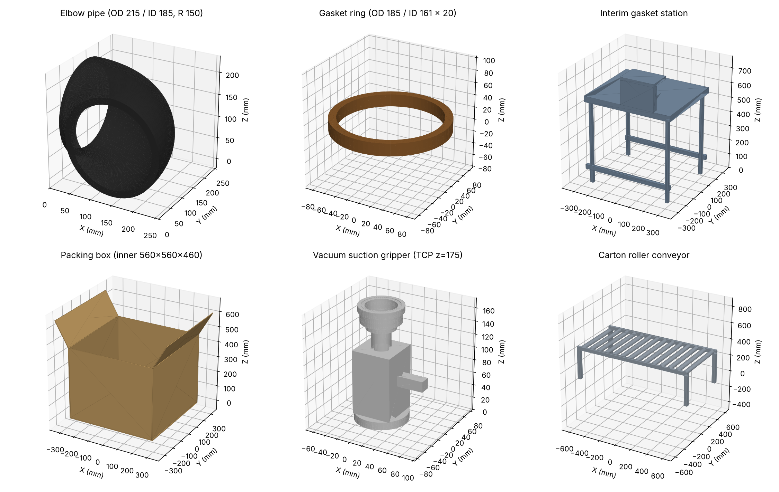
Figure 1. Custom models: elbow pipe, gasket, interim station, packing box, vacuum gripper, carton conveyor

4.2 Cell layout
The robot is placed at the centre of the cell with the three work zones arranged around it so that all targets lie between 0.64 m and 0.97 m from axis 1, well inside the 1.4 m reach. The infeed conveyor runs along the +Y side, the interim station is on the +X side and the carton conveyor is behind the robot, which keeps the two transfer moves short and avoids passing over the operator side. A safety fence encloses the cell.
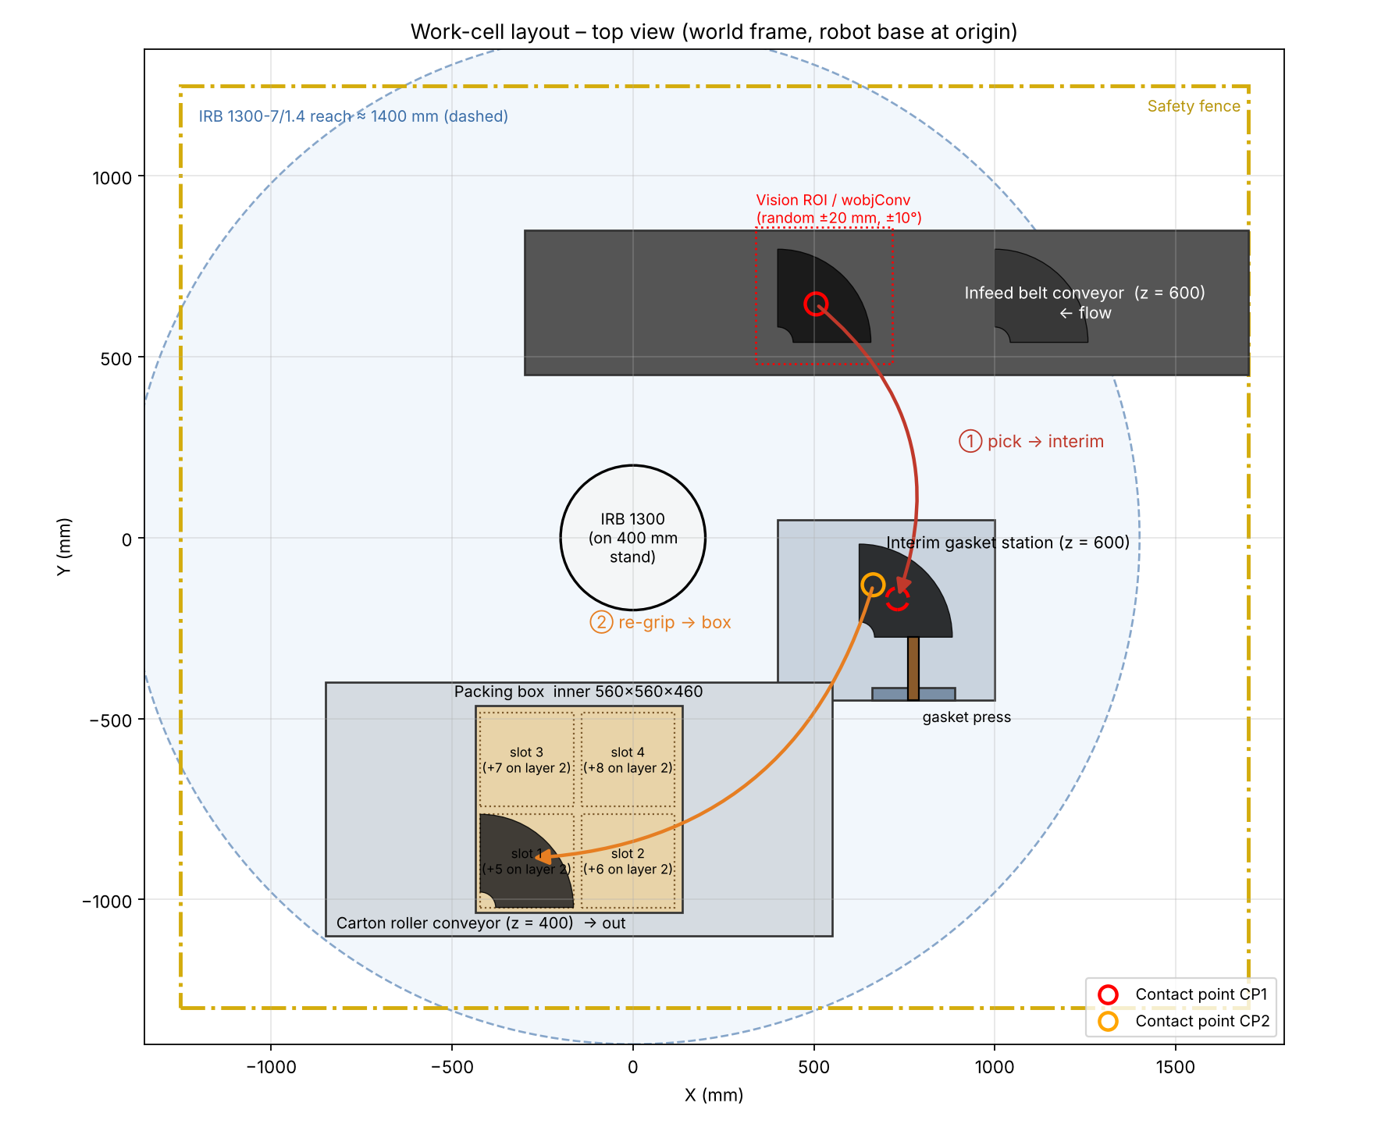
Figure 2. Top view of the work-cell layout with transfer paths and contact points
[INSERT ROBOTSTUDIO SCREENSHOT – full station view]
Figure 3. RobotStudio station
[INSERT ROBOTSTUDIO SCREENSHOT – paths and targets (pick, interim, box) with vision frame wobjVision shown]
Figure 4. Programmed paths, targets and vision frame

4.3 Smart Components and I/O
Two Smart Components make the simulation behave like the real cell. The infeed conveyor uses a Source to create a new elbow, a LinearMover to transport it and a PlaneSensor to stop the part and set diPartReady. The gripper uses a LineSensor at the cup, an Attacher (triggered by doVacuum = 1) and a Detacher (doVacuum = 0), combined through a LogicGate NOT.
Signal | Type | Connected to | Function
diPartReady | DI | Conveyor PlaneSensor | Part has reached the pick position
doConvStop | DO | Conveyor LinearMover | Holds the belt while the robot picks
doVacuum | DO | Gripper Attacher / Detacher | 1 = grip part, 0 = release part
doGasket | DO | Interim station | Triggers the gasket press (1.5 s pulse)
doBoxFull | DO | Carton conveyor | Indexes the full box out and an empty box in
Table 4. Station I/O signals

5. Workflow and Program Design

5.1 Cell workflow
Figure 5 shows the flow of material through the cell (solid arrows) together with the handshake signals between the robot and the peripheral equipment (dashed arrows).
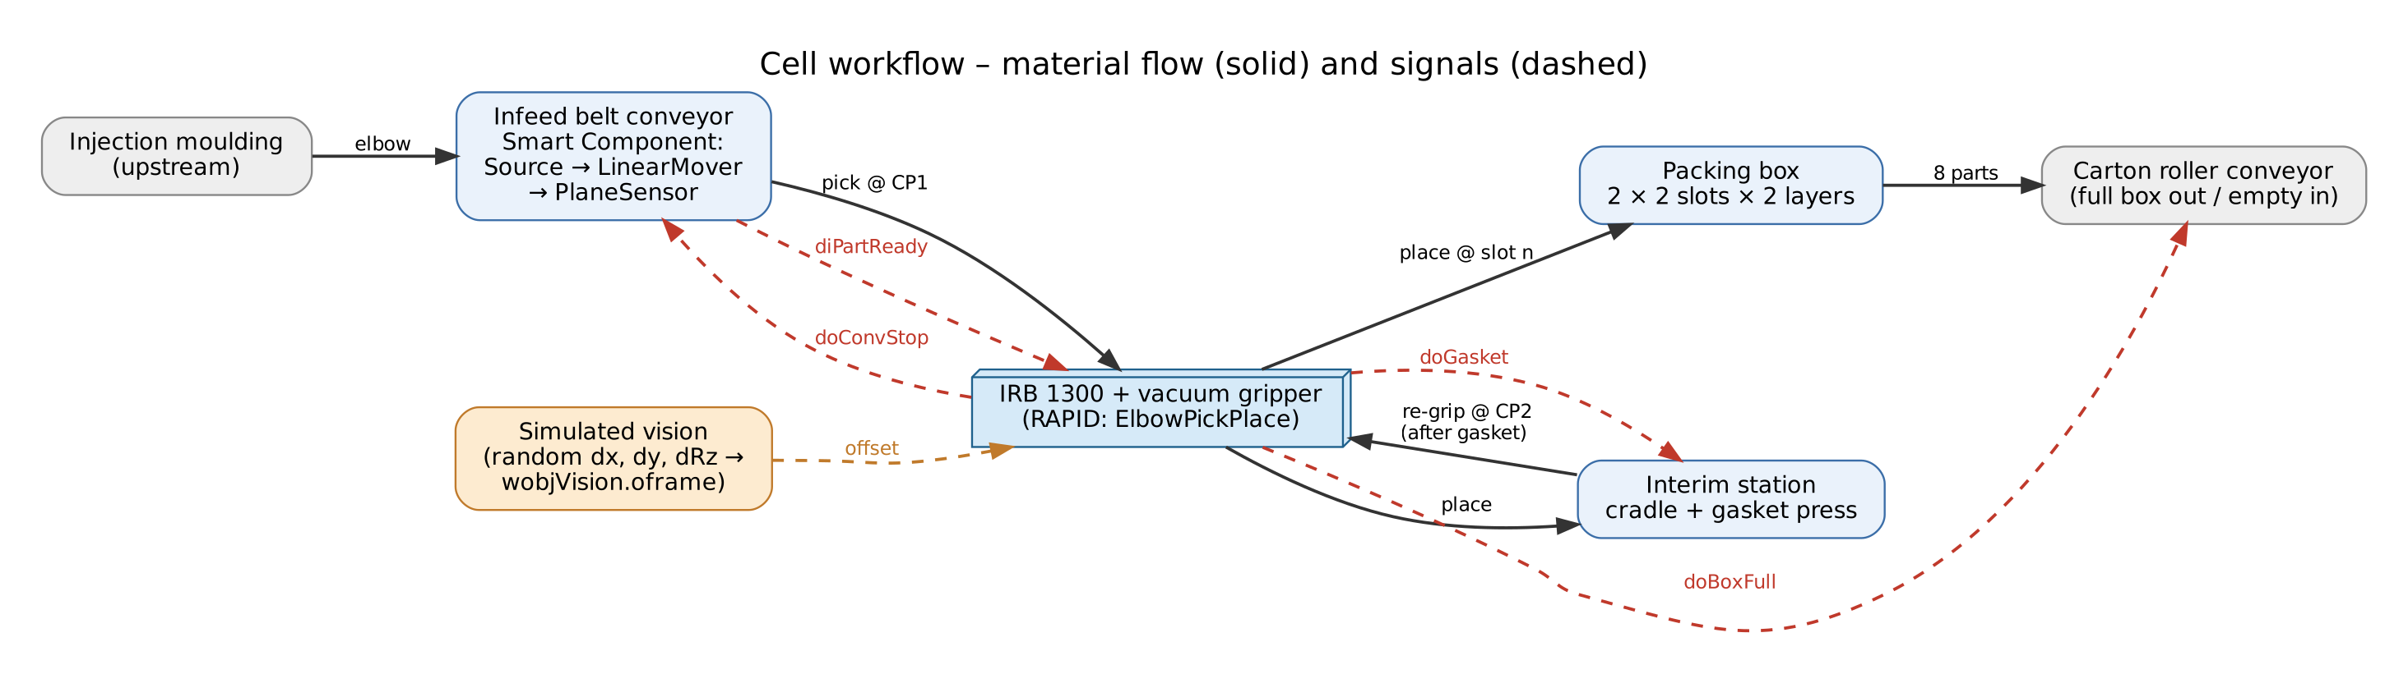
Figure 5. Cell workflow diagram

5.2 Program flowchart
The RAPID module ElbowPickPlace is organised as one routine per process step, so the flowchart in Figure 6 maps one-to-one onto the code listing in Appendix A. The main loop runs a batch of 16 parts (two full boxes), timing each cycle and logging it to the controller HOME directory.
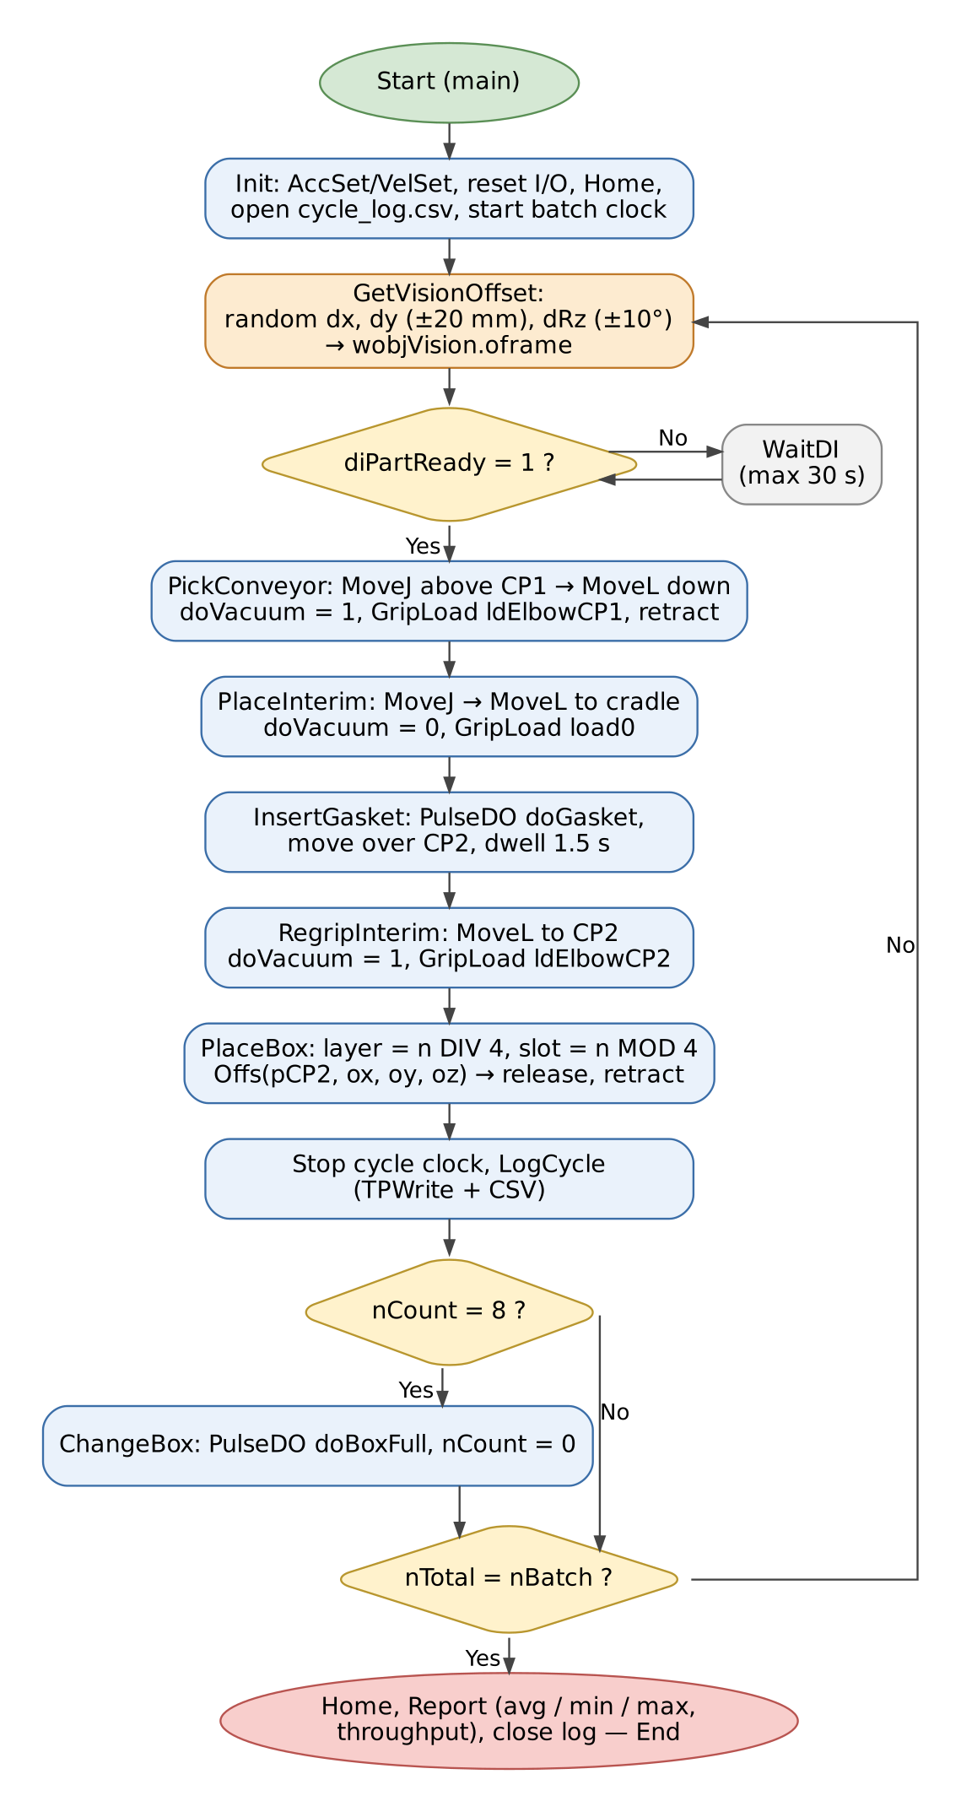
Figure 6. RAPID program flowchart

5.3 Motion strategy
- MoveJ is used for all transfers between zones (conveyor → interim → box) at 2000 mm/s with large zones (z50–z100), because the path shape between zones is irrelevant and joint moves are the fastest.
- MoveL is used for the last 150 mm of every approach and retract so the cup travels straight along the surface normal; the final 10–30 mm is executed at 150 mm/s with a fine point to guarantee a sealed vacuum contact and accurate placement.
- GripLoad switches between load0 and two load-data sets (ldElbowCP1, ldElbowCP2) because the pipe centre of gravity relative to the flange differs for the two contact points, which keeps the dynamic model and path accuracy correct.

5.4 Simulated vision offset
For every new part, GetVisionOffset draws dx, dy ∈ [−20, 20] mm and dRz ∈ [−10°, 10°] from a Wichmann-Hill style generator (nSeed = 171·nSeed MOD 30269, exact in RAPID num arithmetic) and writes them to wobjVision.oframe. Because the pick target pCP1 is defined in wobjVision, the robot follows the displaced part automatically. The place target at the interim station uses the nominal orientation, so the yaw error measured by the vision is removed during the transfer and the part always arrives square to the fixture.

5.5 Box indexing
PlaceBox computes the slot from the running count n: layer k = n DIV 4, position in layer = n MOD 4, row i = (n MOD 4) MOD 2 and column j = (n MOD 4) DIV 2. The target is Offs(pCP2, −272 + 280i, −272 + 280j, 215k) in wobjBox, giving 23 mm clearance between parts and 12 mm to the carton walls. After eight parts ChangeBox pulses doBoxFull and resets the count.

6. Simulation Results

6.1 Pre-simulation estimate
Before running the station, the cycle was estimated from the programmed path with a trapezoidal velocity model (4 m/s² acceleration, programmed TCP speeds, 0.08 s settling at fine points). The estimate gives an average of 10.45 s per part, i.e. about 344 parts per hour, which is in the same range as the 8–10 s observed in the video.
Cycle component | Time (s) | Share
Joint transfers (MoveJ) | 3.25 | 31 %
Linear approach / retract (MoveL) | 4.77 | 46 %
Vacuum on/off (4 × 0.2 s) | 0.80 | 8 %
Gasket insertion dwell | 1.50 | 14 %
Total (average of 8 slots) | 10.45 | 100 %
Table 5. Estimated cycle-time breakdown

6.2 RobotStudio simulation
The station was run for a batch of 16 parts (two boxes). Cycle times were read from the controller clock (ClkRead) and written to cycle_log.csv; the summary is given in Table 6.
Metric | Value
Parts simulated | 16 (2 boxes × 8)
Average cycle time | [from cycle_log.csv] s
Minimum / maximum cycle time | [min] s / [max] s
Throughput | [3600 / avg] parts/h
Total batch time | [batch time] s
Collisions detected | [none / list]
Table 6. Simulated performance
[INSERT SCREENSHOT – RobotStudio simulation in progress / Signal Analyzer or RAPID output window with cycle times]
Figure 7. Simulation run and cycle-time output

6.3 Discussion and optimisation
- Linear approach and retract moves account for the largest share of the cycle. Raising the MoveL approach speed from 600 to 1000 mm/s and shortening the approach height from 150 to 100 mm are the most effective optimisations [state measured gain].
- The 1.5 s gasket dwell is partly hidden because the robot moves to the re-grip position while the press works; with a second fixture the robot could pick the next part during insertion and remove the dwell from the critical path.
- Vision offsets of ±20 mm / ±10° did not change the cycle time noticeably, since the transfer moves are dominated by joint motion rather than path length.
- Safety: the cell is fenced, and Collision Detection sets were used between the gripper/part and the conveyor, station and carton walls. The 23 mm clearance between packed parts and the vertical final approach prevent contact with neighbouring parts.
- Precision: the IRB 1300 repeatability (±0.02 mm) is far below the placement tolerance needed for packing; the limiting factor in a real cell would be the vision accuracy and the compliance of the bellows cup.

7. Conclusion
A complete RobotStudio model of the elbow-pipe gasket and packing cell was built, including custom CAD models, a vacuum tool, Smart Components for the conveyor and gripper, and a structured RAPID program with simulated vision offsets and indexed box placement. The two-stage pick-and-place sequence was simulated for a batch of parts, and the cycle time of about [avg] s per part ([throughput] parts/h) is comparable with the real cell in the reference video. The modular program structure makes it straightforward to change the box pattern, add a real vision interface or re-balance the cycle with a second fixture.

Appendix A. RAPID Code Listing (ElbowPickPlace.mod)
MODULE ElbowPickPlace
!***********************************************************************
! MA6212 Group Project - Elbow pipe pick-and-place with gasket station
! Robot : ABB IRB 1300-7/1.4 (base on 400 mm stand)
! End effector: vacuum suction gripper, TCP 175 mm from flange
! Cycle : (1) pick elbow from infeed conveyor at contact point CP1
! (2) place on interim station, gasket is inserted
! (3) re-grip at contact point CP2
! (4) place at indexed slot in packing box (2 x 2 x 2 = 8)
! Vision : simulated - each new part gets a pseudo-random offset
! (+/-20 mm in X/Y, +/-10 deg about Z) written into the
! object frame of wobjVision, exactly as a camera would.
! Units : mm, deg. All user frames are given in the world frame.
!***********************************************************************

!------------------------------------------------------------- tool & load
! Gripper 1.2 kg, centre of gravity 70 mm from flange, TCP at cup lip.
PERS tooldata tVacuum:=[TRUE,[[0,0,175],[1,0,0,0]],[1.2,[0,0,70],[1,0,0,0],0,0,0]];
! Elbow pipe 2.5 kg. CoG expressed in the flange frame (tool0).
! Centroid of the 90 deg bend lies at r = R*sin45/(pi/4) = 135 mm on the
! 45 deg bisector, i.e. part coords (95.5, 95.5, 107.5).
! Gripped at CP1: CoG - CP1 = (-10.6,-10.6,-107.5) part -> (-10.6,10.6,107.5) tool
! Gripped at CP2: CoG - CP2 = (56.7,-49.4,-107.5) part -> (56.7,49.4,107.5) tool
! plus 175 mm TCP offset along flange Z.
PERS loaddata ldElbowCP1:=[2.5,[-10.6,10.6,282.5],[1,0,0,0],0,0,0];
PERS loaddata ldElbowCP2:=[2.5,[56.7,49.4,282.5],[1,0,0,0],0,0,0];

!------------------------------------------------------------- work objects
! Infeed conveyor: uframe = nominal part origin (bend centre, belt surface)
! oframe = vision correction, rewritten for every part.
PERS wobjdata wobjVision:=[FALSE,TRUE,"",[[400,540,600],[1,0,0,0]],[[0,0,0],[1,0,0,0]]];
! Interim gasket station: frame at the part origin on the cradle
PERS wobjdata wobjInterim:=[FALSE,TRUE,"",[[625,-275,630],[1,0,0,0]],[[0,0,0],[1,0,0,0]]];
! Packing box: frame at centre of the inner floor
PERS wobjdata wobjBox:=[FALSE,TRUE,"",[[-150,-750,406],[1,0,0,0]],[[0,0,0],[1,0,0,0]]];

!------------------------------------------------------------- targets
! Contact points on the elbow (part frame, tool pointing down = q[0,1,0,0])
! CP1 : top of tube at 45 deg of the bend -> used for conveyor pick
! CP2 : top of tube at 75 deg of the bend -> used for re-grip at station
CONST robtarget pCP1:=[[106.07,106.07,215],[0,1,0,0],[0,0,0,0],[9E9,9E9,9E9,9E9,9E9,9E9]];
CONST robtarget pCP2:=[[38.82,144.89,215],[0,1,0,0],[0,0,0,0],[9E9,9E9,9E9,9E9,9E9,9E9]];
CONST jointtarget jHome:=[[0,-10,20,0,60,0],[9E9,9E9,9E9,9E9,9E9,9E9]];

!------------------------------------------------------------- parameters
CONST num nRows:=2; ! slots along box X
CONST num nCols:=2; ! slots along box Y
CONST num nLayers:=2; ! layers
CONST num nPitch:=280; ! slot pitch [mm]
CONST num nLayerH:=215; ! layer height = pipe OD [mm]
CONST num nSlot0:=-272; ! first slot part-origin offset from box centre
CONST num nBatch:=16; ! parts to run (2 boxes)
CONST num nApproach:=150; ! approach / retract height [mm]
CONST num tGasket:=1.5; ! gasket insertion dwell [s]
CONST num tVac:=0.2; ! vacuum build-up / release [s]

VAR speeddata vFast:=[2000,500,5000,1000];
VAR speeddata vApp:=[600,200,5000,1000];
VAR speeddata vGrip:=[150,100,5000,1000];

!------------------------------------------------------------- I/O (virtual)
! diPartReady : from infeed conveyor plane sensor (Smart Component)
! doVacuum : to gripper Smart Component (Attacher / Detacher)
! doGasket : to interim station (gasket press animation)
! doBoxFull : to carton conveyor (index full box out, new box in)
! doConvStop : stop infeed conveyor while robot picks

!------------------------------------------------------------- variables
VAR num nCount:=0; ! parts placed in current box
VAR num nTotal:=0; ! parts placed in batch
VAR num nSeed:=1234; ! pseudo-random seed (simulated vision)
VAR num dX; VAR num dY; VAR num dRz;
VAR clock clkCycle; VAR clock clkBatch;
VAR num tCycle; VAR num tSum:=0; VAR num tMin:=999; VAR num tMax:=0;
VAR iodev logFile;

!=======================================================================
PROC main()
Init;
WHILE nTotal < nBatch DO
ClkReset clkCycle; ClkStart clkCycle;
GetVisionOffset;
PickConveyor;
PlaceInterim;
InsertGasket;
RegripInterim;
PlaceBox;
ClkStop clkCycle; tCycle:=ClkRead(clkCycle);
LogCycle;
IF nCount >= nRows*nCols*nLayers ChangeBox;
ENDWHILE
MoveAbsJ jHome, vFast, fine, tVacuum;
ClkStop clkBatch;
Report;
ENDPROC

!-----------------------------------------------------------------------
PROC Init()
AccSet 100, 100;
VelSet 100, 2000;
SetDO doVacuum, 0; SetDO doGasket, 0; SetDO doBoxFull, 0; SetDO doConvStop, 0;
GripLoad load0;
nCount:=0; nTotal:=0; tSum:=0; tMin:=999; tMax:=0;
MoveAbsJ jHome, vFast, fine, tVacuum;
Open "HOME:" \File:="cycle_log.csv", logFile \Write;
Write logFile, "part,box_slot,layer,dx_mm,dy_mm,drz_deg,cycle_s";
ClkReset clkBatch; ClkStart clkBatch;
ENDPROC

!-----------------------------------------------------------------------
! Simulated vision: Wichmann-Hill style generator, integer-exact in num.
FUNC num Rnd()
nSeed:=(171*nSeed) MOD 30269;
RETURN nSeed/30269;
ENDFUNC

PROC GetVisionOffset()
dX:=(Rnd()-0.5)*40; ! +/-20 mm
dY:=(Rnd()-0.5)*40; ! +/-20 mm
dRz:=(Rnd()-0.5)*20; ! +/-10 deg
wobjVision.oframe.trans:=[dX,dY,0];
wobjVision.oframe.rot:=OrientZYX(dRz,0,0);
ENDPROC

!-----------------------------------------------------------------------
PROC PickConveyor()
MoveJ Offs(pCP1,0,0,nApproach), vFast, z50, tVacuum\WObj:=wobjVision;
WaitDI diPartReady, 1 \MaxTime:=30;
SetDO doConvStop, 1;
MoveL Offs(pCP1,0,0,20), vApp, z5, tVacuum\WObj:=wobjVision;
MoveL pCP1, vGrip, fine, tVacuum\WObj:=wobjVision;
SetDO doVacuum, 1;
WaitTime tVac;
GripLoad ldElbowCP1;
MoveL Offs(pCP1,0,0,nApproach), vApp, z20, tVacuum\WObj:=wobjVision;
SetDO doConvStop, 0;
ENDPROC

PROC PlaceInterim()
! Part is placed square to the fixture: target uses nominal orientation,
! so the vision rotation dRz is removed during the transfer.
MoveJ Offs(pCP1,0,0,nApproach), vFast, z50, tVacuum\WObj:=wobjInterim;
MoveL Offs(pCP1,0,0,10), vApp, z5, tVacuum\WObj:=wobjInterim;
MoveL pCP1, vGrip, fine, tVacuum\WObj:=wobjInterim;
SetDO doVacuum, 0;
WaitTime tVac;
GripLoad load0;
MoveL Offs(pCP1,0,0,60), vApp, z10, tVacuum\WObj:=wobjInterim;
ENDPROC

PROC InsertGasket()
! Robot moves over CP2 while the press inserts the gasket in end A.
PulseDO \PLength:=tGasket, doGasket;
MoveL Offs(pCP2,0,0,60), vApp, fine, tVacuum\WObj:=wobjInterim;
WaitTime tGasket;
ENDPROC

PROC RegripInterim()
MoveL Offs(pCP2,0,0,20), vApp, z5, tVacuum\WObj:=wobjInterim;
MoveL pCP2, vGrip, fine, tVacuum\WObj:=wobjInterim;
SetDO doVacuum, 1;
WaitTime tVac;
GripLoad ldElbowCP2;
MoveL Offs(pCP2,0,0,nApproach), vApp, z20, tVacuum\WObj:=wobjInterim;
ENDPROC

!-----------------------------------------------------------------------
! Box index: slot = nCount MOD 4 (row-major), layer = nCount DIV 4
PROC PlaceBox()
VAR num nInLayer; VAR num nLayer; VAR num nRow; VAR num nCol;
VAR num ox; VAR num oy; VAR num oz;
VAR robtarget pPlace;
nLayer:=nCount DIV (nRows*nCols);
nInLayer:=nCount MOD (nRows*nCols);
nRow:=nInLayer MOD nRows;
nCol:=nInLayer DIV nRows;
ox:=nSlot0+nRow*nPitch;
oy:=nSlot0+nCol*nPitch;
oz:=nLayer*nLayerH;
pPlace:=Offs(pCP2, ox, oy, oz);
MoveJ Offs(pPlace,0,0,nApproach+200), vFast, z100, tVacuum\WObj:=wobjBox;
MoveL Offs(pPlace,0,0,30), vApp, z10, tVacuum\WObj:=wobjBox;
MoveL pPlace, vGrip, fine, tVacuum\WObj:=wobjBox;
SetDO doVacuum, 0;
WaitTime tVac;
GripLoad load0;
MoveL Offs(pPlace,0,0,nApproach+200), vApp, z50, tVacuum\WObj:=wobjBox;
Incr nCount;
Incr nTotal;
ENDPROC

PROC ChangeBox()
TPWrite "Box full - indexing carton conveyor";
PulseDO \PLength:=1, doBoxFull;
nCount:=0;
ENDPROC

!-----------------------------------------------------------------------
PROC LogCycle()
tSum:=tSum+tCycle;
IF tCycle < tMin tMin:=tCycle;
IF tCycle > tMax tMax:=tCycle;
TPWrite "Part "\Num:=nTotal;
TPWrite " cycle time [s] = "\Num:=tCycle;
Write logFile, NumToStr(nTotal,0)+","+NumToStr(((nCount-1) MOD 4)+1,0)+","
+NumToStr(((nCount-1) DIV 4)+1,0)+","+NumToStr(dX,2)+","+NumToStr(dY,2)+","
+NumToStr(dRz,2)+","+NumToStr(tCycle,3);
ENDPROC

PROC Report()
VAR num tAvg; VAR num tBatch;
tAvg:=tSum/nTotal;
tBatch:=ClkRead(clkBatch);
TPWrite "==== Batch finished ====";
TPWrite "Parts = "\Num:=nTotal;
TPWrite "Avg cycle [s] = "\Num:=tAvg;
TPWrite "Min cycle [s] = "\Num:=tMin;
TPWrite "Max cycle [s] = "\Num:=tMax;
TPWrite "Batch time [s] = "\Num:=tBatch;
TPWrite "Throughput [pcs/h]= "\Num:=3600/tAvg;
Write logFile, "avg,"+NumToStr(tAvg,3)+",min,"+NumToStr(tMin,3)+",max,"+NumToStr(tMax,3)
+",throughput_pph,"+NumToStr(3600/tAvg,0);
Close logFile;
ENDPROC

ENDMODULE

Appendix B. Submitted Files
File | Description
MA6212_ElbowCell.rspag | RobotStudio Pack & Go of the station and virtual controller
elbow_pipe.stl | Elbow pipe model (OD 215, ID 185, R 150)
gasket.stl | Gasket ring
interim_station.stl | Interim gasket-insertion station
packing_box.stl | Packing carton
vacuum_gripper.stl | Vacuum suction gripper
box_conveyor.stl | Carton roller conveyor
robot_stand.stl | Robot pedestal
ElbowPickPlace.mod | RAPID module
cycle_log.csv | Cycle-time log exported from the virtual controller

