Task1:
Database-Centric Architecture (Shared Database Architecture).

Why:
Every application directly accesses the same database.
Database acts as the central integration point.
Applications are tightly coupled through database schema.
Business logic is spread across multiple applications.

Problems with Current Architecture:
- Tight Coupling - (Single database change impacts all systems.
- Security Issues
- Scalability Problems (one country to Many)
- All applications hit the same database. -(High CPU, High Memory, Connection Bottleneck, Slow Queries)
- Difficult Maintenance (Business rules duplicated)
- Impossible Independent Deployment (Every application depends on the same schema.

Pros:
- Simple
- Low cost
- Easy to start
- Fewer infrastructure components
- Suitable for small business

Cons:
- Tight coupling
- Hard to scale
- Security concerns
- Difficult maintenance
- Single point of failure
- Database bottleneck
- Not suitable for global expansion

Task 2: Proposed Architecture (Modern Solution)
Since company plans global expansion, Microservices Architecture is a better choice.
Divide/separate large application into smaller services.

Proposed Architecture Diagram

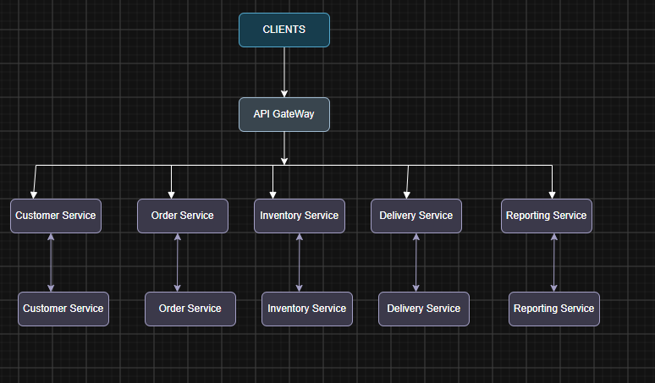

Warehouse App ------> Inventory Service
Manager Web --------> Order Service
-> Inventory Service
-> Customer Service
Customer Web -------> API Gateway
Customer Mobile ----> API Gateway
Courier Mobile -----> Delivery Service

Instead of direct database access use Event-Driven Communication

Order Created
|
v
Message Queue
|
+---- Inventory Service
+---- Delivery Service
+---- Reporting Service

Example Order Flow
Customer App
|
API Gateway
|
Order Service
|
Order Database
|
Publish OrderCreated Event
|
-----------------------------------
| | |
Inventory Delivery Reporting
Service Service Service

Pros
- Independent deployment
- High scalability
- Better fault isolation
- Easier maintenance
- Supports multiple countries
- Technology flexibility
- Separate databases
- Better security
- Team autonomy
- Cloud-native design

Cons
- More infrastructure
- Higher operational cost
- Distributed transactions complexity
- Network latency
- Monitoring complexity
- Requires DevOps maturity

