ROV GUI

We implement a GUI for ROV machine

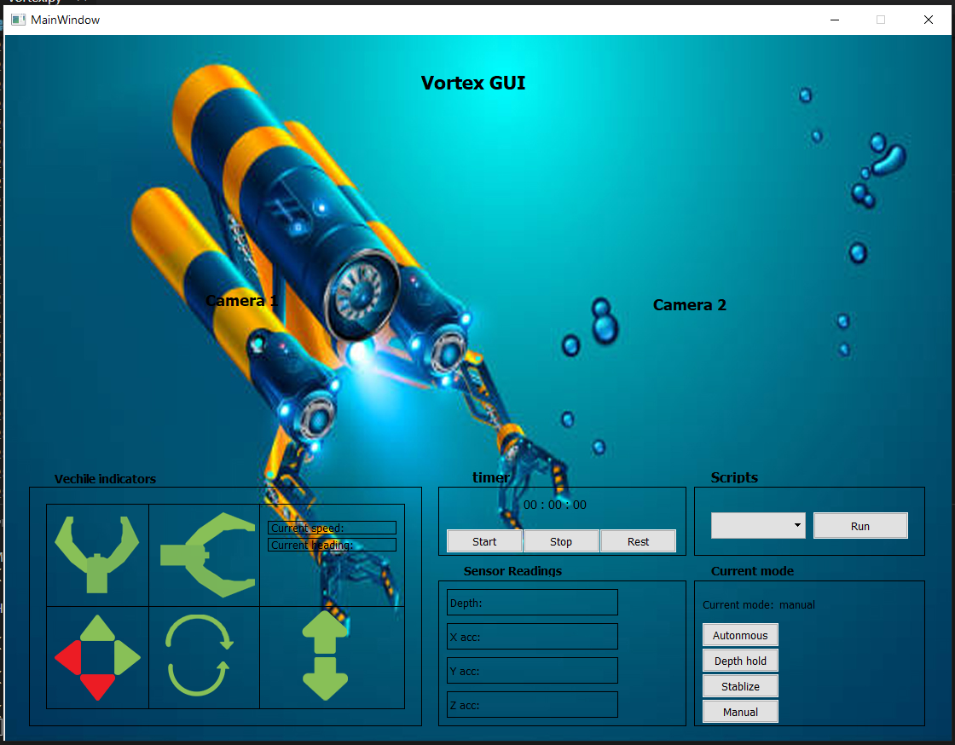

We built this GUI with

* {‘w’,’d’,’s’,’a’} keys for arrows,
* {‘e’,’q’} for open and close horizontal grapper,
* {‘z’,’x’} for open and close vertical grapper,
* {‘upKey’,’downkey’} for direction
* {‘leftkey’,’rightkey’} for rotate left and right

Working on GUI outline, shapes and photos – Abdelrahman Elzarka

Working on sender and receiver code for stream video – Ahmed Sobhy

We implement functions of the GUI together at zoom meeting