

**EPITECH YEAR-END PROJECT**

**AREA**

MOBILE APPLICATION DOCUMENTATION

Adrien MOREAU, Maxime VERRIER,

Sobihan MAHEDRAN, Alexandre BERTHOMIER

**Document Description**

|  |  |
| --- | --- |
| Title | Documentation |
| Object | AREA Application User & Admin Documentation |
| Author | Sobihan MAHENDRAN |
| Manager | Alexandre BERTHOMIER |
| Email | sobihan.mahedran@epitech.eu |
| Keywords | AREA, Action, Reaction, Documentation, User, Admin |
| **Last** Update | February 28, 2022 |
| Model Version | 1.0 |

**Table of revisions**

|  |  |  |  |  |
| --- | --- | --- | --- | --- |
| **Date** | **Version** | **Author** | **Section(s)** | **Comment** |
| 28/02/2022 | 1.0 | Sobihan M. | All | First Version |

**Contents**

**1. The AREA Project .........................................................................** **4**

**a. General Considerations …..................................................................** **4**

**b. The Project …....................................................................................** **4**

**2. User Documentation ….................................................................** **5**

**a. Registration ......................................................................................** **5**

**b. Authentication …...............................................................................** **6**

**c. Create a new AREA …........................................................................** **7**

**d. Edit an AREA ….................................................................................** **8**

**e. Delete an AREA …..............................................................................** **8**

**f. Register to a service …........................................................................** **9**

**g. Logout …...........................................................................................** **9**

**3. Admin Documentation …..............................................................** **10**

**a. How to build the Application................................................................** **10**

**b. Create / Edit / Delete an Action …........................................................** **10**

**c. Create / Edit / Delete a reaction …........................................................** **10**

**d. Edit Home Page .................................................................................** **10**

**e. Edit Job List …...................................................................................** **10**

**f. Edit Create AREA …............................................................................** **10**

**g. Edit AREA …....................................................................................... 10**

**h. Edit / Add a service …..........................................................................** **10**

1. **The AREA Project**
2. **General Considerations**

As part of this project, you will assume the role of a Software Architect. Your main goal is neither reinventing the wheel nor writing numerous lines of code.

On the contrary, your main goal is to understand, select and integrate a wide range of existing libraries.

The code you write will only implement the so-called business logic. In other words, your main job will be to write glue between selected software components to complete the requested project. Before embarking on the creation of such a project, we suggest you take the time to analyze and understand the operation of each software brick. In this theory, we will talk about state of the art and POC:

* State of the art: Study the different possible solutions and choose the right component based on the requirements.
* POC (Proof of Concept): Make a quick demo program that proves the proper functioning of a component or algorithm.

1. **The Project**

The goal of this project is to discover the software platform that you have chosen through the creation of a business application. To do this, you must implement a software suite that functions like that of IFTTT and/or Zapier. This software suite will be broken into three parts:

* An application server to implement all the features listed below (see Features)
* A web client to use the application from your browser by querying the application server
* A mobile client to use the application from your phone by querying the application server

1. **User Documentation**
2. **Registration**

Users can register an account by clicking on [Don't have an account? Sign Up](http://localhost:8081/signup) on the login page. This will redirect him on the registration page.

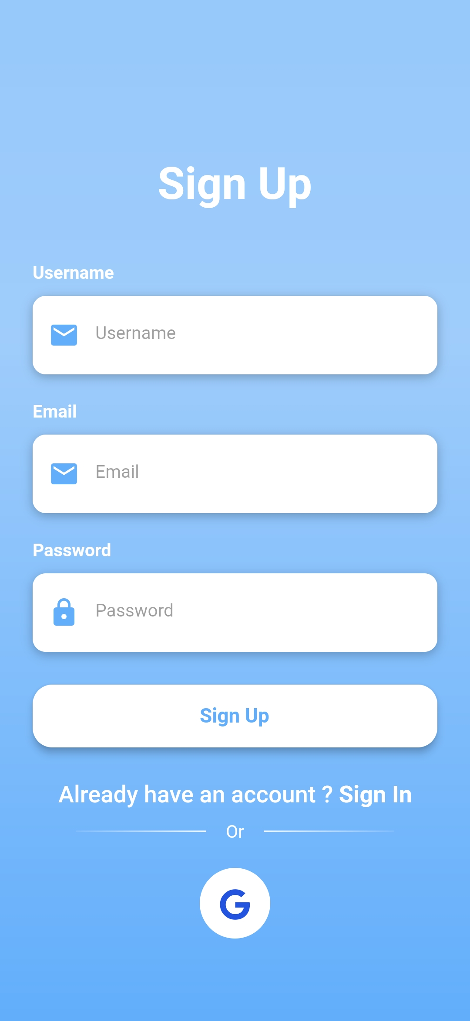

1. **Authentication**

Users can Login by entering his credentials on the login page or by clicking on **Login with Google** to authenticate with a Google account.

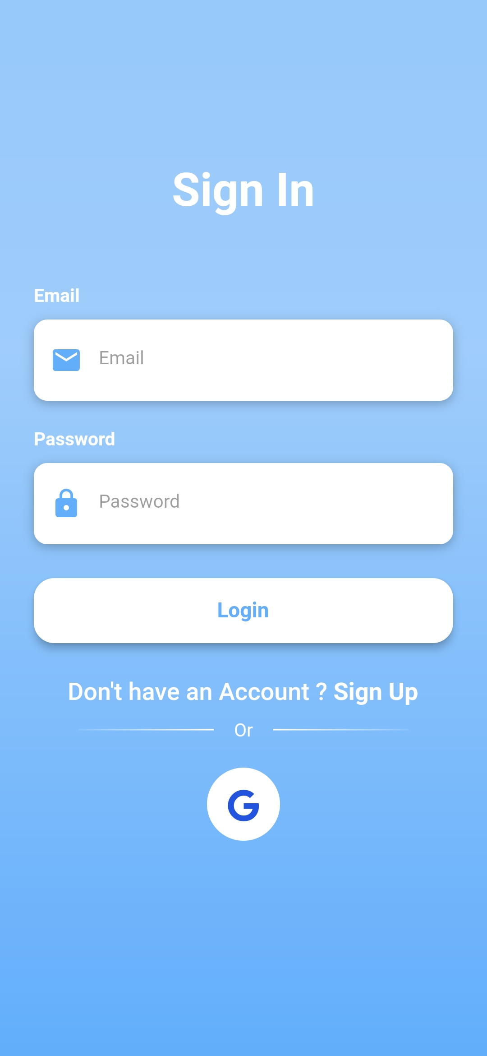

1. **Create a new AREA**

To Create a new AREA, Users just need to click on the **+** button on the bottom of the **Jobs** page. This will display a popup where users can customize their new AREA.

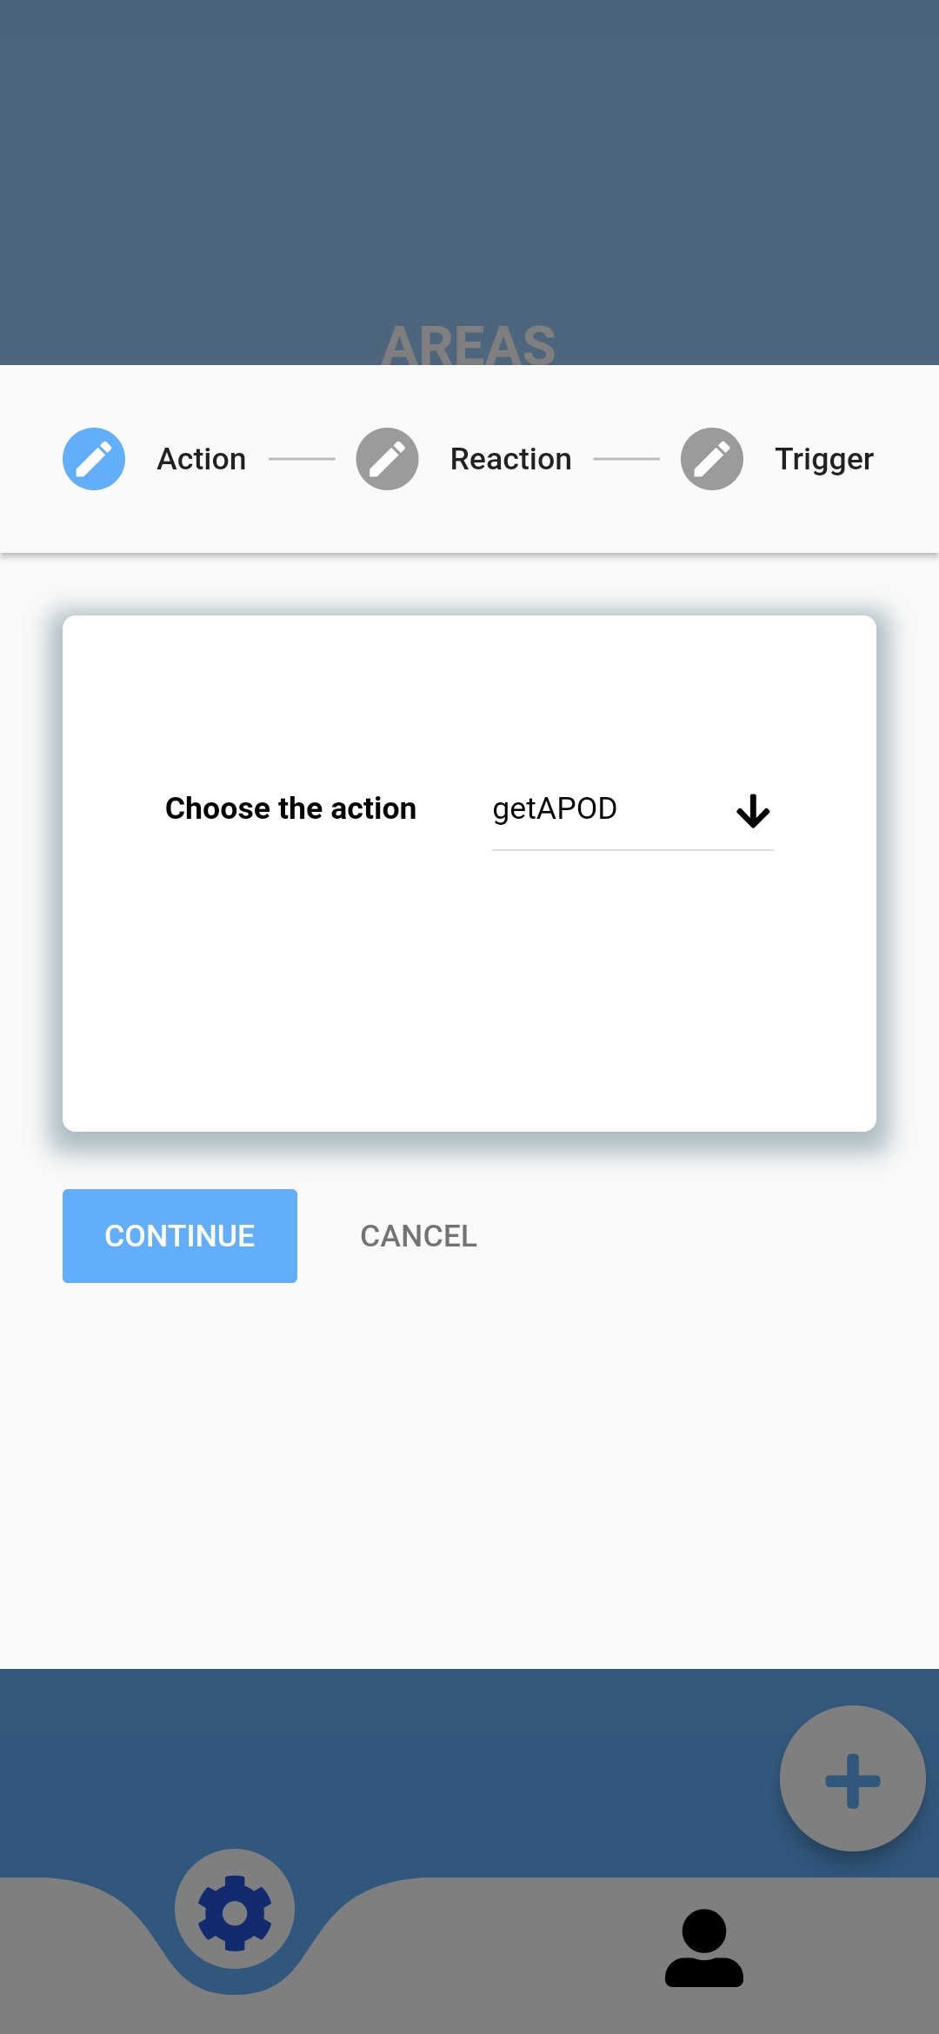

1. **Edit an AREA**

To edit a created AREA, just click the AREA on the **Jobs** page.

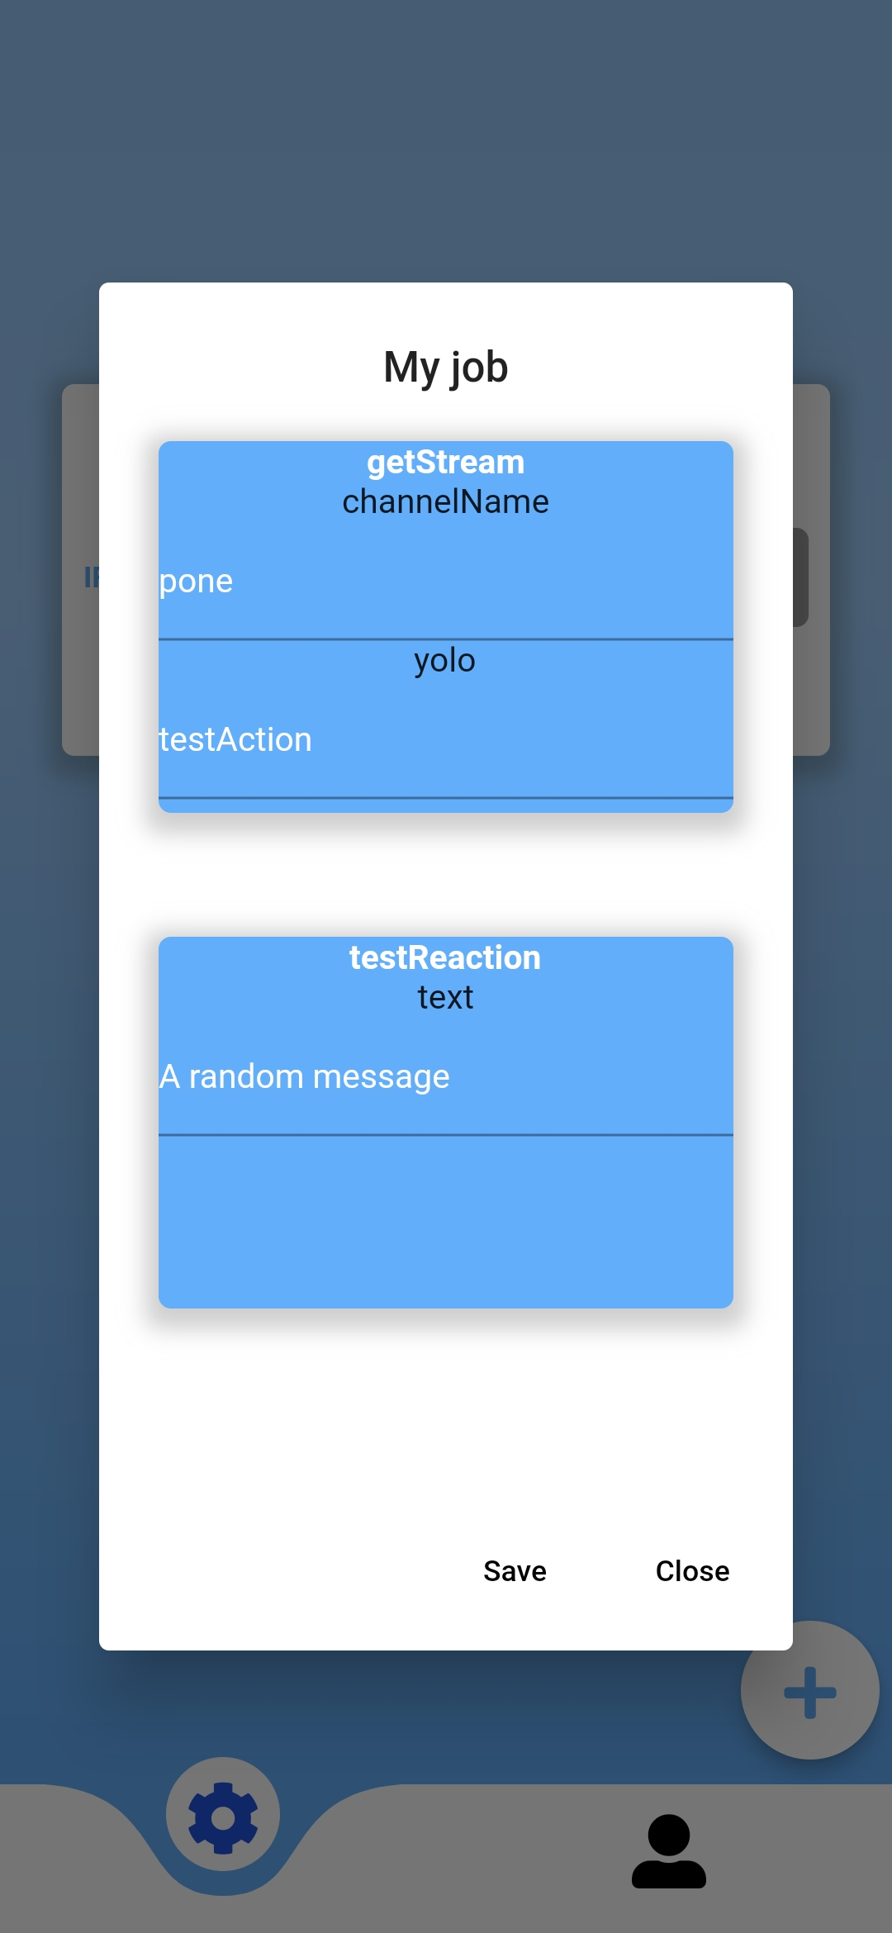

1. **Delete an AREA**

To delete an AREA, just swipe to left the AREA on the **Jobs** page.

1. **Register to a service**

Service registration is available on the **USER** page. To register to a service, users need to click on the associated **CONNECT** button.

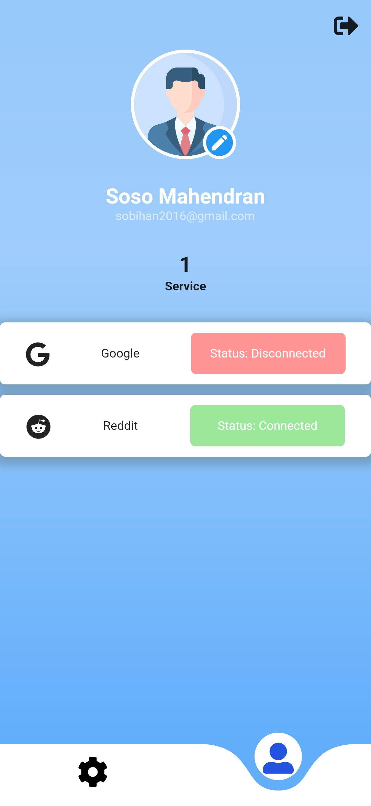

1. **Log out**

Users can Logout by clicking on the **Logout** button located in the top right of the **USER** page.



1. **Admin Documentation**
2. **How to build the mobile application**

To edit / build the application code, firstly, clone the GitHub repository of the project. All of the project is containerized with docker. To build the application, go in the cloned GitHub repository and type **docker-compose up** at the folder root. The application will be available at “/app-apk/:/usr/src/app/build/app/outputs/flutter-apk/” folder to rebuild the application just type **docker-compose stop && docker-compose build app && docker-compose up**

1. **Create / Edit / Delete an Action**

Actions are managed by the backend of the project. To Create / Edit / Delete an Action please refer to the backend Documentation.

1. **Create / Edit / Delete a reaction**

Reactions are managed by the backend of the project. To Create / Edit / Delete a Reaction please refer to the backend Documentation.

1. **Edit Job Page**

If you want to edit the Home Page, you can find all the code related to the Job Page in the **app/lib/pages/area_page.dart** file and if you want to edit some component of the Job Page you can find all the code in the folder app/lib/Components/Area.

1. **Edit Job List**

If you want to edit the job list / add a new button, you can find all the code related to the job list in the **app/lib/pages/area_page.dart** file.

1. **Edit Create AREA**

If you want to edit the Create AREA box, you can find all the code related to this box in the **app/lib/pages/area_page.dart** file.

1. **Edit Edit AREA**

If you want to edit the Edit AREA box, you can find all the code related to this box in the **app/lib/pages/area_page.dart** file.

1. **Edit / Add a service**

If you want to edit or add a new service, you can find all the code related to this in the **app/lib/pages/user_page.dart** file. If you want to add or edit an existing service, you can create or edit files located in the **app/lib/API/** folder.