

$15,043,470,000 — Uzbekistan’s agriculture value in US dollars.

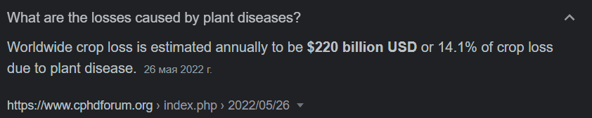

Information from: <https://www.cphdforum.org>

14.1% — Average plant loss ratio due to common plant diseases.

**14.1% of $15,043,470,000 is *$210,608,580*.**