LECTURE – 1.**THE HISTORY OF THE DEVELOPMENT OF THE SCIENCE OF SOLAR PHYSICS AND PROBLEMS IN STUDYING THE SCIENCE. THE PLACE OF THE SCIENCE OF SOLAR PHYSICS IN THE DEPARTMENTS OF ASTRONOMY AND PHYSICS AND THE STUDY OF OTHER NATURAL SCIENCES.**

Solar physics is a branch of astrophysics that specializes in the study of the Sun. It deals with as much detail as possible for the nearest star to us. The science of solar physics includes fundamental physics, astrophysics and computer science, including fluid dynamics, plasma physics, magnetohydrodynamics, seismology, elementary particle physics, atomic physics, nuclear physics, stellar evolution, space physics, spectroscopy, radiative transfer, applied optics, signal processing, computer theory, computational physics, stellar physics, and solar astronomy are inextricably linked.

Since the Sun is the only one for close-range observations (other stars have similar results to the Sun's spatial and temporal solutions, the difference between observational astrophysics (distant stars) and the corresponding fields of observational solar physics there is.

The study of solar physics is even more important because changes in the solar atmosphere and solar activity are thought to have major effects on Earth's climate. The Sun also acts as a "physical laboratory" for the study of plasma physics.

**History of solar physics**

**In ancient times.**The Babylonians kept records of solar eclipses, with the oldest inscriptions coming from the ancient city of Ugarit (modern day Syria). These records date back to 1300 BC. Ancient Chinese astronomers also observed solar phenomena (such as solar eclipses and visible sunspots) in order to track calendars based on lunar and solar cycles. Unfortunately, records preserved before 720 BC are very vague and do not provide useful information. However, after 720 BC, 37 eclipses were recorded over a period of 240 years.

**In the Middle Ages.**Astronomical sciences developed in the Islamic world during the Middle Ages. Many observatories were built in cities from Damascus to Baghdad, where detailed astronomical observations were made. In particular, several parameters of the sun were determined and detailed observations of the sun were made. Solar observations were made for navigational purposes, but were often used for chronometry (precise measurement of time). Islam requires its followers to pray five times a day at the specific exact position of the Sun in the sky. Therefore, accurate observations of the Sun and its trajectory in the sky were necessary. At the end of the 10th century, the Iranian astronomer Abu Mahmoud Khojandi built a huge observatory near Tehran. There he accurately recorded the sequence of meridian transits of the Sun. lchadi and later used this to calculate the magnitude of the ecliptic. As a result of the fall of the Western Roman Empire, Western Europe lost all sources of ancient scientific information, especially those written in Greek. This, as well as the crisis of urbanization and diseases such as the plague (Black Death), led to a decline in scientific knowledge in medieval Europe, especially in the early Middle Ages. During this period, observations of the Sun were made in relation to the Zodiac or used to help build places of worship such as churches and cathedrals. Also, the crisis of urbanization and diseases such as the plague (Black Death) led to the decline of scientific knowledge in medieval Europe, especially in the early Middle Ages. During this period, observations of the Sun were made in relation to the Zodiac or used to help build places of worship such as churches and cathedrals. Also, the crisis of urbanization and diseases such as the plague (Black Death) led to the decline of scientific knowledge in medieval Europe, especially in the early Middle Ages. During this period, observations of the Sun were made in relation to the Zodiac or used to help build places of worship such as churches and cathedrals.

**Renaissance.**The renaissance in astronomy began with the work of Nicolaus Copernicus. He proposed that the planets revolved around the Sun rather than the Earth. This model is known as the heliocentric model. His work was later expanded upon by Johann Kepler and Galileo Galilei. In particular, Galileo used his newly built telescope to look at the Sun, and in 1610 he discovered sunspots on the surface of the Sun. In the fall of 1611, Johannes Fabricius wrote the first book on sunspots, De Maculis in Sole Observatis (On Spots Observed in the Sun).

**Modern era.**Solar physics is now focused on understanding many phenomena that can be observed with modern telescopes and satellites. His main interests include the structure of the Sun's photosphere, the coronal heating problem, and sunspots. A major focus of current (2009) efforts in solar physics is a comprehensive understanding of the entire solar system, including the sun, as well as the interplanetary environment within the heliosphere and the effects of the sun on planets and planetary atmospheres.

**[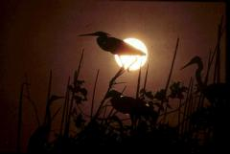](https://solarscience.msfc.nasa.gov/images/sun_crane.jpg)Why do we study the Sun?[1]**

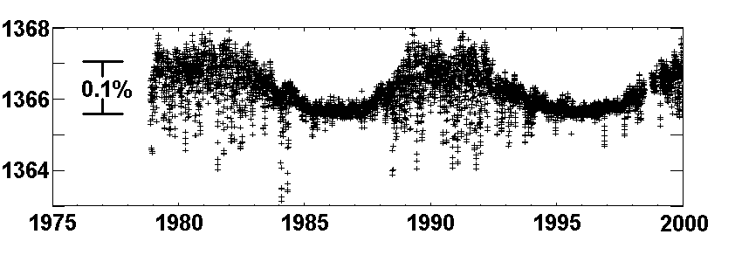**Climate communication.**The Sun is the source of light and heat for life on Earth. From long ago, our ancestors understood that their lives depended on the sun and showed respect to the sun. We still recognize the importance of the Sun and know that it is an inspiring body. In addition, we try to understand how it works, why it changes, and how these changes affect us, the Earth. The Sun was very dim at the beginning of its evolution, but the Earth was not frozen. The amount and properties of light from the Sun vary over timescales ranging from milliseconds to billions of years. The interannual cycles of sunspots show that the total amount of solar irradiance decreases by about 0.1% as the sun becomes brighter at its maximum number of sunspots. shows the change. Some of these changes will certainly affect our climate, but in uncertain ways.

**[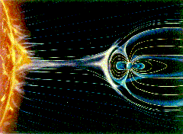](https://solarscience.msfc.nasa.gov/images/sunearth_lg.gif)Space weather.**The Sun is the source of the solar wind; The stream of gases passing from the Sun through the Earth flows at a speed greater than 500 km/s. Disturbances in the solar wind compress the Earth's magnetic field and transfer energy to the radiation belts. Active areas on the Sun's surface frequently flare and emit ultraviolet and X-rays that heat the Earth's upper atmosphere. This "Space Weather" can change the orbits of satellites and shorten the life of a mission. Too much radiation can physically damage satellites and endanger astronauts. A compression of the Earth's magnetic field can destroy equipment and energize large areas. can cause an increase in the current in the power lines that will disable the ride. As we become more dependent on satellites in space, we will increasingly experience and anticipate the effects of space weather.

**[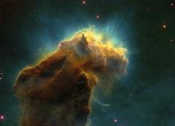](https://solarscience.msfc.nasa.gov/images/m16wf2.jpg)The sun is a star.**The Sun again plays an important role in helping us understand the rest of the astronomical universe. The Sun is the only star close enough to reveal details about its surface. Without the Sun, we wouldn't easily know that other stars have sunspots and hot outer atmospheres. The Sun is the key to understanding the other stars. We know the Sun's age, radius, mass, and luminosity (luminosity), and we've even learned details about its interior and atmosphere. This information is crucial to our understanding of other stars and their evolution. Many physical processes that occur elsewhere in the universe can be studied in detail in the Sun. So solar astronomy tells us the stars,

**[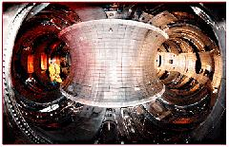](https://solarscience.msfc.nasa.gov/images/tftr.jpg)The sun is a physical laboratory.**The sun produces its energy through fusion, which is the fusion of four hydrogen nuclei in the deep core of the sun to form one helium nucleus. We have worked (under control) to create this process on Earth for several decades. Most of these actions are associated with very hot plasma in strong magnetic fields (This plasma is not a blood product, but a mixture of ions and electrons formed at high temperatures). Solar astronomy mainly involves the observation and understanding of plasmas under such conditions. In this and many other fields, there are many interactions between solar astronomers and scientific researchers.

**Big problems[2]**

**[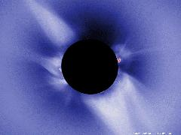](https://solarscience.msfc.nasa.gov/images/Ecl1991a.jpg)Coronal heating process.**The Sun's outer atmosphere (Corona) is hotter than 1000000 °C, and the visible surface has a temperature of 6000 °C. The nature of the processes that heat the corona, hold it at high temperatures, and accelerate the solar wind is one of the Sun's great mysteries. Generally, the temperature decreases with distance from the heat source. This corresponds to the surface as seen from the interior of the sun. Then, from a relatively small distance, the temperature suddenly rises to very high values. Several mechanisms have been proposed as the source of this warming, but there is no agreement as to which one or a combination of them is truly responsible.

**[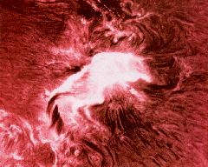](https://solarscience.msfc.nasa.gov/images/flare.jpg)The nature of solar flares.** Flares occur frequently in areas around sunspots, heating materials to millions of degrees in seconds and throwing billions of tons of matter into space. The exact causes of solar flares and coronal mass ejections are another of the great solar puzzles. Again, we know many details about explosive events and understand the underlying mechanisms, but many details are missing. We still cannot reliably predict when and where a flash will occur or how big it will be. This problem is similar to predicting tornadoes.

**The origin of the sunspot cycle.** Over the course of about 11 years, **[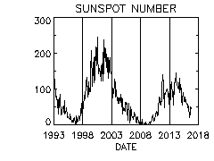](https://solarscience.msfc.nasa.gov/images/zurich.gif)**the number of sunspots increases from nearly zero to 200, and will return to zero until the next cycle begins. The nature and causes of the sunspot cycle is one of the great mysteries of solar astronomy. While we have learned many details about the sunspot cycle (as well as some of the dynamical processes that must have played key roles in their formation), we can predict the number of future sunspots using basic physical principles. we cannot develop a model that allows us to reliably determine. This problem is like trying to predict what the weather will be like next year's winter or summer.

**The disappearance of neutrinos (paradox).**The Sun should produce more than twice as many neutrinos as observed neutrinos. In the core of the Sun, these amazing subatomic particles are released as a result of fusion reactions. Then they go straight through the sun and out into space. Neutrinos are notoriously difficult to detect, but several independent experiments confirm that they detect about a third of 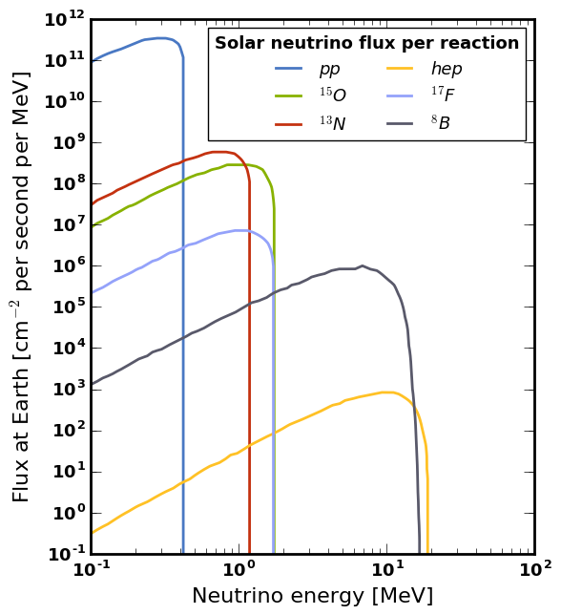the neutrinos predicted on Earth today. Solar astronomers have tried to modify their model of the Sun and its 4.5 billion year evolution to create a model of the Sun that produces fewer neutrinos. These attempts failed. This has led many scientists to question our understanding of neutrons themselves. And so, this last conundrum may shake some of the foundations of physics.

1. https://solarscience.msfc.nasa.gov/whysolar.shtml
2. https://solarscience.msfc.nasa.gov/quests.shtml