LECTURE – 4. **INTERNAL STRUCTURE OF THE SUN.**

The mathematical conditions of equilibrium within the Sun can be expressed using four differential equations representing the mass distribution, gas pressure, and energy release and transfer in the star. Let's derive these equations.

**Hydrostatic equilibrium**. Gravitational (gravity) forces pull material in the sun toward the center. It is directed against the pressure force caused by the thermal motion of the gas molecules. The first condition of equilibrium is that both forces are in equilibrium.

Consider a cylindrical element of volume located at a distance r from the center of the Sun (Figure 1).

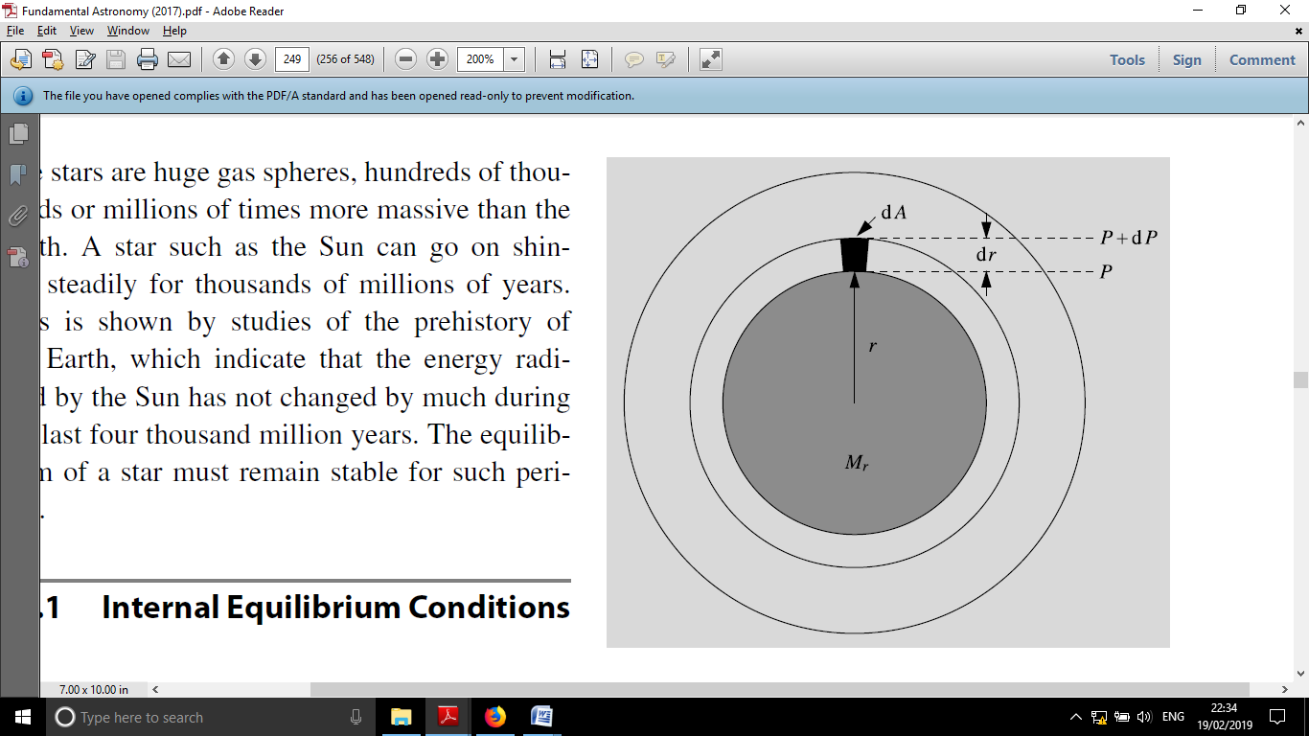

**Figure 1.** The sum of pressure and gravitational forces acting on a unit volume in hydrostatic equilibrium is zero.

The size of this element, where the surface of its base, is its height; its mass, where is the density of the gas at the radius r. If the mass inside the radius r is the gravitational force per unit volume $dV=dA drdAdrdm=ρ dA drρ=ρ\left(r\right)M_{r}$

$$dF_{g}=-\frac{GM_{r}dm}{r^{2}}=-\frac{GM_{r}ρ}{r^{2}}dA dr$$

will be, where G is the gravitational constant. The minus sign in this expression means that the force is directed towards the center of the star. If the pressure on the lower surface per unit volume is P, on the upper surface, then the resultant force acting on the element $P+dP$

$$dF_{p}=P dA-\left(P+dP\right) dA=-dP dA$$

will be equal to

dP is negative, dF because the pressure decreases outwardpand will be positive. The balance condition is that the total force acting on the unit volume must be equal to zero, that is:

$$0=dF_{g}+dF_{p}=-\frac{GM_{r}ρ}{r^{2}}dA dr-dP dA$$

or

$$\frac{dP}{dr}=-\frac{GM_{r}ρ}{r^{2}} (1)$$

This expression is the hydrostatic equilibrium equation.

**Mass distribution**. The second equation gives the mass within a given radius. Consider a spherical shell with a distance r from the center and a thickness (Figure 2). Its mass is equal to , giving the mass continuum: $drdM_{r}=4πr^{2}ρ dr$

$$\frac{dM_{r}}{dr}=4πr^{2}ρ (2)$$

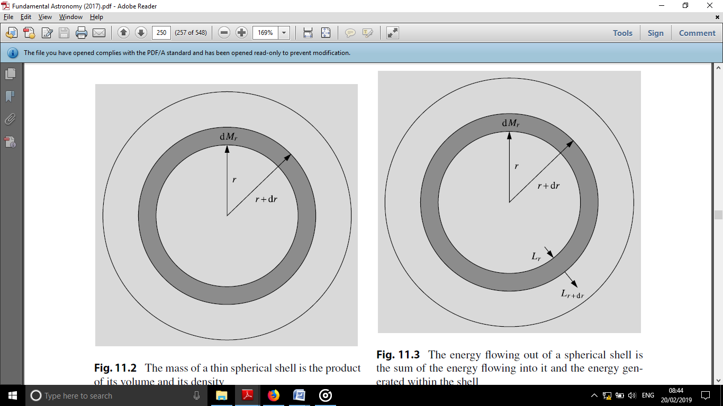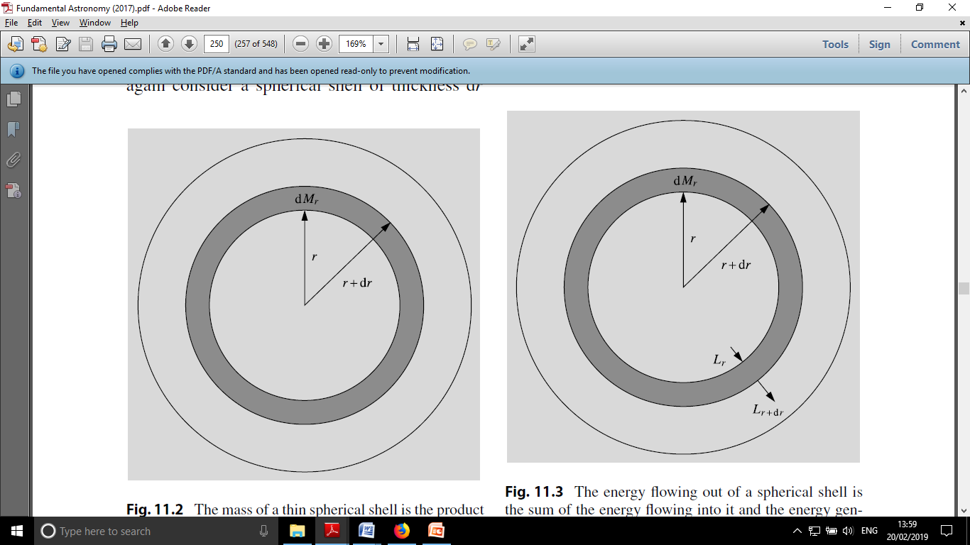

**Figure 3.**The energy flowing through the spherical shell is equal to the sum of the energy flowing through the shell itself and the energy released inside the shell

**Figure 2.**The mass of a thin spherical shell depends on its volume and density

**Energy dissipation**. The third condition of equilibrium represents the conservation of energy, since the free energy released in the star must reach its surface and be radiated. Again, r is within the radius $dM_{r}$ Let's take a spherical shell with a location and a thickness (Fig. 3). Let r be the energy flow, that is, the amount of energy passing through the surface per unit time. If the amount of energy released in the sun in units of time and mass, that is, the coefficient of energy release is e, then $drL_{r}$

$$dL_{r}=L_{r+dr}-L_{r}=εdM_{r}=4πr^{2}ρε dr$$

Thus, the energy conservation equation becomes:

$$\frac{dL_{r}}{dr}=4πr^{2}ρε (3)$$

The rate of energy dissipation depends on the distance to the center. In general, all the energy radiated by the sun is released in the hot and dense core. Energy dissipation in the outer layers is negligible and almost constant. $L_{r}$

**Temperature gradient**. The fourth equation of equilibrium gives the temperature as a function of radius, i.e. the temperature gradient. The form of the equation depends on the form of energy transfer: heat conduction, convection or radiation. ${dT}/{dr}$

In the core of normal stars, heat conduction is extremely inefficient, because the electrons involved in energy transfer can travel small distances without colliding with other particles. Thermal conductivity can become significant only in compact stars - white dwarfs and neutron stars, where the free range of photons is very small, but relatively large for some electrons. Therefore, the conduction of energy transfer in normal stars can be neglected.

In the radiative transfer of energy, photons emitted from the hotter parts of the star are absorbed and heated by the cooler parts. The star is in light (radiative) equilibrium if the energy released in the core of the star is transferred by total radiation.

The radiative temperature gradient is related to the energy flow, respectively, as follows: $L_{r}$

$$\frac{dT}{dr}=\left(-\frac{3}{4ac}\right)\left(\frac{kρ}{T^{3}}\right)\left(\frac{L_{r}}{4πr^{2}}\right) (4)$$

where is the radiation constant, c is the speed of light, and r is the density. The mass absorption coefficient k represents the amount of absorption per unit mass. Its value depends on temperature, density and chemical composition. $a={4σ}/c=7.564×{10}^{-16 }J m^{-3}K^{-4}$

$$F_{r}=\frac{L_{r}}{4πr^{2}}=-D\frac{dU_{r}}{dr}$$

Here is the radiation energy density, i.e. ( is the radiation constant and , where is the average path of the l-photon). It is necessary to know the absorption of photons determined by k, because k $U_{r}U_{r}=aT^{4}a={4σ}/c=7.564×{10}^{-16 }J m^{-3}K^{-4}D=\frac{1}{3}λc$*ρ*The distance dl gives the energy of the part lost by absorption through dl (lk*ρ* =1 expression logically as λ – free running path), the unit of k is m2/kg.

The radiative transfer equation in deriving (4).

$$cosθ\frac{dI_{ν}\left(z, θ\right)}{dτ_{ν}}=I_{ν}-S_{ν}$$

was used. In terms of the variables used in this chapter, it can be written as follows:

$$cosθ\frac{dI_{ν}}{dr}=-k_{ν}ρI_{ν}+j_{ν}$$

In this equation, the corresponding average value is replaced by . The equation is then multiplied by and integrated over all directions and frequencies. The one on the left $k_{ν}kcosθI_{ν}$ Planck's function $B_{ν}$ can be approximated using Then the frequency integral can be evaluated using the formula The first term on the right-hand side $B\left(T\right)=AT^{4}$

$$F_{ν}=\frac{1}{dAdνdt}\int_{s}{dE_{ν}=\int_{s}{I_{ν}cosθdω}}$$

is expressed in current densities corresponding to , the integral of the second term over the directions gives zero, because $j_{ν}$*Th*does not depend on And so,

$$\frac{4π}{3}\frac{d}{dr}\left(\frac{ac}{4π}T^{4}\right)=-kρF_{r}$$

and finally, the connection between current density and energy flow $F_{r}L_{r}$

$$F_{r}=\frac{L_{r}}{4πr^{2}}$$

using , we get (4).

${dT}/{dr}$ The derivative of is negative because the temperature increases inward. Clearly, if energy is transferred there by radiation, there must be a temperature gradient, otherwise the radiation field would be the same in all directions and the net flux would remain zero. $F_{r}$

If light migration becomes inefficient, the absolute value of the light gradient of temperature becomes very large. In this case, more effective energy-releasing actions are established in the gas compared to radiation. In these convective movements, hot gas rises to relatively cold layers, where it loses its energy and sinks again. Elements of the accreting gas mix the material of the star and the composition of the convective part of the star remains homogeneous. On the other hand, radiation and conduction cannot mix the material, because they are involved in the transfer of energy, not gas.

To understand the temperature gradient in the convective state, consider a rising bubble. Assume that the gas moves with a bubble and obeys the adiabatic equation of state:

$$T∝P^{1-\frac{1}{γ}} (5)$$

where P is the gas pressure, is the adiabatic exponent, that is, the ratio of specific heat capacities at constant pressure and volume: $γ$

$$γ={C_{P}}/{C_{V}} (6)$$

This ratio of relative heat capacities depends on the degree of ionization of the gas and can be calculated when the temperature, density, and chemical composition are known.

Taking the derivative from (5), we get the expression for the convective temperature gradient:

$$\frac{dT}{dr}=\left(1-\frac{1}{γ}\right)\frac{T}{P}\frac{dP}{dr} (7)$$

In practice, when calculating the stellar structure, using (4) or (7) separately, the equation that gives a relatively smoother temperature gradient is chosen. The heat exchange with the environment in the outer layers of the star should also be taken into account, in which the approximation (7) is not very good. Mixing length theory is often used to calculate the convective temperature gradient. Convection theory is still a complex, unsolved problem, the solution of which is beyond the scope of this presentation.

Convective movements occur when the radiative gradient of temperature becomes greater than the adiabatic gradient in absolute value, that is, when the radiative gradient becomes steeper or when the convective gradient becomes smaller. As can be seen from the formula (4), the radiation gradient can be expected to increase when the energy flow density or mass absorption coefficient increases. As the adiabatic exponent approaches 1, the convective gradient decreases.

**Boundary conditions**. In order to formulate the problem correctly, the boundary conditions should be written in the previous differential equations:

* *r*= there should be no energy source or mass in the central part within the radius of 0; and so, $M_{0}=0, L_{0}=0$
* Within the limits of the stellar radius R, the total mass inside is strictly obtained: . $M_{R}=M$
* The temperature and pressure on the surface of the star are some exact or $T_{R}P_{R}$ has values. They are usually much smaller than the averages, so it is enough to take and. $T_{R}=0 P_{R}=0$

In addition to these boundary conditions, an expression for the pressure given by the equation of state is needed, as well as expressions for the mass absorption coefficient and the energy production rate. The solution of the basic differential equations gives the mass, temperature, energy flux and density as a function of radius. The radius of a star and its luminosity can also be found by comparing observations.

The properties of equilibrium star models are generally determined by a given mass and chemical composition. This result is known as the Vogt-Ressel theorem.