**LECTURE – 5. BASIC THERMONUCLEAR REACTIONS**

At the time when the equations of the solar structure were derived, the classification of solar energy sources remained unknown. Knowing the usual brightness of the sun, one can know the duration and types of energy sources. For example, normal chemical combustion can supply energy for only a few thousand years. The energy released in a solar contraction may last a little longer, but it should also run out after a few million years.

Biological and geological data on Earth indicate that the Sun's brightness has remained virtually unchanged for billions of years. The age of the Earth is about 5 billion years, and the Sun must have existed for at least that period. The Sun's luminosity is 4×1026 W, and it radiated 6×1043 J of energy over 5×109 years. Considering that the mass of the Sun is 2×1030 kg, it can produce at least 3×1013 J/kg.

Regardless of the source of energy, the conditions at the bottom of the Sun are known. Thus, in the examples, it was calculated that the temperature inside the Sun at a distance equal to half the radius is about 5 million degrees. The temperature at the core is around ten million Kelvin, which is high enough for fusion reactions to take place.

In synthesis reactions, light elements are converted into relatively heavy elements. The final reaction product has a total mass that is less than that of the initial nuclei. This mass difference is separated in the form of energy according to Einstein's formula E = mc2. Fusion reactions are called combustion reactions, although they have nothing to do with the simple chemical combustion of fuel.

The nucleus of an atom consists of protons and neutrons, which together are called nucleons. Let's clarify:

*mp*= proton mass,

*mn*= neutron mass,

*Z*= nuclear charge = atomic number,

*N*= number of neutrons,

*A*= Z + N = atomic weight,

*m*(Z , N) = nuclear mass.

The mass of a nucleus is less than the sum of the masses of all its nucleons. This difference is known as the binding energy. The binding energy corresponding to one nucleon, that is, the specific binding energy, is equal to:

$$Q=\frac{1}{A}\left(Zm_{p}+Nm_{n}-m\left(Z, N\right)\right)c^{2} (5.1)$$

*Q*it increases towards heavy elements, i.e. up to iron (Z = 26), after iron it starts to decrease again (Figure-5.1).



**Picture-5.1**The binding energy corresponding to one nucleon depends on the atomic weight of the nucleus. Among the isotopes with the same atomic weight, those with the highest binding energies are shown. Dots correspond to even numbers of protons and neutrons, and crosses to odd numbers. Preston, MA (1962)

It is known that the Sun consists mainly of hydrogen. Let's see how much energy is released as a result of the fusion of four hydrogen atoms to a helium atom. The mass of a proton is 1.672×10–27 kg, and the mass of a helium nucleus is 6.644×10–27 kg. The difference in masses is 4.6×10–29 kg, the energy released from it is equal to E = 4.1×10–12 J. Thus, 0.7% of the mass is converted into energy, which gives 6.4×1014 J of energy released per kilogram of hydrogen. This is much larger than our estimate above, as only 3×1013 J/kg was required.

By the 1930s, there was no doubt that the energy of the Sun and stars came from nuclear fusion. In 1938, Hans Bethe (1906-2005, German-American) and independently Carl Friedrich von Weissäcker (1912-2007, Germany) proposed a detailed mechanism of energy separation in stars, which is carbon-nitrogen-oxygen (carbon-nitrogen-oxygen), that is, it was a CNO – cycle. Other important energy production processes (the proton-proton chain and the triple alpha reaction) were not discovered until the 1950s.

**Proton-proton chain**(Picture-5.2). In stars with the mass of the Sun or less, energy is released through a proton-proton (pp) chain reaction. It consists of the following steps:

ppI: (1) 1H + 1H → 2H + e+ + ne

1H + 1H + e– → 2H + ne

(2) 2H + 1H → 3He + g

(3) 3He + 3He → 4He + 2 1H

For each reaction (3), reactions (1) and (2) are repeated twice. The probability that the first step of the reaction will be measured in laboratories is very small, so it has a very small probability. At the existing density and temperature in the center of the Sun, the time it takes for two protons to collide to form a deuteron is on average 1010 years. The Sun is still shining because of the slowness of this reaction. If this reaction had gone a little faster, the Sun would have already burned out. The neutrino produced in the reaction (1) can easily leave the Sun, taking with it a certain fraction of the released energy. The positron e+ collides with an electron and disappears to form two gamma quanta.

In the second reaction, a deuteron and a proton combine to form the helium isotope 3He, which is much faster than the previous reaction. Therefore, the amount of deuterons in stars is very small.

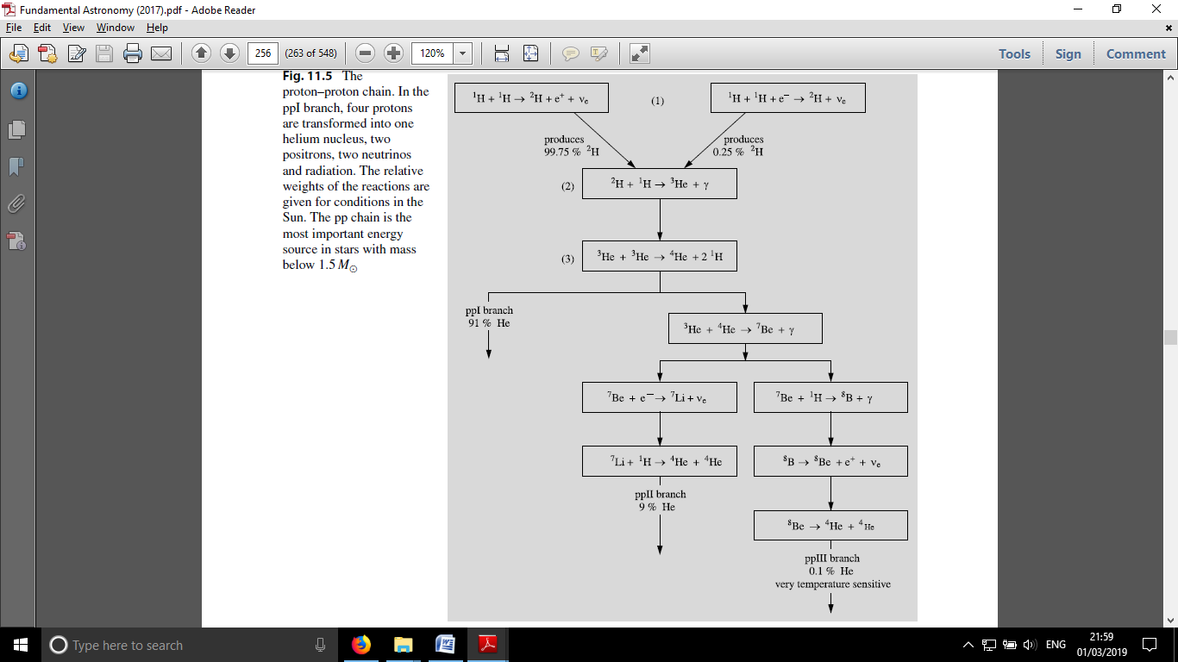

**Picture-5.2**Proton-proton chain. In the ppI reaction, four protons are converted into one helium nucleus, two positrons, two neutrons, and radiation. The relative importance of these reactions is given for the conditions of the Sun. Reactions of this type are important in stars with masses less than 1.5 Mʘ.

ppThe last step in the chain can take three forms. As indicated above, ppI may be the most likely. 91% of the energy in the sun is produced in the ppI chain. There is also a possibility that two 3He nuclei merge into 4He nuclei in two additional branches of the pp chain.

ppII: (3) 3He + 4He → 7Be + g,

(4) 7Be + e– → 7Li + ne,

(5) 7Li + 1H → 4He + 4He,

ppIII: (3) 3He + 4He → 7Be + g,

(4) 7Be + 1H → 8B + g,

(5) 8B → 8Be + e+ + ne,

(6) 8B → 4He + 4He.

**Carbon cycle** (Picture-5.3). At temperatures below 20 million degrees, the pp-chain remains the main energy release mechanism. At even higher temperatures, corresponding to stars greater than 1.5 Mʘ, the carbonaceous (CNO) cycle begins to dominate, as its reaction rate accelerates with increasing temperature. CNO plays the role of oxygen and nitrogen catalyst (accelerator) in the cycle. The reaction cycle consists of the following steps:

(1) 12C + 1H → 13N + g,

(2) 13N → 13C + e+ + ne ,

(3) 13C + 1H → 14N + g,

(4) 14N + 1H → 15O + g,

(5) 15O → 15N + g + ne,

(6) 15N + 1H → 12C + 4He.

(4) is the slowest reaction, so it determines the rate of the CNO cycle. At 20 million degrees (4), the time required for the reaction is a million years.

The share of energy released in the form of radiation in the CNO cycle is slightly less than in the pp-chain, because most of the energy is taken away by neutrinos.

**Triple α-reaction**. As a result of previous reactions, the amount of helium in the inner parts (core) of the star increases. When the temperature exceeds 108 degrees, helium can be converted to carbon by the α-reaction:

(1) 4He + 4He ↔ 8Be,

(2) 8Be + 4He → 12C + g.

Here, 8Be is unstable and decays into two helium nuclei or α-particles in 2.6×10–16 seconds. Thus, the formation of carbon requires three particles to collide almost simultaneously. The reaction is often written as:

3 4He → 12C + g.

After helium combustion is complete, other reactions involving elements as heavy as iron and nickel are likely to occur at higher temperatures. Examples of such reactions include various α-reactions and the combustion of oxygen, carbon, and silicon.

**α-reactions**. Some of the carbon nuclei formed during helium combustion react with helium nuclei to form oxygen, which in turn reacts to form neon, etc. These reactions are rare enough that the sun is of little importance as a source of energy. it's not. Examples of such reactions include:

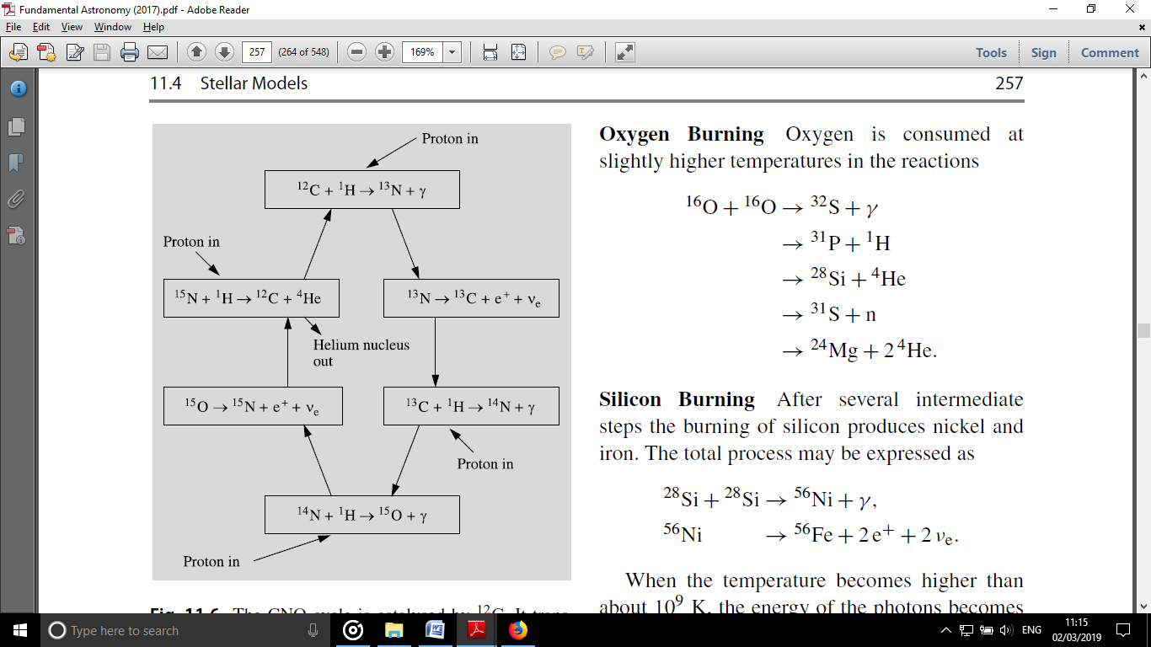

**Picture-5.3**The CNO cycle is catalyzed by 12C. It converts four protons into helium nuclei, two positrons, two neutrinos, and radiation. It is considered to be the main source of energy in stars larger than 1.5 Mʘ.

12C + 4He → 16O + g,

16O + 4He → 20Ne + g,

20Ne + 4He → 24Mg + g.

**Carbon combustion**. After the helium is exhausted, carbon combustion begins at temperatures of (5–8)×1010 K:

12C + 12C → 24Mg + g

→ 23Na + 1H

→ 20Ne + 4He

→ 23Mg + n

→ 16O + 2 4He.

**Oxygen combustion**. At higher temperatures, oxygen enters the reaction:

16O + 16O → 32S + g

→ 31P + 1H

→ 28Si + 4He

→ 31S + n

→ 24Mg + 2 4He.

**Silicon combustion**. After several steps in the combustion of silicon, nickel and iron are formed. The whole process can be described as follows:

28Si + 28Si → 56Ni + g,

56Ni → 56Fe + 2e+ + 2ne.

At temperatures above 109 K, the energy of the photons is large enough to annihilate certain nuclei. Such reactions are called photonuclear reactions or photodissociations.

Elements heavier than iron require additional input of energy to form, so such elements cannot be formed in fusion reactions. Elements heavier than iron can only form when stars capture neutrons during the final, violent stages of stellar evolution.

The rates of the above reactions can be determined using laboratory experiments or theoretical calculations. Knowing this, it is possible to calculate how much energy is released per unit of mass and time, depending on the density, temperature and chemical composition:

$$ε = ε\left(T, ρ, X, Y, Z\right) (5.2)$$

In practice, not only the total amount of heavy nuclei Z, but also the relative amount should be known.