**LECTURE-6 THE SOLAR NEUTRINO PROBLEM. RESULTS OF INTERNATIONAL NEUTRINO EXPERIMENTS.**

Thermonuclear reactions in the Sun play an important role in the formation of neutrinos, which completely penetrate the entire Earth's surface, in addition to the energy released in the form of γ-quanta, as well as the kinetic energy of directly generated particles. Neutrinos are particles that interact very weakly with matter. Therefore, they freely leave the interior of the sun and spread into the space environment at a speed very close to the speed of light and almost without being absorbed by the matter in their path.

Each of the above fusion reactionsαIt can be seen that the formation of the -particle is associated with the emission of 26.7 MeV energy, which provides the observed brightness of the Sun. Each such reaction is accompanied by the emission of two neutrinos. It follows that the total neutrino "brightness" of the Sun, regardless of the details of fusion processes, is at least 2 per 1×3.85×1020 MW/26.7 MeV≈1.8×1038 make up neutinos. Dividing this value by the surface of a sphere of radius 1 ab gives the solar neutrino flux on Earth of about 1011 neutrinos/(s⋅cm2) is equal to

Table 6.1 summarizes the fact that neutrinos from different reactions have different energies, and it is important that some of them have a fixed energy ("monochromatic" neutrino), and others have a continuous spectrum (Fig. 6.1). The speed of individual nuclear reactions and the magnitude of the corresponding neutrino flux strongly depend on the temperature and the parameters of the chemical composition and, first of all, on the helium content. Therefore, solar neutrino fluxes of different energies can be recorded, and it is possible to obtain direct experimental information about the conditions in the inner layer of the sun.

Currently, complex experiments are being conducted in various laboratories around the world to record solar neutrinos. These are based on the high probability of capture of neutrinos by some atomic nuclei (Cl, Ga, Li, Br, I, etc.) and also on the recording of Cherenkov radiation caused by the scattering of neutrinos on electrons. Let's look at the results of three of the most important experiments.

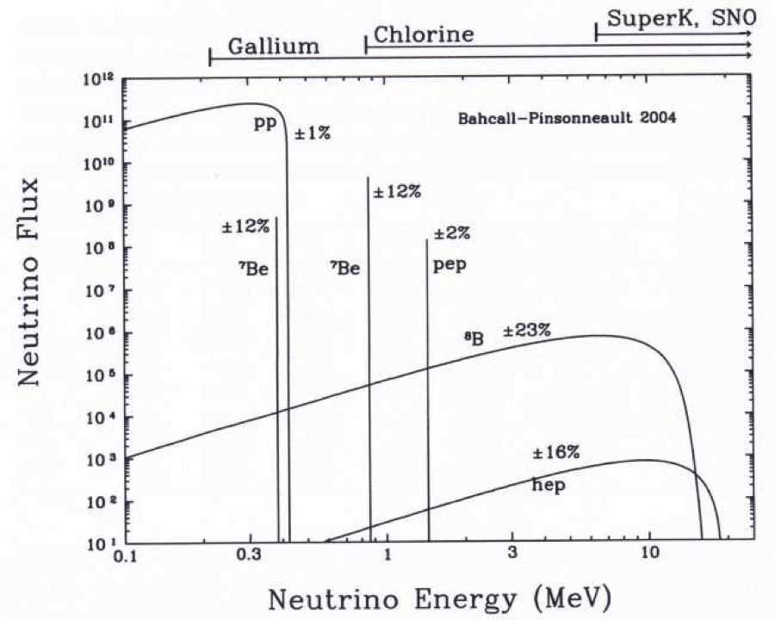

Figure-6.1 Theoretical spectrum of solar neutrinos and the probability of their registration by different detectors.

Table-6.1 Nuclear reactions in the sun with neutrino emission

|  |  |  |  |  |
| --- | --- | --- | --- | --- |
| Reaction | energy,  MeV | Naz. current  1010 n (cm2 s) | Counting speed 37Cl  SNU | Counting speed is 71Ga  SNU |
| 1H(p, e+n)2D | < 0.420 | 6.01 | 0 | 70.0 |
| 1H(pe- ,n)2D | 1.44 | 0.014 | 0.22 | 3.1 |
| 7Be(e- ,n)7Li | 0.861 | 0.47 | 1.00 | 30.5 |
| 8B(e+n)8Be | < 14.06 | 0.00058 | 5.11 | 14.2 |
| 13N(e+n)13C | < 12 | 0.06 | 0.06 | 2.1 |
| 15O(e+n)15N | < 1.74 | 0.05 | 0.22 | 3.9 |

The chlorine-argon experiment was proposed by Bruno Pontecorvo in 1946 and was first performed in 1967 by Raymond Davis in South Dakota (USA). It is based on the neutrino absorption reaction

37Cl(n, e-)37Ar.

The working substance is perchlorethylene (tetrachloroethylene) C2Cl4, which is rich in chlorine.

Chlorine nuclei in this substance are capable of absorbing neutrinos with an energy higher than 0.814 MeV, ejecting an electron and forming the radioactive isotope 37Ar with a half-life of 35 days. This allows to collect the product of the reaction for a long time (3-4 months) and to use physical and chemical methods of its extraction.

In order to eliminate the effects caused by cosmic rays, a 615-ton container of liquid perchlorethylene was installed in the lower part of the mine at a depth of 1455 meters. Figure 6.2 shows the results of twenty years of observations, where the observed flux of solar neutrinos with energies above 0.814 MeV averages 0.420 + 0.045 acquisitions per day (increase), or 2.55 in special "solar neutrino units". + 0.25 corresponds to SNU (Solar Neutrino Units). 1 SNU corresponds to the neutron flux at which one 37Ar nucleus is produced for 1 s in a detector with 1036 37Cl nuclei. Thus, in the Davis experiment, in fact (taking into account the background created by cosmic rays), one solar neutrino particle was recorded in 2-3 days.±1.0 corresponds to SNU.

Gallic experience. Based on the reaction proposed by VA Kuzmin

71Ga(n, e-)71Ge.

An important advantage is a large effective cross-section (sechenium) and a low energy threshold (0.233 MeV), which allows recording neutrinos from the main reaction of a proton in a positron decay. The half-life of radioactive 71Ge is 11.4 days.

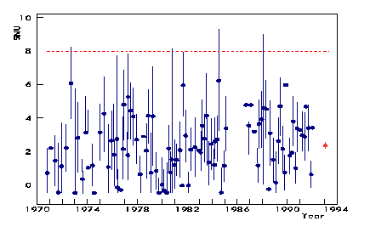

Figure 6.2 Observed and theoretically expected (upper dashed line) solar neutrino fluxes for the chlorine detector

One20 tons of gallium are enough to capture one neutrino per day. In 1990, 57 tons of gallium were used in Russia's SAGE (Soviet-American Gallium Experiment) detector in the Boksan Gorge in the North Caucasus, and the following year it was launched in the Italian Alps (GALLEX, 30 tons of gallium). Preliminary results from SAGE compute speed of 73±19 SNU ni and GALLEX 79±12 showed SNU, while the theoretically expected value is 132±7 was evaluated with SNU.

Table-6.2 Results of solar neutrino recording experiments

|  |  |  |  |  |  |
| --- | --- | --- | --- | --- | --- |
| Detector | Experiment | Border  MeV | Measured  SNU | Approx. do it  SNU | Size/Approx. |
| 37Cl | Davis | 0.814 | 2.55±0.25 | 8.0±1.0 | 0.32 |
| H2O | Kamiokande | 7.5 |  |  | 0.49 |
| 71Ga | SAGE | 0.2 | 73±19 | 132±7 | 0.55 |
| 71Ga | GALLEX | 0.2 | 79±12 | 132±7 | 0.63 |

Water detector n + e electrons of water molecules→n′+ e′is used to record Cherenkov radiation from the scattering of neutrinos with energy greater than 7.5 MeV. The Kamiokande II experiment was built at a depth of 1 km in the Kamioka mine (Japanese Alps). The working substance consists of 680 tons of water. Flashes are recorded by photomultipliers on the wall of the tank (vessel), which cover 20% of the total internal surface. The results of the first measurements showed that the values ​​of the neutrino flux will be two times less than expected (in the late 90s, the SuperKamiokande experiment was launched, which made it possible to obtain a neutron "image" of the Sun for the first time). All the results of recording solar neutrinos showed that they have values ​​several times lower than the expected value (Table 8.2). Especially, the biggest difference is 4 times for the chlorine detector (Figure-6.1), for which there is the longest series of observations. The main difficulty in interpreting these differences (differences) is due to the lack of internal agreement between the data of different experiments. In the last two decades of the last century, a lot of work was done to improve the methodology of the experimental experiment and to redevelop the standard theoretical models of the internal structure of the sun. All of this suggests that the main reason for the discrepancies comes from our lack of knowledge about the specific physical nature of neutrinos. The main difficulty in interpreting these differences (differences) is due to the lack of internal agreement between the data of different experiments. In the last two decades of the last century, a lot of work was done to improve the methodology of the experimental experiment and to redevelop the standard theoretical models of the internal structure of the sun. All of this suggests that the main reason for the discrepancies comes from our lack of knowledge about the specific physical nature of neutrinos. The main difficulty in interpreting these differences (differences) is due to the lack of internal agreement between the data of different experiments. In the last two decades of the last century, a lot of work was done to improve the methodology of the experimental experiment and to redevelop the standard theoretical models of the internal structure of the sun. All of this suggests that the main reason for the discrepancies comes from our lack of knowledge about the specific physical nature of neutrinos. a lot of work has been done to improve the methodology of the experimental experiment and to redevelop the standard theoretical models of the internal structure of the sun. All of this suggests that the main reason for the discrepancies comes from our lack of knowledge about the specific physical nature of neutrinos. a lot of work has been done to improve the methodology of the experimental experiment and to redevelop the standard theoretical models of the internal structure of the sun. All of this suggests that the main reason for the discrepancies comes from our lack of knowledge about the specific physical nature of neutrinos.

**Control questions:**

1. Knowing the approximate brightness and age of the Sun, how can we determine the amount of energy it has radiated so far?

2. Given the mass of the sun, how much energy can it produce at least per kilogram of mass?

3. Explain the nature of the binding energy of a nucleus.

4. What is the binding energy corresponding to one nucleon?

5. Calculate how much energy is released as a result of the fusion of four hydrogen atoms to a helium atom in the sun? (The mass of a proton is 1.672×10–27 kg, the mass of a helium nucleus is 6.644×10–27 kg)

6. In the sun, as a result of the fusion of four hydrogen atoms into a helium atom, show what % of the mass is converted into energy, and how much energy is released from one kilogram of hydrogen?