**LECTURE-7: CHECKING THE INTERNAL STRUCTURE OF THE SUN BY OBSERVING ITS VIBRATION. HELIOSEISMOLOGY.**

The oscillation of the Sun was discovered in the 60s by American astronomers R. Layton, R. Noyce and J. Simon. They observed periodic oscillations in the Sun's photosphere with a period of about 5 minutes. The nature of these vibrations has been dark for many years.

By 1975, German astronomer FL Doibner discovered the "secret" of the 5-minute solar oscillation. It turns out that these vibrations, called Solar Resonance Acoustic Vibrations, are caused by the combination of a large number of different modes. These vibrations occur not only on the surface of the Sun, but in its deep depths, up to the zone of thermonuclear reactions in the core, and their study is distinguished from other astrophysical methods by providing rich information about the internal structure of the Sun.

Globalacoustic vibrations are elastic resonant vibrations of the Sun, which are essentially sound vibrations. Their energy source is noise generated by turbulent convection in the surface layers of the Sun. The sound waves created by such a noise are radiated in different directions at a very wide frequency. Considering that wave trajectories can be closed, it is not difficult to understand that due to their interference, a standing wave appears. A standing wave is one of the modes of an acoustic wave. The way traveling waves add up to form a standing wave is very similar to how it occurs in an ordinary string at precisely discrete (resonant) frequencies.

The vibrational spectrum of a string consists of the fundamental tones of the first and second overtones. Solar oscillations have not only a different number of nodes according to the radius of the Sun (they are called overtone radial numbers), but also have a different distribution of amplitude across the surface.

In the course of oscillations, each substance, a separate section of the Sun's surface moves in the opposite phase and is separated from each other by nodal lines with zero amplitude.

The total number of such lines on the surface of the Sun is called the level of waves and is denoted by l. The simplest type of radial oscillation is λ = 0, in which the Sun's surface contracts and expands without changing its spherical shape. Vibrations of l = 1 type are called dipole, and we can clearly see it by shaking a half-baked egg: in this case, the egg yolk and surrounding shell-white move in opposite directions relative to each other and vibrate around the common center of mass. λ = 2 oscillations, called quadrupoles, deform the Sun's surface in an alternately stretched and compressed ellipsoid. Higher-order oscillations (λ > 2) have a more complex form (the range of solar oscillations is very wide, and λ≈2000). Recording of solar oscillations is done by measuring doppler (light) velocities on its surface. Oscillation amplitudes are very small on the scale of the Sun (centimeters per second), but can easily be measured with modern, more accurate methods.

Many thousands of frequencies of various modes of solar oscillations were recorded in the course of a wide scientific program with the help of the most sensitive modern instruments designed for the study of solar oscillations. Their measurements were made with relative accuracy up to 10-5.

*l*The main volume of high-quality data on solar oscillations in a wide range of degrees was obtained from the observations of the Big Bear and Mount Wilson observatories (USA) and the South Pole expeditions.

The development of helioseismology research made it possible to develop a standard model of the internal structure of the Sun using the data obtained by this method. As a result, when the thickness of the Sun's convective zone was measured, it was found to be 29% of the Sun's radius.

The observations also allowed us to measure the thickness of the Sun's light zone, revealing flaws in the Standard Model's settled view of light energy transport. Seismic data made it possible to make corrections to the coefficient of "turbidity" assumed in the theory of interaction of solar plasma radiation with mode.

And, finally, with the help of helioseismology, new information about the structure of the Sun's core was obtained. According to these data, mixing of substances is observed in the nucleus. It was concluded that such mixing of matter took place during the entire evolution of the Sun.

Also, high-precision observations of recent years have revealed that the reason for the Sun's 11-year cycle is that the frequency of oscillations changes with such a period.

Thus, helioseismology is important because it can play a decisive role in solving problems related to the internal structure, evolution and periodicity of the activity of the Sun.

A cross-section of the surface of the quiescent Sun is 5000÷Many parts of 10000 km are 0.1 in the vertical direction with a period of 5m÷It oscillates sinusoidally with a speed of 1.6 km/s. Such spheres evenly cover 2/3 of the Sun's surface, and each sphere is 4÷After 5 (in some cases up to 9) times in a row, it calms down for 30 minutes and vibrates with a very small amplitude, after which it vibrates again 4-5 times for 23m. Such spheres (3-5) corresponding to a supergranule with a size of 30,000 km oscillate with the same phase. The oscillation speed is equal to 0.4 km/s in the photosphere and increases with height.

Phase speed is 30 in vertical and horizontal directions÷It corresponds to the range of 100 km/h. In the process of rising and falling, the light of the field, therefore, its temperature (600 K) also fluctuates. The luminosity maximum occurs before the upward velocity maximum, meaning that the oscillations have a 90º phase shift. Such a situation indicates that the vibrations are not running but standing longitudinal gas pressure waves.

Five-minute oscillations have been found to exist even when observing the entire Sun as a whole. For this, the yellow part of the sunlight separated by an interference filter is passed through the sodium vapor (nest) placed in a strong magnetic field. Sodium atoms separated into their energy levels under the effect of the Zeeman effect in a magnetic field scatter the radiation falling on them at frequencies suitable for them.

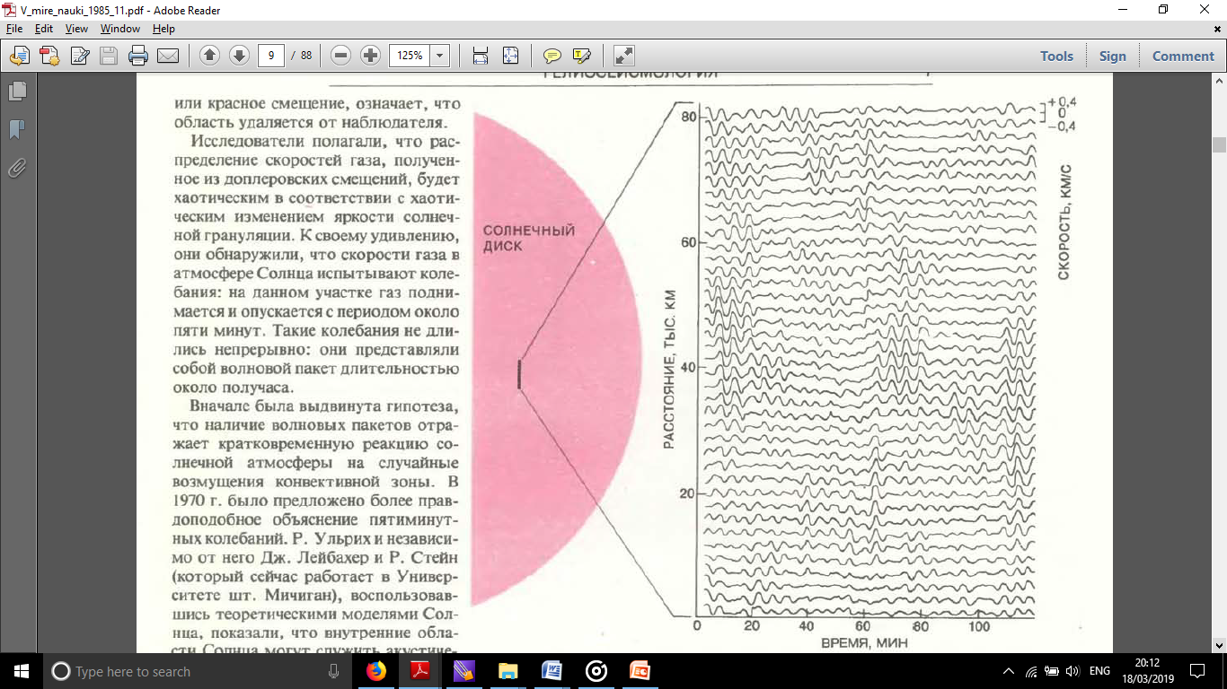

Figure-7.1 Time variation of vertical speed at points of the Sun's surface 2200 km apart.

The periodic oscillation of the Sun's surface periodically shifts the sodium line in its spectrum. This causes a change in the intensity of the light emitted from the sodium cell. If the intensity of sunlight passing through the sodium cell is measured for a long time (from several weeks to several months) and the collected material is analyzed by spherical harmonics, periodic fluctuations in the power spectrum show maximum amplitude. Such investigations have shown that the photosphere has 75 different modes with a period of 3 to 10 minutes at values ​​of spherical azimuthal harmonic λ from 0 to 4. The amplitude of these modes is 4÷The maximum amplitude corresponds to 5 m at a distance of 40 cm/s.

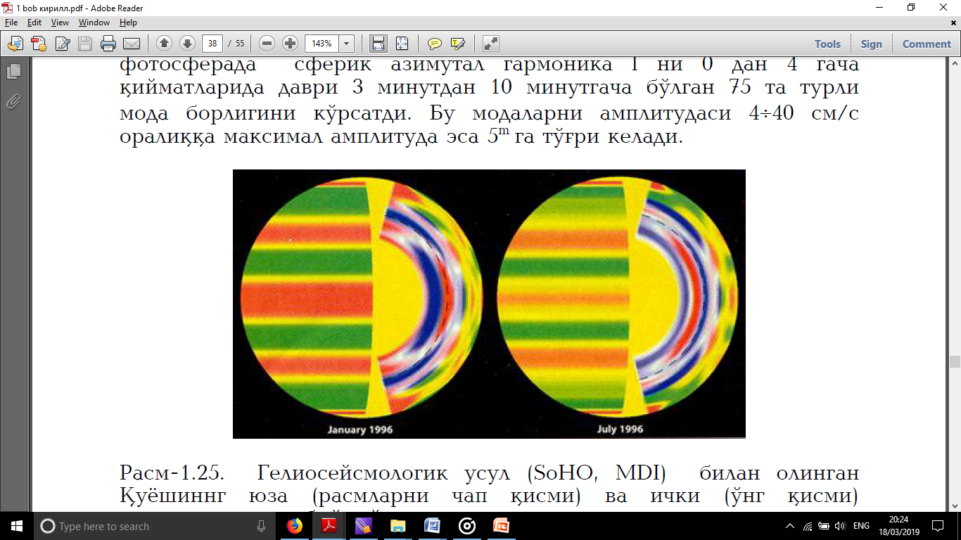

Fig. 7.2 Maps of the relative rotation speed of the surface (left) and inner (right) layers of the Sun obtained by the helioseismological method (SOHO, MDI): on the left, red bands are fast compared to the average differential rotation (yellow), green bands are slow; on the right - in the inner layers: the inner boundary of the dotted semicircular convective zone; red areas - fast, purple - slow rotating layers.

These 5-minute oscillations in the photosphere are stationary acoustic modes captured by the layer below the temperature minimum. Because the buoyant force in the convective zone below the photosphere creates turbulent motions. These movements in turn create pressure irregularities that propagate as acoustic waves. And acoustic modes become standing waves in the photosphere.

These 5m pressure waves in the photosphere create sound waves that propagate towards the inner and outer layers of the Sun. A shock wave is formed in the outer layers, and as it rises, it becomes a shock wave. These pressure waves spreading towards the inner layers, like seismic waves generated by earthquakes, pass through the inner layers of the Sun from one side to the other side and go out into the photosphere, from which the reflection again goes towards the depth of the Sun. If there is a layer in the interior of the Sun with a sudden change in density or rotation speed, its frequency and amplitude may change during such movement, and such a change is reflected in the spectrum of vibrations. Investigating the internal structure of the Sun with this method is called helioseismology, and it has been successfully used in the last 15 years. There are several international programs in this direction, some of which (GONG - Global Vibration Observing Group) include many observatories on Earth. The system is implemented using other space stations (SOHO, MDI).