**LECTURE-8: ROTATION OF THE INTERIOR LAYERS OF THE SUN. CONVECTIVE ZONE. GRANULATION.**

The inner and outer parts of the sun are divided into different layers that differ from each other according to their physical nature. The names of these layers are as follows:

1. The field of nuclear reactions. It includes the central part of the Sun, where nuclear reactions take place, and the part from the center of the Sun up to 0.3Rʘ.
2. Radioactive field (or radiation field). Radiation balance is observed in this area, and the process of energy transport occurs with radiation absorption and re-radiation. On average, this area covers the range of 0.3-0.7Rʘ.
3. Convective field. In this area, energy is mainly transported by convective means. This area is 0.7-1.0Rʘ.

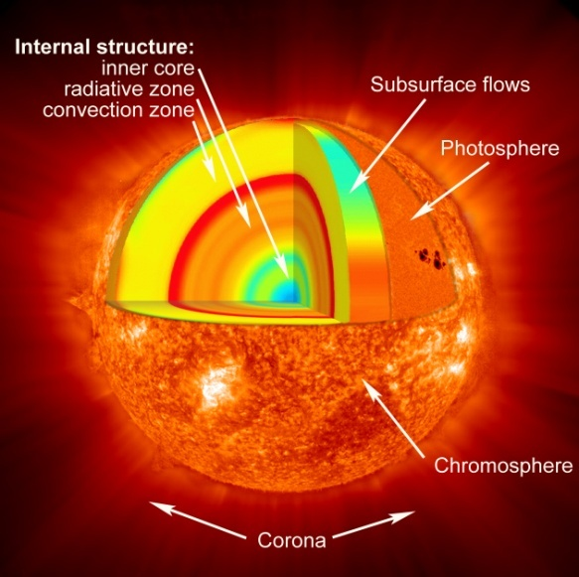

The area starting from the surface of the Sun is called its outer layers, which make up the Sun's atmosphere. The solar atmosphere consists of three layers: photosphere, chromosphere and corona. When observed with the naked eye or through a telescope, only the photosphere, the lowest layer of the Sun's atmosphere, can be seen. The chromosphere and the Sun's corona are observed only in special telescopes.

The surface layer of the Sun, that is, the photosphere, is about 300 kilometers thick and is better studied than other layers. The following objects can be observed in the photosphere: granulation, flares and sunspots.

At the end of the 19th century, Jansen and Gansky were the first to study solar granulation photographically. The Sun's photosphere does not consist of a surface of uniform brightness, but has a granular structure reminiscent of a beehive. This is called granulation (the Greek word "granule" means granulation). Granulation can be seen in large telescopes with a strong resolution, when the conditions for observation are good (the Earth's atmosphere is free of dust, when the flow of air in different directions is greatly reduced). In the following years, the concept of granulation was enriched by the results of observations outside the Earth's atmosphere - in the stratosphere. Astronomical stations launched into the stratosphere to study the Sun and other celestial bodies, the size of granulation grains, introduced the physical nature and character of gas mass flow in them. According to the spectrum of granulation obtained with the help of the "Stratoscope-2" solar station launched in 1970, the granules in the granulation are convective cells, in the central part of which an increase in the gas flow (v = 0.2 km/s) was observed. Cells range in size from 300 km to 1000 km, sometimes larger. The shape of the granules indicates that the sunspot is affected by the sunspot's magnetic field in the photosphere's spotted areas, the oblong radial direction of the spot, the plasma flow rising along the granule. Granules disappear and reappear in the photosphere. Their average "living period" does not exceed 6-7 minutes. According to the spectrum of granulation obtained with the help of the "Stratoscope-2" solar station launched in 1970, the granules in the granulation are convective cells, in the central part of which an increase in the gas flow (v = 0.2 km/s) was observed. Cells range in size from 300 km to 1000 km, sometimes larger. The shape of the granules indicates that the sunspot is affected by the sunspot's magnetic field in the photosphere's spotted areas, the oblong radial direction of the spot, the plasma flow rising along the granule. Granules disappear and reappear in the photosphere. Their average "living period" does not exceed 6-7 minutes. According to the spectrum of granulation obtained with the help of the "Stratoscope-2" solar station launched in 1970, the granules in the granulation are convective cells, in the central part of which an increase in the gas flow (v = 0.2 km/s) was observed. Cells range in size from 300 km to 1000 km, sometimes larger. The shape of the granules indicates that the sunspot is affected by the sunspot's magnetic field in the photosphere's spotted areas, the oblong radial direction of the spot, the plasma flow rising along the granule. Granules disappear and reappear in the photosphere. Their average "living period" does not exceed 6-7 minutes. an increase in gas flow (v = 0.2 km/s) was observed in their central part. Cells range in size from 300 km to 1000 km, sometimes larger. The shape of the granules indicates that the sunspot is affected by the sunspot's magnetic field in the photosphere's spotted areas, the oblong radial direction of the spot, the plasma flow rising along the granule. Granules disappear and reappear in the photosphere. Their average "living period" does not exceed 6-7 minutes. an increase in gas flow (v = 0.2 km/s) was observed in their central part. Cells range in size from 300 km to 1000 km, sometimes larger. The shape of the granules indicates that the sunspot is affected by the sunspot's magnetic field in the photosphere's spotted areas, the oblong radial direction of the spot, the plasma flow rising along the granule. Granules disappear and reappear in the photosphere. Their average "living period" does not exceed 6-7 minutes. indicates that the sunspot is affected by the magnetic field. Granules disappear and reappear in the photosphere. Their average "living period" does not exceed 6-7 minutes. indicates that the sunspot is affected by the magnetic field. Granules disappear and reappear in the photosphere. Their average "living period" does not exceed 6-7 minutes.



In the photosphere, which is the layer of the solar atmosphere, flares are also observed, they are chain-like objects that differ in brightness. Spectral analysis shows that flares are 10-20% brighter than the photosphere. Flares can be observed only near the edges of the Sun's visible disk, and around the center of the disk they are almost invisible. The reason for this is that the radiation in the center of the Sun's disk is stronger than at its edges, due to its emanation from deeper regions. Torches have a magnetic field, the field strength of which is 50-100 ersted. One of the most problematic objects in the photosphere are sunspots.