4-Lecture. PRIMARY ANALYSIS OF IMAGES. IRAF IMAGE ANALYSIS SOFTWARE PACKAGE, ITS STRUCTURE
The IRAF (Image Reduction and Analysis Facility) software package is a comprehensive system primarily used for the reduction and analysis of astronomical data. Its structure is modular, composed of several fundamental components and a hierarchical organization of image processing tools.
The IRAF applications packages are divided into two broad classes, the system packages and the scientific reduction and analysis packages. In this section we introduce the system packages, which are listed in Figure 1. When describing the applications packages, we list all packages which have been implemented or which we plan to implement, since the purpose of this paper is as much to present the design of IRAF as to report its current state. The status of each package is indicated in the table below, where done means that the package has reached its
planned baseline functionality (of course, all packages continue to evolve after they reach this state), incomplete means that the package is in use but has not yet reached baseline functionality, in progress means the package is actively being worked on but is not yet in use, and future means that work has not yet begun on the package. It should be pointed out that each of these packages typically contains several dozen tasks, and many contain subpackages as well. It is beyond the scope of this paper to delve into the contents of these packages in any detail.
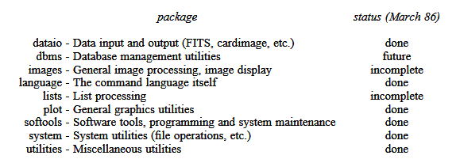

Fig 1. System Packages
The system packages include both those packages containing the usual operating system utilities, e.g., for listing directories or printing files, as well as those packages which are required by any scientific data processing system, e.g., for general image processing and graphics. The conventional operating system utilities are found in the system package. The language package contains those tasks which are built into the CL itself. The softools package contains the software development and system maintenance tools, including the HSI bootstrap utilities, i.e., the compiler, librarian, the mkpkg utility (similar to the UNIX make), the UNIX tar format reader/writer programs, and so on. The dbms package is the user interface to a planned IRAF relational database facility. The lists package contains an assortment of tasks for operating upon text files containing tabular data, e.g., for performing a linear transformation on one or more of the columns of a list.
The dataio package contains a number of tasks for reading and writing data in various formats, including FITS, cardimage, and a number of other more NOAO specific formats. These programs are typically used to read or write magtape files, but all such programs can be used to operate upon a disk file as well, a useful alternative for sites which have access to an electronic network. The plot package contains a number of vector graphics utilities, including CL callable versions of all the NCAR graphics utilities (using the IRAF/GIO GKS emulator). The images package, which is actually a tree of related packages, contains the general image processing tasks plus the image display and display control tasks.
The NOAO packages for the reduction and analysis of optical astronomy data are summarized in Figures 2 and 3. There are two categories of optical astronomy packages. The packages listed in Figure 2 are intended to be of general use for any optical astronomy data, not just for data taken at an NOAO observatory with an NOAO instrument. Since these are intended to be general purpose, instrument independent packages, naturally they are not always the most convenient packages to use for reducing data from a specific instrument. The imred packages, sum marized in Figure 3, fulfill the need for easy to use or "canned" reduction procedures for specific instruments. In many cases the tasks in the imred packages are CL scripts which fetch instrument specific parameters from the image headers and call tasks in the more general, instrument independent packages. The list of imred packages is continually growing as new instruments are supported.

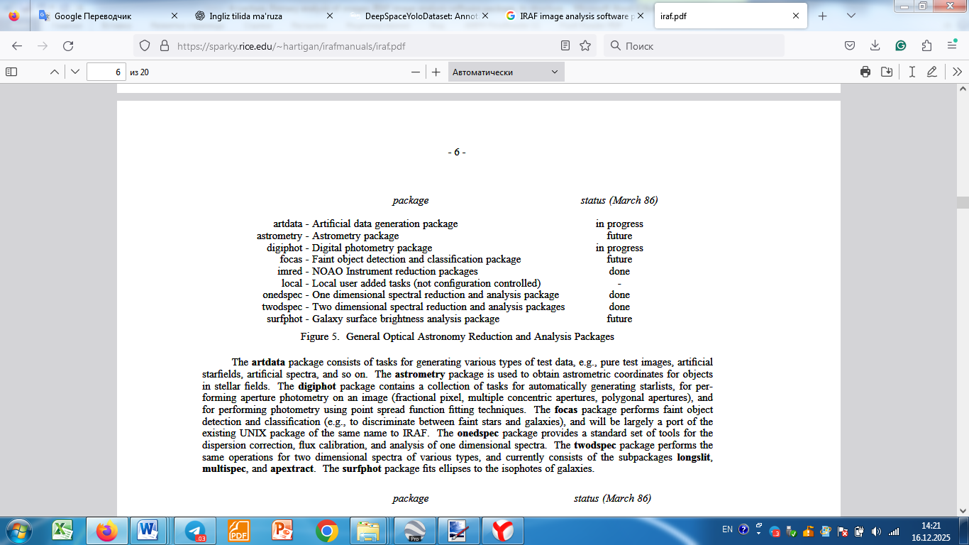
Figures 2. General Optical Astronomy Reduction and Analysis Packages
The artdata package consists of tasks for generating various types of test data, e.g., pure test images, artificial starfields, artificial spectra, and so on. The astrometry package is used to obtain astrometric coordinates for objects in stellar fields. The digiphot package contains a collection of tasks for automatically generating starlists, for performing aperture photometry on an image (fractional pixel, multiple concentric apertures, polygonal apertures), and for performing photometry using point spread function fitting techniques. The focas package performs faint object detection and classification (e.g., to discriminate between faint stars and galaxies), and will be largely a port of the existing UNIX package of the same name to IRAF. The onedspec package provides a standard set of tools for the dispersion correction, flux calibration, and analysis of one dimensional spectra. The twodspec package performs the same operations for two dimensional spectra of various types, and currently consists of the subpackages longslit, multispec, and apextract. The surfphot package fits ellipses to the isophotes of galaxies.
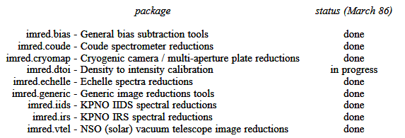

Figure 3. Current NOAO Instrument Reduction Packages
The imred packages perform general CCD image reductions, as well as the reductions for other more specialized instruments. The cryomap, iids, irs, and vtel packages deal with specific NOAO instruments and are probably only of interest to people who observe at an NOAO observatory. The remaining packages should be useful for anyone with CCD, Echelle, or photographic (density) data.
In addition to the applications packages already mentioned, all of which are being developed by the IRAF group at NOAO, we anticipate that a fair amount of third party software will eventually be available for use within IRAF as well. The STScI SDAS software is the first example of this. Third party software appears within IRAF as a new branch on the package tree. There is no limit on the size of such an addition, and in the case of SDAS we find a suite of packages comparable to the IRAF system itself in size. As of this writing, a number of other groups are
either actively developing additional third party software or are contemplating doing so, but it would be inappropriate to be more specific until these packages are announced by the institutions developing them. Third party software may unfortunately not meet IRAF standards, hence the software may not be usable on all IRAF hosts, nor usable with all the graphics and image display devices supported by IRAF. Applications software which is built according to IRAF standards is automatically portable to all IRAF hosts without modification (although some debugging is typically required on a new host), hence sites considering adding their own software to IRAF are encouraged to model their software after the existing NOAO IRAF applications.

