5-Lecture. PRELIMINARY ANALYSIS OF ASTRONOMICAL IMAGES
Preliminary analysis of astronomical images is a crucial initial stage in observational astronomy and astrophysics. Before advanced scientific interpretation can be performed, raw astronomical data must be examined, corrected, and evaluated to ensure reliability and accuracy. This stage bridges the gap between raw data acquisition and high-level scientific analysis, enabling astronomers to assess data quality, detect artifacts, and prepare images for quantitative measurements.
Astronomical images are obtained from ground-based and space-based telescopes operating across the electromagnetic spectrum. Due to the extreme sensitivity of detectors and the faint nature of astronomical signals, raw images are often contaminated by noise, instrumental effects, and environmental disturbances. Preliminary analysis aims to identify these effects and apply systematic corrections based on established scientific methodologies.
This lecture provides a comprehensive, scientifically grounded discussion of the preliminary analysis of astronomical images. It draws upon authoritative academic literature and emphasizes both theoretical principles and practical techniques used in modern astronomical research.

Astronomical Image Formation
Astronomical images are formed by recording photons emitted or reflected by celestial objects. Telescopes collect incoming radiation and focus it onto detectors such as Charge-Coupled Devices (CCDs) or Complementary Metal-Oxide-Semiconductor (CMOS) sensors. Each pixel in the detector records the number of photons accumulated during an exposure, converting physical radiation into digital data.
The recorded signal depends on several factors, including telescope aperture, exposure time, detector sensitivity, atmospheric conditions, and wavelength range. As described by Howell (2006), astronomical image formation is inherently probabilistic due to the discrete nature of photon arrival.

Characteristics of Raw Astronomical Images
Raw astronomical images differ significantly from conventional digital images. They typically exhibit:
- Low signal-to-noise ratios
- Non-uniform background illumination
- Detector-specific artifacts
- Large dynamic ranges in brightness
These characteristics necessitate specialized preliminary analysis techniques to preserve scientific integrity.

Visual Inspection and Metadata Analysis
The first step in preliminary analysis involves visual inspection of raw images and examination of metadata stored in image headers (e.g., FITS headers). Metadata includes information about exposure time, filter type, detector temperature, observation date, and telescope configuration. According to Wells et al. (1981), proper interpretation of metadata is essential for reproducibility and calibration.
Visual inspection helps identify obvious defects such as saturated regions, tracking errors, cosmic ray hits, and optical distortions.

Signal-to-Noise Ratio Evaluation
Signal-to-noise ratio (SNR) is a fundamental metric used to assess image quality. It quantifies the strength of the astronomical signal relative to background noise. Preliminary SNR estimation guides decisions regarding data usability and processing strategies.
Mathematically, SNR is expressed as:
SNR = S / √(S + N)
where S represents the signal and N represents noise contributions. Accurate SNR estimation is critical for photometric and astrometric reliability.

Types of Noise in Astronomical Images
Noise sources in astronomical imaging are well documented in scientific literature. Major types include:
- Photon (Shot) Noise: Statistical fluctuations in photon detection
- Readout Noise: Electronic noise during data readout
- Dark Current Noise: Thermally generated electrons in the detector
- Cosmic Ray Events: High-energy particle interactions
- Sky Background Noise: Light pollution and natural sky emission
Understanding the statistical properties of each noise source is essential for effective correction.

Noise Modeling
Preliminary analysis often includes modeling noise distributions to distinguish signal from background fluctuations. Gaussian and Poisson models are commonly applied depending on signal strength. Such modeling forms the basis for later denoising and error estimation.
Image Processing [1] is the collective term given to techniques or procedures used to process an image for analysis, feature extraction, object detection, et cetera. Image Processing has several applications in mostly all kind of domains including
medical science, astronomy, automation industry amongst many others. With a huge volume of image data being generated or captured these days along with more powerful hardware including lenses and computational processing
power, the popularity and necessity of Image Processing is increasing exponentially.
Image Processing along with Digital Signal Processing is highly important in Astronomy especially with the recent advancements in space exploration and the technological development of more robust and technically sound observatories with more powerful telescopes. The use of Image Processing and Digital Signal Processing in Astronomy varies from detection and classification or categorization of celestial objects, determining the distance from earth, understanding the physical properties of the subject in the image by performing spectrum analysis using the signal data. With the recent advents in Machine Learning, astronomers
and cosmological experts are having more tools at their disposal to understand our near celestial neighbours and Image Processing is undeniably one of the most crucial pre-processing and analytical steps in that pipeline. Currently, astronomers and cosmological scientists use the standard image processing and analysing systems for astronomy available which includes:
AIPS (Astronomical Image Processing System): Originally designed using FORTRAN programming language by professionals at NRAO (National Radio Astronomy Observatory) in 1978, AIPS has been in use for 40 years now. AIPS provides a wide array of automated tools like Gaussian fitting of images, applying mathematical operators, spectra analysis, et cetera, for astronomers to analyze data considered in FITS (Flexible Image Transport System) format. Though being partially replaced by its to-be successor called CASA (Common Astronomy Software Applications), formerly known as AIPS++, AIPS has evolved over the years and has received significant updates and remains popular to this date.
IRAF (Image Reduction and Analysis Facility): IRAF, developed at NOAO (National Optical Astronomy Observatory), is an assemblage of software aimed at reducing astronomical images to their pixel array representation for advanced statistical analysis. IRAF is primarily confined to data obtained from imaging array detectors as CCDs (Charged Coupled Device). IRAF includes stacks of various
applicative functionalities which includes determining redshifts of absorption or spectral analysis, the combination of images, calibration of fluxes and orientation of astronomical/ celestial objects captured within the image, compensation of variation in pixel sensitivity, et cetera.
Other Software based analyzing systems available include STSDAS (Space Telescope Science Data Analysis System), StarLink Project and many more. The existence of these automated frameworks have greatly improved the analytical
pipeline and boosted research in astronomy in total.
Image Processing plays a vital role in understanding, analyzing and interpreting astronomical images. Starting from Image Smoothening, Noise removal, Edge Detection and Contour Mapping to Object Segmentation, digital image processing combined with signal processing is a powerful set of tools for astronomers to use while analyzing astronomical data. In the subsequent sub-sections, the research results along with the application of various mathematical algorithms and techniques have been described in detail.

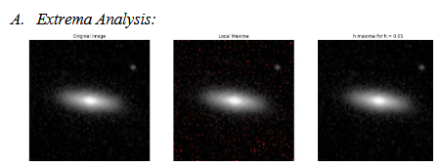

Fig. 1. (a). Original Elliptical Galaxy Image with label 806304. (b). Local Maxima of the Original Image. (c). h Maxima for h=0.05 of the Original Image.
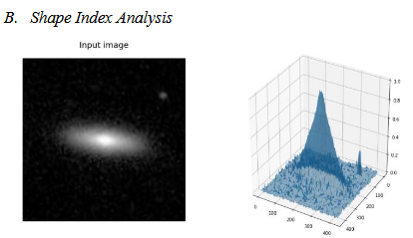

Fig. 2. (a). Original Input Image. (b). 3-dimensional visualization of shape index profile of the Input Image.

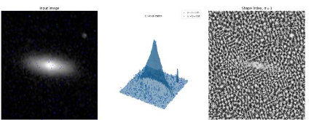

Fig. 3. (a). Original Input Image with Extrema Analysis. (b). 3-dimensional visualization of shape index profile of the Input Image. (c). Shape Index with 𝜎 = 1
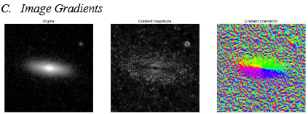

Usually, in Galaxy Imaging, telescopes often capture images containing galaxies along with clusters of stars and other celestial objects. Correctly identifying the Galaxy within the image is the preliminary step before moving towards analyzing the galaxy subject. Extrema Analysis proves to be extremely helpful in such cases to find regional maximas and minimas within the image for segmentation. Due to the noisy characteristics of the input image, h-maxima was applied with a magnitude of 0.05 for preferred results. With high level of noise, many local maximas were generated as seen in Fig. 1(b). The h parameter is scaled with the dynamic range of the image and represents the grayscale level known as height by which the algorithm needs to descend to potentially reach a higher maximum which is technically local contrast observable in the image.
Preliminary analysis in astronomical image processing includes understanding the dimensional properties or the shape index profile of the celestial object in the image. Interpreting the shape index, orientation index and dimensional profile of the object helps astronomers to correctly identify the class it
belongs to and also to conduct subsequent research on it. Shape Index Profile is a single-valued entity measuring the local curvature and is derived from the Eigen values of the Hessian. As seen in Fig. 2.(b)., the shape index does get affected due to apparent noise pattern hampering the general texture of the image but is immune to uneven illumination. Fig. 3 shows the shape index profile of the input image
along with spherical caps detection due to the 𝜎 parameter being 1. This provides a clear intuition of the illumination concentration in the image, spatial orientation of the celestial object and also helps in defining the shape index of that object making it a crucial step in astronomical image analysis.
Image Gradients are the fundamental building block of any digital image which represents a directional change in pixel intensity or contrast levels. Gradient Computation is a high priority task for many post-processing image processing techniques including edge detection and segmentation. For instance, Watershed Segmentation uses Local Gradients of the image to establish markers to define boundaries between objects in the image for Segmentation. Image Gradients computation is also used as a process for feature extraction and texture matching or pattern recognition within the image.
Fig. 4 shows both the Gradient Magnitude Mapping and Gradient Orientation of the Input image of the elliptical galaxy. This provides a lot of information on the orientation of the object in the image and also is used in subsequent sections for image segmentation performed on the image to segment the galaxy from the image.

References:
1. Diganta Misra, Sparsha Mishra and Bhargav Appasani. Advanced Image Processing for Astronomical Images. https://arxiv.org/pdf/1812.09702

