Lecture 2: INTRODUCTION TO THE UNIX OPERATING SYSTEM. GENERAL INFORMATION ABOUT THE UNIX OPERATING SYSTEM, WORKING WITHIN IT

During the early 1960s, many computers were working in batch mode, running single jobs. Programmers had to use punch cards to input their programs and then wait for the output on the line printer. The UNIX operating system was born in 1969 as a response to the frustration of the programmers and the need for new computing tools to help them with their projects.
The UNIX operating system was the brainchild of Ken Thompson and Dennis Ritchie, two Bell Laboratories researchers. At the time, Ken Thompson was working on a program called Space Travel, a program simulating the motion of the planets in the solar system. The program was under an operating system called Multics, one of the first operating systems that provided a multiuser environment, and ran on a General Electric 6000 Series computer. But Multics was large and slow and required substantial computer resources. Thompson found a smaller computer and transferred the Space Travel program to
run on it. The smaller computer was a little-used PDP-7, one of the series of machines made by Digital Equipment Corporation (DEC). On that computer, Thompson created a new operating system that he called UNIX, and he adapted some of the advanced Multics concepts to that operating system. Other operating systems had more or less the same ca pabilities, and UNIX took advantage of the work that had gone into those operating systems by combining some of the most desirable aspects of each of them.
UNIX was transferred to the PDP-11/20 in 1970, then to the PDP-11/40, the PDP-11/45, and eventually the PDP-11/70. Each of these machines had features that gradually added to the complexity of the hardware that UNIX could support. Dennis Ritchie and others at Bell Labs continued the development process of UNIX, adding utilities (such as a text processor). Like most of the operating systems, UNIX was originally written in assembly language. Assembly language is a primitive set of instructions that depend on the computer architecture. Programs written in assembly language are machine dependent and work on only one computer (or one family of computers). Therefore, moving UNIX from one
computer to another involved significant rewriting of the programs. Thompson and Ritchie were experienced users of Multics, which was written in a high-level language called PL/1, and they were aware of the advantages of using a high level language to write operating systems. (A high-level language is much easier to use than assembly language.) They decided to rewrite the UNIX operating system in a high level language. The language they chose was C. The C programming language is a general-purpose language featuring the commands and structures of modern, high-level computer languages. In 1973, Ken and Dennis successfully rewrote the UNIX operating system in C.
In 1983, AT&T released the standard UNIX System V, which was based on the UNIX that AT&T was using internally. As the UNIX development effort continued, other features were added and some existing features were improved. Over the years, UNIX System V grew larger in size as well as in the number of its tools and utilities. The early improvements and new features were incorporated into the UNIX operating system’s later releases, UNIX System V Release 3.0 in 1987 and UNIX System V Release 4.0 (SVR4) in 1989. UNIX System V Release 4.0 was an effort to merge most of the popular features of the Berkeley UNIX and other UNIX systems. This unification helped simplify the UNIX product and reduced the need for manufacturers to create new UNIX variants.
The UNIX operating system is available on all types of computers (micros, minis, mainframes, and supercomputers) and is an important operating system in the computer industry. As more UNIX-based systems were introduced into the market and more application programs became available, an effort toward UNIX standardization began. AT&T’s UNIX System V Release 4.0 was an effort to standardize the UNIX system and, in turn, to facilitate the writing of the applications that run on all versions.
The written UNIX standard from AT&T is called System V Interface Definition (SVID). Other companies that market UNIX operating systems or related UNIX products have joined together and developed a standard called Portable Operating System Interface for Computer Environments (POSIX). POSIX is largely based on the System V Interface Definition.
UNIX is one of the most widely used operating systems in the world and has long been the standard for workstations and servers. UNIX is a commercial product and must be purchased for each platform it will run on. The Linux variant of the UNIX operating system is the brainchild of Linus Torvalds, a computer science student at the University of Helsinki in Finland. It was designed to run on Intel-based personal computers. Many programmers worked on Linux, and Linux grew as programmers adapted features and programs that were originally written as commercial UNIX products to Linux. Unlike other versions of UNIX, Linux is a freely distributable version of UNIX, and there are no licensing fees involved. Some companies have undertaken the task of assembling and testing versions of Linux, which they package on a CD-ROM for a (usually) minimal price.
SunOS, later called Solaris, was the operating system of Sun Microsystems that was based on UNIX System V Release 2 and BSD (Berkeley Software Distribution) 4.3. Solaris 2.0 was based on SVR4 and was released in 1990. Since then, many releases of Solaris have provided a large installations base. The naming scheme for Sun Solaris was changed many times. After the Solaris 2.6 release, Sun referred to Solaris releases by just its point release. Thus, Solaris 2.7 was named Solaris 7. Solaris 10 is the current release.
The unix system is said to consist of the following three major components.
1. The kernel
2. The shell
3. The file system
Figure 1. shows the UNIX operating system. The UNIX operating system is implemented in a layered-style software model.
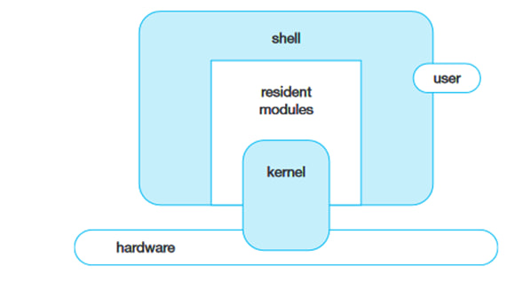

fig. 1. The Unix System Components.

The kernel is the heart of any Unix operating system. This kernel is relatively a small piece of code that is embedded on the hardware. Actually, it is a collection of programs that are mostly written in C. Every Unix system has a kernel (just one) that gets automatically loaded on to the memory as soon as the system is booted. As the kernel sits on the hardware it can directly communicate with the hardware. Kernel The UNIX kernel, also called the base operating system, is the layer that manages all the hardware-dependent functions. These functions are spread over a number of modules within the UNIX kernel. The kernel layer consists of modules closest to the hardware that are for the most part protected from the application programs. Users have no direct access to it.
The Unix kernel consists of several interrelated subsystems:
- Process Management: Handles process creation, scheduling, and termination.
- Memory Management: Implements virtual memory, paging, and address space isolation.
- File System Management: Controls access to persistent storage using inodeased structures.
- Device Management: Provides uniform access to hardware through device drivers.
These subsystems operate together to ensure efficient and secure system operation.

The Shell
Every Unix system has, at least, one shell. A shell is a program that sits on the kernel and acts as an agent or interface between the users and the kernel and hence the hardware. It is similar to the command prompt in the MS-DOS environment. The shell has certain programming capability of its own. Using this capability, programs called shell programs can be written. Generally shell programs are called shell scripts.

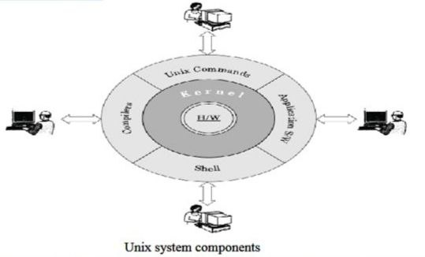

Types of shells There are different types of shells available. Some of them are discussed here. The Bourne shell (sh) This is the most common shell available on Unix systems and the first major shell to be developed. This shell is widely used. It has been named after its author, Stephen Bourne at AT&T Bell Labs. This shell is distributed as the standard shell on almost all Unix systems. The C shell (csh) Bill Joy developed this shell at UCB as a part of the BSD release. It is called the C
shell because its syntax and usage is very similar to the C programming language. Unfortunately this shell is not available on all machines. Shell scripts written in the C shell are not compatible with the Bourne shell. One of the major advantages of the C shell over the Bourne shell is its capability to execute processes in the background. A version of this shell called tcsh is available free of cost under
Linux. The Korn shell (ksh) This shell was developed by David Korn at AT&T Bell labs. Basically it is built on the Bourne shell. It also incorporates certain features of the C shell. At present it is one of the widely used shells. It can run Bourne shell scripts without any modifications. One of its versions, the public-
domain Korn shell (pdksh), comes with Linux free of cost. The Bourne-Again shell (bash) This shell was developed by B Fox and C Ramey at Free Software Foundation. Certain Linux operating system variants come with this shell as its default shell. This is clearly a free ware shell.
Shell as a Command Processor As already discussed, the shell acts both as a command processor and a small programming language. Given here is a brief account of the behaviour of the shell as a command processor. When interpreting a command line given at its prompt, the shell follows one or more or all of the following steps, depending on the contents of the command line given to it.
1. It parses the command line and identifies each and every word in it and removes additional spaces or tabs present, if any.
2. Evaluates all the variables present that might be prefixed with a $.
3. If commands are present within back quotes, they are executed and their output is substituted into the command line. In other words, command substitution takes place.
4. It then checks for any redirection of the input and/or output and establishes the connectivity between the concerned files accordingly.
5. It then checks for the presence of wildcard characters like *, ? and [, ]. If any of these characters are present, file name generation and substitution take place.
It then looks out for the required commands as well as files, retrieves them and hands them to the kernel for execution. The route or the path taken for looking out for the required commands will be in the PATH shell variable. Also the semicolon that allows multiple commands, and logical operators are taken care of by the shell.
The File System
A file system is another major component of a Unix system. Unix treats everything-including hardware devices—as a file. All the files in a Unix system are organized in an inverted tree-like hierarchical structure. This structured arrangement in which all the files are stored is referred to as a file system. A file system could be local to a system or it could be distributed. Local file systems store and manage their data on devices directly connected to the system. Distributed file systems allow a user to access files residing on remote machines.
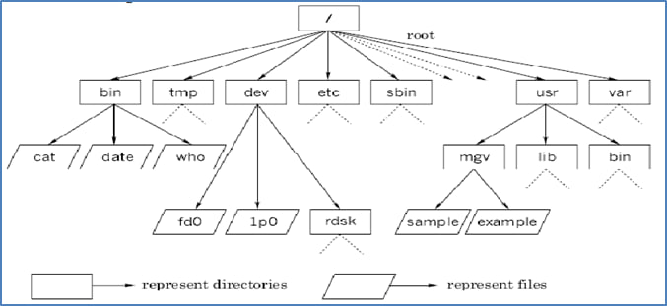

When interpreting a command line given at its prompt, the shell follows one or more or all of the following steps, depending on the contents of the command line given to it.
1. It parses the command line and identifies each and every word in it and removes additional spaces or tabs present, if any.
2. Evaluates all the variables present that might be prefixed with a $.
3. If commands are present within back quotes, they are executed and their output is substituted into the command line. In other words, command substitution takes place.
4. It then checks for any redirection of the input and/or output and establishes the connectivity between the concerned files accordingly.
5. It then checks for the presence of wildcard characters like *, ? and [, ]. If any of these characters are present, file name generation and substitution take place.
It then looks out for the required commands as well as files, retrieves them and hands them to the kernel for execution. The route or the path taken for looking out for the required commands will be in the PATH shell variable. Also the semicolon that allows multiple commands, and logical operators are taken care of by the shell.
The File System
A file system is another major component of a Unix system. Unix treats everything—including hardware devices—as a file. All the files in a Unix system are organized in an inverted tree-like hierarchical structure. This structured arrangement in which all the files are stored is referred to as a file system. A file system could be local to a system or it could be distributed. Local file systems store and manage their data on devices directly connected to the system. Distributed file systems allow a user to access files residing on remote machines.
USING UNIX
To use Unix, one has to get into the Unix environment. The process of getting into the Unix environment is known as logging in into the system. As soon as the system is booted a daemon called init gets started. This init daemon spawns a process called getty for every terminal. Each one of these gettys print the login prompt on the respective terminal. When a user attempts to enter into the Unix environment, that is, tries to login, the login program is executed in order to verify the user name and the password. A file called password file under the /etc directory contains a line for every user, containing the user’s login name, numerical user id, encrypted password, home directory, and other such information. When the user logs in, the login program encrypts the password just read from the terminal and compares it with the password in the password file. If they agree, the login is permitted; if not, it is disallowed. Every user has a user id as well as a password allocated to them by the system administrator. This is true even in the case of single-user systems. However, it may be noted that the user will be the system administrator in the case of single-user systems. The sequence of events in a
complete login process can be listed as follows.
• The user enters a login name at the getty’s login prompt on the terminal.
• getty executes the login program with the login name as the argument.
• login requests for a password and validates it against /etc/passwd.
• login sets up the TERM environment variable and runs a shell.
• The shell executes the appropriate startup files like .profile.
• The shell then prints a prompt, usually a $ or a % symbol and waits for further input. This indicates the successful entry made into a Unix environment with a proper shell. The above-listed sequence of events that take place during a login process is schematically shown.

https://www.tecnrt.org/docs/cse/materials/UNIX.pdf

